Short Form Catalog 2013

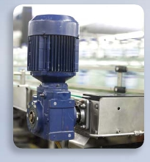

High Power Semiconductors for Industrial Applications

[www.infineon.com](http://www.infineon.com)

The  standard



work  for  IGBTs

Second  Edition

Reference book IGBT Modules

Technologies, Driver and Application

The  aim  of  this  book  is  to  give  the  reader  an  understanding  of  the  specific

fundamentals  of  IGBT  in  conjunction  with  their  application.  This  book  will

provide  students  of  power  electronics  with  valuable  information  about  the  main

contemporary  power  semiconductors  and  the  applications  in  which  they  are  used,

while  development  engineers  targeting  power  electronic  converters  will  find  all

the  essentials  of  selecting,  dimensioning  and  applying  IGBT  modules  laid  out

clearly  and  comprehensively.

IGBT  Modules  –  Technologies,  Driver  and  Applications

Andreas  Volke  (Author),  Michael  Hornkamp  (Author),  Jost  Wendt  (Translator)

ISBN:  978-3-00-040134-3

For  further  information  please  visit  our  website:

[www.infineon.com/igbt-book](http://www.infineon.com/igbt-book)

High power semiconductors



for your industrial applications

What sets our products apart is based on a deep understanding of our customer’s

current and future application needs. The core values of quality, reliability, lon-

gevity and innovation are therefore an essential part of any new development and

product improvement. This applies to our chip design, as well as our module devel-

opment and manufacturing.

Accordingly, we offer a broad portfolio of power semiconductor products for in-

dustrial applications in the power range from 0.5 kW up to several MW. The appli-

cations range from traditional industrial drives and complete systems for renew-

able energies (wind and solar), transportation (traction, construction and utility

vehicles), power supplies, welding applications, to medical equipment and Major

Home Appliances.

With the short form catalogue (Kuka) 2013, we offer an overview of this range in-

cluding many details. Through continuous dialogue with our customers we have

once again increased the effectiveness this year.

The blue application pictures you’ll find inside show the range of applications were

the related  products are used for. In the electronic version of this catalogue, at

[www.infineon.com/highpower,](http://www.infineon.com/highpower) you can click on Short-links to find even more in-

formation useful for your application

We would welcome your information to assist in improving this catalogue.

To do so, please send us your suggestions via the “Contact” form on

[www.infineon.com/highpower](http://www.infineon.com/highpower)

III

Content

IGBT

LowPower



Introduction III

Legend VII

IGBT Modules - Discrete IGBTs 1.1

Overview IGBT 1.2

IGBT Selection Tree 1.3

TRENCHSTOP™ 5 Product Spectrum – First Wave 1.4

Induction Cooking Series Portfolio 1.5

TRENCHSTOP™ and RC-Drives IGBT 1.6

HighSpeed 3 - Single IGBT & DuoPack™ 1.7

TRENCHSTOP IGBT and DuoPack™ 1.8

HighSpeed 2 IGBT and DuoPack™ 1.9

Discrete Emitter Controlled Diodes 1.10

Rapid Diode Families 1st Wave Release 1.11

HighSpeed 2/HighSpeed 2 DuoPack 1.12

HighSpeed 3 1.13

HighSpeed 3 DuoPack 1.14

RC Drives Fast Series DuoPack/RC Drives Series DuoPack1.15

RC-H Soft & Hard Switching Series 1.16

RC-H Soft Switching & Fast Soft Switching Series 1.17

TRENCHSTOP™ 1.18

TRENCHSTOP™ Duo Pack 1.19

TRENCHSTOP™ DuoPack/ TRENCHSTOP™ F5/

TRENCHSTOP™ F5 DuoPack 1.20

TRENCHSTOP™ H5/ TRENCHSTOP™ H5 DuoPack 1.21

TRENCHSTOP™2 DuoPack 1.22

Links 1.23

IGBT Modules - Low Power 2.1

Overview IGBT 2.2

Easy 1B & 2B Product Portfolio 2.3

IV

Econo Product Portfolio for New Designs            2.3

EasyPIM™ Power Integrated Modules              2.4

EasyDUAL                                 2.6

EasyPACK                                 2.7

EASY Solar/UPS-High Efficiency Line               2.8

SmartPIM                                 2.10

SmartPACK                                2.11

EconoPIM™                               2.12

EconoPACK™                              2.14

Outlines                                 2.17

Package Units                             2.36

Mounting Hardware for EasyPIM™, EasyPACK,

EasyBRIDGE, EasyDUAL Modules              2.37

Links                                    2.38

IGBT Modules - Medium Power                  3.1

Overview IGBT                              3.2

34 mm and 62 mm Modules                     3.3

EconoPACK™ 4                             3.8

EconoPACK™ +                             3.10

EconoPACK™ + D-Series                      3.11

EconoDUAL™                              3.12

Outlines                                 3.15

Package Units                             3.22

Links                                    3.23

IGBT Modules - High Power                     4.1

Overview IGBT                              4.2

PrimePACK™                               4.3

IHM Modules                               4.4

IHV Modules                               4.7

Diode Modules 4.9

IGBT

LowPower



Outlines 4.10

Package Units 4.13

Links 4.14

Systems and Drivers 5.1

Overview Stacks an MIPAQ™ 5.2

MIPAQ™ 5.3

Outlines 5.5

PrimeSTACK ™ 5.7

Available configurations 5.8

PrimeSTACK ™ 5.9

PrimeSTACK ™ with DC Link 5.10

ModSTACK ™ / ModSTACK ™ HD 5.11

ModSTACK ™ 5.12

ModSTACK ™ HD 5.14

Type Designations 5.15

EiceDRIVER™ 5.17

HV Gate Driver ICs – EiceDRIVER™ ICs 5.18

Outlines 5.23

HV Gate Driver Boards – EiceDriver™ Boards 5.25

Evaluation Driver and Adapter Boards 5.27

Evaluation boards 5.28

Links 5.30

SCR Diode Modules 6.1

Bridge Rectifier & AC-Switches 6.1

Overview Bridge Rectifier, AC-Switches 6.2

EasyBRIDGE 6.3

eupec™ EconoBRIDGE ™ Rectifier 6.5

eupec™ IsoPACK ™ Bridge Rectifier 6.6

eupec™ IsoPACK ™ AC-Switches                  6.6

Outlines                                  6.7

Package Units                             6.10

Thyristor & Diode Modules                    6.11

Overview

PowerBLOCK Thyristor Modules for Phase Control   6.12

PowerBLOCK Thyristor Modules for Phase Control     6.13

PowerBLOCK Single Thyristor Modules for Phase Control 6.14

Overview PowerBLOCK Thyristor/

Diode Modules for Phase Control              6.15

PowerBLOCK Thyristor/Diode Modules for Phase Control 6.16

Overview PowerBLOCK Diode/

Thyristor Modules for Phase Control            6.17

PowerBLOCK Diode/Thyristor Modules for Phase Control 6.18

Overview PowerBLOCK Diode Modules for Phase Control 6.19

PowerBLOCK Rectifier Diode Modules             6.20

PowerBLOCK Fast Diode Modules                6.21

Gate Leads for PowerBLOCK Thyristor Modules       6.22

Screws for electrical connection

of PowerBLOCK Thyristor and Diode Modules      6.22

Outlines                                 6.23

Package Units                             6.27

Links                                    6.29

Presspacks                               7.1

Thyristor & Diode Presspacks                   7.1

Overview Phase Control Thyristors in Disc Housings    7.2

Phase Control Thyristors                       7.3

Light Triggered Thyristors                       7.5

Pulsed Power Applications                      7.6

Outlines                                  7.7

Clamping Forces for Thyristor Discs               7.12

V

Package Units Thyristor Discs 7.13

IGBT

LowPower



Standard Gate Leads for Disc Type Devices 7.14

Laser Diode and Light Fiber for light triggered Thyristors (LTT) 7.15

Overview Rectifier in Disc Housings 7.16

Rectifier Diodes 7.17

Welding Diodes 7.18

Overview IGCT/IGBT-Freewheeling Diodes and

Fast Rectifier Diodes 7.19

IGCT/IGBT Freewheeling Diodes 7.20

Fast Rectifier Diodes 7.21

Outlines 7.22

Clamping Forces for Diode Discs 7.26

Package Units for Diode Discs 7.28

Clamping Units for Disc Type Devices 7.29

Outlines 7.30

Links 7.32

Accessories & Explanations 8.1

Certificates 8.1

Type Designations 8.2

Letter Symbols 8.5

Terms and conditions of delivery 8.6

Further data sheets are available on request: IGBT-Modules,

Thyristor-/Diode-Modules, Fast Thyristors, Thyristors for Phase

Control, Power Rectifier Diodes, Snubber and Freewheeling Di-

odes Actual, extensive data can be obtained in PDF-format from

our internet address:

[www.infineon.com/powersemiconductors](http://www.infineon.com/powersemiconductors)

VI

Legend

IGBT

LowPower



Drives

Wind

Solar

Induction

Traction

CAV

UPS

Welding

SMPS

Aircon

Telecom

Home appliance

Server

PC Power

AC/DC

VII

VIII

Discrete

IGBTs

Discrete

Discrete

IGBTs

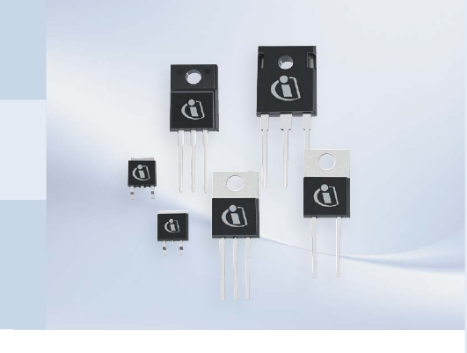

IGBTs

We  are  famous  for  IGBT  technology  leadership  and  offer  a  comprehensive  port-

folio  for  the  general  purpose  inverters,  solar  inverters,  UPS,  Induction  heating,

Microwave  Oven,  Rice  cookers,  Welding  and  SMPS  segments.

Benefits:

n  IGBTs  offer  much  higher  current  density  than  MOSFET  power  switches  due  to

bipolar  action

n  Insulated  gate  allows  bipolar  performance  with  MOSFET  gate  drive  performance

n  High  efficiency  =  smaller  heat  sink  which  leads  to  lower  overall  system  cost

n  175°C  T j(max) leading  to  higher  reliability

Soft  Switching/Resonant  and  Hard  Switching  Topologies  are  Comprehensively

Supported

Infineon  has  a  huge  portfolio  addressing  the  following  two  switching  techniques:

Soft  Switching/resonant

n  The  world  famous  IHW  series  IGBTs  –  #1  best  selling  family  worldwide

n

n

Available  in  600V,  1100V,  1200V,  1350V  and  1600V  voltage  classes

Best-in-Class  efficiency  and  robustness

Hard  Switching

n  600V  RC-D  IGBTs

n  600V  RC-Drives  Fast

n  600V  TRENCHSTOP™  DuoPack  IGBTs

n  600V/1200V  HighSpeed  3

n  1200V  TRENCHSTOP™  2

n  650V  TRENCHSTOP™  5

1.1

1.2

Discrete

IGBTs

3300V

IHVP.4.7

1200V

IHMP.4.4

1200V

PrimePACK™P.4.3

600V

1700V

62mmP.3.3

600V

34mmP.3.3

600V

650V

1200V

EconoDUAL™P.3.12

1200V

EconoPACK™+P.3.10

600V

EconoPACK™4P.3.8

1200V

MIPAQ™P.5.4

1200V

1200V

1700V

1200V

1700V

1700V

1700V

1200V

1700V

650V

1200V

1700V

1600V

1700V

4500V

6500V

1600V

P[kW]

600V

650V

EconoPIM™/EconoPACK™P.2.12

650V

SmartPIM/SmartPackP.2.10

600V

650V

1200V

EasyPIM™/EasyPACKP.2.4

600V

650V

1100V

1200V

1350V

TO-247

600V

650V

1200V

TO-220Full-PAK

600V

TO-262

I2-PAK

600V

650V

1200V

TO-220

600V

1200V

TO-263D2-PAK

600V

1200V

TO-252D-PAK

600V

TO-251I-PAK

IC[A]

50

75

100

150

200

600

800

900

1000

1500

400500

450

2000

3000

3600

1

2

3

4

6

8

10252015

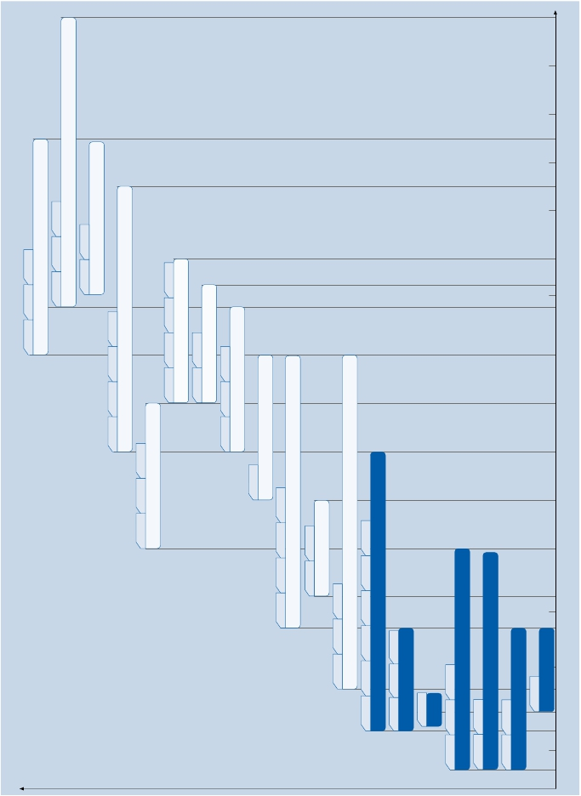

1.3

IGBTSelectionTree

Single

IGBT

IGBT+

Anti-Parallel

Diode

Soft

Diode

Commutation

Hard

NO

YES

IGBT

FrequencyRange

2–20kHz

TRENCHSTOP™(Duopack)

8–60kHz

RCseries(monolythic)

2–20kHz

TRENCHSTOP™

20–120kHz

HighSpeed

2–20kHz

TRENCHSTOP™

20–120kHz

HighSpeed

HighSpeed3

(H3)

TRENCHSTOP™5

(H5/F5)

RC-Drives

(monolythic)

DuoPack

(discrete)

HighSpeed3

(H3)

TRENCHSTOP™5

(H5/F5)

VoltageRange

600V

1200V

600V1100V1200V1350V1600V

600V

600V1200V

600V

1200V

650V

600V

1200V

600V

1200V

650V

PartNumber

IHpccN60T

IHpccT60…

IHpccT120…

IKpccN60R

IKpccN60RF

IKpccN60T

IKpccT120…

IKpccN120T2

IGpccN60T…

IGpccT120…

IGpccN120T2

IGpccN60H3

IGpccN120H2

IGpccN120H3

IGpccN65H5

IGpccN65F5

IHpccNvvvR2

IHpccNvvvR3

IHpccN60R

IHpccN60RF

IKpccN60H3

IKpccN120H2

IKpccN120H3

IKpccN65H5

IKpccN65F5

Application

ConductionLossOptimized

InductionHeating

Microwave

MultifunctionPrinters

HalfBridgeResonant

(Currentresonance–

600Vparts)

SingleSwitch

(Voltageresonance

>600Vparts)

InductionHeating

Microwave

MultifunctionPrinters

HalfBridgeResonant

(Currentresonance–

600Vparts)

SingleSwitch

(Voltageresonance

>600Vparts)

ConductionLossOptimized

DC/DC:

WeldingInverter

FullBridge

TwoTransitorForward

SolarInverter

DC/DC:

WeldingInverter

FullBridge

TwoTransitorForward

SolarInverter

AC/DC:

CCM-PFC

Welding

UPS

Solarbooststage

AirCon

Washingmachine

Hardswitching

topologies

without

anti-paralleldiode

AC/DC:

CCM-PFC

Welding

UPS

Solarbooststage

AirCon

Washingmachine

SolarInverter

AsymmetricalBridge

Symmetricalfullbridge

ThreeleveltypeIor

ThreeleveltypeIIconverter

MotorControl

Threephaseinverter

Fullbridgeinverter

UPSBridge

UninterruptablePowerSupply

ThreeleveltypeIIconverter

MajorHomeAppliances

Symmetricalfullbridge

Discrete

IGBTs

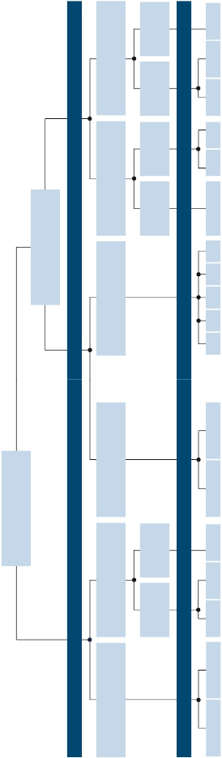

|  |  |  |  |  |
| --- | --- | --- | --- | --- |
| Single IGBT | 40 A  50 A | IGP40N65F5 /H5 |  | IGW40N65F5 / H5  IGW50N65F5 / H5 |
| DuoPack | 8A  15 A  40 A  50 A | IKP08N65F5 / H5  IKP15N65F5 / H5  IKP40N65F5 / H5 | IKA08N65F5 / H5  IKA15N65F5 / H5 | IKW40N65F5 / H5  IKW50N65F5 / H5 |

TRENCHSTOP™ 5

Discrete

IGBTs

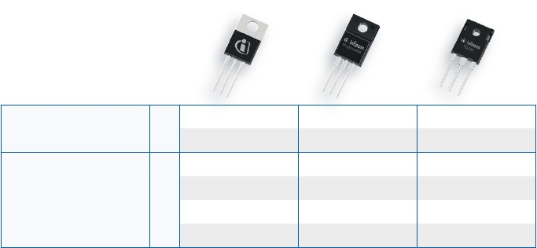

Product Spectrum – First Wave

Continuous

Full-Pak                 TO-247

Current IC

TC=100°C

TO-220               TO-220FP

1.4

|  |  |  |  |  |  |  |
| --- | --- | --- | --- | --- | --- | --- |
| IGBT  and Diode | IC | 600V | 1100V | 1200V | 1350V | 1600V |
| 15A  20A  25A  30A  40A  50A  60A  75A | IKW20N60H3  IHW30N60T  IKW30N60H3  IHW40T60  IHW40N60R  IHW40N60RF  IKW50N60H3  IKW60N60H3  IKW75N60H3 | IHW30N110R3 | IHW15N120R3  IHW20N120R3  IHW25N120R2  IHW30N120R3  IHW40T120  IHW40N120R3 | IHW20N135R3  IHW30N135R3  IHW40N135R3 | IHW30N160R2 |

Induction Cooking Series Portfolio

Discrete

IGBTs

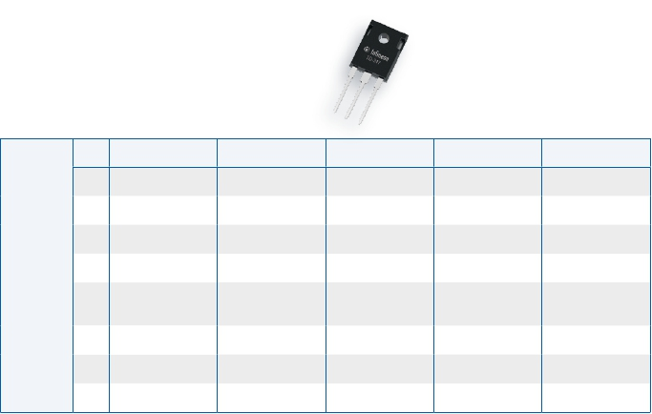

600 V, 1100 V, 1200 V, 1350 V and 1600 V

Revolutionary Application Specific – Resonant Converters and Induction Cooking Series IGBTs

Continuous

Current IC

TC=100°C

TO-247

1.5

TRENCHSTOP™ and RC-Drives IGBT

Discrete

IGBTs

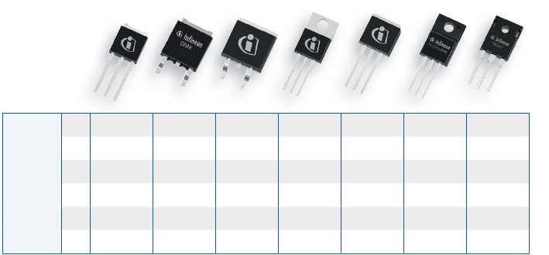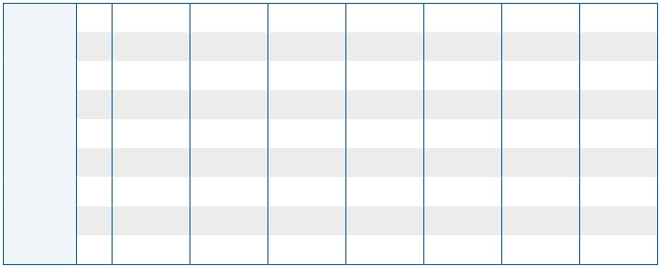

600 V Product Family

TRENCHSTOP™, RC-Drives and RC-Drives Fast IGBTs

Continuous

Current IC

TC=100°C

TO-251

I-PAK

TO-252

D-PAK

TO-263

D²-PAK

TO-220      TO-262

I²-PAK

TO-220FP

Full-PAK

TO-247

Single

IKD04N60RF               IKP04N60T   IKI04N60T

6A              IKD06N60R

IKD10N60RF   IKB10N60T   IKP10N60T           IKA10N60T

IKD15N60RF   IKB15N60T   IKP15N60T           IKA15N60T

IGBT

IGBT and

Diode

6A             IGD06N60T               IGP06N60T

10A                         IGB10N60T   IGP10N60T

15A                         IGB15N60T   IGP15N60T

30A                         IGB30N60T                                      IGW30N60T

50A                         IGB50N60T   IGP50N60T                          IGW50N60T

75A                                                                       IGW75N60T

3A             IKD03N60RF

4A             IKD04N60R

IKD06N60RF  IKB06N60T  IKP06N60T          IKA06N60T

10A             IKD10N60R

15A             IKD15N60R

20A                         IKB20N60T   IKP20N60T                          IKW20N60T

30A                                                                       IKW30N60T

50A                                                                       IKW50N60T

75A                                                                       IKW75N60T

1.6

HighSpeed 3 - Single IGBT & DuoPack™

Discrete

IGBTs

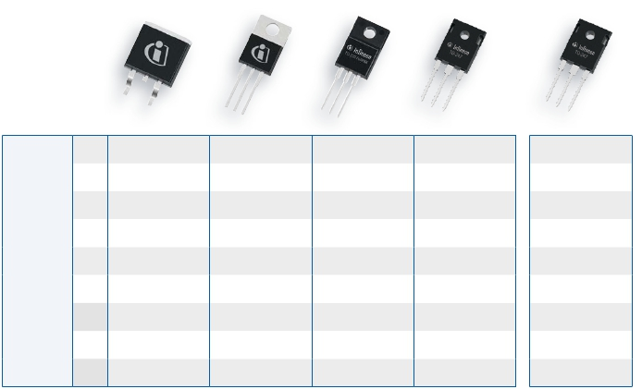

600 V / 1200 V Product family

High Speed 3 - Single IGBT & DuoPack™

Continuous

Current IC

TC=100°C

TO-263

D²-PAK

TO-220         TO-220FP

Full-PAK

TO-247            TO-247

Single

IGBT

IGBT and

Diode

15A                                                                   IGW15N120H3

20A  IGB20N60H3      IGP20N60H3                      IGW20N60H3

25A                                                                   IGW25N120H3

30A  IGB30N60H3      IGP30N60H3      IGA30N60H3      IGW30N60H3

40A                                                 IGW40N60H3        IGW40N120H3

50A                                                 IGW50N60H3

60A                                                 IGW60N60H3

75A                                                 IGW75N60H3

100A                                                 IGW100N60H3

20A  IKB20N60H3      IKP20N60H3                      IKW20N60H3        IKW15N120H3

30A                                                 IKW30N60H3        IKW25N120H3

60A                                                 IKW40N60H3        IKW40N120H3

50A                                                 IKW50N60H3

60A                                                 IKW60N60H3

75A                                                 IKW75N60H3

1.7

|  |  |  |  |
| --- | --- | --- | --- |
| Single  IGBT |  | TRENCHSTOP™ | TRENCHSTOP™2 |
| 8A  15A  25A  40A  60A | IGW08T120  IGW15T120  IGW25T120  IGW40T120  IGW60T120 |  |

TRENCHSTOP IGBT and DuoPack™

Discrete

IGBTs

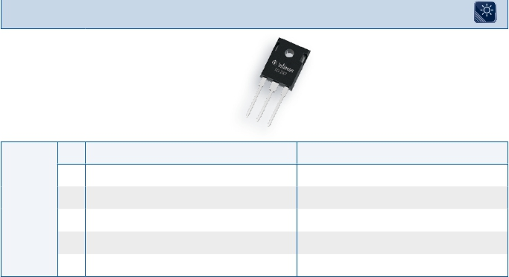

1200 V Product Family

TO-247

Continuous

Current IC

TC=100°C

8A IKW08T120

15A IKW15T120 IKW15N120T2

DuoPack™

25A IKW25T120 IKW25N120T2

40A IKW40T120 IKW40N120T2

1.8

HighSpeed 2 IGBT and DuoPack™

Discrete

IGBTs

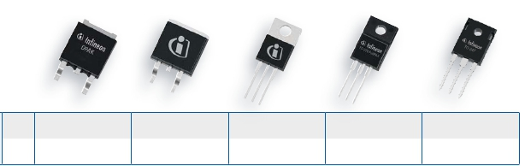

1200 V Product Family

HighSpeed 2 IGBT & DuoPack™

Continuous

Current IC

TC=100°C

TO-252

D-PAK

TO-263

D²-PAK

TO-220          TO-220FP

Full-PAK

TO-247

Single

IGBT

1A  IGD01N120H2      IGB01N120H2      IGP01N120H2

3A                  IGB03N120H2      IGP03N120H2      IGA03N120H2      IGW03N120H2

DuoPack™ 3A IKB03N120H2 IKP03N120H2 IKA03N120H2 IKW03N120H2

1.9

|  |  |  |  |  |  |  |
| --- | --- | --- | --- | --- | --- | --- |
| 600V | 3A  6A  9A  15 A  23 A  30 A  45 A  75 A  100 A | IDD03E60  IDD06E60  IDD09E60  IDD15E60 | IDB09E60  IDB15E60  IDB23E60  IDB30E60  IDB45E60 | IDP06E60  IDP09E60  IDP15E60  IDP23E60  IDP30E60  IDP45E60 | IDV30E60C | IDW30E60  IDW75E60  IDW100E60 |
| 1200V | 4A  9A  12 A  18 A  30 A |  | IDB12E120  IDB18E120  IDB30E120 | IDP04E120  IDP09E120  IDP12E120  IDP18E120  IDP30E120 |  |  |

Discrete Emitter Controlled Diodes

Discrete

IGBTs

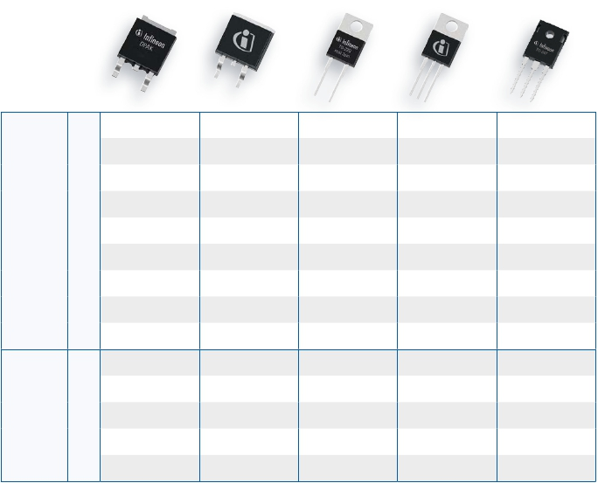

Product Family 600 V & 1200 V

Continuous

D-PAK             TO-263

D²-PAK            TO-220

Real 2pin          TO-220 FullPAK

Real 2pin          TO-247

Current IC

TC=100°C

TO-252

1.10

Rapid Diode Families 1st Wave Release

Discrete

IGBTs

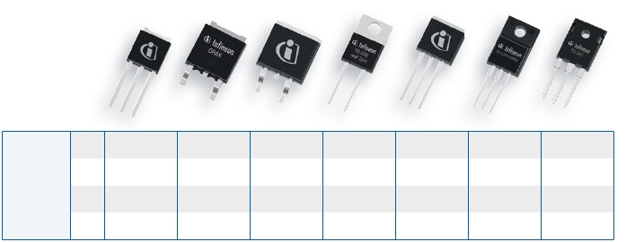

650 V Product Family

Rapid Diode Families 1st Wave Release

Continuous

Current IC

TC=100°C

TO-251

I-PAK

TO-252

D-PAK

TO-263

D²-PAK

TO-220

real 2-leg

TO-262   TO-220 Full-PAK

real 2-leg

TO-247

Rapid 1

Rapid 2

8A                                     IDP08E65D1

15A                                     IDP15E65D1

30A                                                                       IDW30E65D1

40A                                                                       IDW40E65D1

8A                                     IDP08E65D2              IDV08E65D2

15A                                     IDP15E65D2              IDV15E65D2  IDW15E65D2

40                                     IDP40E65D2                         IDW40E65D2

1.11

|  |  |  |  |  |  |  |  |  |  |  |  |  |
| --- | --- | --- | --- | --- | --- | --- | --- | --- | --- | --- | --- | --- |
| 1200V | | | | | | | | | | | | |
| Product | | VCE  [V] | IC  [A] | ICpuls  [A] | VCEsat  [V] | Eon  [mJ] | Eoff  [mJ] | IF  [A] | VF  [V] | Qrr  [nC] | Irrm  [A] | Package |
|  | IGA03N120H2  IGB01N120H2  IGB03N120H2  IGD01N120H2  IGP01N120H2  IGP03N120H2  IGW03N120H2 | 1200  1200  1200  1200  1200  1200  1200 | 3  1,3  3,9  1,3  1,3  3,9  3,9 | 9  3,5  9,9  3,5  3,5  9,9  9,9 | 2,2  2,2  2,2  2,2  2,2  2,2  2,2 | 0,140  0,080  0,140  0,080  0,100  0,140  0,200 | 0,150  0,060  0,150  0,060  0,100  0,150  0,300 | n/a  n/a  n/a  n/a  n/a  n/a  n/a | | | | PG-TO220-3  PG-TO263-3  PG-TO263-3  PG-TO252-3  PG-TO220-3  PG-TO220-3  PG-TO247-3 |

|  |  |  |  |  |  |  |  |  |  |  |  |  |
| --- | --- | --- | --- | --- | --- | --- | --- | --- | --- | --- | --- | --- |
| 1200V | | | | | | | | | | | | |
| Product | | VCE  [V] | IC  [A] | ICpuls  [A] | VCEsat  [V] | Eon  [mJ] | Eoff  [mJ] | IF  [A] | VF  [V] | Qrr  [nC] | Irrm  [A] | Package |
|  | IKA03N120H2  IKB03N120H2  IKP03N120H2  IKW03N120H2 | 1200  1200  1200  1200 | 3  3,9  3,9  3,9 | 9  9,9  9,9  9,9 | 2,2  2,2  2,2  2,2 | 0,140  0,140  0,140  0,140 | 0,150  0,150  0,150  0,150 | 3,9  3,9  3,9  3,9 | 1,55  2  2  2 | 230  230  230  230 | 9,3  12 A  12 A  12 A | PG-TO220-3  PG-TO263-3  PG-TO220-3  PG-TO247-3 |



IGBT Discretes

Discrete

IGBTs

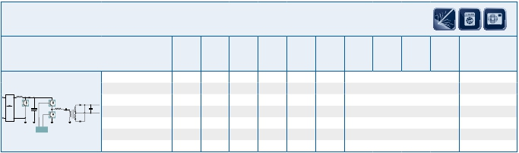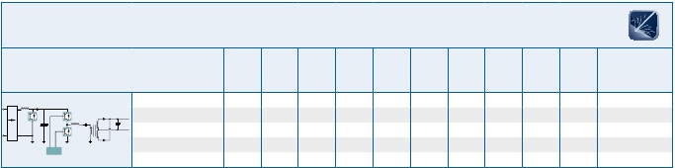

HighSpeed 2

IGBT Discretes

HighSpeed 2 DuoPack

1.12

|  |  |  |  |  |  |  |  |  |  |  |  |  |
| --- | --- | --- | --- | --- | --- | --- | --- | --- | --- | --- | --- | --- |
| 600V | | | | | | | | | | | | |
| Product | | VCE  [V] | IC  [A] | ICpuls  [A] | VCEsat  [V] | Eon  [mJ] | Eoff  [mJ] | IF  [A] | VF  [V] | Qrr  [nC] | Irrm  [A] | Package |
| +  VDCVAC | IGA30N60H3  IGB20N60H3  IGB30N60H3  IGP20N60H3  IGP30N60H3  IGW20N60H3  IGW30N60H3  IGW40N60H3  IGW50N60H3  IGW60N60H3  IGW75N60H3  IGW100N60H3 | 600  600  600  600  600  600  600  600  600  600  600  600 | 11  20  30  20  30  20  30  40  50  60  75  120 | 120  80  120  80  120  80  120  160  200  180  225  300 | 1,95  1,95  1,95  1,95  1,95  1,95  1,95  1,95  1,85  1,85  1,85  1,85 | 0,730  0,450  0,730  0,450  0,730  0,560  0,940  1,100  1,450  2,100  3,000  3,700 | 0,440  0,240  0,440  0,240  0,440  0,240  0,440  0,580  0,910  1,130  1,700  1,900 | n/a  n/a  n/a  n/a  n/a  n/a  n/a  n/a  n/a  n/a  n/a  n/a | | | | PG-TO220-3 FP  PG-TO263-3  PG-TO263-3  PG-TO220-3  PG-TO220-3  PG-TO247-3  PG-TO247-3  PG-TO247-3  PG-TO247-3  PG-TO247-3  PG-TO247-3  PG-TO247-3 |

|  |  |  |  |  |  |  |  |  |  |  |  |  |
| --- | --- | --- | --- | --- | --- | --- | --- | --- | --- | --- | --- | --- |
| 1200V | | | | | | | | | | | | |
| Product | | VCE  [V] | IC  [A] | ICpuls  [A] | VCEsat  [V] | Eon  [mJ] | Eoff  [mJ] | IF  [A] | VF  [V] | Qrr  [nC] | Irrm  [A] | Package |
| +  VDCVAC | IGW15N120H3  IGW25N120H3  IGW40N120H3 | 1200  1200  1200 | 15  25  40 | 60  100  160 | 2,05  2,05  2,05 | 1,100  1,800  3,200 | 0,450  0,850  1,200 | n/a  n/a  n/a | | | | PG-TO247-3  PG-TO247-3  PG-TO247-3 |

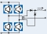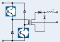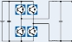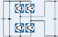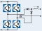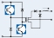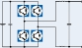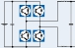

IGBT Discretes

Discrete

IGBTs

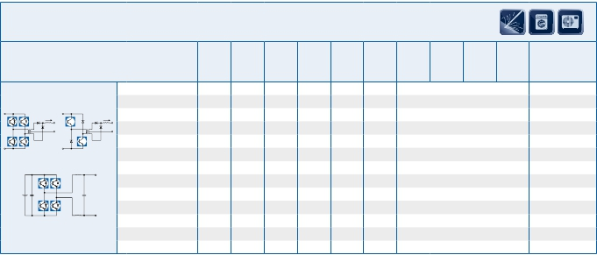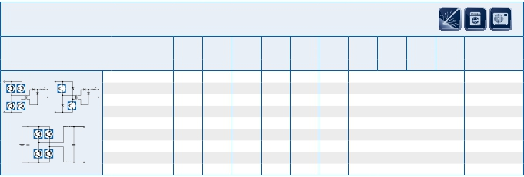

HighSpeed 3

1.13

|  |  |  |  |  |  |  |  |  |  |  |  |  |
| --- | --- | --- | --- | --- | --- | --- | --- | --- | --- | --- | --- | --- |
| 600 V | | | | | | | | | | | | |
| Product | | VCE  [V] | IC  [A] | ICpuls  [A] | VCEsat  [V] | Eon  [mJ] | Eoff  [mJ] | IF  [A] | VF  [V] | Qrr  [nC] | Irrm  [A] | Package |
| +  VDCVAC | IKB20N60H3  IKP20N60H3  IKW20N60H3  IKW30N60H3  IKW40N60H3  IKW50N60H3  IKW60N60H3  IKW75N60H3 | 600  600  600  600  600  600  600  600 | 20  20  20  30  40  50  60  75 | 80  80  80  120  160  200  180  225 | 1,95  1,95  1,95  1,95  1,95  1,85  1,85  1,85 | 0,45  0,45  0,56  0,94  1,1  1,45  2,1  3 | 0,24  0,24  0,24  0,44  0,58  0,91  1,13  1,7 | 10  10  10  15  20  30  30  50 | 1,65  1,65  1,65  1,65  1,65  1,65  1,65  1,65 | 390  390  390  320  810  880  1200  1800 | 11  11  11  12  13,6  16,9  13  19 | PG-TO263-3  PG-TO220-3  PG-TO247-3  PG-TO247-3  PG-TO247-3  PG-TO247-3  PG-TO247-3  PG-TO247-3 |

|  |  |  |  |  |  |  |  |  |  |  |  |  |
| --- | --- | --- | --- | --- | --- | --- | --- | --- | --- | --- | --- | --- |
| 1200 V | | | | | | | | | | | | |
| Product | | VCE  [V] | IC  [A] | ICpuls  [A] | VCEsat  [V] | Eon  [mJ] | Eoff  [mJ] | IF  [A] | VF  [V] | Qrr  [nC] | Irrm  [A] | Package |
| +  VDCVAC | IKW15N120H3  IKW25N120H3  IKW40N120H3 | 1200  1200  1200 | 15  25  40 | 60  100  160 | 2,05  2,05  2,05 | 1,1  1,8  3,2 | 0,45  0,85  1,2 | 7,5  12,5  20 | 1,8  1,8  1,8 | 800  1200  1900 | 7,7  10,4  12,8 | PG-TO247-3  PG-TO247-3  PG-TO247-3 |

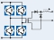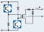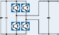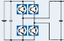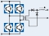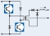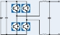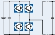

IGBT Discretes

Discrete

IGBTs

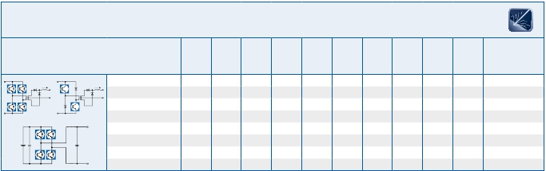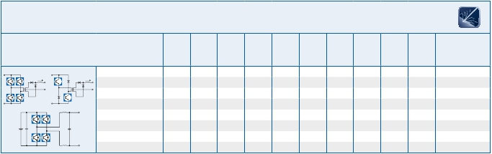

HighSpeed 3 DuoPack

1.14

|  |  |  |  |  |  |  |  |  |  |  |  |  |
| --- | --- | --- | --- | --- | --- | --- | --- | --- | --- | --- | --- | --- |
| 600V | | | | | | | | | | | | |
| Product | | VCE  [V] | IC  [A] | ICpuls  [A] | VCEsat  [V] | Eon  [mJ] | Eoff  [mJ] | IF  [A] | VF  [V] | Qrr  [nC] | Irrm  [A] | Package |
| +3~ | IKD03N60RF  IKD04N60RF  IKD06N60RF  IKD10N60RF  IKD15N60RF | 600  600  600  600  600 | 2,5  4  6  10  15 | 7,5  12  18  30  45 | 2,2  2,2  2,2  2,2  2,2 | 0,05  0,06  0,09  0,19  0,27 | 0,04  0,05  0,09  0,16  0,25 | 2,5  4  6  10  15 | 2,1  2,1  2,1  2,1  2,1 | 60  90  160  270  420 | 3,8  4,6  7,4  9,1  13,2 | PG-TO252-3  PG-TO252-3  PG-TO252-3  PG-TO252-3  PG-TO252-3 |

|  |  |  |  |  |  |  |  |  |  |  |  |  |
| --- | --- | --- | --- | --- | --- | --- | --- | --- | --- | --- | --- | --- |
| 600V | | | | | | | | | | | | |
| Product | | VCE  [V] | IC  [A] | ICpuls  [A] | VCEsat  [V] | Eon  [mJ] | Eoff  [mJ] | IF  [A] | VF  [V] | Qrr  [nC] | Irrm  [A] | Package |
| +3~ | IKD04N60R  IKD06N60R  IKD10N60R  IKD15N60R  IKU15N60R | 600  600  600  600  600 | 4  6  10  15  15 | 12  18  30  45  45 | 1,65  1,65  1,65  1,65  1,65 | 0,09  0,11  0,21  0,37  0,37 | 0,15  0,22  0,38  0,53  0,53 | 4  6  10  15  15 | 1,7  1,7  1,7  1,7  1,7 | 220  370  560  760  760 | 7,6  12  20,3  20,5  20,5 | PG-TO252-3  PG-TO252-3  PG-TO252-3  PG-TO252-3  PG-TO251-3 |

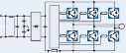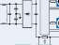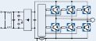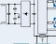

IGBT Discretes

Discrete

IGBTs

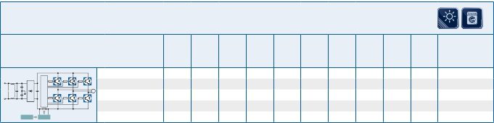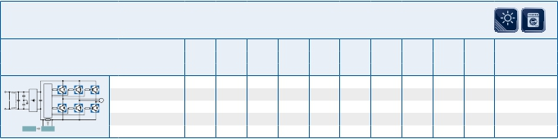

RC Drives Fast Series DuoPack

IGBT Discretes

RC Drives Series DuoPack

1.15

|  |  |  |  |  |  |  |  |  |  |  |  |
| --- | --- | --- | --- | --- | --- | --- | --- | --- | --- | --- | --- |
| 1200V | | | | | | | | | | | |
| Product | | VCE  [V] | IC  [A] | ICpuls  [A] | VCEsat  [V] | Eon  [mJ] | Eoff  [mJ] | IF  [A] | VF  [V] | Qrr         Irrm  [nC]        [A] | Package |
|  | RC-H2 Soft  Switching Series  IHW25N120R2  RC-H3 Soft  Switching Series  IHW15N120R3  IHW20N120R3  IHW30N120R3  IHW40N120R3 | 1200  1200  1200  1200  1200 | 25  15  20  30  40 | 75  45  60  90  120 | 1,6  1,48  1,48  1,55  1,55 | d.o.r.  d.o.r.  d.o.r.  d.o.r.  d.o.r. | 1,59  0,7  0,95  1,47  2,02 | 25  15  20  30  40 | 1,5  1,55  1,55  1,6  1,6 | data on request  data on request  data on request  data on request  data on request | PG-TO247-3  PG-TO247-3  PG-TO247-3  PG-TO247-3  PG-TO247-3 |

|  |  |  |  |  |  |  |  |  |  |  |  |
| --- | --- | --- | --- | --- | --- | --- | --- | --- | --- | --- | --- |
| 600V | | | | | | | | | | | |
| Product | | VCE  [V] | IC  [A] | ICpuls  [A] | VCEsat  [V] | Eon  [mJ] | Eoff  [mJ] | IF  [A] | VF  [V] | Qrr         Irrm  [nC]        [A] | Package |
|  | RC-H Fast Soft  Switching Series  IHW40N60RF  RC-H Soft  Switching Series  IHW40N60R | 600  600 | 40  40 | 120  120 | 1,85  1,65 | d.o.r.  d.o.r. | 0,56  0,75 | 40  40 | 1,75  1,65 | data on request  data on request | PG-TO247-3  PG-TO247-3 |

|  |  |  |  |  |  |  |  |  |  |  |  |
| --- | --- | --- | --- | --- | --- | --- | --- | --- | --- | --- | --- |
| 1100V | | | | | | | | | | | |
| Product | | VCE  [V] | IC  [A] | ICpuls  [A] | VCEsat  [V] | Eon  [mJ] | Eoff  [mJ] | IF  [A] | VF  [V] | Qrr         Irrm  [nC]        [A] | Package |
|  | RC-H3 Soft  Switching Series  IHW30N110R3 | 1100 | 30 | 90 | 1,55 | d.o.r. | 1,15 | 30 | 1,35 | data on request | PG-TO247-3 |

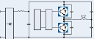

IGBT Discretes

Discrete

IGBTs

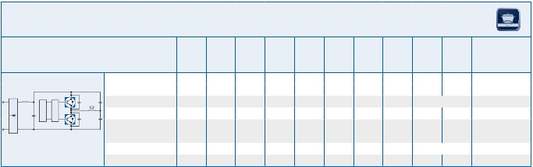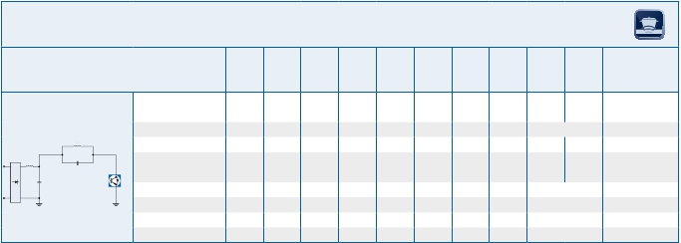

RC-H Soft & Hard Switching Series

1.16

|  |  |  |  |  |  |  |  |  |  |  |  |
| --- | --- | --- | --- | --- | --- | --- | --- | --- | --- | --- | --- |
| 1350V | | | | | | | | | | | |
| Product | | VCE  [V] | IC  [A] | ICpuls  [A] | VCEsat  [V] | Eon  [mJ] | Eoff  [mJ] | IF  [A] | VF  [V] | Qrr         Irrm  [nC]        [A] | Package |
|  | RC-H3 Soft  Switching Series  IHW20N135R3  IHW30N135R3  IHW40N135R3 | 1350  1350  1350 | 20  30  40 | 60  90  120 | 1,6  1,65  1,65 | d.o.r.  d.o.r.  d.o.r. | 1,3  1,93  2,5 | 20  30  40 | 1,6  1,65  1,65 | data on request  data on request  data on request | PG-TO247-3  PG-TO247-3  PG-TO247-3 |

|  |  |  |  |  |  |  |  |  |  |  |  |
| --- | --- | --- | --- | --- | --- | --- | --- | --- | --- | --- | --- |
| 1600V | | | | | | | | | | | |
| Product | | VCE  [V] | IC  [A] | ICpuls  [A] | VCEsat  [V] | Eon  [mJ] | Eoff  [mJ] | IF  [A] | VF  [V] | Qrr         Irrm  [nC]        [A] | Package |
|  | RC-H2 Soft  Switching Series  IHW30N160R2 | 1600 | 30 | 90 | 1,8 | d.o.r. | 2,53 | 30 | 1,65 | data on request | PG-TO247-3 |



IGBT Discretes

Discrete

IGBTs

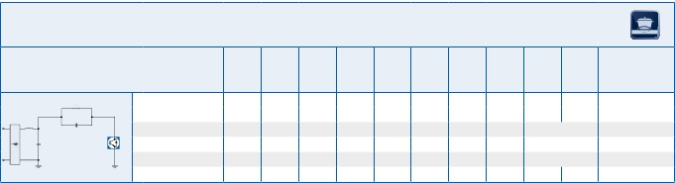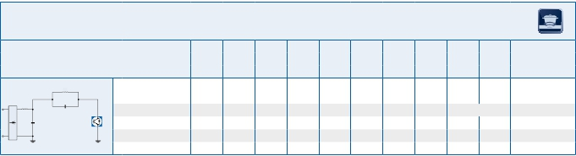

RC-H Soft Switching & Fast Soft Switching Series

1.17

|  |  |  |  |  |  |  |  |  |  |  |  |  |
| --- | --- | --- | --- | --- | --- | --- | --- | --- | --- | --- | --- | --- |
| 600V | | | | | | | | | | | | |
| Product | | VCE  [V] | IC  [A] | ICpuls  [A] | VCEsat  [V] | Eon  [mJ] | Eoff  [mJ] | IF  [A] | VF  [V] | Qrr  [nC] | Irrm  [A] | Package |
| +  N  0 | IGB10N60T  IGB15N60T  IGB30N60T  IGB50N60T  IGD06N60T  IGP06N60T  IGP10N60T  IGP15N60T  IGP50N60T  IGW30N60T  IGW50N60T  IGW75N60T  IHW30N60T  IHW40T60 | 600  600  600  600  600  600  600  600  600  600  600  600  600  600 | 10  15  30  50  6  6  10  15  50  30  50  75  30  40 | 30  45  90  150  18  18  30  45  150  90  150  225  90  120 | 1,5  1,5  1,5  1,5  1,5  1,5  1,5  1,5  1,5  1,5  1,5  1,5  1,5  1,55 | 0,16  0,22  0,69  1,2  0,09  0,09  0,16  0,22  1,2  0,69  1,2  2  n/a  n/a | 0,27  0,35  0,77  1,4  0,11  0,11  0,27  0,35  1,4  0,77  1,4  2,5  0,77  0,92 | n/a  n/a  n/a  n/a  n/a  n/a  n/a  n/a  n/a  n/a  n/a  n/a  13        1,1           n/a  30     1,65      920     16,3 | | | | PG-TO263-3  PG-TO263-3  PG-TO263-3  PG-TO263-3  PG-TO252-3  PG-TO220-3  PG-TO220-3  PG-TO220-3  PG-TO220-3  PG-TO247-3  PG-TO247-3  PG-TO247-3  PG-TO247-3  PG-TO247-3 |

|  |  |  |  |  |  |  |  |  |  |  |  |  |
| --- | --- | --- | --- | --- | --- | --- | --- | --- | --- | --- | --- | --- |
| 1200V | | | | | | | | | | | | |
| Product | | VCE  [V] | IC  [A] | ICpuls  [A] | VCEsat  [V] | Eon  [mJ] | Eoff  [mJ] | IF  [A] | VF  [V] | Qrr  [nC] | Irrm  [A] | Package |
| +  N  0 | IGW08T120  IGW15T120  IGW25T120  IGW40T120  IGW60T120  IKW08T120  IKW15T120  IKW25T120  IKW40T120 | 1200  1200  1200  1200  1200  1200  1200  1200  1200 | 8  15  25  40  60  8  15  25  40 | 24  45  75  105  150  24  45  75  105 | 1,7  1,7  1,7  1,7  1,7  1,7  1,7  1,7  1,7 | 0,67  1,3  2  3,3  4,3  0,67  1,3  2  3,3 | 0,7  1,4  2,2  3,2  5,2  0,7  1,4  2,2  3,2 | n/a  n/a  n/a  n/a  n/a  8        1,7     1000         13  15        1,7     1900         17  25        1,7     2300         21  40     1,75     3800         28 | | | | PG-TO247-3  PG-TO247-3  PG-TO247-3  PG-TO247-3  PG-TO247-3  PG-TO247-3  PG-TO247-3  PG-TO247-3  PG-TO247-3 |

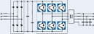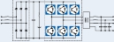

IGBT Discretes

Discrete

IGBTs

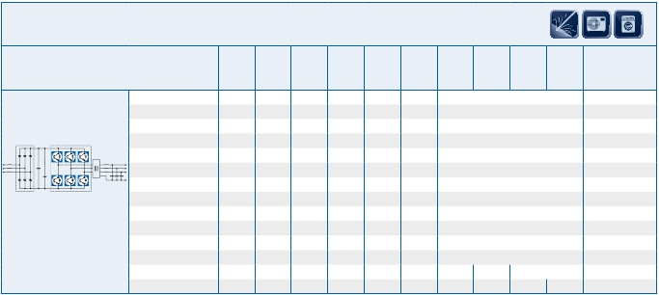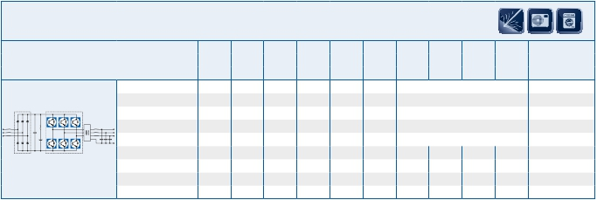

TRENCHSTOP™

1.18

|  |  |  |  |  |  |  |  |  |  |  |  |  |
| --- | --- | --- | --- | --- | --- | --- | --- | --- | --- | --- | --- | --- |
| 600V | | | | | | | | | | | | |
| Product | | VCE  [V] | IC  [A] | ICpuls  [A] | VCEsat  [V] | Eon  [mJ] | Eoff  [mJ] | IF  [A] | VF  [V] | Qrr  [nC] | Irrm  [A] | Package |
| +3~ | IKA06N60T  IKA10N60T  IKA15N60T  IKB06N60T  IKB10N60T  IKB15N60T  IKB20N60T  IKI04N60T  IKP04N60T  IKP06N60T  IKP10N60T  IKP15N60T  IKP20N60T  IKW20N60T  IKW30N60T  IKW50N60T  IKW75N60T | 600  600  600  600  600  600  600  600  600  600  600  600  600  600  600  600  600 | 6,2  7,2  8,9  6  10  15  20  4  4  6  10  15  20  20  30  50  75 | 18  30  45  18  30  45  60  12  12  18  30  45  60  60  90  150  225 | 1,5  1,5  1,5  1,5  1,5  1,5  1,5  1,5  1,5  1,5  1,5  1,5  1,5  1,5  1,5  1,5  1,5 | 0,09  0,16  0,22  0,09  0,16  0,22  0,31  0,061  0,061  0,09  0,16  0,22  0,31  0,31  0,69  1,2  2 | 0,11  0,27  0,35  0,11  0,27  0,35  0,46  0,084  0,084  0,11  0,27  0,35  0,46  0,46  0,77  1,4  2,5 | 6,5  7,4  9  6  10  15  20  4  4  6  10  15  20  20  30  50  75 | 1,6  1,6  1,65  1,6  1,6  1,65  1,65  1,65  1,65  1,6  1,6  1,65  1,65  1,65  1,65  1,65  1,65 | 190  380  240  190  380  240  310  79  79  190  380  240  310  310  920  1800  2400 | 5,3  10  10,4  5,3  10  10,4  13,3  5,3  5,3  5,3  10  10,4  13,3  13,3  16,3  27,7  38,5 | PG-TO220-3  PG-TO220-3  PG-TO220-3  PG-TO263-3  PG-TO263-3  PG-TO263-3  PG-TO263-3  PG-TO262-3  PG-TO220-3  PG-TO220-3  PG-TO220-3  PG-TO220-3  PG-TO220-3  PG-TO247-3  PG-TO247-3  PG-TO247-3  PG-TO247-3 |

|  |  |  |  |  |  |  |  |  |  |  |  |  |
| --- | --- | --- | --- | --- | --- | --- | --- | --- | --- | --- | --- | --- |
| 900V | | | | | | | | | | | | |
| Product | | VCE  [V] | IC  [A] | ICpuls  [A] | VCEsat  [V] | Eon  [mJ] | Eoff  [mJ] | IF  [A] | VF  [V] | Qrr  [nC] | Irrm  [A] | Package |
| +  VDCVAC | IHW30N90T | 900 | 30 | 90 | 1,5 | d.o.r. | 0,77 | 13 | 1,1 | data on request | | PG-TO247-3 |

|  |  |  |  |  |  |  |  |  |  |  |  |  |
| --- | --- | --- | --- | --- | --- | --- | --- | --- | --- | --- | --- | --- |
| 1000V | | | | | | | | | | | | |
| Product | | VCE  [V] | IC  [A] | ICpuls  [A] | VCEsat  [V] | Eon  [mJ] | Eoff  [mJ] | IF  [A] | VF  [V] | Qrr  [nC] | Irrm  [A] | Package |
| +  VDCVAC | IHW30N100T  IKW30N100T | 1000  1000 | 30  30 | 90  90 | 1,55  1,55 | d.o.r.  2,2 | 1,6  1,6 | 12  30 | 1,1  1,65 | data on request  2100         21 | | PG-TO247-3  PG-TO247-3 |

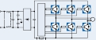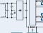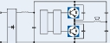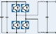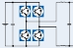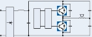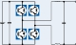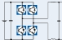

IGBT Discretes

Discrete

IGBTs

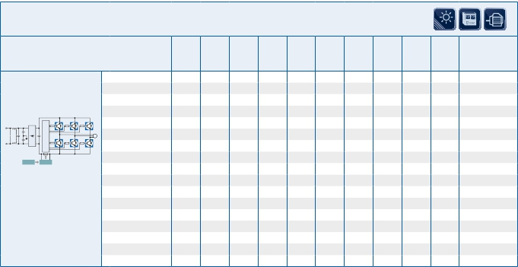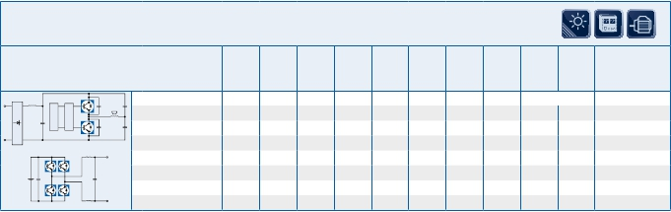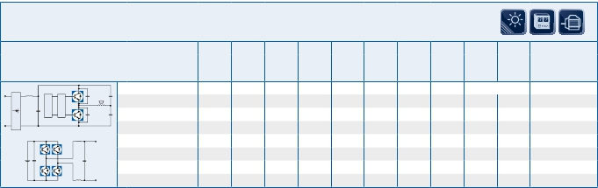

TRENCHSTOP™ Duo Pack

1.19

|  |  |  |  |  |  |  |  |  |  |  |  |  |
| --- | --- | --- | --- | --- | --- | --- | --- | --- | --- | --- | --- | --- |
| 650V | | | | | | | | | | | | |
| Product | | VCE  [V] | IC  [A] | ICpuls  [A] | VCEsat  [V] | Eon  [mJ] | Eoff  [mJ] | IF  [A] | VF  [V] | Qrr  [nC] | Irrm  [A] | Package |
| +  VDCVAC | IKA08N65F5  IKA15N65F5  IKP08N65F5  IKP15N65F5  IKW40N65F5  IKW50N65F5 | 650  650  650  650  650  650 | 6,8  8,5  11  18  46  56 | 24  45  24  45  120  150 | 1,6  1,6  1,6  1,6  1,6  1,6 | 0,07  0,13  0,07  0,13  0,36  0,49 | 0,02  0,04  0,02  0,04  0,14  0,16 | 7,3  7,3  12  12  21  27 | 1,45  1,45  1,45  1,45  1,45  1,45 | 140  100  140  100  420  550 | 6,6  8  6,6  8  12,4  16,5 | PG-TO220-3 FP  PG-TO220-3 FP  PG-TO220-3  PG-TO220-3  PG-TO247-3  PG-TO247-3 |

|  |  |  |  |  |  |  |  |  |  |  |  |  |
| --- | --- | --- | --- | --- | --- | --- | --- | --- | --- | --- | --- | --- |
| 1200V | | | | | | | | | | | | |
| Product | | VCE  [V] | IC  [A] | ICpuls  [A] | VCEsat  [V] | Eon  [mJ] | Eoff  [mJ] | IF  [A] | VF  [V] | Qrr  [nC] | Irrm  [A] | Package |
|  | IHW15T120  IHW20T120  IHW40T120 | 1200  1200  1200 | 15  20  40 | 45  60  105 | 1,7  1,7  1,8 | 1,3  1,8  3,3 | 1,4  1,5  3,2 | 13  13  19,8 | 1,7  1,7  1,65 | 950  950  1880 | 13,3  13,3  20,2 | PG-TO247-3  PG-TO247-3  PG-TO247-3 |

|  |  |  |  |  |  |  |  |  |  |  |  |  |
| --- | --- | --- | --- | --- | --- | --- | --- | --- | --- | --- | --- | --- |
| 650V | | | | | | | | | | | | |
| Product | | VCE  [V] | IC  [A] | ICpuls  [A] | VCEsat  [V] | Eon  [mJ] | Eoff  [mJ] | IF  [A] | VF  [V] | Qrr  [nC] | Irrm  [A] | Package |
| +  VDCVAC | IGP40N65F5  IGW40N65F5  IGW50N65F5 | 650  650  650 | 46  46  56 | 120  120  150 | 1,6  1,6  1,6 | 0,36  0,36  0,49 | 0,14  0,14  0,16 | n/a  n/a  n/a | | | | PG-TO220-3  PG-TO247-3  PG-TO247-3 |

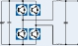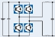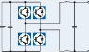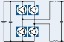

IGBT Discretes

Discrete

IGBTs

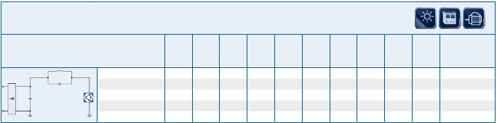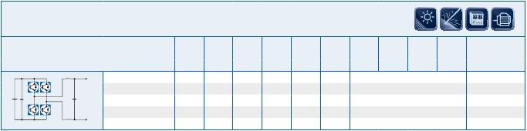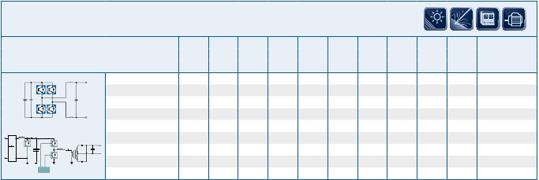

TRENCHSTOP™ DuoPack

IGBT Discretes

TRENCHSTOP™ F5

IGBT Discretes

TRENCHSTOP™ F5 DuoPack

1.20

|  |  |  |  |  |  |  |  |  |  |  |  |  |
| --- | --- | --- | --- | --- | --- | --- | --- | --- | --- | --- | --- | --- |
| 650V | | | | | | | | | | | | |
| Product | | VCE  [V] | IC  [A] | ICpuls  [A] | VCEsat  [V] | Eon  [mJ] | Eoff  [mJ] | IF  [A] | VF  [V] | Qrr  [nC] | Irrm  [A] | Package |
| +  VDCVAC | IGP40N65H5  IGW40N65H5  IGW50N65H5 | 650  650  650 | 46  46  56 | 120  120  150 | 1,65  1,65  1,65 | 0,35  0,35  0,52 | 0,16  0,16  0,18 | n/a  n/a  n/a | | | | PG-TO220-3  PG-TO247-3  PG-TO247-3 |

|  |  |  |  |  |  |  |  |  |  |  |  |  |
| --- | --- | --- | --- | --- | --- | --- | --- | --- | --- | --- | --- | --- |
| 650V | | | | | | | | | | | | |
| Product | | VCE  [V] | IC  [A] | ICpuls  [A] | VCEsat  [V] | Eon  [mJ] | Eoff  [mJ] | IF  [A] | VF  [V] | Qrr  [nC] | Irrm  [A] | Package |
| +  VDCVAC | IKA08N65H5  IKA15N65H5  IKP08N65H5  IKP15N65H5  IKW40N65H5  IKW50N65H5 | 650  650  650  650  650  650 | 6,8  8,5  11  18  46  56 | 24  45  24  45  120  150 | 1,65  1,65  1,65  1,65  1,65  1,65 | 0,07  0,12  0,07  0,12  0,35  0,52 | 0,02  0,05  0,02  0,05  0,16  0,18 | 7,3  7,3  12  12  21  27 | 1,45  1,45  1,45  1,45  1,45  1,45 | 130  200  130  200  410  570 | 6,8  6,7  6,8  6,7  12,5  16,7 | PG-TO220-3  PG-TO220-3  PG-TO220-3  PG-TO220-3  PG-TO247-3  PG-TO247-3 |

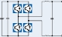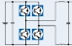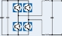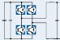

IGBT Discretes

Discrete

IGBTs

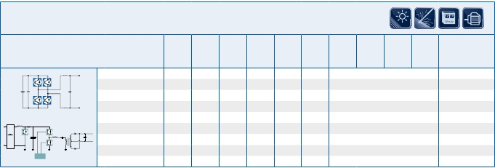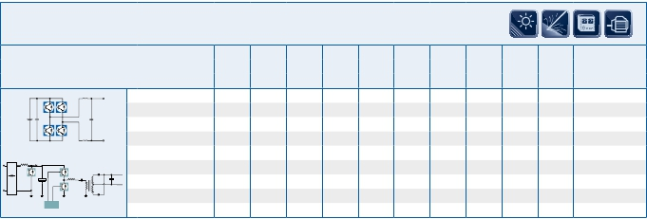

TRENCHSTOP™ H5

IGBT Discretes

TRENCHSTOP™ H5 DuoPack

1.21

|  |  |  |  |  |  |  |  |  |  |  |  |  |
| --- | --- | --- | --- | --- | --- | --- | --- | --- | --- | --- | --- | --- |
| 1200V | | | | | | | | | | | | |
| Product | | VCE  [V] | IC  [A] | ICpuls  [A] | VCEsat  [V] | Eon  [mJ] | Eoff  [mJ] | IF  [A] | VF  [V] | Qrr  [nC] | Irrm  [A] | Package |
| +3~  +  N  0 | IKW15N120T2  IKW25N120T2  IKW40N120T2 | 1200  1200  1200 | 15  25  40 | 60  100  160 | 1,7  1,7  1,75 | 1,25  1,55  3,2 | 0,8  1,35  2,05 | 15  25  40 | 1,75  1,65  1,75 | 1300  2050  3300 | 10  20  23 | PG-TO247-3  PG-TO247-3  PG-TO247-3 |

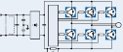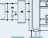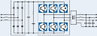

IGBT Discretes

Discrete

IGBTs

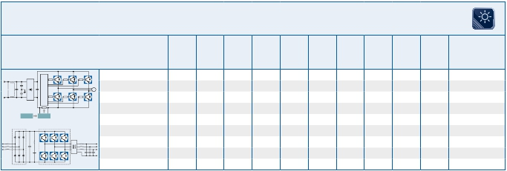

TRENCHSTOP™2 DuoPack

1.22

|  |  |  |
| --- | --- | --- |
| Application Notes, Product Briefs,  Flyers and Brochures | Type | Redirects |
| HighSpeed 3 600V  HighSpeed 3 1200V  TRENCHSTOP™ IGBT for Soft Switching -  3rd Generation Reverse Conducting IGBT  TRENCHSTOP™5 650V  RC Drives and RC Drives Fast  IGBT Selection Guide 2012  HighSpeed 3 1200V 600V  TRENCHSTOP™ IGBT for Soft Switching -  3rd Generation Reverse Conducting IGBT  TrenchStopTM IGBT Technology for Induc-  tion Cooking  TRENCHSTOP™5  RC Drives and RC Drives Fast  TRENCHSTOP™5  Induction Cooking Portfolio  RC Drives Portfolio Extension  TRENCHSTOP™5  TRENCHSTOP™5 Portfolio and Summary  TRENCHSTOP™5 Target Application  HighSpeed 3 1200V 600V  TRENCHSTOP™ IGBT for Hard Switching  TRENCHSTOP™ IGBT for Soft Switching -  3rd Generation Reverse Conducting IGBT  TRENCHSTOP™5  RC Drives and RC Drives Fast  Application Notes  for all packages & technologies | Application Note  Application Note  Application Note  Application Note  Application Note  IGBT Selection Guide  2012  Product Brief  Product Brief  Product Brief  Product Brief  Product Brief  Selection Guide  Video  Video  Video  Video  Video  Webpage  Webpage  Webpage  Webpage  Webpage  Application Note  Collection | <http://www.infineon.com/highspeed3-600V-appnote>  <http://www.infineon.com/highspeed3-1200V-appnote>  <http://www.infineon.com/trenchstop-rc-appnote>  <http://www.infineon.com/trenchstop5-appnote>  <http://www.infineon.com/rc-drives-fast-appnote>  <http://www.infineon.com/igbt-selection-guide>  <http://www.infineon.com/highspeed3-product-brief>  <http://www.infineon.com/trenchstop-rc-product-brief>  <http://www.infineon.com/trenchstop-induction-cooking-appnote>  <http://www.infineon.com/trenchstop5-product-brief>  <http://www.infineon.com/rc-drives-fast-product-brief>  <http://www.infineon.com/trenchstop5-selection-guide>  <http://www.infineon.com/induction-heating-video>  <http://www.infineon.com/rc-drives-video>  <http://www.infineon.com/highspeed5-video>  <http://www.infineon.com/highspeed5-portfolio-video>  <http://www.infineon.com/highspeed5-targetapplications-video>  <http://www.infineon.com/highspeed3>  <http://www.infineon.com/trenchstop-hard-switching>  <http://www.infineon.com/trenchstop-reverse-conducting>  <http://www.infineon.com/trenchstop5>  <http://www.infineon.com/rc-drives-fast>  <http://www.infineon.com/igbt-modules-application-notes> |
| Product Briefs  for all packages & technologies | Product Brief  Collection | <http://www.infineon.com/igbt-modules-product-briefs> |

Links

Discrete

IGBTs



1.23

1.24

Discrete

IGBTs

Low Power

IGBT

LowPower

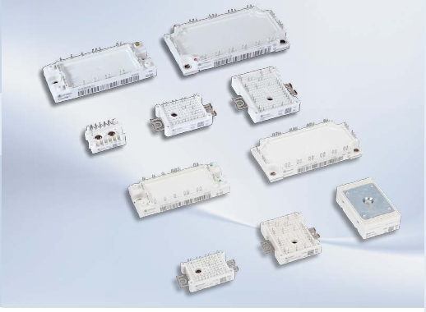

Modules

Our  Easy,  Smart  and  Econo  modules  are  designed  for  cost  effective  and

compact  inverters  as  well  as  a  simplified  and  reliable  mounting.  The  Easy  and

Econo  product  families  are  available  with  the  well  known  solder  pins  or  the  new

state-of-the-art  PressFIT  connections.

The  new  Smart  modules  combine  the  PressFIT  technology  with  a  sophisticated

housing  concept.  Its  new  duplex-frame  reaches  a  very  high  level  of  reliability

during  the  mounting  process  and  operation.  Here  the  PressFIT  pin  is  connected

to  the  PCB,  the  PCB  is  stabilized  and  the  module  is  mounted  on  the  heat  sink  in

one  single  step.

The  Easy  family  with  different  configurations  like  EasyPIM™,  EasyPACK

and  EasyDUAL  covers  a  full  product  scope  in  the  power  range  from  nominal

current  6A  up  to  200A  at  600 V/1200 V.  These  modules  without  base  plates  are

equipped  with  screw  clamps  for  a  new,  fast,  reliable  and  low  cost  mounting

concept.  With  reduced  height  from  17mm  to  12mm  and  injected  mounting

screw  clamps,  the  new  Easy1B  and  Easy2B  housings  are  the  optimal  choice.

The  new  Easy  3-Level  modules  provide  a  complete  phase  leg  from  30 A

up  to  150 A  in  600 V/650 V.  The  solution  offers  the  significant  advantage

for  designing  highly  efficient  UPS  and  Solar  inverters.  New  modules  for

photovoltaic  string  and  multi-string  inverters  are  available.

In  the  Smart  1  package  the  possible  current  range  is  up  to  75 A  in  PACK  and

35 A  in  PIM  configurations  at  650 V  and  1200 V.  With  it’s  Self-Acting  PressFIT

assembly  and  the  benefits  of  the  PressFIT  technology  a  new  generation  of  cost

saving  modules  is  born.

The  Econo  family  extends  the  range  from  15 A  up  to  200  A  at  600  V/650 V/

1200  V/1700  V.  The  available  configurations  are  the  well  known  EconoPIM™

and  EconoPACK™  series.  The  Econo  housing  comes  with  a  copper  base  plate

for  optimized  heat  spread  and  includes  a  thermistor  (NTC).

All module families are also available with the optimized newest IGBT4 technology.

2.1

2.2

IGBT

LowPower

3300V

IHVP.4.7

1200V

IHMP.4.4

1200V

PrimePACK™P.4.3

600V

1700V

62mmP.3.3

600V

34mmP.3.3

600V

650V

1200V

EconoDUAL™P.3.12

1200V

EconoPACK™+P.3.10

600V

EconoPACK™4P.3.8

1200V

MIPAQ™P.5.4

1200V

1200V

1700V

1200V

1700V

1700V

1700V

1200V

1700V

650V

1200V

1700V

1600V

1700V

4500V

6500V

1600V

P[kW]

600V

650V

EconoPIM™/EconoPACK™P.2.12

650V

SmartPIM/SmartPackP.2.10

600V

650V

1200V

EasyPIM™/EasyPACKP.2.4

600V

650V

1100V

1200V

1350V

TO-247

600V

650V

1200V

TO-220Full-PAK

600V

TO-262

I2-PAK

600V

650V

1200V

TO-220

600V

1200V

TO-263D2-PAK

600V

1200V

TO-252D-PAK

600V

TO-251I-PAK

IC[A]

50

75

100

150

200

400500

450

600

800

900

1000

1500

2000

3000

3600

1

2

3

4

6

8

10252015

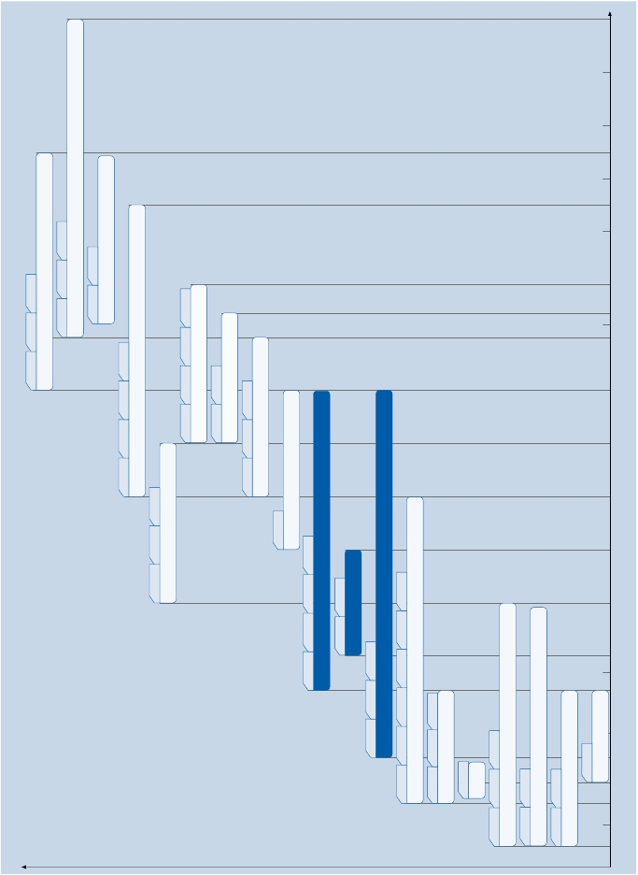

|  |  |  |
| --- | --- | --- |
| IC | Power  Integrated  Module  650 V                                 1200 V | sixpack  650 V                                 1200 V                                1700 V |
| 25 A | FP25R12KT4  FP25R12KT4_B11 |  |
| 35 A | FP35R12KT4  FP35R12KT4_B11 |  |
| 50 A | FP50R07N2E4                  FP50R12KT4  FP50R07N2E4_B11         FP50R12KT4_B11 | FS50R07N2E4                  FS50R12KT4_B15  FS50R07N2E4_B11         FS50R12KT4_B11 |
| 75 A | FP75R07N2E4**FP75R12KT4**  FP75R07N2E4_B11**FP75R12KT4_B11** | FS75R07N2E4                   FS75R12KT4_B15  FS75R07N2E4_B11         FS75R12KT4_B11 |
| 100 A | **FP100R07N3E4                FP100R12KT4**  **FP100R07N3E4_B11      FP100R12KT4_B11** | FS100R07N2E4                FS100R12KT4**FS100R17N3E4**  FS100R07N2E4_B11      FS100R12KT4_B11**FS100R17N3E4_B11**  **FS100R07N3E4                FS100R12KT4G**  **FS100R07N3E4_B11      FS100R12KT4G_B11** |
| 150 A | **FP150R07N3E4**  **FP150R07N3E4_B11** | **FS150R07N3E4                FS150R12KT4                   FS150R17N3E4**  **FS150R07N3E4_B11       FS150R12KT4_B11         FS150R17N3E4_B11** |
| 200 A |  | **FS200R07N3E4R             FS200R12KT4R**  **FS200R07N3E4R_B11     FS200R12KT4R_B11** |

|  |  |  |
| --- | --- | --- |
| IC | Power  Integrated  Module  600 V                                            1200 V | sixpack  600 V                                            1200 V |
| 10 A | FP10R06W1E3                             FP10R12W1T4  FP10R06W1E3_B11                   FP10R12W1T4_B11 |  |
| 15 A | FP15R06W1E3                             FP15R12W1T4  FP15R06W1E3_B11                   FP15R12W1T4_B11  **FP15R12W2T4** |  |
| 20 A | FP20R06W1E3**FP25R12W2T4**  FP20R06W1E3_B11**FP25R12W2T4_B11** | FS20R06W1E3                             FS25R12W1T4  FS20R06W1E3_B11                   FS25R12W1T4_B11 |
| 35 A | FP30R06W1E3**FP35R12W2T4**  FP30R06W1E3_B11**FP35R12W2T4_B11** | FS30R06W1E3                             FS35R12W1T4  FS30R06W1E3_B11                   FS35R12W1T4_B11 |
| 50 A | **FP50R06W2E3**  **FP50R06W2E3_B11** | FS50R06W1E3**FS50R12W2T4**  FS50R06W1E3_B11**FS50R12W2T4_B11** |
| 75 A |  | **FS75R12W2T4**  **FS75R12W2T4_B11** |
| 100 A |  |  |

Easy 1B & 2B Product Portfolio

IGBT

LowPower



Econo IGBT4 Product Portfolio for New Designs

600 V & 1200 V

W1 = Easy1B     **W2 = Easy2B**     B11= PressFIT terminals

2.3

650 V, 1200 V & 1700 V

N2 = Econo2     **N3 = Econo3**   B11= PressFIT terminals    ..._B15 module alternative mechnically compatible to an IGBT3 module

|  |  |  |  |  |  |
| --- | --- | --- | --- | --- | --- |
| Single Phase 600 VCES | | | | | |
| Type | | IGBT Inverter  VCE     IC*       IC     VCEsat RthJH     RthJC     Eon+  V        A        A        V      K/W     K/W Eoff, mJ  TC=     TC=     Tvj=     typ.     max.     Tvj=  80°C 25°C 25°C                         125°C | Rectifier Diodes  VRRM     Id     RthJC  V        A      K/W | Brake Chopper  VCE     IC*     RthJC  V        A      K/W  TC=     max.  80°C | Outline/  page |
| PIM with NTC | IGBT3  FB10R06VE3 | 600      10      16     1,55     4,10     3,10      0,67 | 800      10     2,10 |  | L_750a/2.17 |
| PIM with NTC | IGBT3  FB10R06W1E3  FB15R06W1E3  FB20R06W1E3  FB30R06W1E3 | 600      10      16     1,55     3,35     2,20      0,50  600      15      22     1,55     2,95     1,85      0,76  600      20      27     1,55     2,70     1,60      1,00  600      30      37     1,55     2,25     1,30      1,60 | 800      10     1,35  800      15     1,05  800      20     1,05  800      30     1,05 |  | L_B1c/2.20  L_B1c/2.20  L_B1c/2.20  L_B1c/2.20 |
| PIM with NTC | IGBT3  FB20R06W1E3_B11  FB30R06W1E3_B1 | 600      20      27     1,55     2,70     1,60      1,00  600      30      37     1,55     2,25     1,30      1,60 | 800      20     1,05  800      30     1,05 | 600      20     1,60  600      30     1,30 | L_B1k/2.20  L_B1d/2.20 |

|  |  |  |  |  |  |
| --- | --- | --- | --- | --- | --- |
| Three Phase 600 VCES | | | | | |
| Type | | IGBT Inverter  VCE      IC*       IC     VCEsat     RthJH     RthJC     Eon+  V        A        A        V      K/W     K/W     Eoff, mJ  TC=     TC=     Tvj=     typ.     max.     Tvj=  80°C 25°C 25°C                         125°C | Rectifier Diodes  VRRM     Id      RthJC  V        A      K/W | Brake Chopper  CE  V        IC*     RthJC  V        A      K/W  TC=     max.  80°C | Outline/  page |
| PIM with NTC | IGBT3  FP10R06W1E3  FP15R06W1E3  FP20R06W1E3  FP30R06W1E3  FP50R06W2E3  FP10R06W1E3_B11  FP15R06W1E3_B11  FP20R06W1E3_B11  FP30R06W1E3_B11  FP50R06W2E3_B11 | 600      10      16     1,55     3,35     2,20      0,50  600      15      22     1,55     2,95     1,85      0,76  600      20      27     1,55     2,70     1,60      1,00  600      30      37     1,55     2,25     1,30      1,40  600      50      65     1,45     1,45     0,85      2,25  600      10      16     1,55     3,35     2,20      0,50  600      15      22     1,55     2,95     1,85      0,76  600      20      27     1,55     2,70     1,60      1,00  600      30      37     1,55     2,25     1,30      1,40  600      50      65     1,45     1,45     0,85      2,25 | 1600      10     1,35  1600      15     1,35  1600      20     1,35  1600      30     1,35  1600      50     1,15  1600      10     1,35  1600      15     1,35  1600      20     1,35  1600      30     1,35  1600      50     1,15 | 600      10     2,20  600      15     1,85  600      20     1,60  600      30     1,30  600      50     1,15  600      10     2,20  600      15     1,85  600      20     1,60  600      30     1,30  600      50     1,15 | L_B1a/2.19  L_B1a/2.19  L_B1a/2.19  L_B1a/2.19  L_B2a/2.23  L_B1h/2.19  L_B1h/2.19  L_B1h/2.19  L_B1h/2.19  L_B2b/2.23 |



IGBT Low Power Modules

IGBT

LowPower

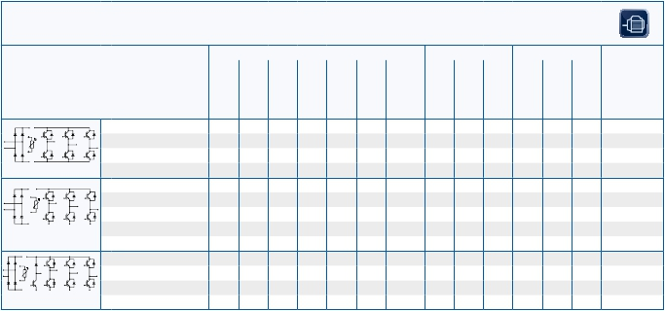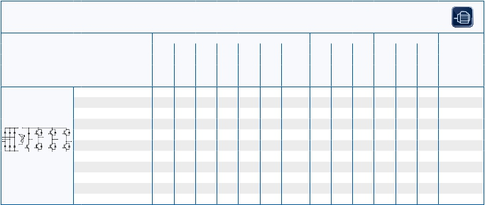

..._B1 1-phase rectifier with brake chopper

EasyPIM™ Power Integrated Modules

* as specified in data sheet                   Mounting Hardware see page 2.37                 ..._B11 PressFIT Modules

2.4

IGBT Low Power Modules

IGBT

LowPower

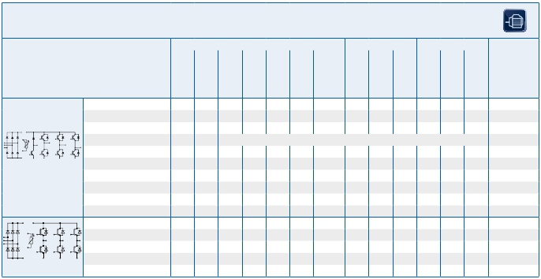

EasyPIM™ Power Integrated Modules

Three Phase 1200 VCES

Type IGBT Inverter Rectifier Diodes Brake Chopper Outline/

VCE IC* IC VCEsat RthJH RthJC Eon+ VRRM Id RthJC VCE IC* RthJC page

V A A V K/W K/W Eoff, mJ V A K/W V A K/W

TC= TC= Tvj= typ. max. Tvj= TC= max.

80°C 25°C 25°C 125°C 80°C

IGBT4

FP10R12W1T4 1200 10 20 1,85 2,40 1,40 2,15 1600 10 1,35 1200 10 1,40 L_B1a/2.19

FP15R12W1T4 1200 15 28 1,85 2,10 1,15 2,95 1600 15 1,35 1200 15 1,15 L_B1a/2.19

FP15R12W2T4 1200 15 data on request

FP25R12W2T4 1200 25 39 1,85 1,45 0,85 4,55 1600 25 1,15 1200 25 0,85 L_B2a/2.23

FP35R12W2T4 1200 35 54 1,85 1,20 0,70 5,80 1600 35 1,15 1200 35 0,70 L_B2a/2.23

FP10R12W1T4_B11 1200 10 20 1,85 2,40 1,40 2,15 1600 10 1,35 1200 10 1,40 L_B1h/2.19

FP15R12W1T4_B11 1200 15 28 1,85 2,10 1,15 2,95 1600 15 1,35 1200 15 1,15 L_B1h/2.19

FP25R12W2T4_B11 1200 25 39 1,85 1,45 0,85 4,55 1600 25 1,15 1200 25 0,85 L_B2b/2.23

PIM with NTC FP35R12W2T4_B11 1200 35 54 1,85 1,20 0,70 5,80 1600 35 1,15 1200 35 0,70 L_B2b/2.23

IGBT4

FP06R12W1T4_B3 1200 6 12 1,50 2,70 1,60 1,35 1600 6 1,60 L_B1b/2.19

FP10R12W1T4_B3 1200 10 20 1,85 2,40 1,40 2,15 1600 10 1,35 L_B1b/2.19

FP15R12W1T4_B3 1200 15 28 1,85 2,10 1,15 2,95 1600 15 1,35 L_B1b/2.19

PIM with NTC

* as specified in data sheet

..._B3 3-phase rectifier without brake chopper ..._B11 PressFIT Modules

2.5

|  |  |  |  |
| --- | --- | --- | --- |
| 600 VCES | | | |
| Type | | IGBT Inverter  VCE                IC*                 IC               VCEsat            RthJH             RthJC            Eon+  V                   A                   A                   V                K/W             K/W          Eoff, mJ  TC=               TC=              Tvj=              typ.             max.             Tvj=  80°C            25°C            25°C                                                      125°C | Outline/  page |
| dual with NTC | IGBT3  FF200R06YE3 | 600              200              220             1,45             0,43            0,29             9,70 | L_2j/2.18 |

|  |  |  |  |
| --- | --- | --- | --- |
| 1200 VCES | | | |
| Type | | IGBT Inverter  VCE                IC*                 IC               VCEsat            RthJH             RthJC            Eon+  V                   A                   A                   V                K/W             K/W          Eoff, mJ  TC=               TC=              Tvj=              typ.             max.             Tvj=  80°C            25°C            25°C                                                      125°C | Outline/  page |
| dual with NTC | IGBT3  FF75R12YT3  FF100R12YT3  FF150R12YT3 | 1200                75              100            1,80             0,53            0,36          15,70  1200              100              140             1,70             0,41            0,28          21,70  1200              150              200             1,70             0,31            0,20          32,00 | L_2j/2.18  L_2j/2.18  L_2j/2.18 |

IGBT Low Power Modules

IGBT

LowPower

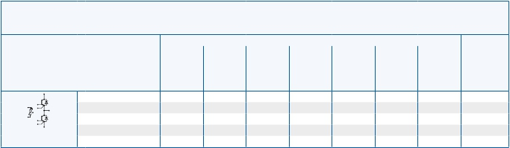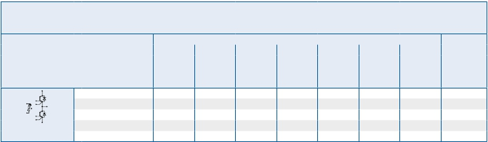

2.6

EasyDUAL

IGBT Low Power Modules

IGBT

LowPower

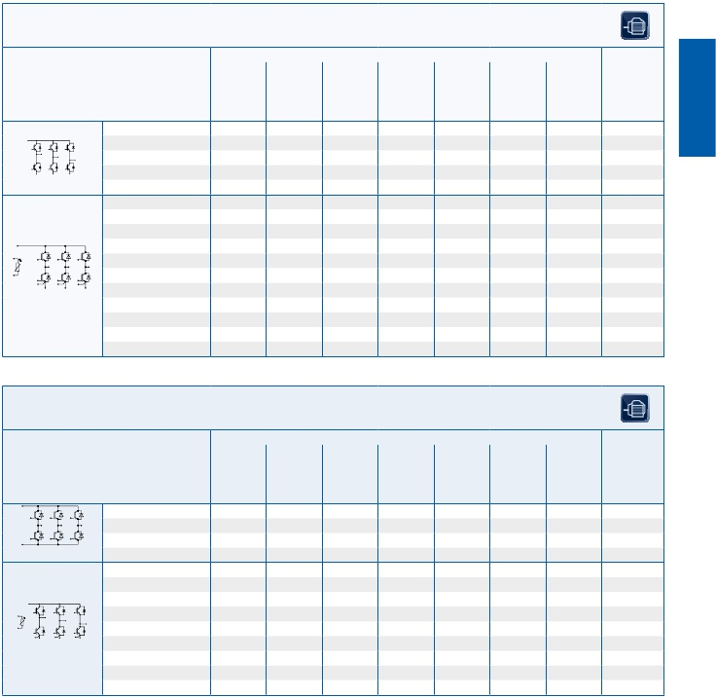

EasyPACK

600 VCES

Type IGBT Inverter Outline/

VCE IC* IC VCEsat RthJH RthJC Eon+ page

V A A V K/W K/W Eoff, mJ

TC= TC= Tvj= typ. max. Tvj=

80°C 25°C 25°C 125°C

IGBT3

FS10R06VE3 600 10 16 1,55 3,70 3,00 0,50 L_750b/2.17

FS15R06VE3 600 15 22 1,55 3,00 2,30 0,76 L_750b/2.17

FS20R06VE3 600 20 25 1,55 2,75 2,00 1,00 L_750b/2.17

sixpack FS30R06VE3 600 30 34 1,55 2,35 1,70 1,6 L_750b/2.17

IGBT3

FS6R06VE3_B2 600 6 11 1,55 4,60 3,70 0,25 L_750c/2.17

FS10R06VE3_B2 600 10 16 1,55 3,70 3,00 0,50 L_750c/2.17

FS15R06VE3_B2 600 15 22 1,55 3,00 2,30 0,76 L_750c/2.17

FS20R06VE3_B2 600 20 25 1,55 2,75 2,00 1,00 L_750c/2.17

FS20R06W1E3 600 20 35 1,55 1,90 1,10 1,05 L_B1e/2.21

FS30R06W1E3 600 30 45 1,55 1,75 1,00 1,58 L_B1e/2.21

FS50R06W1E3 600 50 70 1,45 1,46 0,73 2,06 L_B1e/2.21

FS20R06W1E3_B11 600 20 35 1,55 1,90 1,10 1,05 L_B1j/2.21

FS30R06W1E3_B11 600 30 45 1,55 1,75 1,00 1,58 L_B1j/2.21

sixpack with NTC FS50R06W1E3_B11 600 50 70 1,45 1,46 0,73 2,06 L_B1j/2.21

1200 VCES

Type IGBT Inverter Outline/

VCE IC* IC VCEsat RthJH RthJC Eon+ page

V A A V K/W K/W Eoff, mJ

TC= TC= Tvj= typ. max. Tvj=

80°C 25°C 25°C 125°C

IGBT3

FS10R12VT3 1200 10 16 1,90 2,40 1,95 2,35 L_750f/2.17

FS15R12VT3 1200 15 24 1,70 1,90 1,45 3,40 L_750f/2.17

sixpack

IGBT4

FS25R12W1T4 1200 25 45 1,85 1,46 0,74 4,65 L_B1e/2.21

FS35R12W1T4 1200 35 65 1,85 1,35 0,66 6,65 L_B1e/2.20

FS50R12W2T4 1200 50 83 1,85 1,05 0,45 9,20 L_B2c/2.23

FS75R12W2T4 1200 75 107 1,85 0,95 0,40 13,3 L_B2c/2.23

FS25R12W1T4_B11 1200 25 45 1,85 1,46 0,74 4,65 L_B1j/2.21

FS35R12W1T4_B11 1200 35 65 1,85 1,35 0,66 6,65 L_B1j/2.21

FS50R12W2T4_B11 1200 50 83 1,85 1,05 0,45 9,20 L_B2d/2.23

sixpack with NTC FS75R12W2T4_B11 1200 75 107 1,85 0,95 0,40 13,3 L_B2d/2.23

* as specified in data sheet Mounting Hardware see page 2.37 ..._B2 sixpack with NTC ..._B11 PressFIT Modules

2.7

IGBT Low Power Modules

IGBT

LowPower

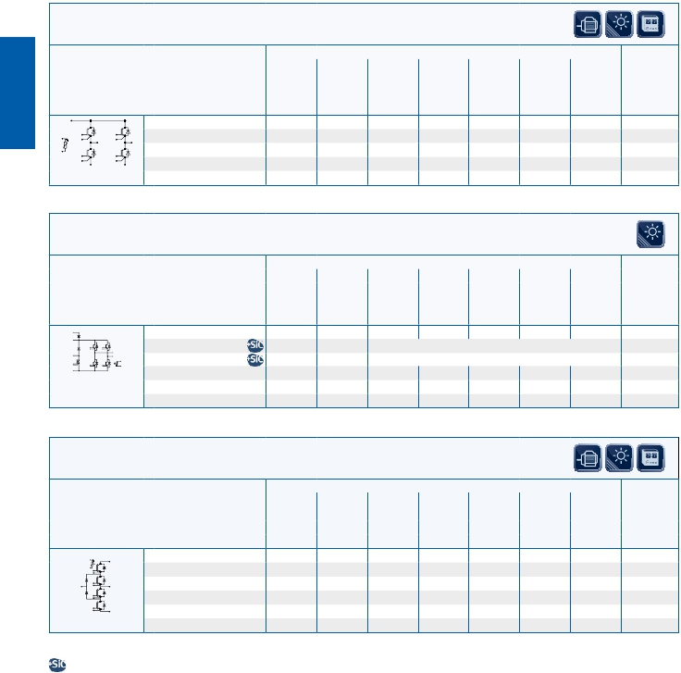

EASY Solar/UPS-High Efficiency Line

600 VCES

Type IGBT Inverter Outline/

VCE IC* IC VCEsat RthJH RthJC Eon+ page

V A A V K/W K/W Eoff, mJ

TC= TC= Tvj= typ. max. Tvj=

80°C 25°C 25°C 125°C

IGBT3

F4-30R06W1E3 600 30 48 1,55 1,55 0,90 1,58 L_B1f/2.21

F4-50R06W1E3 600 50 75 1,45 1,30 0,66 2,06 L_B1f/2.21

F4-75R06W1E3 600 75 100 1,45 1,10 0,55 2,65 L_B1f/2.21

fourpack with NTC

650 VCES

Type IGBT Inverter Outline/

VCE IC* IC VCEsat RthJH RthJC Eon+ page

V A A V K/W K/W Eoff, mJ

TC= TC= Tvj= typ. max. Tvj=

80°C 25°C 25°C 125°C

IGBT HighSpeed 3

F4-50R07W2H3_B51 650 50 data on request L_B2i/2.26

F4-75R07W2H3_B51 650 75 data on request L_B2i/2.26

fourpack with

booster and NTC

600/650 VCES

Type IGBT Inverter Outline/

VCE IC* IC VCEsat RthJH RthJC Eon+ page

V A A V K/W K/W Eoff, mJ

TC= TC= Tvj= typ. max. Tvj=

80°C 25°C 25°C 125°C

IGBT3

F3L30R06W1E3_B11 600 30 45 1,55 1,75 1,0 1,23 L_B1i/2.22

F3L50R06W1E3_B11 600 50 75 1,45 1,45 0,85 1,85 L_B1i/2.22

F3L75R07W2E3_B11 650 75 95 1,45 1,10 0,60 2,90 L_B2e/2.24

F3L100R07W2E3_B11 650 100 117 1,45 0,95 0,50 4,20 L_B2f/2.24

3-level NPC 1 F3L150R07W2E3_B11 650 150 150 1,45 0,85 0,45 6,85 L_B2f/2.24

* as specified in data sheet ..._B51 fourpack with booster and NTC ..._B11 PressFIT Modules

Based on Infineon Silicon-Carbide technology for higher performance and efficiency

2.8

IGBT Low Power Modules

IGBT

LowPower

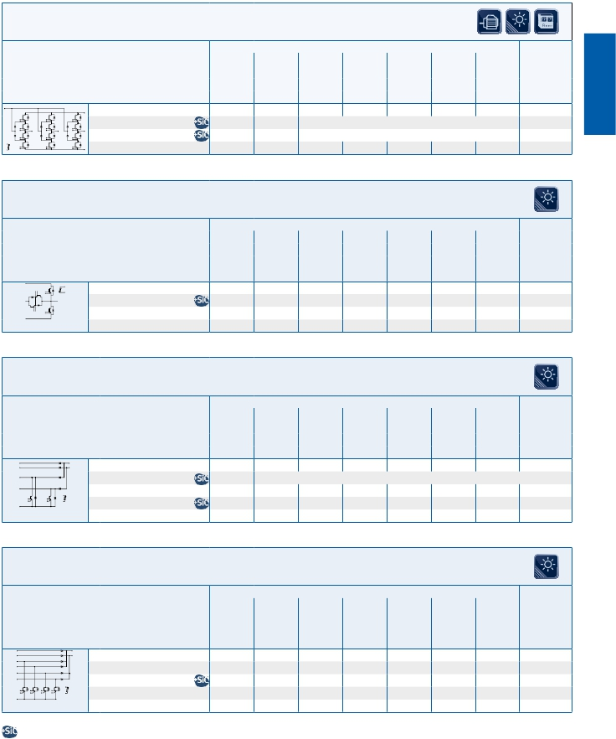

EASY Solar/UPS-High Efficiency Line

650 VCES

Type IGBT Inverter Outline/

VCE IC* IC VCEsat RthJH RthJC Eon+ page

V A A V K/W K/W Eoff, mJ

TC= TC= Tvj= typ. max. Tvj=

80°C 25°C 25°C 125°C

IGBT HighSpeed 3

FS3L30R07W2H3F_B11 650 30 data on request L_B2k/2.27

FS3L50R07W2H3F_B11 650 50 data on request L_B2k/2.27

1200 VCES

Type IGBT Inverter Outline/

VCE IC* IC VCEsat RthJH RthJC Eon+ page

V A A V K/W K/W Eoff, mJ

TC= TC= Tvj= typ. max. Tvj=

80°C 25°C 25°C 125°C

IGBT HighSpeed 3

F3L80R12W1H3_B11 1200 80 90 1,55 0,95 0,55 2,53 L_B1j/2.21

3-level NPC 2

1200 VCES

Type IGBT Inverter Outline/

VCE IC* IC VCEsat RthJH RthJC Eon+ page

V A A V K/W K/W Eoff, mJ

TC= TC= Tvj= typ. max. Tvj=

80°C 25°C 25°C 125°C

IGBT HighSpeed 3

DF75R12W1H4F_B11 1200 data on request

DF80R12W2H3_B11 1200 20 50 1,55 1,1 0,65 2,75 L_B2g/2.25

DF80R12W2H3F_B11 1200 20 50 1,55 1,1 0,65 2,75 L_B2g/2.25

Booster

1200 VCES

Type IGBT Inverter Outline/

VCE IC* IC VCEsat RthJH RthJC Eon+ page

V A A V K/W K/W Eoff, mJ

TC= TC= Tvj= typ. max. Tvj=

80°C 25°C 25°C 125°C

IGBT HighSpeed 3

DF160R12W2H3_B11 1200 20 50 1,55 1,1 0,65 1,52 L_B2h/2.25

DF160R12W2H3F_B11 1200 20 50 1,55 1,1 0,65 1,52 L_B2h/2.25

Booster

* as specified in data sheet ..._B11 PressFIT Modules

Based on Infineon Silicon-Carbide technology for higher performance and efficiency

2.9

|  |  |  |
| --- | --- | --- |
| Three Phase 1200 VCES | | |
| Type | | IGBT Inverter                                 Rectifier Diodes        Brake Chopper        Outline/  thJC  VCE      IC*        IC     VCEsat     RthJH     R        Eon+     VRRM      Id      RthJC     VCE      IC*     RthJC         page  V         A         A         V      K/W     K/W     Eoff,      V         A      K/W      V         A      K/W  TC=     TC=     Tvj=     typ.     max.     mJ                                                      TC=     max.  80°C     25°C     25°C                           Tvj=                                                   80°C  125°C |
| PIM with NTC | IGBT4  u FP25R12U1T4  u FP35R12U1T4 | 1200       25       39     1,85     1,30     0,80     4,55 1600       25     1,05 1200       25     0,80 L_S1a/2.28  1200       35       54     1,85     1,05     0,60     5,80 1600       35     1,05 1200       35     0,60 L_S1a/2.28 |
| PIM with NTC | IGBT4  u FP35R12U2T4  u FP50R12U2T4 | 1200                                                                     data on request  1200                                                                     data on request |

|  |  |  |  |  |  |
| --- | --- | --- | --- | --- | --- |
| Three Phase 650 VCES | | | | | |
| Type | | IGBT Inverter  thJC  VCE      IC*        IC     VCEsat     RthJH     R        Eon+  V         A         A         V      K/W     K/W     Eoff,  TC=     TC=     Tvj=     typ.     max.     mJ  80°C     25°C     25°C                           Tvj=  125°C | Rectifier Diodes  VRRM      Id      RthJC  V         A      K/W | Brake Chopper  VCE      IC*     RthJC  V         A      K/W  TC=     max.  80°C | Outline/  page |
| PIM with NTC | IGBT4  u FP30R07U1E4  u FP50R07U1E4 | 650       30       50     1,60     1,75     0,95     2,10  650       50       75     1,55     1,20     0,65     3,35 | 1600       30     0,65  1600       50     0,65 | 1,60       30     0,95  1,55       50     0,65 | L_S1a/2.28  L_S1a/2.28 |



IGBT Low Power Modules

IGBT

LowPower

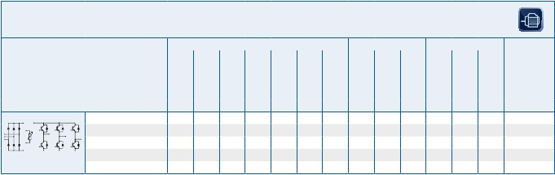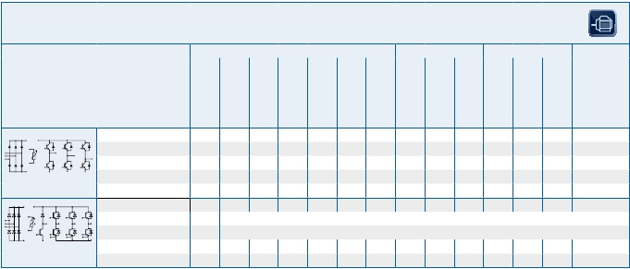

2.10

SmartPIM Power Integrated Modules

u New type       * as specified in data sheet

|  |  |  |  |  |
| --- | --- | --- | --- | --- |
| 1200 VCES | | | | |
| Type | | VCES  V | IC  A | VCEsat                    Ptot                     RthJC               Outline/  V                         W                      K/W                  page  Tvj= 25°C                                            max  typ. |
| sixpack with NTC | IGBT4  u FS35R12U1T4  u FS50R12U1T4 | 1200  1200 | 35  50 | data on request                            L_S1b/2.29  data on request                            L_S1b/2.29 |
| sixpack with NTC | IGBT4  u FS75R12U2T4 | 1200 | 75 | data on request |

|  |  |  |  |  |  |  |  |
| --- | --- | --- | --- | --- | --- | --- | --- |
| 650 VCES | | | | | | | |
| Type | | VCES  V | IC  A | VCEsat  V  Tvj= 25°C  typ. | Ptot  W | RthJC  K/W  max | Outline/  page |
| sixpack with NTC | IGBT4  u FS50R07U1E4  u FS75R07U1E4 | 650  650 | 50  75 | 1,55  1,55 | 230  275 | 0,65  0,55v | L_S1c/2.30  L_S1c/2.30 |



IGBT Low Power Modules

IGBT

LowPower

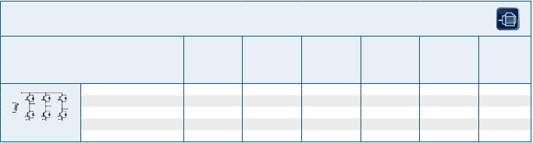

2.11

SmartPACK Modules

u New type       * as specified in data sheet

|  |  |  |  |  |  |
| --- | --- | --- | --- | --- | --- |
| Three Phase 1200 VCES | | | | | |
| Type | | IGBT Inverter  VCE         IC        RthjC     VCEsat  V           A        K/W        V  max      Tvj=  25°C | Rectifier Diodes  VRRM        Id        RthJC        Vf  V           A        K/W        V  TC=      max      Tvj=  80°C                 150°C | Brake Chopper  VCES     IC,IGBT     RthJC  V           A        K/W  TC=      max  80°C | Outline/  page |
| PIM with NTC | IGBT2 Fast  FP15R12KS4C  FP25R12KS4C  FP50R12KS4C  IGBT3  FP15R12KE3G  FP25R12KE3  FP40R12KE3  FP40R12KE3G  FP50R12KE3  FP75R12KE3 | 1200        15     0,70     3,20  1200        25     0,55     3,20  1200        50     0,35     3,20  1200        15     1,20     1,70  1200        25     0,80     1,70  1200        40     0,60     1,80  1200        40     0,60     1,80  1200        50     0,45     1,70  1200        75     0,35     1,70 | 1600        40     1,00     0,95  1600        40     1,00     1,05  1600        40     0,65     1,05  1600        50     1,00     0,95  1600        50     1,00     1,05  1600        50     1,00     1,20  1600        50     1,00     1,20  1600        80     0,65     1,00  1600        80     0,65     1,15 | 1200     10,0     1,20  1200     12,5     1,20  1200     25,0     0,55  1200     10,0     1,50  1200     15,0     1,20  1200     15,0     1,20  1200     40,0     0,60  1200     40,0     0,60  1200     40,0     0,60 | M_E2a/2.31  M_E2a/2.31  M_E3a/2.33  M_E2a/2.31  M_E2a/2.31  M_E2a/2.31  M_E3a/2.33  M_E3a/2.33  M_E3a/2.33 |

|  |  |  |  |  |  |
| --- | --- | --- | --- | --- | --- |
| Three Phase 650 VCES | | | | | |
| Type | | IGBT Inverter  VCE         IC        RthjC     VCEsat  V           A        K/W        V  max      Tvj=  25°C | Rectifier Diodes  VRRM        Id        RthJC        Vf  V           A        K/W        V  TC=      max      Tvj=  80°C                 150°C | Brake Chopper  VCES     IC,IGBT     RthJC  V           A        K/W  TC=      max  80°C | Outline/  page |
| PIM with NTC | IGBT4  FP50R07N2E4  FP75R07N2E4  FP100R07N3E4  FP150R07N3E4  IGBT4 PressFIT  FP50R07N2E4_B11  FP75R07N2E4_B11  FP100R07N3E4_B11  FP150R07N3E4_B11 | 650        50     0,80     1,55  650        75     0,60     1,55  650      100     0,45     1,55  650      150     0,35     1,55  650        50     0,80     1,55  650        75     0,60     1,55  650      100     0,45     1,55  650      150     0,35     1,55 | 1600     80        0,65     1,00  1600     80        0,65     1,00  1600     100      0,50     1,10  1600     150      0,40     1,10  1600     80        0,65     1,00  1600     80        0,65     1,00  1600     100      0,50     1,10  1600     150      0,40     1,10 | 650      50,0     0,80  650      50,0     0,80  650      75,0     0,60  650      100,0     0,45  650      50,0     0,80  650      50,0     0,80  650      75,0     0,60  650      100,0     0,45 | M_E2o/2.33  M_E2o/2.33  M_E3g/2.35  M_E3g/2.35  M_E2n/2.33  M_E2n/2.33  M_E3h/2.35  M_E3h/2.35 |

|  |  |  |  |  |  |
| --- | --- | --- | --- | --- | --- |
| Three Phase 600 VCES | | | | | |
| Type | | IGBT Inverter  VCE         IC        RthjC     VCEsat  V           A        K/W        V  max      Tvj=  25°C | Rectifier Diodes  VRRM        Id        RthJC        Vf  V           A        K/W        V  TC=      max      Tvj=  80°C                 150°C | Brake Chopper  VCES     IC,IGBT     RthJC  V           A        K/W  TC=      max  80°C | Outline/  page |
| PIM with NTC | IGBT3  FP30R06KE3  FP50R06KE3  FP50R06KE3G  FP75R06KE3  FP100R06KE3 | 600        30     1,20     1,55  600        50     0,80     1,45  600        50     0,80     1,45  600        75     0,60     1,45  600      100     0,45     1,45 | 1600        60     0,85     0,90  1600        70     0,85     1,05  1600        80     0,65     1,00  1600      100     0,50     1,05  1600      100     0,50     1,10 | 600     30,0     1,20  600     30,0     1,20  600     50,0     0,80  600     50,0     0,80  600     50,0     0,80 | M_E2a/2.31  M_E2a/2.31  M_E3a/2.33  M_E3a/2.33  M_E3a/2.33 |



IGBT Low Power Modules

IGBT

LowPower

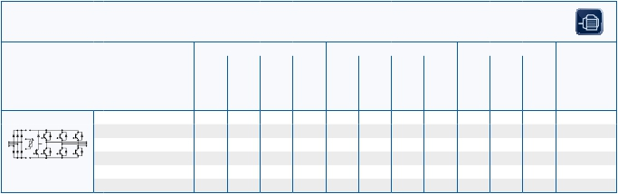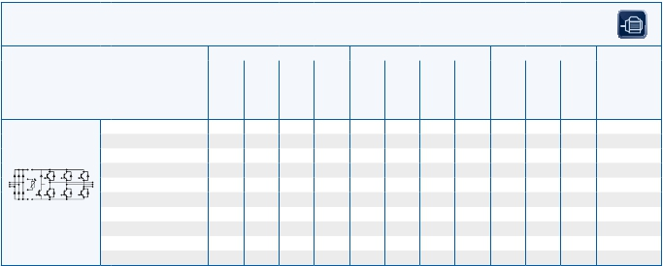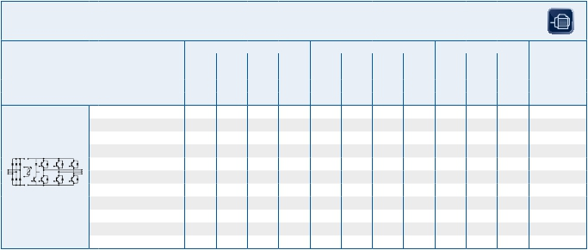

2.12

EconoPIM™

..._B11 PressFIT Modules

|  |  |  |  |  |  |
| --- | --- | --- | --- | --- | --- |
| Three Phase 1200 VCES | | | | | |
| Type | | IGBT Inverter  VCE         IC        RthjC     VCEsat  V           A        K/W        V  max      Tvj=  25°C | Rectifier Diodes  VRRM        Id        RthJC        Vf  V           A        K/W        V  TC=      max      Tvj=  80°C                 150°C | Brake Chopper  VCES     IC,IGBT     RthJC  V           A        K/W  TC=      max  80°C | Outline/  page |
| PIM with NTC | IGBT3 Fast  FP15R12KT3  FP25R12KT3  FP40R12KT3  FP40R12KT3G  FP50R12KT3  FP75R12KT3  IGBT4  FP25R12KT4  FP25R12KT4_B15  FP35R12KT4  FP35R12KT4_B15  FP50R12KT4  FP50R12KT4G_B15  FP50R12KT4G  FP75R12KT4  FP75R12KT4_B15  FP100R12KT4  IGBT4 PressFIT  u FP25R12KT4_B11  FP35R12KT4_B11  FP50R12KT4_B11  FP75R12KT4_B11  FP100R12KT4_B11 | 1200        15     1,20     1,70  1200        25     0,80     1,70  1200        40     0,60     1,80  1200        40     0,60     1,80  1200        50     0,45     1,70  1200        75     0,35     1,70  1200        25     0,95     1,85  1200        25     0,95     1,85  1200        35     0,72     1,85  1200        35     0,72     1,85  1200        50     0,54     1,85  1200        50     0,54     1,85  1200        50     0,54     1,85  1200        75     0,39     1,85  1200        75     0,39     1,85  1200      100     0,29     1,75  1200        25     0,95     1,85  1200        35     0,72     1,85  1200        50     0,54     1,85  1200        75     0,39     1,85  1200      100     0,29     1,75 | 1600        50     1,00     0,90  1600        50     1,00     1,05  1600        50     1,00     1,20  1600        50     1,00     1,20  1600        80     0,65     1,00  1600        80     0,65     1,10  1600        80     0,85     0,90  1600        50     0,85     0,90  1600        80     0,85     0,95  1600        80     0,85     0,95  1600        80     0,85     1,05  1600        80     0,65     1,15  1600        80     0,85     1,15  1600      140     0,65     1,15  1600      140     0,65     1,15  1600      150     0,40     1,00  1600        80     0,85     0,90  1600        80     0,85     0,95  1600        80     0,85     1,05  1600      140     0,65     1,15  1600      150     0,40     1,00 | 1200        10     1,50  1200        15     1,20  1200        15     1,20  1200        40     0,60  1200        40     0,60  1200        40     0,60  1200        15     1,40  1200        15     1,40  1200        25     0,95  1200        25     1,40  1200        25     0,95  1200        25     1,40  1200        25     0,95  1200        50     0,54  1200        35     0,72  1200        50     0,54  1200        15     1,40  1200        25     0,95  1200        25     0,95  1200        50     0,54  1200        50     0,54 | M_E2a/2.31  M_E2a/2.31  M_E2a/2.31  M_E3a/2.33  M_E3a/2.33  M_E3a/2.33  M_E2m/2.32  M_E2a/2.31  M_E2m/2.32  M_E2a/2.31  M_E2m/2.32  M_E3a/2.33  M_E3j/2.34  M_E3j/2.34  M_E3a/2.33  M_E3j/2.34  M_E2h/2.31  M_E2h/2.31  M_E2h/2.31  M_E3f/2.34  M_E3f/2.34 |



IGBT Low Power Modules

IGBT

LowPower

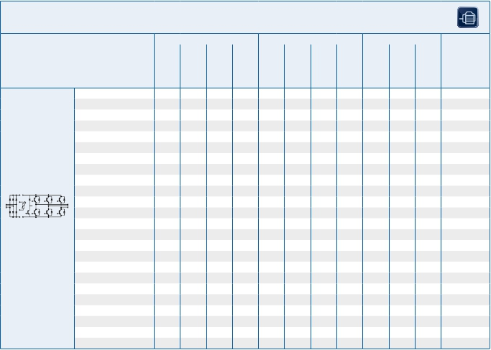

2.13

EconoPIM™

u New type       ..._B11 PressFIT Modules   ..._B15 module alternative mechnically compatible to an IGBT3 module

|  |  |  |  |  |  |  |  |
| --- | --- | --- | --- | --- | --- | --- | --- |
| 650 VCES PressFIT | | | | | | | |
| Type | | VCES  V | IC  A | VCEsat  V  Tvj= 25°C  typ. | Ptot  W | RthJC  K/W  max | Outline/  page |
| sixpack with NTC | IGBT4  FS50R07N2E4_B11  FS75R07N2E4_B11  FS100R07N2E4_B11  FS100R07N3E4_B11  FS150R07N3E4_B11  *)  FS200R07N3E4R_B11 | 650  650  650  650  650  650 | 50  75  100  100  150  200 | 1,55  1,55  1,55  1,55  1,55  1,55 | 190  250  335  335  430  600 | 0,80  0,60  0,45  0,45  0,35  0,25 | M_E2p/2.33  M_E2p/2.33  M_E2p/2.33  M_E3e/2.34  M_E3e/2.34  M_E3e/2.34 |

|  |  |  |  |  |  |  |  |
| --- | --- | --- | --- | --- | --- | --- | --- |
| 650 VCES | | | | | | | |
| Type | | VCES  V | IC  A | VCEsat  V  Tvj= 25°C  typ. | Ptot  W | RthJC  K/W  max | Outline/  page |
| sixpack with NTC | IGBT4  FS50R07N2E4  FS75R07N2E4  FS100R07N2E4  FS100R07N3E4  FS150R07N3E4  FS200R07N3E4 R | 650  650  650  650  650  650 | 50  75  100  100  150  200 | 1,55  1,55  1,55  1,55  1,55  1,55 | 190  250  335  335  430  600 | 0,80  0,60  0,45  0,45  0,35  0,25 | M_E2b/2.31  M_E2b/2.31  M_E2b/2.31  M_E3b/2.34  M_E3b/2.34  M_E3b/2.34 |

|  |  |  |  |  |  |  |  |
| --- | --- | --- | --- | --- | --- | --- | --- |
| 600 VCES | | | | | | | |
| Type | | VCES  V | IC  A | VCEsat  V  Tvj= 25°C  typ. | Ptot  W | RthJC  K/W  max | Outline/  page |
| sixpack with NTC | IGBT3  FS50R06KE3  FS75R06KE3  FS100R06KE3  FS150R06KE3  FS200R06KE3 | 600  600  600  600  600 | 50  75  100  150  200 | 1,45  1,45  1,45  1,45  1,45 | 190  250  335  430  600 | 0,80  0,60  0,45  0,35  0,25 | M_E2b/2.31  M_E2b/2.31  M_E3b/2.34  M_E3b/2.34  M_E3b/2.34 |



IGBT Low Power Modules

IGBT

LowPower

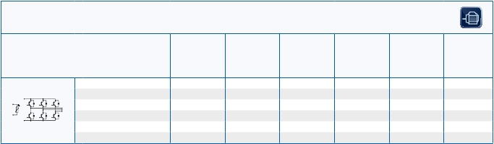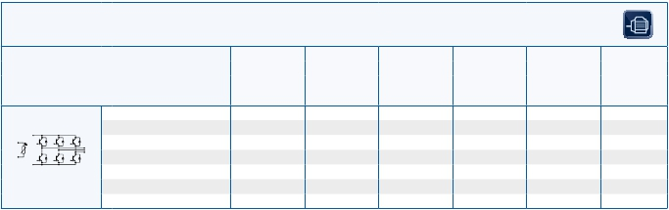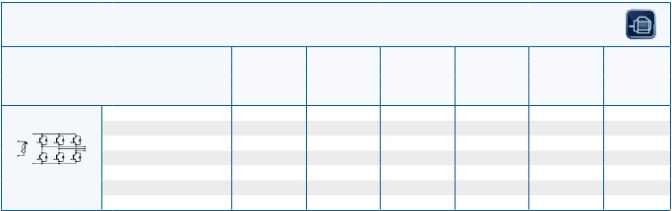

2.14

EconoPACK™

..._B11 PressFIT Modules          *) continious operation power limited to 150A rms.

IGBT Low Power Modules

IGBT

LowPower



EconoPACK™

1200 VCES

Type VCES IC VCEsat Ptot RthJC Outline/

V A V W K/W page

Tvj= 25°C max

typ.

IGBT2 Fast

FS75R12KS4 1200 75 3,20 500 0,25 M_E3c/2.35

FS100R12KS4 1200 100 3,20 660 0,19 M_E3c/2.35

sixpack

IGBT3

FS25R12KE3G 1200 25 1,70 145 0,86 M_E2b/2.31

FS35R12KE3G 1200 35 1,70 200 0,60 M_E2b/2.31

FS50R12KE3 1200 50 1,70 270 0,45 M_E2b/2.31

FS75R12KE3 1200 75 1,70 350 0,35 M_E2b/2.31

FS75R12KE3G 1200 75 1,70 350 0,35 M_E3b/2.34

FS100R12KE3 1200 100 1,70 480 0,26 M_E3b/2.34

sixpack with NTC FS150R12KE3 1200 150 1,70 700 0,18 M_E3b/2.34

IGBT3 Fast

FS25R12KT3 1200 25 1,70 145 0,86 M_E2b/2.31

FS35R12KT3 1200 35 1,70 210 0,60 M_E2b/2.31

FS50R12KT3 1200 50 1,70 280 0,45 M_E2b/2.31

FS75R12KT3 1200 75 1,70 355 0,35 M_E2b/2.31

FS75R12KT3G 1200 75 1,70 355 0,35 M_E3b/2.34

FS100R12KT3 1200 100 1,70 480 0,26 M_E3b/2.34

FS150R12KT3 1200 150 1,70 700 0,18 M_E3b/2.34

IGBT4

FS50R12KT4_B15 1200 50 1,85 280 0,54 M_E2b/2.31

FS75R12KT4_B15 1200 75 1,85 385 0,39 M_E2b/2.31

FS100R12KT4G 1200 100 1,75 515 0,29 M_E3b/2.34

FS150R12KT4 1200 150 1,75 750 0,20 M_E3b/2.34

sixpack with NTC FS200R12KT4R*) 1200 200 1,75 1000 0,15 M_E3b/2.34

IGBT4 PressFIT

FS50R12KT4_B11 1200 50 1,85 280 0,54 M_E2k/2.32

FS75R12KT4_B11 1200 75 1,85 385 0,39 M_E2k/2.32

FS100R12KT4G_B11 1200 100 1,75 515 0,29 M_E3e/2.34

FS150R12KT4_B11 1200 150 1,75 750 0,20 M_E3e/2.34

sixpack with NTC FS200R12KT4R_B11*) 1200 200 1,75 1000 0,15 M_E3e/2.34

IGBT4

FS100R12KT4 1200 100 1,75 515 0,29 M_E2i/2.32

IGBT4 PressFIT

sixpack FS100R12KT4_B11 1200 100 1,75 515 0,29 M_E2j/2.32

..._B11 PressFIT Modules ..._B15 module alternative mechnically compatible to an IGBT3 module

*) continious operation power limited to 150A rms.

2.15

IGBT Low Power Modules

IGBT

LowPower

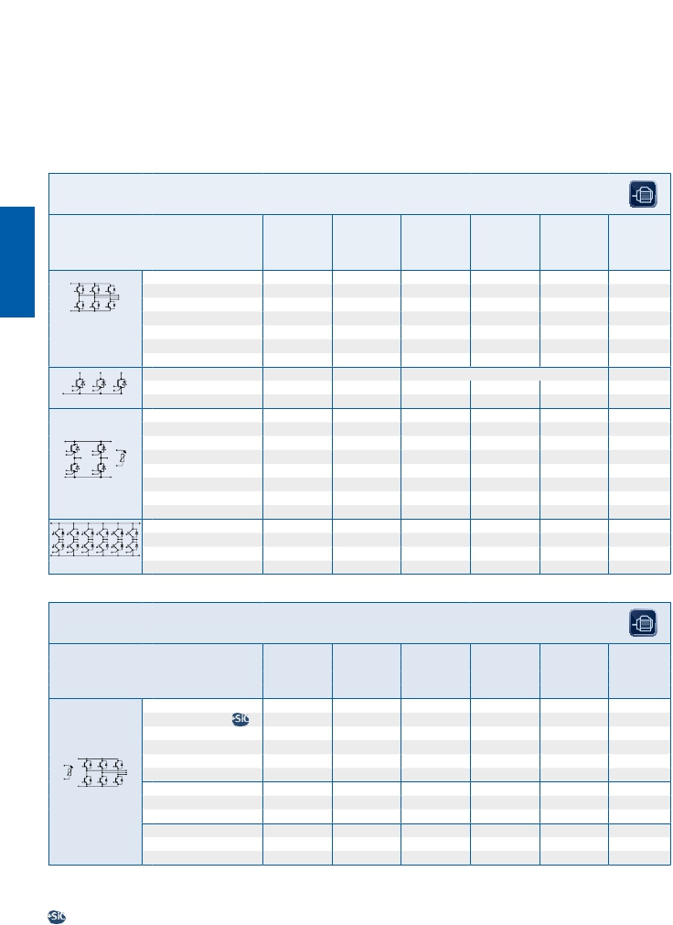

EconoPACK™

1200 VCES

Type VCES IC VCEsat Ptot RthJC Outline/

V A V W K/W page

Tvj= 25°C max

typ.

IGBT3

FS75R12KE3_B9 1200 75 1,7 355 0,35 M_E2l/2.32

IGBT4

FS150R12KT4_B9 1200 150 1,75 750 0,20 M_E3l/2.35

sixpack

for active front-end

applications

FT150R12KE4_B5**) 1200 150 data on request M_E2f/2.31

tripack low

IGBT2 Fast

F4-50R12KS4 1200 50 3,2 355 0,35 M_E2e/2.31

F4-75R12KS4 1200 75 3,2 500 0,25 M_E2e/2.31

F4-100R12KS4 1200 100 3,2 660 0,19 M_E3d/2.34

F4-150R12KS4 1200 150 3,2 690 0,19 M_E3d/2.34

IGBT2 Fast PressFIT

F4-50R12KS4_B11 1200 50 3,2 355 0,35 M_E2c/2.32

fourpack with NTC F4-75R12KS4_B11 1200 75 3,2 500 0,25 M_E2c/2.32

IGBT4

F12-25R12KT4G 1200 25 1,85 160 0,95 M_E3i/2.34

F12-35R12KT4G 1200 35 1,85 210 0,72 M_E3i/2.34

12-pack

1700 VCES

Type VCES IC VCEsat Ptot RthJC Outline/

V A V W K/W page

Tvj= 25°C max

typ.

IGBT2 fast

FS100R17KS4F 1700 100 4,15 960 0,130 M_E3p/2.35

IGBT3

FS50R17KE3_B17 1700 50 2,00 345 0,360 M_E2g/2.31

FS75R17KE3 1700 75 2,00 465 0,270 M_E3b/2.34

FS100R17KE3 1700 100 2,00 555 0,225 M_E3b/2.34

IGBT4

FS100R17N3E4 1700 100 1,95 600 0,25 M_E3b/2.34

FS150R17N3E4 1700 150 1,95 835 0,18 M_E3b/2.34

IGBT4 PressFIT

FS100R17N3E4_B11 1700 100 1,95 600 0,25 M_E3b/2.34

sixpack with NTC FS150R17N3E4_B11 1700 150 1,95 835 0,18 M_E3b/2.34

**) High side to be found in MIPAQ™ base configuration

..._B5 low side module ..._B9 module for active front-end applications

..._B11 PressFIT Modules ..._B17 Module with special pinning for increased creepage distance

Based on Infineon Silicon-Carbide technology for higher performance and efficiency

2.16

Outlines

IGBT

LowPower

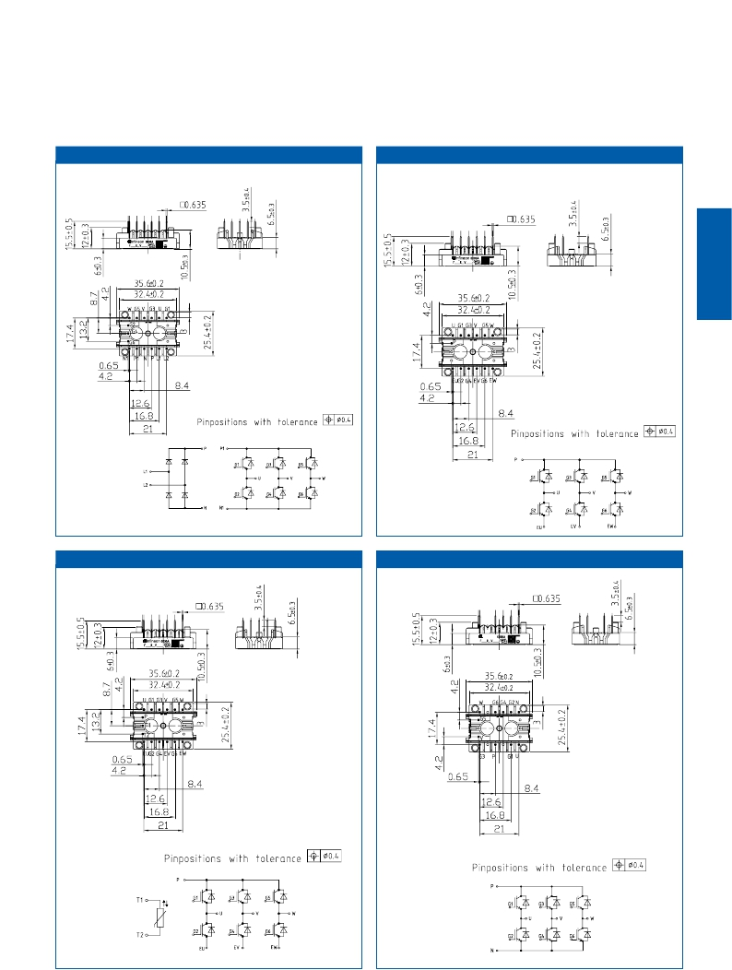

EasyPIM™ 750 L_750a

EasyPACK 750                               L_750b

EasyPACK 750 L_750c

EasyPACK 750                               L_750f

Infineon

2.17

EasyPACK2 L_2j

IGBT

LowPower

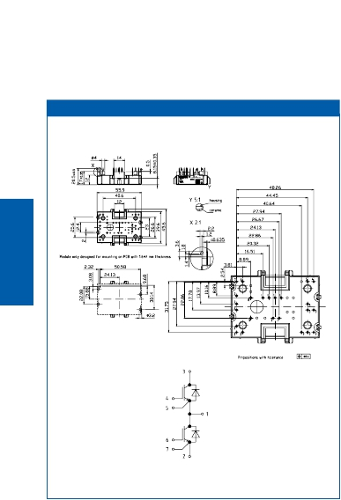

2.18

EasyPIM™ 1B L_B1a

IGBT

LowPower

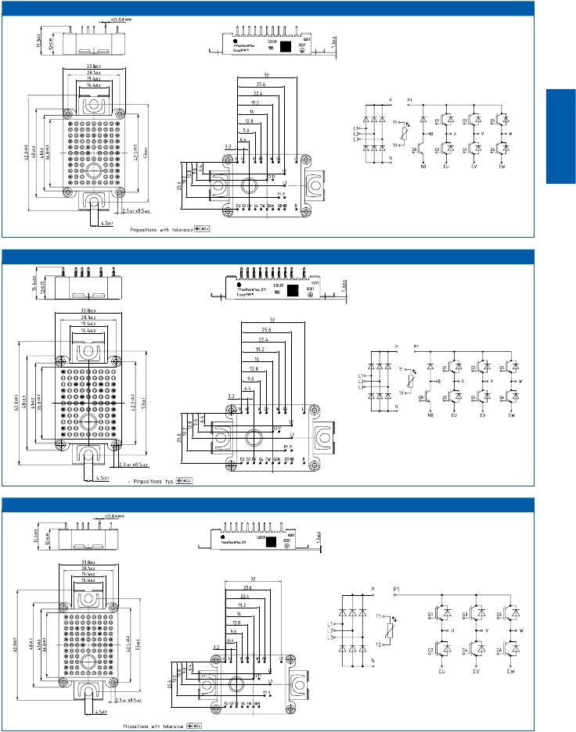

Infineon

EasyPIM™ 1B L_B1h

Infineon

EasyPIM ™ 1B L_B1b

Infineon

2.19

EasyPIM™ 1B L_B1c

IGBT

LowPower

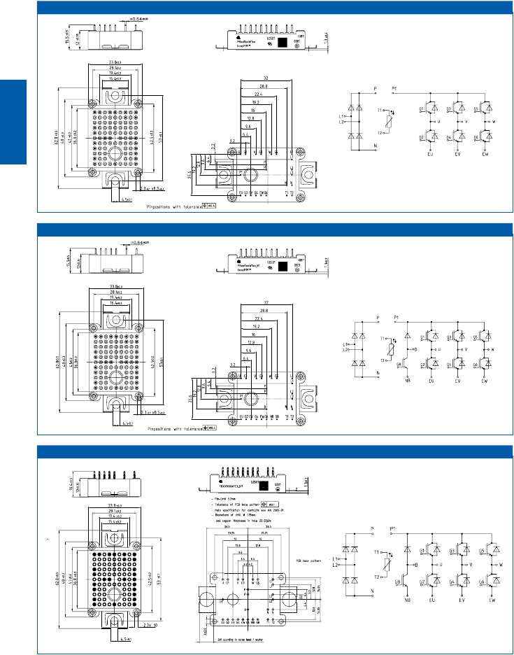

Infineon

EasyPIM™ 1B L_B1d

Infineon

EasyPACK 1B L_B1k

Infineon

2.20

EasyPACK 1B L_B1e

IGBT

LowPower

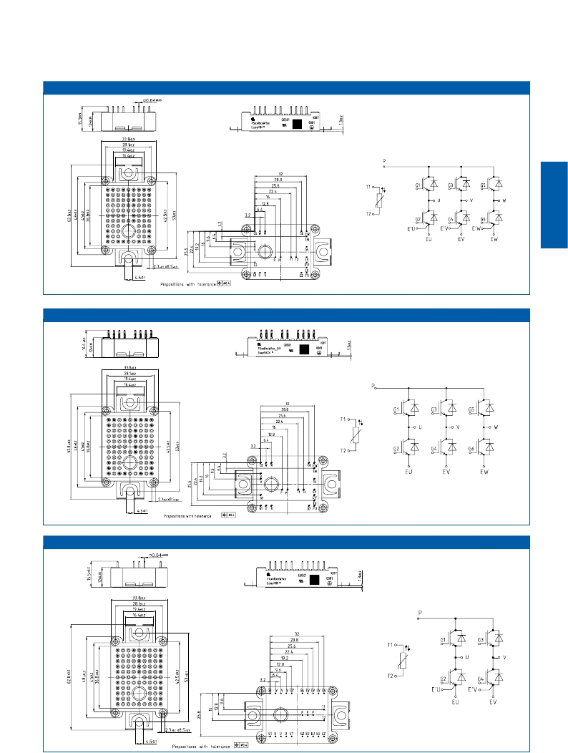

Infineon

EasyPACK 1B L_B1j

Infineon

EasyFourPACK 1B L_B1f

Infineon

2.21

Easy3-level 1B L_B1i

IGBT

LowPower

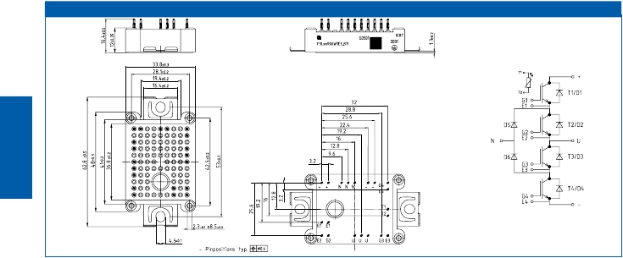

Infineon

2.22

EasyPIM™ 2B L_B2a EasyPIM™ 2B L_B2b

IGBT

LowPower

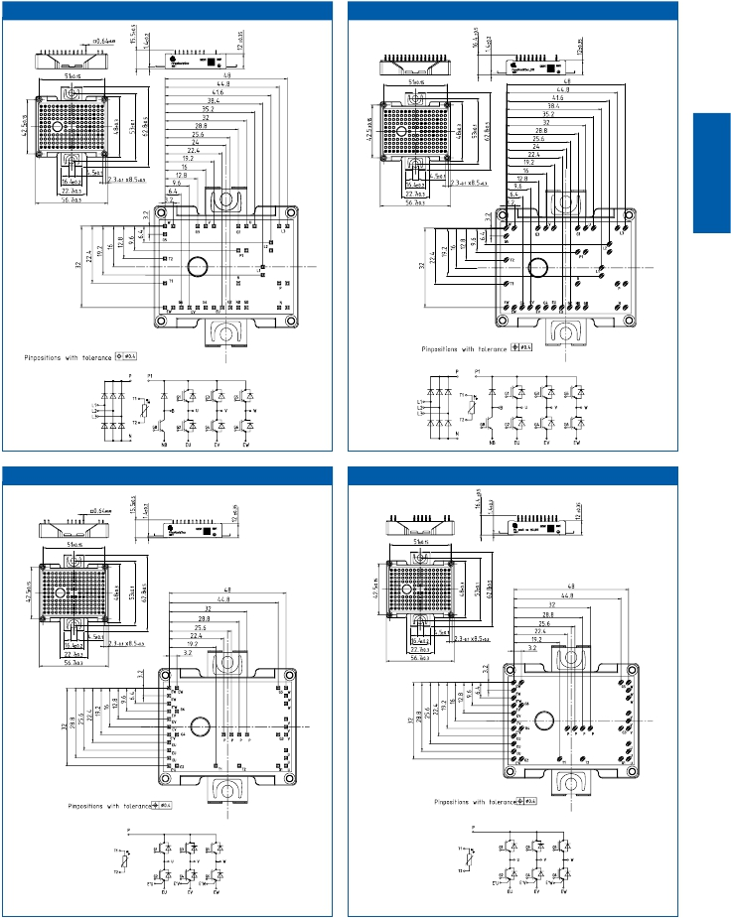

Infineon

Infineon

EasyPACK 2B L_B2c EasyPACK 2B L_B2d

Infineon Infineon

2.23

Easy3-level 2B L_B2e

IGBT

LowPower

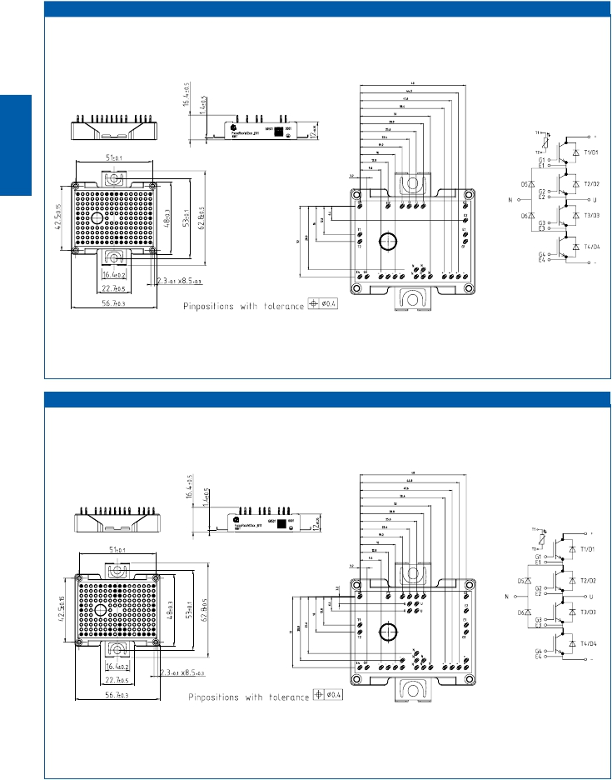

Infineon

Easy3-level 2B L_B2f

Infineon

2.24

Easy Booster 2B L_B2g

IGBT

LowPower

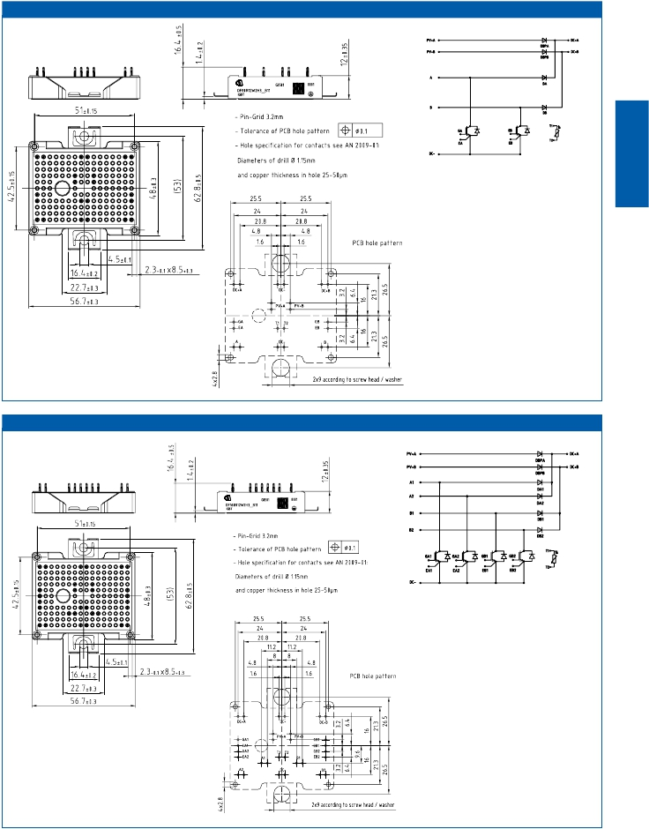

Infineon

Easy Booster 2B L_B2h

Infineon

2.25

Easy Booster 2B L_B2i

IGBT

LowPower

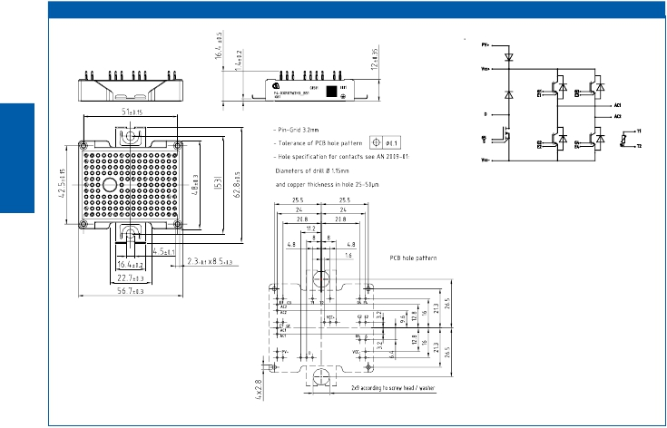

Infineon

2.26

Easy FourPACK with Booster 2B L_B2j

IGBT

LowPower

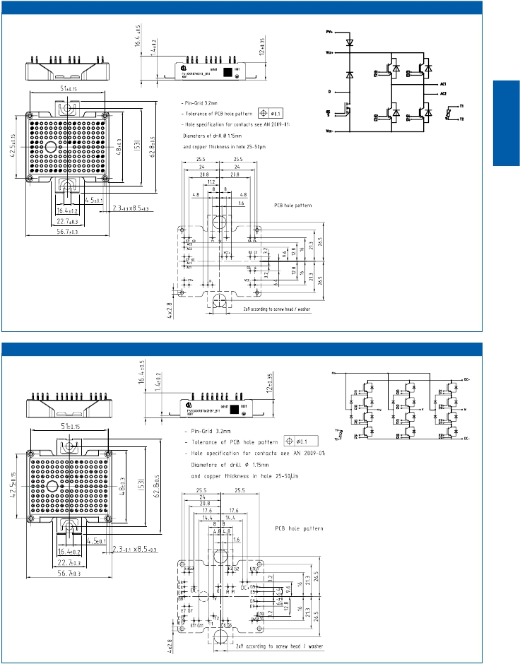

Infineon

Easy 3-Level 2B 3-Phase L_B2k

Infineon

2.27

SmartPIM 1 L_S1a

IGBT

LowPower

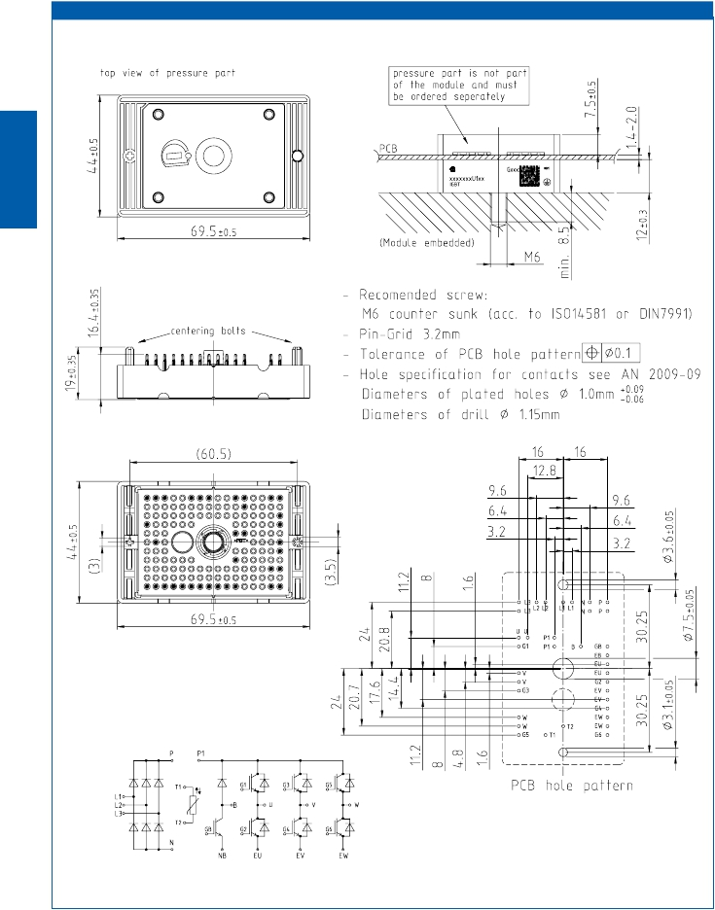

Infineon

2.28

SmartPACK 1 1200V L_S1b

IGBT

LowPower

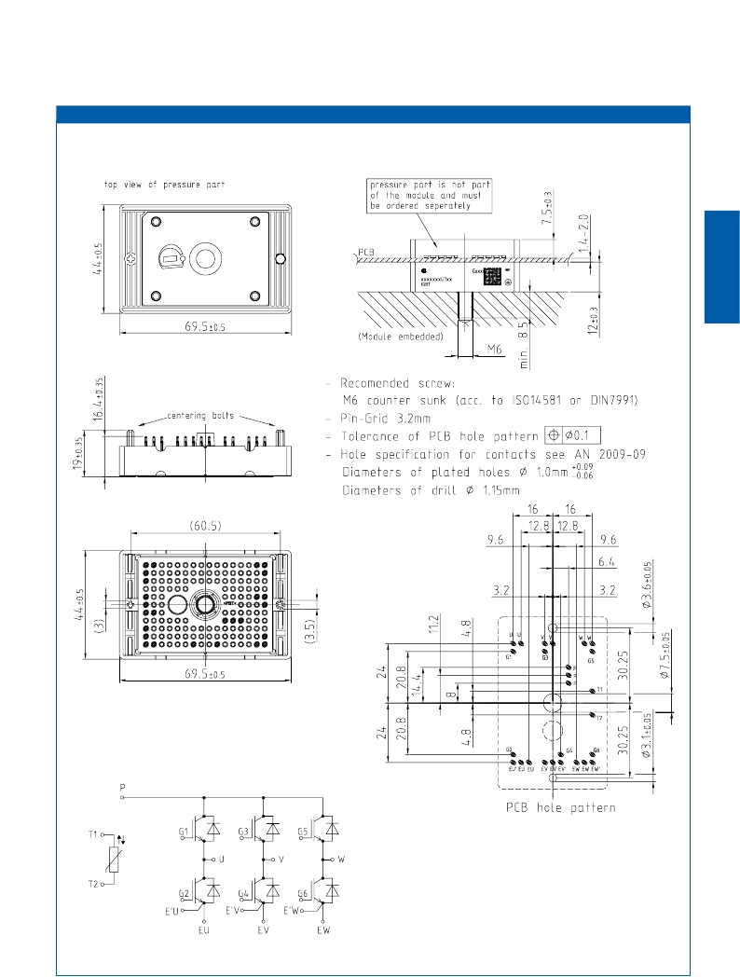

Infineon

2.29

SmartPACK 1 650V L_S1c

IGBT

LowPower

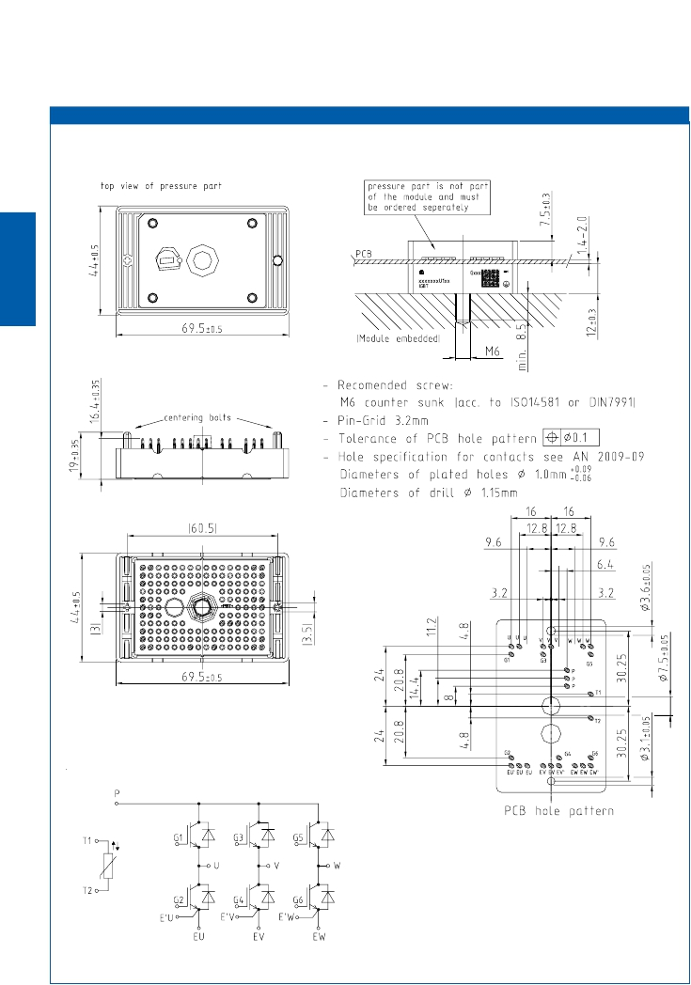

Infineon

2.30

EconoPIM™ C M_E2a

IGBT

LowPower

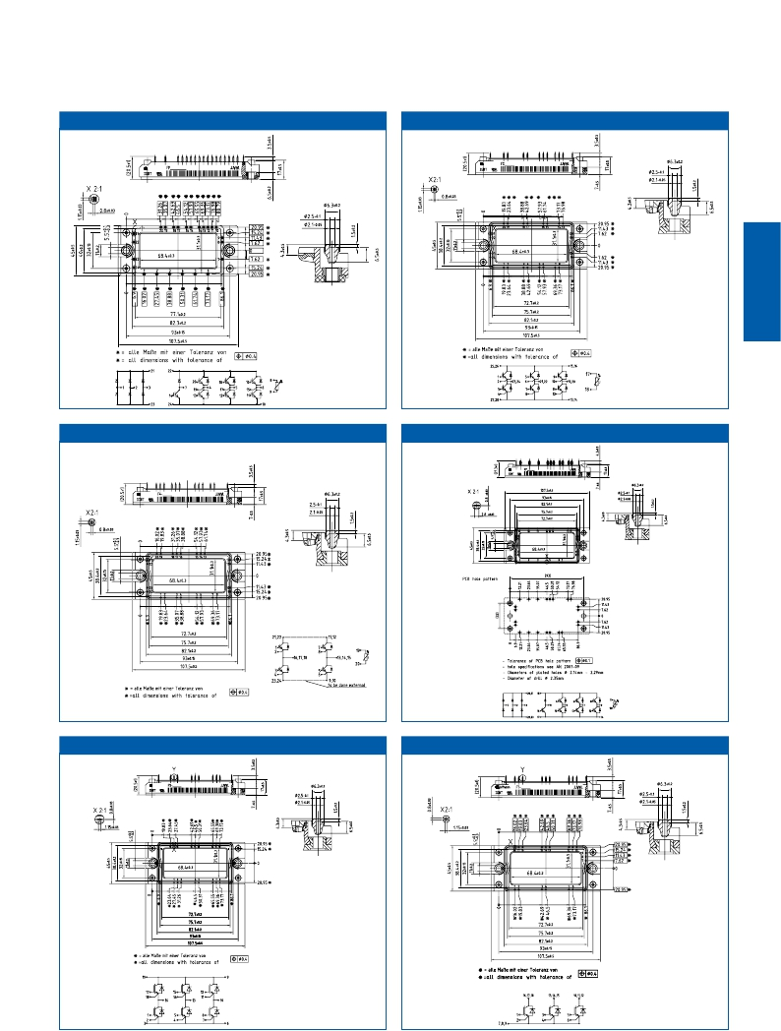

Infineon

EconoPACK™ 2B                             M_E2b

Infineon

EconoPACK™ 2B FourPACK M_E2e

Infineon

EconoPIM™ 2B PressFIT                        M_E2h

Infineon

EconoPACK™ 2B M_E2g EconoPACK™ 2B (TriPACK-Low) M_E2f

Infineon

2.31

EconoPACK™ 2B PressFIT M_E2k EconoPACK™ 2B M_E2i

IGBT

LowPower

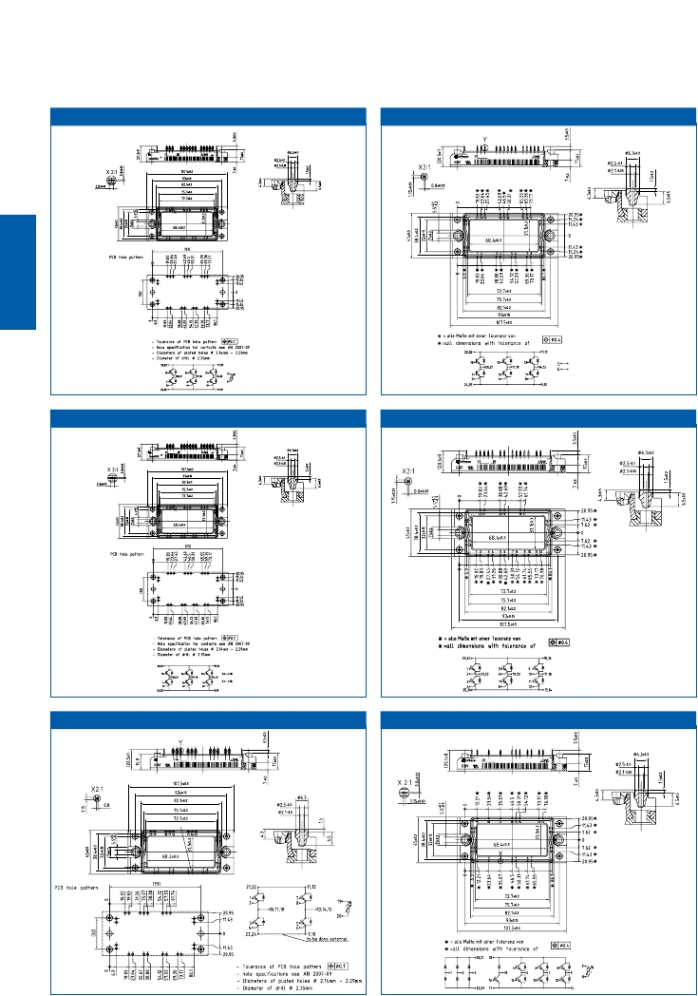

Infineon

EconoPACK™ 2B PressFIT M_E2j

Infineon

EconoPACK™ 2B                              M_E2l

EconoPACK™ 2B FourPACK PressFIT M_E2c

Infineon

EconoPIM™ 2B                              M_E2m

2.32

EconoPIM™ 2B PressFIT M_E2n EconoPACK™ 2B PressFIT M_E2p

IGBT

LowPower

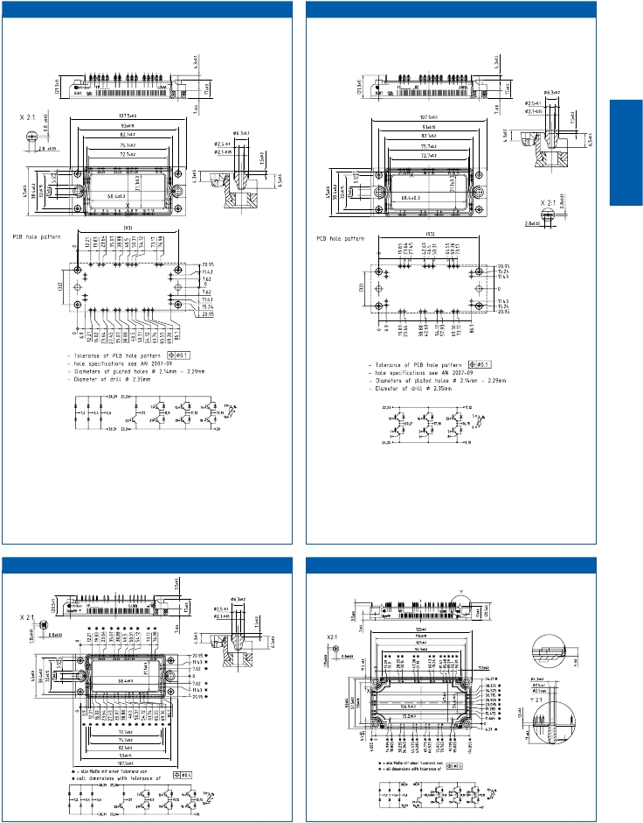

Infineon

EconoPIM™ 2B M_E2o

EconoPIM™ 3B                              M_E3a

Infineon

2.33

EconoPACK™ 3B M_E3b

IGBT

LowPower

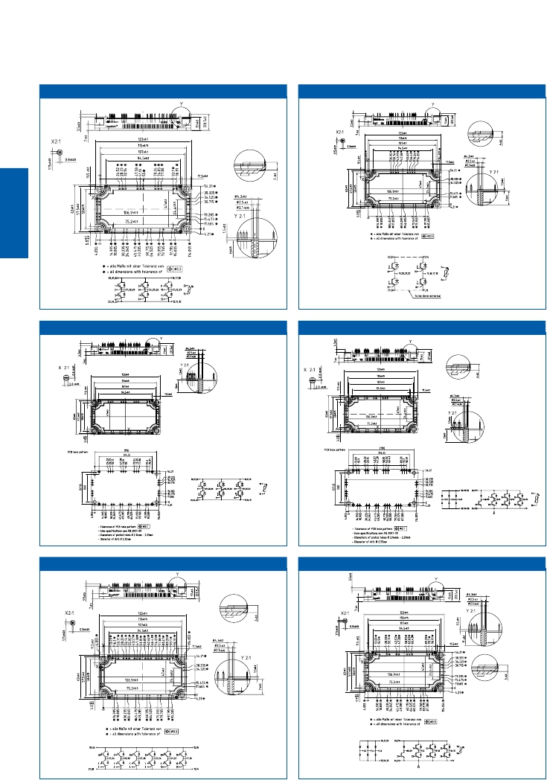

EconoPACK™ 3B FourPACK                      M_E3d

Infineon

EconoPACK™ 3B PressFIT M_E3e

EconoPIM™ 3B PressFIT                         M_E3f

Infineon

EconoPACK™ 3B M_E3i

EconoPIM™ 3B                               M_E3j

Infineon

2.34

EconoPACK™ 3B M_E3l

IGBT

LowPower

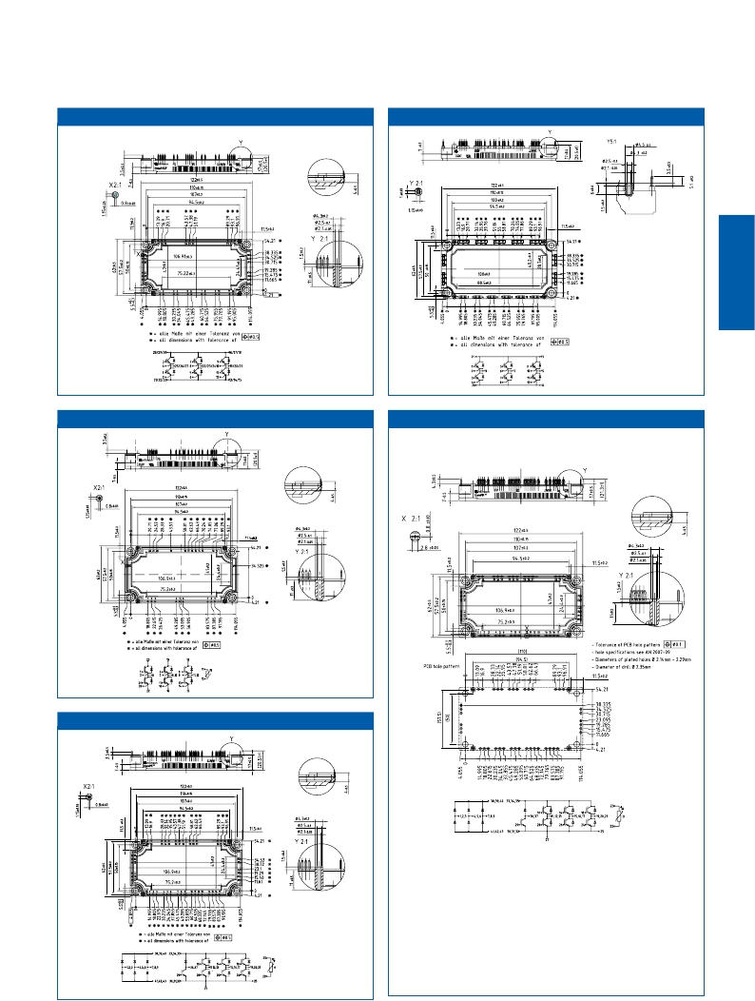

EconoPACK™ 3A                             M_E3c

Infineon

EconoPACK™ 3B M_E3p

EconoPIM™ 3B PressFIT                        M_E3h

EconoPIM™ 3B M_E3g

2.35

|  |  |  |
| --- | --- | --- |
| EasyPIM™ Modules | Housing Size (overall) | Packing  Units |
| EasyPIM™ 750  EasyPIM™ 1  EasyPIM™ 1B  EasyPIM™ 2  EasyPIM™ 2B | 25,4 mm x 35,6 mm  33,0 mm x 45,6 mm  33,8 mm x 48,0 mm  45,6 mm x 55,9 mm  48,0 mm x 56,7mm | 40  20  24  20  15 |

|  |  |  |
| --- | --- | --- |
| EasyPACK Modules | Housing Size (overall) | Packing  Units |
| EasyPACK 750  EasyPACK 1  EasyPACK 1B  EasyPACK 2  EasyPACK 2B | 25,4 mm x 35,6 mm  33,0 mm x 45,6 mm  33,8 mm x 48,0 mm  45,6 mm x 55,9 mm  48,0 mm x 56,7mm | 40  20  24  20  15 |

|  |  |  |
| --- | --- | --- |
| SmartPIM Modules | Housing Size (overall) | Packing  Units |
| SmartPIM 1  Counterholder | 44,0 mm x 69,5 mm  44,0 mm x 69,5mm | 30  30 |

|  |  |  |
| --- | --- | --- |
| EconoPIM™ Modules | Housing Size (overall) | Packing  Units |
| EconoPIM™ 2  EconoPIM™ 3 | 45,0 mm x 107,0 mm  62,0 mm x 122,0 mm | 10  10 |

|  |  |  |
| --- | --- | --- |
| EconoPACK™ Modules | Housing Size (overall) | Packing  Units |
| EconoPACK™ 2  EconoPACK™ 3 | 45,0 mm x 107,0 mm  62,0 mm x 122,0 mm | 10  10 |

|  |  |  |
| --- | --- | --- |
| SmartPACK Modules | Housing Size (overall) | Packing  Units |
| SmartPACK 1  Counterholder | 44,0 mm x 69,5 mm  44,0 mm x 69,5 mm | 30  30 |

|  |  |  |
| --- | --- | --- |
| EasyDUAL Modules | Housing Size (overall) | Packing  Units |
| EasyDUAL 2 | 45,6 mm x 55,9 mm | 20 |

Package Units

IGBT

LowPower



2.36

IGBT Low Power Modules

|  |  |  |  |  |
| --- | --- | --- | --- | --- |
|  | Suitable for | Type | Outline | Part-No. |
| SC750 | Easy750 housing  Easy750housing | ScrewClamp Easy750  IsolationCap Easy750 | SC750  IC750 | 24126  27332 |

Mounting Hardware for EasyPIM™, EasyPACK,

IGBT

LowPower

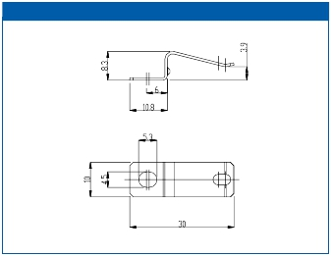

SC750

EasyBRIDGE and EasyDUAL Modules

IC750

2.37

|  |  |  |
| --- | --- | --- |
| Application Notes, Product Briefs,  Flyers and Brochures | Type | Redirects |
| Easy PressFIT - Mounting Instructions  Smart - Evaluation Board  Easy B-Series - Mounting Instructions  Econo (PressFIT )- Mounting Instructions  Smart - Mounting Instructions  Easy B-Serien - Mounting Instructions  Econo (PressFIT) - Mounting Instructions  Smart - Mounting Instructions  3-Level Inverter 650V / 1200V  Easy B-series modules and Easy750  Easy & Econo Modules  SmartPIM and SmartPACK -  Self-acting PressFIT assembly  PressFIT - Mounting technology  EasyPACK 3-Level Modules  EconoPIM™ / EconoPACK™ 650V IGBT4  Thermal Interface Material  SmartPIM and SmartPACK  Application Notes  for all packages & technologies  Product Briefs  for all packages & technologies | Application Note  Application Note  Application Note  (english)  Application Note  (english)  Application Note  (english)  Application Note  (german)  Application Note  (german)  Application Note  (german)  Product Brief  Product Brief  Product Brief  Product Brief  Product Information  Webpage  Webpage  Webpage  Webpage  Application Note  Collection  Product Brief  Collection | <http://www.infineon.com/easy-pressfit-appnote>  <http://www.infineon.com/smart1-evalboard-appnote>  <http://www.infineon.com/easy-appnote>  <http://www.infineon.com/econo-pressfit-appnote>  <http://www.infineon.com/smart-appnote>  <http://www.infineon.com/easy-appnote-german>  <http://www.infineon.com/econo-pressfit-appnote-german>  <http://www.infineon.com/smart-appnote-german>  <http://www.infineon.com/3-level-product-brief>  <http://www.infineon.com/easyb-product-brief>  <http://www.infineon.com/easy-econo-product-brief>  <http://www.infineon.com/smart-product-brief>  <http://www.infineon.com/pressfit-product-information>  <http://www.infineon.com/3-level-easy>  <http://www.infineon.com/econo650v>  <http://www.infineon.com/tim>  <http://www.infineon.com/smart>  <http://www.infineon.com/igbt-modules-application-notes>  <http://www.infineon.com/igbt-modules-product-briefs> |

Links

IGBT

LowPower



2.38

Medium

IGBT

MediumPower

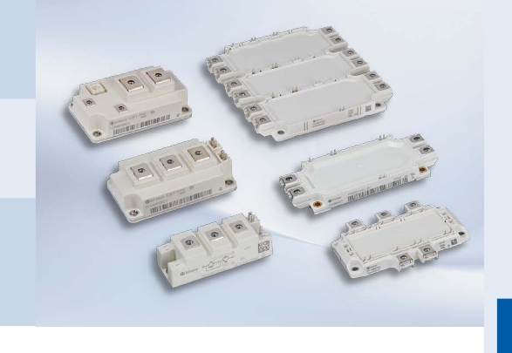

Power

Modules

Flexibility,  optimal  electrical  performance,  highest  reliability.  These  are  the

keywords  for  a  successful  inverter  design.  The  34  and  62  mm  packages  as  well

as  the  EconoPACK™  +,  EconoDUAL™  and  EconoPACK™  4  modules  are  the  right

choice  for  your  design.

Our  well  known  34 mm  and  62 mm  standard  IGBT  modules  are  available  in  vari-

ous  configurations  like  Single  Switch,  Half  Bridge,  Chopper  and  Diode  modules.

Besides  the  IGBT  chip  technologies  for  low  switching  losses,  saturation  voltage

and  high  switching  frequency,  the  34mm  and  62mm  modules  are  also  available

with  the  state-of-the-art  IGBT4  Trench  with  Field  Stop.  The  product  portfolio  cov-

ers  current  ranges  from  50 A  up  to  900 A  at  600 V/650V/1200 V/1700 V.

The  EconoPACK™  +,  EconoDUAL™  and  EconoPACK™  4  modules  combine

17 mm  height  and  leading  edge  IGBT  technology  for  highest  power  density,

enabling  inverter  applications  in  the  power  range  from  20 kVA  to  250 kVA  and

above.  The  key  for  parallel  operation  is  the  symmetrical  design  of  the  module,

resulting  in  an  optimized  current  sharing  between  the  IGBT  half  bridges.  This

concept  allows  to  create  one  inverter  design  for  all  line  voltages  up  to  690 V  AC.

The  EconoPACK™  +,  EconoPACK™  4  and  EconoDUAL™  product  lines  offer  the

complete  current  range  from  50 A  up  to  600 A  at  600 V/650V/1200 V/1700 V.  Fur-

thermore,  all  of  these  packages  are  now  available  with  solderless  high  reliable

PressFIT  control  terminals.

3.1

3.2

IGBT

MediumPower

3300V

IHVP.4.7

1200V

IHMP.4.4

1200V

PrimePACK™P.4.3

600V

1700V

62mmP.3.3

600V

34mmP.3.3

600V

650V

1200V

EconoDUAL™P.3.12

1200V

EconoPACK™+P.3.10

650V

EconoPACK™4P.3.8

1200V

MIPAQ™P.5.4

1200V

1200V

1700V

1200V

1700V

1700V

1700V

1200V

1700V

650V

1200V

1700V

1600V

1700V

4500V

6500V

1600V

P[kW]

600V

650V

EconoPIM™/EconoPACK™P.2.12

650V

SmartPIM/SmartPackP.2.10

600V

650V

1200V

EasyPIM™/EasyPACKP.2.4

600V

650V

1100V

1200V

1350V

TO-247

600V

650V

1200V

TO-220Full-PAK

600V

TO-262

I2-PAK

600V

650V

1200V

TO-220

600V

1200V

TO-263D2-PAK

600V

1200V

TO-252D-PAK

600V

TO-251I-PAK

IC[A]

50

75

100

150

200

400500

450

600

800

900

1000

1500

2000

3000

3600

1

2

3

4

6

8

10252015

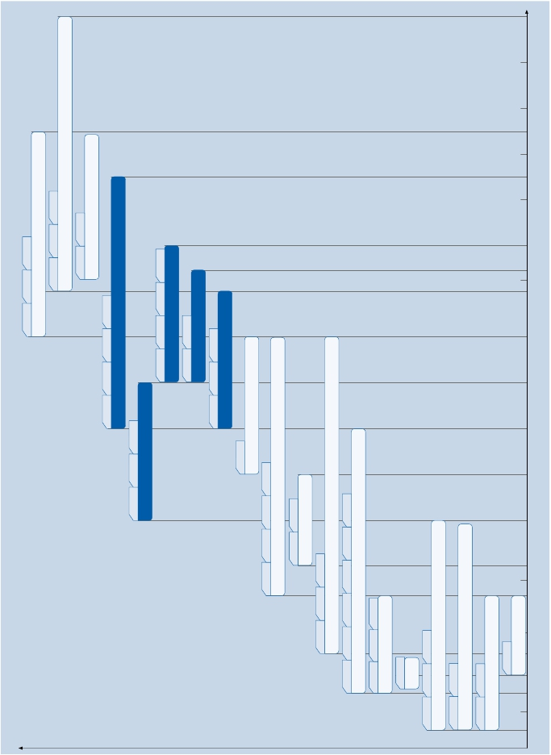

|  |  |  |  |  |  |  |  |
| --- | --- | --- | --- | --- | --- | --- | --- |
| 600 VCES | | | | | | | |
| Type | | VCES  V | IC  A | VCEsat  V  Tvj= 25°C  typ. | Ptot  W | RthJC  K/W  max | Outline/  page |
| dual modules | IGBT2 Low Loss  BSM50GB60DLC  BSM75GB60DLC  BSM100GB60DLC  BSM150GB60DLC  BSM200GB60DLC  IGBT3  FF200R06KE3  FF300R06KE3  FF400R06KE3 | 600  600  600  600  600  600  600  600 | 50  75  100  150  200  200  300  400 | 1,95  1,95  1,95  1,95  1,95  1,45  1,45  1,45 | 280  355  445  595  730  680  940  1250 | 0,44  0,35  0,28  0,21  0,17  0,22  0,16  0,12 | M_34a/3.15  M_34a/3.15  M_34a/3.15  M_34a/3.15  M_34a/3.15  M_62a/3.15  M_62a/3.15  M_62a/3.15 |
| FD chopper | IGBT3  FD300R06KE3 | 600 | 300 | 1,45 | 640 | 0,16 | M_62a/3.15 |

|  |  |  |  |  |  |  |  |
| --- | --- | --- | --- | --- | --- | --- | --- |
| 650 VCES | | | | | | | |
| Type | | VCES  V | IC  A | VCEsat  V  Tvj= 25°C  typ. | Ptot  W | RthJC  K/W  max | Outline/  page |
| dual modules | IGBT4  u FF300R07KE4  u FF400R07KE4 | 650  650 | 300  400 | 1,55  1,55 | 940  1250 | 0,16  0,12 | M_62a/3.15  M_62a/3.15 |



IGBT Medium Power Modules

IGBT

MediumPower

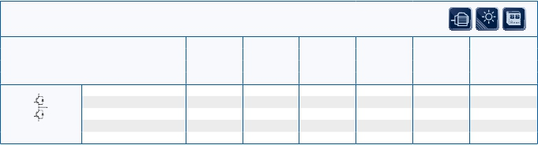

3.3

34 mm and 62 mm Modules

u New type       …_B1 with auxiliary collector sense

|  |  |  |  |  |  |  |  |
| --- | --- | --- | --- | --- | --- | --- | --- |
| 1200 VCES | | | | | | | |
| Type | | VCES  V | IC  A | VCEsat  V  Tvj= 25°C  typ. | Ptot  W | RthJC  K/W  max | Outline/  page |
| dual modules | IGBT3  FF150R12KE3G  FF200R12KE3  FF300R12KE3  FF400R12KE3  IGBT3 Fast  FF150R12KT3G  FF200R12KT3  FF300R12KT3  FF400R12KT3 | 1200  1200  1200  1200  1200  1200  1200  1200 | 150  200  300  400  150  200  300  400 | 1,70  1,70  1,70  1,70  1,70  1,70  1,70  1,70 | 780  1040  1450  2000  780  1050  1450  2000 | 0,16  0,12  0,085  0,062  0,16  0,12  0,085  0,062 | M_62a/3.15  M_62a/3.15  M_62a/3.15  M_62a/3.15  M_62a/3.15  M_62a/3.15  M_62a/3.15  M_62a/3.15 |
| dual modules | IGBT4 Fast  FF50R12RT4  FF75R12RT4  FF100R12RT4  FF150R12RT4  FF200R12KT4  FF300R12KT4  FF450R12KT4  IGBT4  FF200R12KE4  FF300R12KE4  FF450R12KE4  IGBT2 Fast  FF100R12KS4  FF150R12KS4  FF200R12KS4  FF300R12KS4 | 1200  1200  1200  1200  1200  1200  1200  1200  1200  1200  1200  1200  1200  1200 | 50  75  100  150  200  300  450  200  300  450  100  150  200  300 | 1,75  1,75  1,75  1,75  1,75  1,75  1,75  1,75  1,75  1,75  3,20  3,20  3,20  3,20 | 285  395  555  790  1100  1600  2400  1100  1600  2400  780  1200  1400  1950 | 0,53  0,38  0,27  0,19  0,135  0,093  0,062  0,135  0,093  0,062  0,160  0,100  0,090  0,060 | M_34a/3.15  M_34a/3.15  M_34a/3.15  M_34a/3.15  M_62a/3.15  M_62a/3.15  M_62a/3.15  M_62a/3.15  M_62a/3.15  M_62a/3.15  M_62a/3.15  M_62a/3.15  M_62a/3.15  M_62a/3.15 |



IGBT Medium Power Modules

IGBT

MediumPower



3.4

34 mm and 62 mm Modules

|  |  |  |  |  |  |  |  |
| --- | --- | --- | --- | --- | --- | --- | --- |
| 1200 VCES | | | | | | | |
| Type | | VCES  V | IC  A | VCEsat  V  Tvj= 25°C  typ. | Ptot  W | RthJC  K/W  max | Outline/  page |
| FD chopper | IGBT2 Fast  FD300R12KS4  IGBT3  FD200R12KE3  FD300R12KE3  FD400R12KE3  IGBT4 Fast  FD150R12RT4 | 1200  1200  1200  1200  1200 | 300  200  300  400  150 | 3,20  1,70  1,70  1,70  1,75 | 1950  1040  1450  2000  790 | 0,060  0,120  0,085  0,062  0,19 | M_62a/3.15  M_62a/3.15  M_62a/3.15  M_62a/3.15  M_34a/3.15 |
| DF chopper | IGBT3  DF200R12KE3  DF300R12KE3  DF400R12KE3  IGBT4 Fast  DF150R12RT4 | 1200  1200  1200  1200 | 200  300  400  150 | 1,70  1,70  1,70  1,75 | 1040  1450  2000  790 | 0,120  0,085  0,062  0,190 | M_62a/3.15  M_62a/3.15  M_62a/3.15  M_34a/3.15 |
| single switches | IGBT3  FZ300R12KE3G  FZ400R12KE3  FZ400R12KE3_B1  FZ600R12KE3  FZ600R12KE3_B1  FZ800R12KE3  IGBT4  FZ400R12KE4  FZ600R12KE4  FZ900R12KE4  FZ400R12KP4  FZ600R12KP4  FZ900R12KP4  IGBT2 Fast  FZ400R12KS4  FZ600R12KS4 | 1200  1200  1200  1200  1200  1200  1200  1200  1200  1200  1200  1200  1200  1200 | 300  400  400  600  600  800  400  600  900  400  600  900  400  600 | 1,70  1,70  1,70  1,70  1,70  1,70  1,75  1,75  1,75  1,70  1,70  1,70  3,20  3,20 | 1450  2250  2250  2750  2750  3550  2400  3000  4300  2400  3000  4300  2500  3900 | 0,085  0,055  0,055  0,045  0,045  0,035  0,062  0,050  0,035  0,062  0,050  0,035  0,050  0,030 | M_62b/3.15  M_62b/3.15  M_62c/ 3.15  M_62b/3.15  M_62c/ 3.15  M_62b/3.15  M_62b/3.15  M_62b/3.15  M_62b/3.15  M_62b/3.15  M_62b/3.15  M_62b/3.15  M_62b/3.15  M_62b/3.15 |



IGBT Medium Power Modules

IGBT

MediumPower



3.5

34 mm and 62 mm Modules

…_B1 with auxiliary collector sense

|  |  |  |  |  |  |  |  |
| --- | --- | --- | --- | --- | --- | --- | --- |
| 1700 VCES | | | | | | | |
| Type | | VCES  V | IC  A | VCEsat  V  Tvj= 25°C  typ. | Ptot  W | RthJC  K/W  max | Outline/  page |
| dual modules | IGBT2 Standard  BSM50GB170DN2  BSM75GB170DN2  IGBT3  FF200R17KE3  FF300R17KE3  IGBT4  FF150R17KE4  FF200R17KE4  FF300R17KE4 | 1700  1700  1700  1700  1700  1700  1700 | 50  75  200  300  150  200  300 | 3,40  3,40  2,00  2,00  1,95  1,95  1,95 | 500  625  1250  1470  1150  1650  1800 | 0,250  0,200  0,100  0,085  0,130  0,090  0,083 | M_34a/3.15  M_34a/3.15  M_62a/3.15  M_62a/3.15  M_62a/3.15  M_62a/3.15  M_62a/3.15 |
| single switches | IGBT3  FZ400R17KE3  FZ600R17KE3  IGBT4  FZ400R17KE4  FZ600R17KE4 | 1700  1700  1700  1700 | 400  600  400  600 | 2,00  2,00  1,95  1,95 | 2270  3120  2500  3400 | 0,055  0,040  0,060  0,044 | M_62b/3.15  M_62b/3.15  M_62b/3.15  M_62b/3.15 |

|  |  |  |  |  |  |  |  |
| --- | --- | --- | --- | --- | --- | --- | --- |
| Diode Modules | | | | | | | |
| Type | | VRRM  V | IC  A | VF  V  Tvj= 25°C  typ. | QR  µAs  Tvj = 125°C  typ. | RthJC  K/W  max | Outline/  page |
| single diodes | BYM300A120DN2  BYM600A170DN2  DZ800S17KE3 | 1200  1700  1700 | 300  600  800 | 2,30  2,00  1,80 | 40  100  345 | 0,125  0,090  0,058 | M_62d/3.15  M_62d/3.15  M_62d/3.15 |
| dual diodes | BYM300B170DN2 | 1700 | 300 | 2,20 | 75 | 0,120 | M_62e/3.15 |



IGBT Medium Power Modules

IGBT

MediumPower

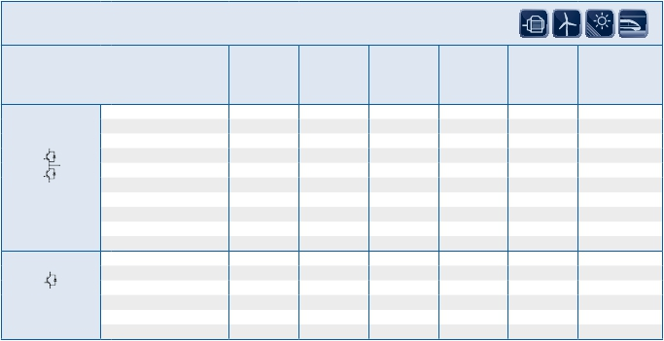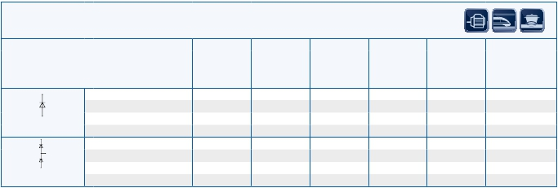

3.6

34 mm and 62 mm Modules

|  |  |  |  |  |  |  |  |
| --- | --- | --- | --- | --- | --- | --- | --- |
| 1200 VCES | | | | | | | |
| Type | | VCES  V | IC  A | VCEsat  V  Tvj= 25°C  typ. | Ptot  W | RthJC  K/W  max | Outline/  page |
| single switches  with series diode | IGBT2 Fast  FD300R12KS4_B5 | 1200 | 300 | 3,20 | 1950 | 0,064 | M_62a/3.15 |
| IGBT3  FD400R12KE3_B5 | 1200 | 400 | 1,70 | 2000 | 0,062 | M_62a/3.15 |
| dual modules with  common emitter | IGBT3 Fast  FF200R12KT3_E  FF300R12KT3_E  FF400R12KT3_E | 1200  1200  1200 | 200  300  400 | 1,70  1,70  1,70 | 1050  1450  2000 | 0,120  0,085  0,062 | M_62f/3.16  M_62f/3.16  M_62f/3.16 |



IGBT Medium Power Modules

IGBT

MediumPower

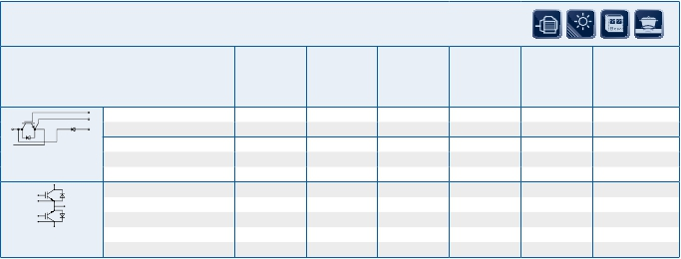

3.7

34 mm and 62 mm Modules

…_B5 with series diode               …_E common emitter

IGBT Medium Power Modules

IGBT

MediumPower

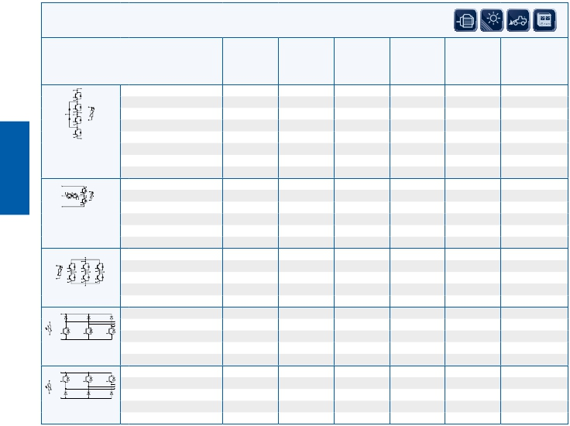

EconoPACK™ 4

650 VCES

Type VCES IC VCEsat Eon/Eoff RthJC Outline/

V A V mWs K/W page

Tvj= 25°C Tvj=125°C max

typ. typ.

IGBT4

u F3L200R07PE4 650 200 1,55 2,0/12,5 0,22 M_EP4a/3.17

u F3L300R07PE4 650 300 1,55 2,0/17,5 0,16 M_EP4a/3.17

3-level one-phase

NPC1 topology with

NTC

IGBT4

u

F3L400R07PE4_B26         650       400       1,55    11/26,5      0,125  M_EP4b/3.17

3-Level one-phase

NPC2 topology with

NTC

IGBT4

FS100R07PE4 650 100 1,55 1,3/4,9 0,45 M_EP4d/3.18

FS150R07PE4 650 150 1,55 2,65/7,15 0,35 M_EP4d/3.18

FS200R07PE4 650 200 1,55 3,55/10,5 0,25 M_EP4d/3.18

sixpack with NTC

IGBT4

u FD300R07PE4_B6 650 300 1,55 3,3/15,5 0,16 M_EP4d/3.18

u FD400R07PE4R_B6 650 400 1,55 7,95/24 0,13 M_EP4d/3.18

FD Chopper

with NTC

IGBT4

u DF300R07PE4_B6 650 300 1,55 3,85/15,5 0,16 M_EP4d/3.18

u DF400R07PE4R_B6 650 400 1,55 8,95/23,5 0,135 M_EP4d/3.18

DF Chopper

with NTC

u New type …_B26 3-Level NPC2 inverter part …_B6 three phase chopper …R… limited DC current

3.8

IGBT Medium Power Modules

IGBT

MediumPower

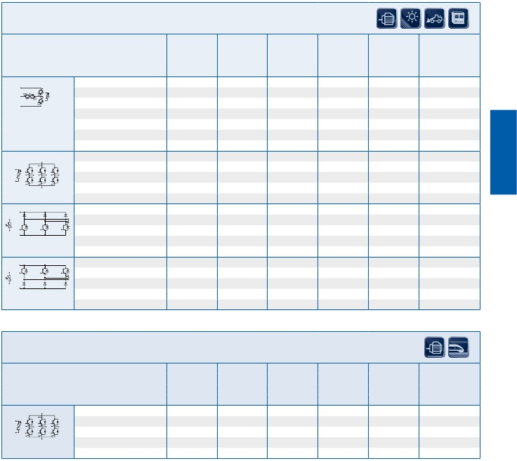

EconoPACK™ 4

1200 VCES

Type VCES IC VCEsat Eon/Eoff RthJC Outline/

V A V mWs K/W page

Tvj= 25°C Tvj=125°C max

typ. typ.

IGBT4

u

F3L300R12PT4_B26        1200       300       1,75   1,15/19,0       0,09  M_EP4b/3.17

u F3L400R12PT4_B26 1200 400 1,75 13,0/26,0 0,07 M_EP4b/3.17

3-Level one-phase

NPC2 topology with

NTC

IGBT4

FS100R12PT4 1200 100 1,75 9,3/8,3 0,30 M_EP4d/3.18

FS150R12PT4 1200 150 1,75 14/12,5 0,22 M_EP4d/3.18

FS200R12PT4 1200 200 1,75 18,5/16,5 0,15 M_EP4d/3.18

sixpack with NTC

IGBT4

u FD200R12PT4_B6 1200 200 1,75 17,5/21,0 0,14 M_EP4d/3.18

FD Chopper

with NTC

IGBT4

u DF200R12PT4_B6 1200 200 1,75 19,5/21,0 0,135 M_EP4d/3.18

DF Chopper

with NTC

1700 VCES

Type VCES IC VCEsat Eon/Eoff RthJC Outline/

V A V mWs K/W page

Tvj= 25°C Tvj=125°C max

typ. typ.

IGBT4

FS100R17PE4 1700 100 1,95 19/29 0,25 M_EP4d/3.18

FS150R17PE4 1700 150 1,95 29/43,5 0,18 M_EP4d/3.18

sixpack with NTC

u New type …_B26 3-Level NPC2 inverter part …_B6 three phase chopper

3.9

|  |  |  |  |  |  |  |  |
| --- | --- | --- | --- | --- | --- | --- | --- |
| 1200 VCES | | | | | | | |
| Type | | VCES  V | IC  A | VCEsat  V  Tvj= 25°C  typ. | Eon/Eoff  mWs  Tvj=125°C  typ. | RthJC  K/W  max | Outline/  page |
| sixpack  with NTC | IGBT3  n FS150R12KE3G  n FS225R12KE3  n FS300R12KE3  n FS450R12KE3  IGBT4  n FS225R12KE4  n FS300R12KE4  n FS450R12KE4 | 1200  1200  1200  1200  1200  1200  1200 | 150  225  300  450  225  300  450 | 1,70  1,70  1,70  1,70  1,85  1,75  1,75 | 11/24  15/36  22/43  33/65  12,5/26,5  17/37,5  26/55,5 | 0,180  0,110  0,085  0,060  0,140  0,094  0,066 | M_E+a/3.19  M_E+a/3.19  M_E+a/3.19  M_E+a/3.19  M_E+a/3.19  M_E+a/3.19  M_E+a/3.19 |

|  |  |  |  |  |  |  |  |
| --- | --- | --- | --- | --- | --- | --- | --- |
| 1700 VCES | | | | | | | |
| Type | | VCES  V | IC  A | VCEsat  V  Tvj= 25°C  typ. | Eon/Eoff  mWs  Tvj=125°C  typ. | RthJC  K/W  max | Outline/  page |
| sixpack  with NTC | IGBT3  n FS150R17KE3G  n FS225R17KE3  n FS300R17KE3  n FS450R17KE3  IGBT4  n FS225R17KE4  n FS300R17KE4  n FS450R17KE4 | 1700  1700  1700  1700  1700  1700  1700 | 150  225  300  450  225  300  450 | 2,00  2,00  2,00  2,00  1,95  1,95  1,95 | 48/47  71,5/70,5  95/94  140/140  67,5/73,5  92/98,5  135/155 | 0,120  0,090  0,075  0,055  0,099  0,083  0,060 | M_E+a/3.19  M_E+a/3.19  M_E+a/3.19  M_E+a/3.19  M_E+a/3.19  M_E+a/3.19  M_E+a/3.19 |



IGBT Medium Power Modules

IGBT

MediumPower

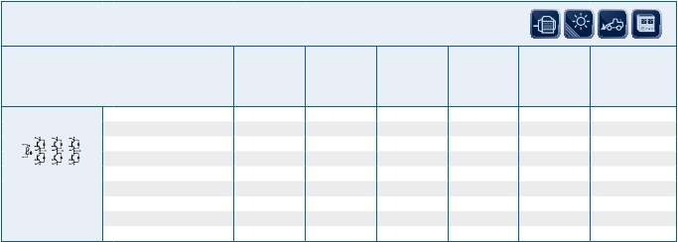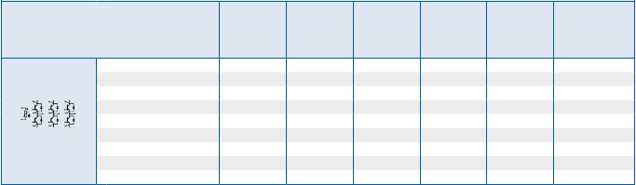

3.10

EconoPACK™ +

n Not for new design

|  |  |  |  |  |  |
| --- | --- | --- | --- | --- | --- |
| 1200 VCES | | | | | |
| Type | | VCES  V | IC  A | VCEsat               Eon/Eoff                RthJC  V                     mWs                  K/W  Tvj= 25°C         Tvj=125°C             max  typ.                   typ. | Outline/  page |
| sixpack  with NTC | IGBT4  u FS225R12OE4  u FS300R12OE4  u FS450R12OE4 | 1200  1200  1200 | 225  300  450 | 1,75           20/28,5                0,120  1,75        29,5/38,0               0,091  1,75        40,5/56,5               0,067 | M_E+d/3.19  M_E+d/3.19  M_E+d/3.19 |

|  |  |  |  |  |  |
| --- | --- | --- | --- | --- | --- |
| 1200 VCES  – Modules with preapplied Thermal Interface Material (TIM) | | | | | |
| Type | | VCES  V | IC  A | VCEsat               Eon/Eoff                RthJC  V                     mWs                  K/W  Tvj= 25°C         Tvj=125°C             max  typ.                   typ. | Outline/  page |
| sixpack  with NTC | IGBT4  u FS225R12OE4P  u FS300R12OE4P  u FS450R12OE4P | 1200  1200  1200 | 225  300  450 | 1,75           20/28,5                0,120  1,75           29,5/38               0,091  1,75        40,5/56,5               0,067 | M_E+d/3.19  M_E+d/3.19  M_E+d/3.19 |

|  |  |  |  |  |  |  |  |
| --- | --- | --- | --- | --- | --- | --- | --- |
| 1700 VCES | | | | | | | |
| Type | | VCES  V | IC  A | VCEsat  V  Tvj= 25°C  typ. | Eon/Eoff  mWs  Tvj=125°C  typ. | RthJC  K/W  max | Outline/  page |
| sixpack  with NTC | IGBT4  u FS225R17OE4  u FS300R17OE4  u FS450R17OE4  u FS500R17OE4D | 1700  1700  1700  1700 | 225  300  450  500 | 1,95  1,95  1,95  1,95 | 60/73,5  90,5/93  165/135  165/155 | 0,100  0,082  0,062  0,05 | M_E+d/3.19  M_E+d/3.19  M_E+d/3.19  M_E+d/3.19 |

|  |  |  |  |  |  |  |  |
| --- | --- | --- | --- | --- | --- | --- | --- |
| 1700 VCES – Modules with preapplied Thermal Interface Material (TIM) | | | | | | | |
| Type | | VCES  V | IC  A | VCEsat  V  Tvj= 25°C  typ. | Eon/Eoff  mWs  Tvj=125°C  typ. | RthJC  K/W  max | Outline/  page |
| sixpack  with NTC | IGBT4  u FS225R17OE4P  u FS300R17OE4P  u FS450R17OE4P  u FS500R17OE4DP | 1700  1700  1700  1700 | 225  300  450  500 | 1,95  1,95  1,95  1,95 | 60/73,5  90,5/93  165/135  165/155 | 0,100  0,082  0,062  0,05 | M_E+d/3.19  M_E+d/3.19  M_E+d/3.19  M_E+d/3.19 |



IGBT Medium Power Modules

IGBT

MediumPower

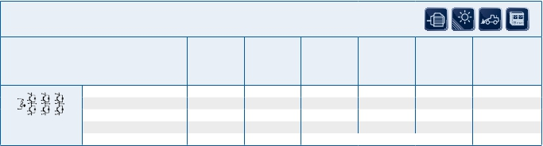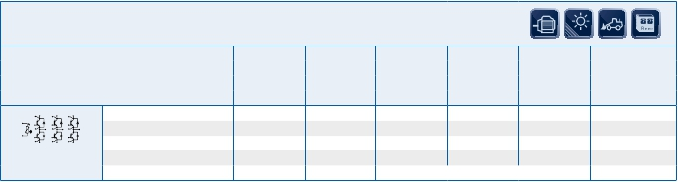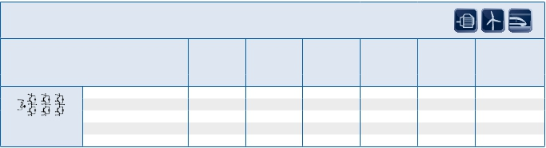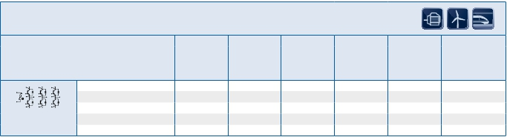

3.11

EconoPACK™ + D-Series

u New type       …P = preapplied Thermal Interface Material (TIM)        …D with enhanced diode

|  |  |  |  |  |  |  |  |
| --- | --- | --- | --- | --- | --- | --- | --- |
| 600 VCES/650 VCES | | | | | | | |
| Type | | VCES  V | IC  A | VCEsat  V  Tvj= 25°C  typ. | Eon/Eoff  mWs  Tvj=125°C  typ. | RthJC  K/W  max | Outline/  page |
| dual modules  with NTC | IGBT3  FF450R06ME3  FF600R06ME3  IGBT4  u FF300R07ME4_B11  u FF450R07ME4_B11  u FF600R07ME4_B11 | 600  600  650  650  650 | 450  600  300  450  600 | 1,45  1,45  1,55  1,75  1,75 | 6,3/17,5  9,9/25  2,8/18  26/55,5  83/72 | 0,120  0,090  0,140  0,066  0,041 | M_ED3/3.20  M_ED3/3.20  M_ED3_PF/3.20  M_ED3_PF/3.20  M_ED3_PF/3.20 |
| chopper modules  with NTC | IGBT3  FD600R06ME3_S2 | 600 | 600 | 1,30 | 6,1/17,5 | 0,055 | M_ED3/3.20 |
| 3-level one-phase  NPC1 topology with  NTC | IGBT4  u F3L400R07ME4_B22  u F3L400R07ME4_B23 | 650  650 | 400  400 | 1,55  1,55 | 12/25,5  12/25,5 | 0,13  0,13 | M_ED3/3.20  M_ED3/3.20 |



IGBT Medium Power Modules

IGBT

MediumPower



3.12

EconoDUAL™

u New type   …_B11 PressFIT Modules    …_S2 low VCEsat    …_B22 3-Level NPC1 upper switch   …_B23 3-Level NPC1 lower switch

|  |  |  |  |  |  |  |  |
| --- | --- | --- | --- | --- | --- | --- | --- |
| 1200 VCES | | | | | | | |
| Type | | VCES  V | IC  A | VCEsat  V  Tvj= 25°C  typ. | Eon/Eoff  mWs  Tvj=125°C  typ. | RthJC  K/W  max | Outline/  page |
| dual modules  with NTC | IGBT4 Fast  FF200R12MT4  IGBT2 Fast  FF150R12MS4G  FF225R12MS4  FF300R12MS4  IGBT3  FF150R12ME3G  FF225R12ME3  FF300R12ME3  FF450R12ME3  IGBT4  FF225R12ME4  FF300R12ME4  FF450R12ME4  u FF600R12ME4  u FF600R12ME4C  u FF225R12ME4_B11  u FF300R12ME4_B11  u FF450R12ME4_B11  u FF600R12ME4_B11  u FF600R12ME4C_B11 | 1200  1200  1200  1200  1200  1200  1200  1200  1200  1200  1200  1200  1200  1200  1200  1200  1200  1200 | 200  150  225  300  150  225  300  450  225  300  450  600  600  225  300  450  600  600 | 1,75  3,20  3,20  3,20  1,70  1,70  1,70  1,70  1,85  1,75  1,75  1,75  1,75  1,85  1,75  1,75  1,75  1,75 | 18,5/16,5  14,5/11  20/15  25/15  11/24  15/36  22/43  33/65  12,5/26,5  17/37,5  26/55,5  83/72  data on request  12,5/26,5  17/37,5  26/55,5  83/72  data on request | 0,140  0,100  0,085  0,064  0,180  0,110  0,085  0,060  0,140  0,094  0,066  0,041  0,037  0,140  0,094  0,066  0,041  0,037 | M_ED2a/3.21  M_ED3/3.20  M_ED3/3.20  M_ED3/3.20  M_ED3/3.20  M_ED3/3.20  M_ED3/3.20  M_ED3/3.20  M_ED3/3.20  M_ED3/3.20  M_ED3/3.20  M_ED3/3.20  M_ED3/3.20  M_ED3_PF/3.20  M_ED3_PF/3.20  M_ED3_PF/3.20  M_ED3_PF/3.20  M_ED3_PF/3.20 |



IGBT Medium Power Modules

IGBT

MediumPower

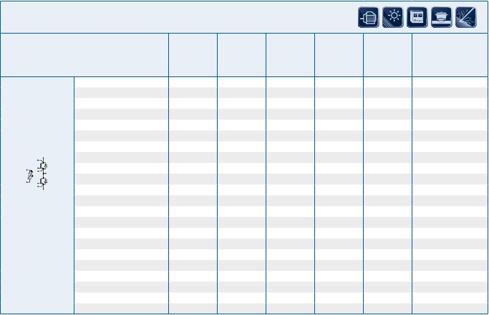

3.13

EconoDUAL™

u New type       …C soft diode performance  …_B11 PressFIT Modules

IGBT Medium Power Modules

IGBT

MediumPower

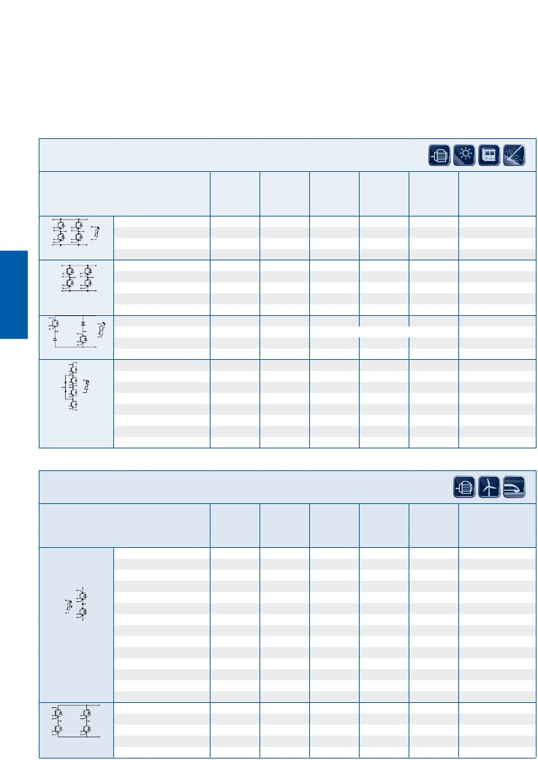

EconoDUAL™

1200 VCES

Type VCES IC VCEsat Eon/Eoff RthJC Outline/

V A V mWs K/W page

Tvj= 25°C Tvj=125°C max

typ. typ.

IGBT2 Fast

F4-50R12MS4 1200 50 3,20 6/2,5 0,350 M_ED2b/3.21

F4-75R12MS4 1200 75 3,20 9/3,8 0,250 M_ED2b/3.21

fourpack with NTC

IGBT4

F4-100R12MT4 1200 100 1,75 11,0/11,0 0,230 M_ED3/3.20

F4-100R12MT4 1200 200 1,75 19,0/18,0 0,160 M_ED3/3.20

fourpack without

NTC

IGBT4

u F4-400R12ME4_B29 1200 400 data on request M_ED3/3.20

chopper

IGBT4

u

F3L300R12ME4_B22       1200      300      1,75   24/36,5     0,097      M_ED3/3.20

u F3L300R12ME4_B23 1200 300 1,75 24/36,5 0,097 M_ED3/3.20

3-level one-phase

NPC1 topology with

NTC

1700 VCES

Type VCES IC VCEsat Eon/Eoff RthJC Outline/

V A V mWs K/W page

Tvj= 25°C Tvj=125°C max

typ. typ.

IGBT3

FF150R17ME3G 1700 150 2,00 48/47 0,120 M_ED3/3.20

FF225R17ME3 1700 225 2,00 71,5/70,5 0,090 M_ED3/3.20

FF300R17ME3 1700 300 2,00 95/94 0,075 M_ED3/3.20

FF450R17ME3 1700 450 2,00 140/140 0,055 M_ED3/3.20

IGBT4

FF225R17ME4 1700 225 1,95 67,5/73,5 0,099 M_ED3/3.20

FF300R17ME4 1700 300 1,95 92/98,5 0,083 M_ED3/3.20

FF450R17ME4 1700 450 1,95 135/155 0,060 M_ED3/3.20

u FF600R17ME4 1700 600 1,95 210/180 0,037 M_ED3/3.20

u FF225R17ME4_B11 1700 225 1,95 67,5/73,5 0,099 M_ED3_PF/3.20

u FF300R17ME4_B11 1700 300 1,95 92/98,5 0,083 M_ED3_PF/3.20

dual modules u FF450R17ME4_B11 1700 450 1,95 135/155 0,060 M_ED3_PF/3.20

with NTC u FF600R17ME4_B11 1700 600 1,95 210/180 0,037 M_ED3_PF/3.20

IGBT4

u F4-100R17ME4 1700 100 1,95 22,0/30,0 0,250 M_ED3/3.20

u F4-150R17ME4 1700 150 1,95 30,0/44,0 0,180 M_ED3/3.20

fourpack u F4-250R17MP4 1700 250 1,75 95,0/110,0 0,100 M_ED3/3.20

without NTC

u New type …_B29 Chopper …_B22 3-Level NPC1 upper switch …_B23 3-Level NPC1 lower switch …_B11 PressFIT Modules

3.14

Outlines

5

22

29,5

30,5

13,25

10

5

6.5

ø6,4

13

17

26

34

15

27

30

48

61,4

20

M6

6

30,5

30,9

25.4

36.5

13,2

61,4

48

36.5

6.5

M6

20

20

6

25.4

6

13,25

13,2

61,4

48

20

20

M6

6.5

6.5

15

27

30

48

61,4

20

M6

6

30,5

30,9

IGBT

MediumPower

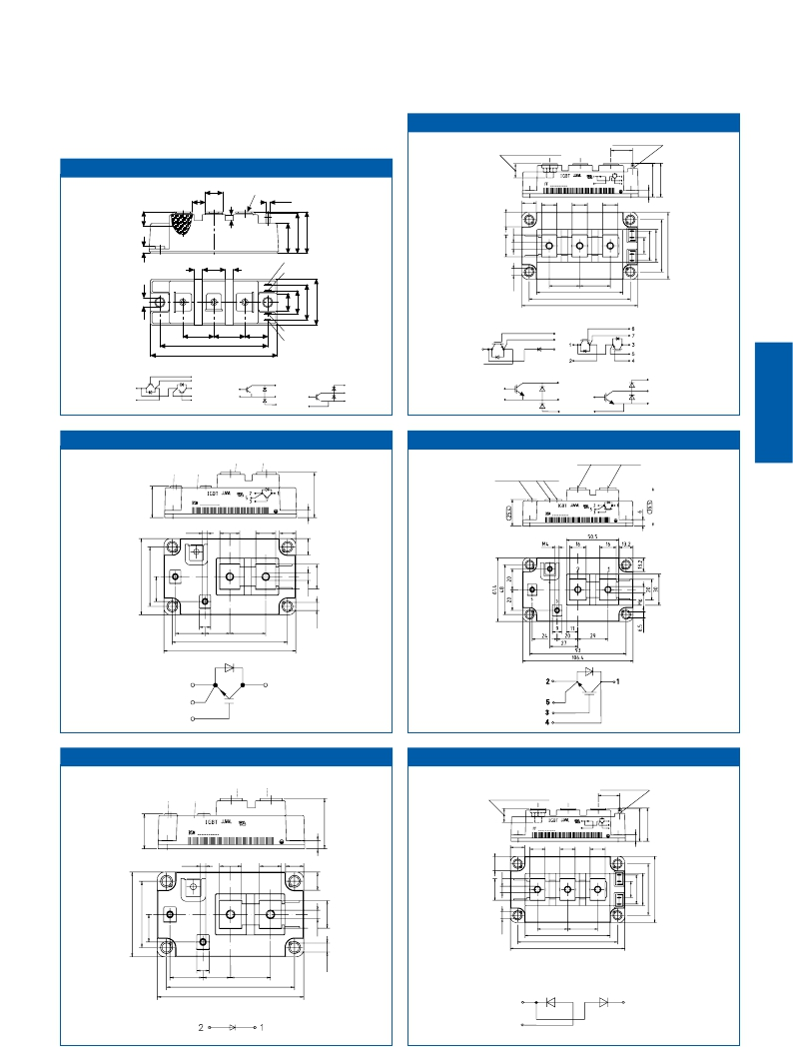

62 mm Module                              M_62a

plug-in depth 7mm min.

screwing depth 10mm max.

20

34 mm Module M_34a

10

13

M5

2,8 x 0,5

13,25          14

14

14

1

2

3

6

7

6  17

6

6

7

5

4

1 2 3

28

106.4 93

79

28

23

80

94

23

17

5

4

1

Single Switches

with Series Diode

6

7

3

dual modules:

2

dual modules:

62 mm Module

4

M_62a 2

DF-Chopper:

4

5

3

1

2

FD-Chopper:

6

7

3

1

2

DF-Chopper:                      3

FD-Chopper:

3

1

5                     6

1

2                  7

Single Switch 62 M_62b

screwing depth 10mm max.

screwing depth 8mm max.

Single Switch 62, collector sense                  M_62c

screwing depth 10mm max.

screwing depth 8mm max.

M4 16

4 2

16

1

13,2

5

3

24 9

20

93

106.4

29

2

5

3

1

Single Diode 62 M_62d

screwing depth 10mm max.

Dual Diode 62                               M_62e

plug-in depth 7mm min.

screwing depth 8mm max.

screwing depth 10mm max.

20

M4 16

16

13,2

13,25          14

14

14

4 2

1

1

2

3

6

7

5

4

5

3

24  9

20

29

28

106.4 93

79

28

93

106.4

1

2

3

3.15

Dual Modules with Common Emitter 62 M_62f

IGBT

MediumPower

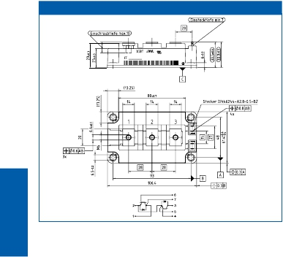

3.16

EconoPACK™ 4 M_EP4a

IGBT

MediumPower

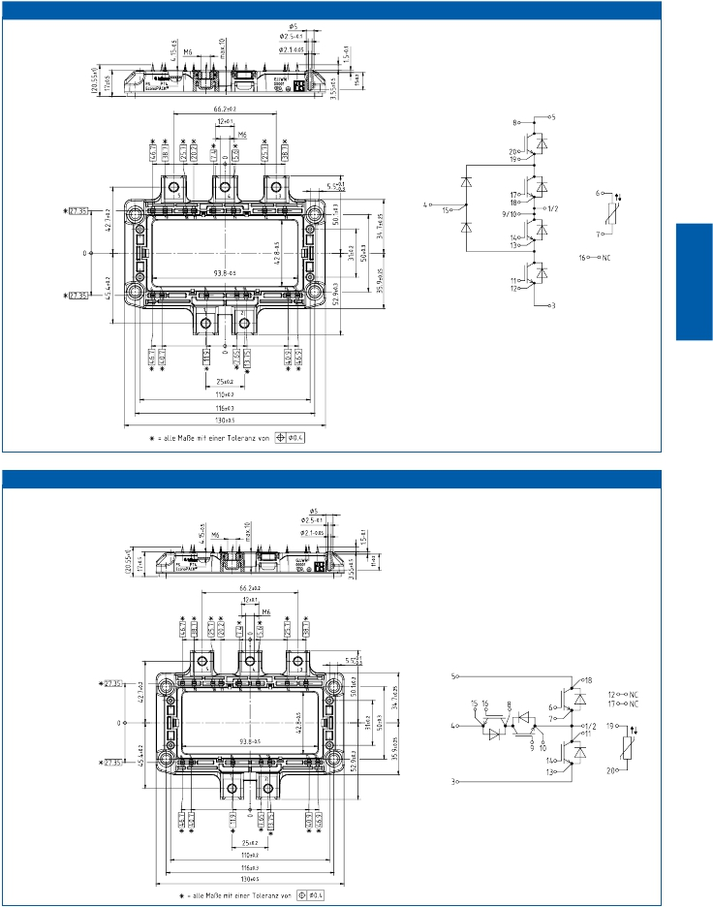

3-level one-phase NPC1 topology

with NTC

EconoPACK™ 4 M_EP4b

3-level one-phase NPC2 topology

with NTC

3.17

EconoPACK™ 4 M_EP4c

IGBT

MediumPower

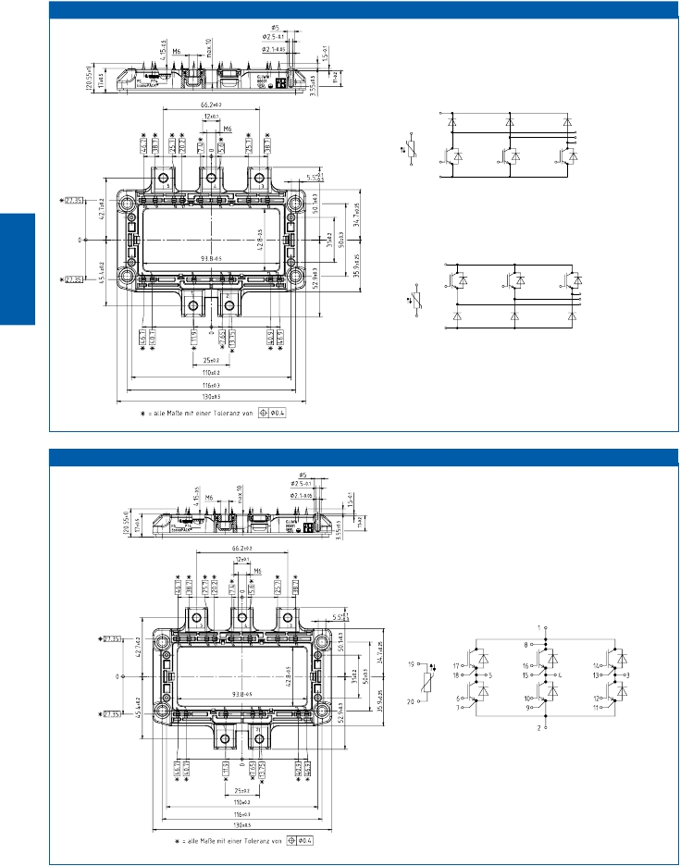

FD chopper with NTC

DF chopper with NTC

EconoPACK™ 4 M_EP4d

sixpack with NTC

3.18

EconoPACK™ + M_E+a

20.5±1

17±0.5

12.5

1,5

4.5

26

27

25

28

29

12

11.5

6±0.3

max.10

0,8

17±0.5

W

22

50

M6

11

20

21

22

23

24

16

17

15

U

18

19

13

14

22

50

22

50

157.5

162

147

61

39

V

IGBT

MediumPower

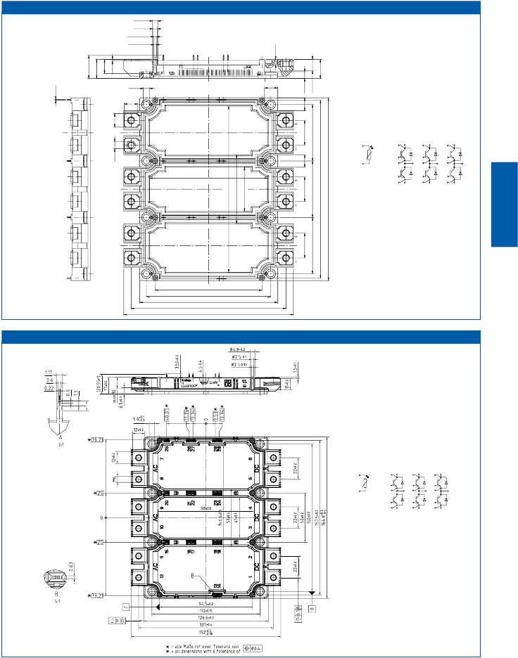

ø4.5

ø4.3

ø2.5-0.3

ø2.1-0.3

5.5

12

11.5

sixpack with NTC

28

15

+

20

+

25

+

16

21

26

29

17

U

22

V

27

W

104

13

14

-

18

19

-

23

24

-

94.5

110

122

137

150

EconoPACK™ + D-Series M_E+d

sixpack with NTC

28

15

+

20

+

25

+

16

21

26

29

17

U

22

V

27

W

13

18

23

14

-

19

-

24

-

3.19

EconoDUAL™ 3 Pressfit M_ED3_PF

IGBT

MediumPower

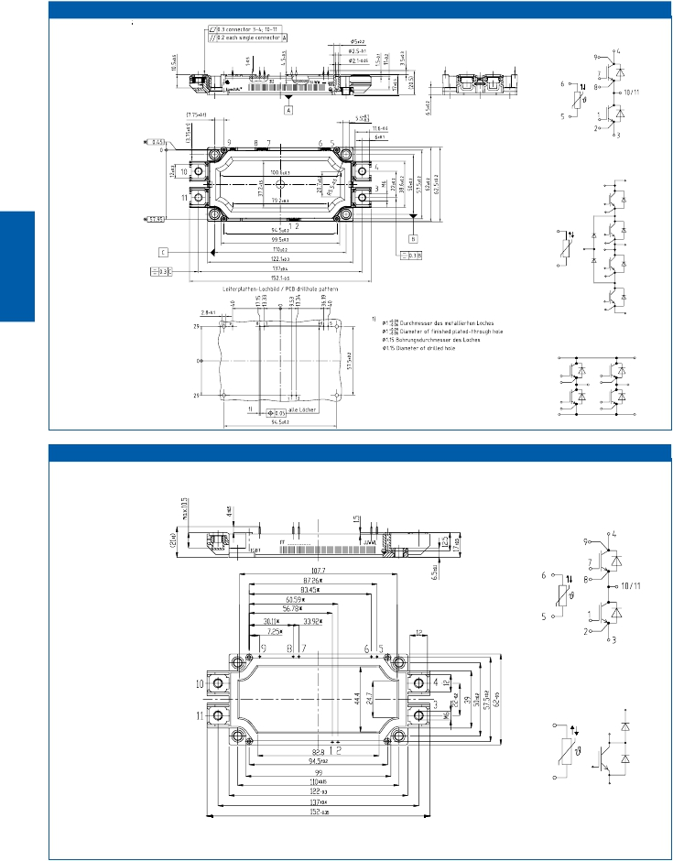

dual modules with NTC

Infineon

3-level one-phase NPC1

topology with NTC

fourpack without NTC

EconoDUAL™ 3 M_ED3

dual modules with NTC

chopper modules with NTC

3.20

EconoDUAL™ 2 M_ED2a

IGBT

MediumPower

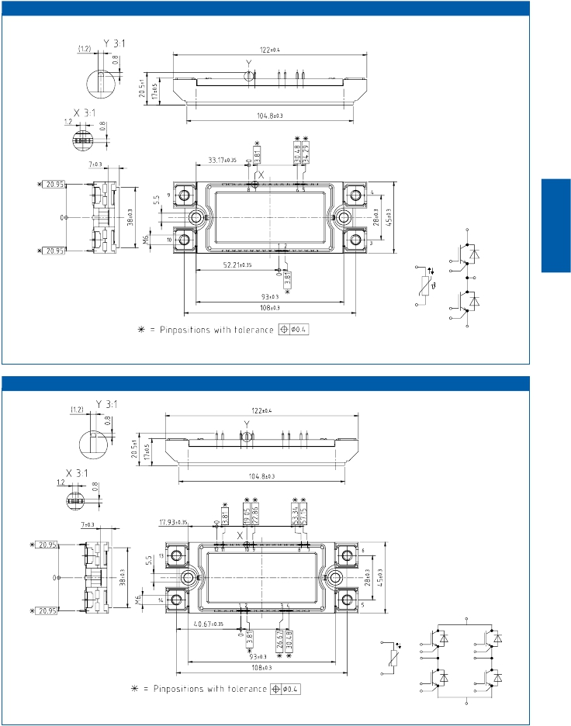

dual modules with NTC

4

1

5

6

9,10

2

8

7

3

EconoDUAL™ 2 M_ED2b

fourpack with NTC

6

8

7

9

10

13

11

12

4

3

14

2

1

5

3.21

|  |  |  |
| --- | --- | --- |
|  | Housing Size (overall) | Packing  Units |
| EconoPACK™ +  EconoPACK™ 4 | 162,0 mm x 150,0 mm  130,0 mm x 103,0 mm | 4  6 |
| EconoDUAL™ 2  EconoDUAL™ 3  EconoDUAL™ 3 PressFIT | 45,0 mm x 122,0 mm  62,0 mm x 152,0 mm  62,0 mm x 152,0 mm | 14  10  6 |

|  |  |  |
| --- | --- | --- |
|  | Housing Size (overall) | Packing  Units |
| Standard 34mm  Standard 62mm | 34,0 mm x 94,0 mm  62,0 mm x 106,4 mm | 10  10 |

Package Units

IGBT

MediumPower



3.22

IGBT Medium Power Modules

|  |  |  |
| --- | --- | --- |
| Application Notes, Product Briefs,  Flyers and Brochures | Type | Redirects |
| 34 & 62mm IGBT Modules  3-Level Inverter 650V / 1200V  EconoDUAL™ , EconoPACK™ 4, Econo-  PACK™ +  EconoPACK™ 4 - The new world standard  EconoPACK™ 4 - IGBT Modules  EconoPACK™+ D-series - Fit for the future  EconoDUAL™ 3 - 1200V, 600A - best in  class  Application Notes  for all packages & technologies | Product Brief  Product Brief  Product Brief  Product Brief  Webpage  Webpage  Webpage  Application Note  Collection | <http://www.infineon.com/34mm-62mm-product-brief>  <http://www.infineon.com/3-level-product-brief>  <http://www.infineon.com/econo-medium-power-product-brief>  <http://www.infineon.com/econopack4-product-brief>  <http://www.infineon.com/econopack4>  <http://www.infineon.com/econopack-d-series>  <http://www.infineon.com/dual3>  <http://www.infineon.com/igbt-modules-application-notes> |
| Product Briefs  for all packages & technologies | Product Brief  Collection | <http://www.infineon.com/igbt-modules-product-briefs> |

Links

IGBT

MediumPower



3.23

3.24

IGBT

MediumPower

High Power

IGBT

HighPower

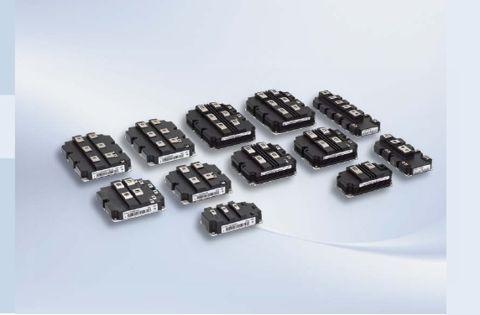

Modules

The  High  Power  IGBT  modules  are  used  for  applications  in  power  range  of  0.5 MW

(1200 V,  450 A)  till  6  MW  (1700 V,  3600 A)  and  are  offered  in  3  different  package

categories,  namely  PrimePACK™,  IHM  (IGBT  High  power  Module)  and  IHV  (IGBT

High  Voltage).  For  high  voltage  applications  (3.3,  4.5  and  6.5  KV)  the  IHV  mod-

ules  are  available  in  various  flavors  with  current  ratings  from  200 A  to  1500 A.

Different  available  topologies:  chopper,  diode,  dual,  half-bridge,  and  single

switch  enhance  the  high  power  modules  product  portfolio  further.

The  innovative  PrimePACK™  (1200 V  &  1700 V,  450…1400 A),  IHM  (1200 V  &

1700 V,  400…3600 A)  and  IHV  housing  introduced  by  us  is  very  well  accepted  in

the  market  and  has  established  itself  as  an  industry  standard  which  is  adopted

by  all  well  known  manufacturers  and  used  in  countless  applications  worldwide.

Our  high  power  modules  are  highly  integrated,  robust,  and  work  with  100 %  reli-

ability  under  any  temperature  conditions  ranging  from  -40…+150 °C.  Low  leaking

current  and  continuously  improved  thermal  properties  of  these  PrimePACK™,

IHM  and  IHV  modules  are  well  appreciated  by  the  customers.  Electrical  separa-

tion  between  power  and  auxiliary  terminals  reduces  the  stray  inductance  influ-

ence  on  sense  contacts  thereby  making  the  module  easy  to  control  and  safe  to

use.  The  widely  accepted  driving  techniques  and  vastly  available  design  support

solutions  make  these  modules  a  preferred  choice  for  a  powerful,  compact  and

modular  converter  design.

Our  products  today  are  contributing  to  daily  demanding  secure  transportation

applications,  CAV  (Construction  &  Agriculture  Vehicles),  working  excellently

even  under  harsh  and  rough  conditions  in  power-  generation  &  -distribution,

industrial  drives  and  are  the  innovative  semiconductor  solutions  for  energy  ef-

ficiency  and  secure  mobility.

4.1

4.2

IGBT

HighPower

3300V

IHVP.4.7

1200V

IHMP.4.4

1200V

PrimePACK™P.4.3

600V

1700V

62mmP.3.3

600V

34mmP.3.3

600V

650V

1200V

EconoDUAL™P.3.12

1200V

EconoPACK™+P.3.10

600V

EconoPACK™4P.3.8

1200V

MIPAQ™P.5.4

1200V

1200V

1700V

1200V

1700V

1700V

1700V

1200V

1700V

650V

1200V

1700V

1600V

1700V

4500V

6500V

1600V

P[kW]

600V

650V

EconoPIM™/EconoPACK™P.2.12

650V

SmartPIM/SmartPackP.2.10

600V

650V

1200V

EasyPIM™/EasyPACKP.2.4

600V

650V

1100V

1200V

1350V

TO-247

600V

650V

1200V

TO-220Full-PAK

600V

TO-262

I2-PAK

600V

650V

1200V

TO-220

600V

1200V

TO-263D2-PAK

600V

1200V

TO-252D-PAK

600V

TO-251I-PAK

IC[A]

50

75

100

150

200

400500

450

600

800

900

1000

1500

2000

3000

3600

1

2

3

4

6

8

10252015

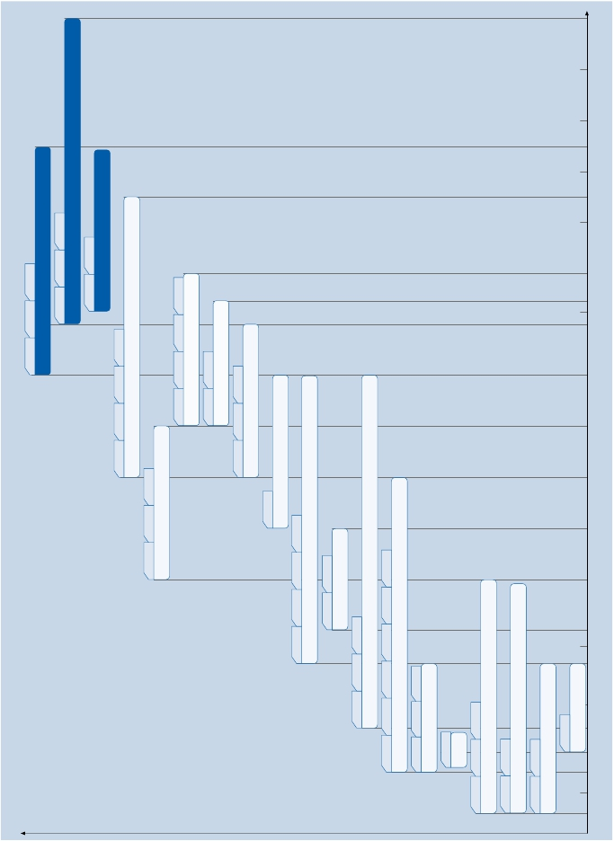

|  |  |  |  |  |  |  |  |
| --- | --- | --- | --- | --- | --- | --- | --- |
| 1200 VCES 1) | | | | | | | |
| Type | | VCES  V | IC  A | VCEsat  V  Tvj= 25°C  typ. | Eon/Eoff  mWs  Tvj=125°C  typ. | RthJC  K/W  per arm | Outline/  page |
| halfbridge with NTC | IGBT4  FF450R12IE4  FF600R12IE4  FF600R12IP4  FF600R12IS4F  FF900R12IE4  FF900R12IP4  FF900R12IP4D  FF1400R12IP4 | 1200  1200  1200  1200  1200  1200  1200  1200 | 450  600  600  600  900  900  900  1400 | 1,75  1,75  1,70  3,20  1,75  1,70  1,70  1,75 | 59/52  61/73  77/105  20/40  70/120  100/160  100/160  80/280 | 0,0590  0,0450  0,0450  0,0340  0,0295  0,0295  0,0295  0,0195 | H_PP2/4.10  H_PP2/4.10  H_PP2/4.10  H_PP2/4.10  H_PP2/4.10  H_PP2/4.10  H_PP2/4.10  H_PP3/4.10 |
| DF             FD  chopper modules  with NTC | IGBT4  FD600R12IP4D  DF600R12IP4D  FD900R12IP4D  DF900R12IP4D  FD1400R12IP4D  DF1400R12IP4D | 1200  1200  1200  1200  1200  1200 | 600  600  900  900  1400  1400 | 1,70  1,70  1,70  1,70  1,75  1,75 | 77/105  77/105  100/160  100/160  80/280  80/280 | 0,0450  0,0450  0,0295  0,0295  0,0195  0,0195 | H_PP2/4.10  H_PP2/4.10  H_PP2/4.10  H_PP2/4.10  H_PP3/4.10  H_PP3/4.10 |

|  |  |  |  |  |  |  |  |
| --- | --- | --- | --- | --- | --- | --- | --- |
| 1700 VCES 1) | | | | | | | |
| Type | | VCES  V | IC  A | VCEsat  V  Tvj= 25°C  typ. | Eon/Eoff  mWs  Tvj=125°C  typ. | RthJC  K/W  per arm | Outline/  page |
| halfbridge with NTC | IGBT4  FF450R17IE4  FF650R17IE4  FF650R17IE4D_B2  FF1000R17IE4  FF1000R17IE4D_B2  FF1400R17IP4 | 1700  1700  1700  1700  1700  1700 | 450  650  650  1000  1000  1400 | 2,00  2,00  2,00  2,00  2,00  1,75 | 200/140  300/205  260/205  390/295  365/315  500/625 | 0,054  0,036  0,036  0,024  0,024  0,024 | H_PP2/4.10  H_PP2/4.10  H_PP2/4.10  H_PP3/4.10  H_PP3/4.10  H_PP3/4.10 |
| DF            FD  chopper modules  with NTC | IGBT4  FD650R17IE4  DF650R17IE4  FD1000R17IE4  DF1000R17IE4  FD 650R17IE4D_B2  DF 650 R17IE4D_B2  FD1000 R17IE4D_B2  DF1000 R17IE4D_B2 | 1700  1700  1700  1700  1700  1700  1700  1700 | 650  650  1000  1000  650  650  1000  1000 | 2,00  2,00  2,00  2,00  2,00  2,00  2,00  2,00 | 300/205  300/205  390/295  390/295  260/205  260/205  365/315  365/315 | 0,036  0,036  0,024  0,024  0,036  0,036  0,024  0,024 | H_PP2/4.10  H_PP2/4.10  H_PP3/4.10  H_PP3/4.10  H_PP2/4.10  H_PP2/4.10  H_PP3/4.10  H_PP3/4.10 |



IGBT High Power Modules

IGBT

HighPower

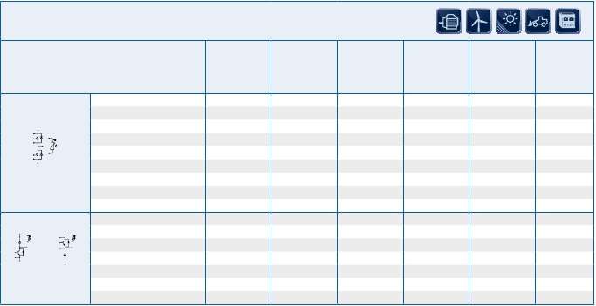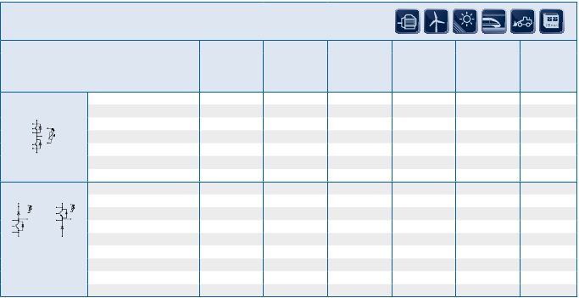

All modules with internal NTC All modules are UL recognized …_B2: Traction …F: SiC Diodes

PrimePACK™

1) PrimePACK™: Tvj, op = 150°C

4.3

|  |  |  |  |  |  |  |  |
| --- | --- | --- | --- | --- | --- | --- | --- |
| 1200 VCES | | | | | | | |
| Type | | VCES  V | IC  A | VCEsat  V  Tvj= 25°C  typ. | Eon/Eoff  mWs  Tvj=125°C  typ. | RthJC  K/W  per arm | Outline/  page |
| dual modules | IGBT3  FF600R12KE3  FF800R12KE3  FF1200R12KE3 | 1200  1200  1200 | 600  800  1200 | 1,70  1,70  1,70 | 120/95  160/125  245/190 | 0,0440  0,0320  0,0250 | H_IH2/4.10  H_IH2/4.10  H_IH2/4.10 |
| single switches | 1)  IGBT4 Standard (IHM B)  FZ1200R12HP4  FZ1600R12HP4  FZ1800R12HP4_B9  FZ2400R12HP4  FZ2400R12HP4_B9  FZ3600R12HP4  1)  IGBT4 Fast (IHM B)  FZ1200R12HE4  FZ1800R12HE4_B9  FZ2400R12HE4_B9 | 1200  1200  1200  1200  1200  1200  1200  1200  1200 | 1200  1600  1800  2400  2400  3600  1200  1800  2400 | 1,70  1,70  1,70  1,70  1,70  1,70  1,75  1,75  1,95 | 155/265  250/370  330/405  460/560  460/560  595/895  115/145  245/245  510/630 | 0,0210  0,0160  0,0140  0,0120  0,0110  0,0080  0,0210  0,0140  0,0097 | H_IH4B/4.10  H_IH4B/4.10  H_IH7B/4.11  H_IH4B/4.10  H_IH7B/4.11  H_IH7B/4.11  H_IH4B/4.10  H_IH7B/4.11  H_IH7B/4.11 |



IGBT High Power Modules

IGBT

HighPower



4.4

IHM Modules

1) IHM B / IHV B: Tvj,op = 150°C             All modules are UL recognised      …_B9: Bigger Housing

|  |  |  |  |  |  |  |  |
| --- | --- | --- | --- | --- | --- | --- | --- |
| 1700 VCES | | | | | | | |
| Type | | VCES  V | IC  A | VCEsat  V  Tvj= 25°C  typ. | Eon/Eoff  mWs  Tvj=125°C  typ. | RthJC  K/W  per arm | Outline/  page |
| dual modules | IGBT3  FF600R17KE3  FF800R17KE3  FF1200R17KE3 | 1700  1700  1700 | 600  800  1200 | 2,00  2,00  2,00 | 185/210  240/280  350/445 | 0,034  0,028  0,021 | H_IH2/4.10  H_IH2/4.10  H_IH2/4.10 |
| single switches | IGBT4 Standard (IHM B) 1)  FZ1200R17HP4  FZ1600R17HP4  FZ1800R17HP4_B9  FZ2400R17HP4  FZ2400R17HP4_B9  FZ3600R17HP4  IGBT4 Fast (IHM B) 1)  FZ1200R17HE4  FZ1800R17HE4_B9  FZ2400R17HE4_B9  FZ3600R17HE4 | 1700  1700  1700  1700  1700  1700  1700  1700  1700  1700 | 1200  1600  1800  2400  2400  3600  1200  1800  2400  3600 | 1,90  1,90  1,90  1,90  1,90  1,90  1,95  1,95  1,95  1,95 | 365/415  500/570  510/620  570/830  620/870  800/1450  225/315  390/410  510/630  650/1100 | 0,0190  0,0145  0,0130  0,0110  0,0097  0,0072  0,0220  0,0130  0,0097  0,0072 | H_IH4B/4.10  H_IH4B/4.10  H_IH7B/4.11  H_IH4B/4.10  H_IH7B/4.11  H_IH7B/4.11  H_IH4B/4.10  H_IH7B/4.11  H_IH7B/4.11  H_IH7B/4.11 |
| FD…  FD…-K  chopper modules | IGBT3  FD600R17KE3-K_B5  FD1200R17KE3-K | 1700  1700 | 600  1200 | 2,00  2,00 | 185/220  350/445 | 0,029  0,021 | H_IH11/4.11  H_IH4/4.10 |



IGBT High Power Modules

IGBT

HighPower



…_B9: Bigger Housing

IHM Modules

1) IHM B / IHV B: Tvj,op = 150°C              All modules are UL recognised       …_B5: 6.5kV housing / 10.2kV insulation

4.5

|  |  |  |  |  |  |  |  |
| --- | --- | --- | --- | --- | --- | --- | --- |
| 1700 VCES | | | | | | | |
| Type | | VCES  V | IC  A | VCEsat  V  Tvj= 25°C  typ. | Eon/Eoff  mWs  Tvj=125°C  typ. | RthJC  K/W  per arm | Outline/  page |
| dual modules | IGBT2 Low Loss  n FF401R17KF6C_B2  n FF800R17KF6C_B2  IGBT3  FF600R17KE3_B2  IGBT4 Standard  FF800R17KP4_B2  FF1200R17KP4_B2 | 1700  1700  1700  1700  1700 | 400  800  600  800  1200 | 2,60  2,60  2,00  1,90  1,90 | 190/150  290/335  185/220  215/275  370/340 | 0,040  0,020  0,029  0,025  0,020 | H_IH9/4.11  H_IH2/4.10  H_IH2/4.10  H_IH2/4.10  H_IH2/4.10 |
| single switches | 1)  IGBT4 Standard (IHM B)  FZ1200R17HP4_B2  FZ1600R17HP4_B2  FZ1600R17HP4_B21  FZ1800R17HP4_B29  FZ2400R17HP4_B2  FZ2400R17HP4_B28  FZ2400R17HP4_B29  FZ3600R17HP4_B2 | 1700  1700  1700  1700  1700  1700  1700  1700 | 1200  1600  1600  1800  2400  2400  2400  3600 | 1,90  1,90  1,90  1,90  1,90  1,90  1,90  1,90 | 245/415  330/570  415/570  380/620  680/830  680/870  450/870  980/1450 | 0,0175  0,0140  0,0115  0,0115  0,0105  0,0078  0,0093  0,0071 | H_IH4B/4.10  H_IH4B/4.10  H_IH4B/4.10  H_IH7B/4.11  H_IH4B/4.10  H_IH7B/4.11  H_IH7B/4.11  H_IH7B/4.11 |
| FD…  FD…-K  chopper modules | IGBT2 Low Loss  n FD1600/1200R17KF6C_B2  IGBT3  FD600R17KE3_B2  FD800R17KE3_B2  n FD1200R17KE3-K_B2  1)  IGBT4 Standard (IHM B)  FD800R17HP4-K_B2  FD1200R17HP4-K_B2  FD1600/1200R17HP4_B2 | 1700  1700  1700  1700  1700  1700  1700 | 1600  600  800  1200  800  1200  1600 | 2,60  2,00  2,00  2,00  1,90  1,90  1,90 | 430/670  185/220  240/295  350/445  250/385  350/440  460/570 | 0,010  0,029  0,024  0,019  0,0280  0,0215  0,0140 | H_IH7/4.11  H_IH2/4.10  H_IH2/4.10  H_IH4/4.10  H_IH4B/4.10  H_IH4B/4.10  H_IH7B/4.11 |



IGBT High Power Modules

IGBT

HighPower



All modules are UL recognised

IHM Modules

1) IHM B / IHV B: Tvj,op = 150°C       n Not recommended for new design

…_B2: AlSiC base-plate and bigger diode

…_B21: AlSiC base-plate with standard diode

…_B28: bigger housing, AlSiC base-plate and standard diode

…_B29: bigger housing, AlSiC base-plate and bigger diode

4.6

|  |  |  |  |  |  |  |  |
| --- | --- | --- | --- | --- | --- | --- | --- |
| 3300 VCES | | | | | | | |
| Type | | VCES  V | IC  A | VCEsat  V  Tvj= 25°C  typ. | Eon/Eoff  mWs  Tvj=125°C  typ. | RthJC  K/W | Outline/  page |
| dual modules | IGBT2 Standard  FF200R33KF2C  FF400R33KF2C | 3300  3300 | 200  400 | 3,40  3,40 | 365 /255  730 /510 | 0,0570  0,0260 | H_IH9/4.11  H_IH6/4.11 |
| single switches | IGBT2 Standard  FZ800R33KF2C  FZ1200R33KF2C  High Insulation  FZ400R33KL2C_B5  FZ800R33KL2C_B5  FZ1200R33KL2C_B5 | 3300  3300  3300  3300  3300 | 800  1200  400  800  1200 | 3,40  3,40  3,00  3,00  3,00 | 1450/1000  2200/1550  1200/600  2250/1250  3150/1900 | 0,0130  0,0085  0,0260  0,0130  0,0085 | H_IH4/4.10  H_IH7/4.11  H_IH10/4.12  H_IH11/4.12  H_IH12/4.12 |
| FD…  FD…-K  chopper modules | IGBT2 Standard  FD400R33KF2C  FD800R33KF2C  IGBT2 Standard  FD400R33KF2C-K  FD800R33KF2C-K  High Insulation  FD800R33KL2C-K_B5  IGBT3 in IHV B 1)  FD1000R33HE3-K | 3300  3300  3300  3300  3300  3300 | 400  800  400  800  800  1000 | 3,40  3,40  3,40  3,40  3,40  2,55 | 730/510  1450/1000  730/510  1450/1000  2250/1250  1700/1400 | 0,0260  0,0130  0,0260  0,0130  0,0130  0,0130 | H_IH4/4.10  H_IH7/4.11  H_IH4/4.10  H_IH7/4.11  H_IH12/4.12  H_IH7B/4.11 |
| single switches | IGBT3 in IHV B 1)  FZ1000R33HE3  FZ1200R33HE3  FZ1500R33HE3  FZ1000R33HL3  FZ1500R33HL3 | 3300  3300  3300  3300  3300 | 1000  1200  1500  1000  1500 | 2,55  2,7  2,55  2,40  2,40 | 1700/1400  1950/1800  2550/2100  2150/1950  3200/2950 | 0,0130  0,0110  0,0085  0,0130  0,0085 | H_IH4B/4.10  H_IH7B/4.11  H_IH7B/4.11  H_IH4B/4.10  H_IH7B/4.11 |



IGBT High Power Modules

IGBT

HighPower



4.7

IHV Modules

1) IHM B / IHV B: Tvj,op = 150°C             …_B5: 6.5kV housing / 10.2kV insulation

|  |  |  |  |  |  |  |  |
| --- | --- | --- | --- | --- | --- | --- | --- |
| 6500 VCES | | | | | | | |
| Type | | VCES  V | IC  A | VCEsat  V  Tvj= 25°C  typ. | Eon/Eoff  mWs  Tvj=125°C  typ. | RthJC  K/W | Outline/  page |
| single switches | IGBT2 Standard  n FZ200R65KF2  n FZ400R65KF2  n FZ600R65KF2  IGBT3 Standard  u FZ250R65KE3  u FZ400R65KE3  FZ500R65KE3  FZ600R65KE3  FZ750R65KE3 | 6500  6500  6500  6500  6500  6500  6500  6500 | 200  400  600  250  400  500  600  750 | 4,30  4,30  4,30  3,00  3,00  3,00  3,00  3,00 | 1900/1200  4000/2300  5900/3500  2200/1400  3450/2250  4300/2800  5200/3400  6500/4200 | 0,0330  0,0170  0,0110  0,0260  0,0150  0,0130  0,0100  0,0087 | H_IH10/4.12  H_IH11/4.12  H_IH12/4.12  H_IH10/4.12  H_IH11/4.12  H_IH11/4.12  H_IH12/4.12  H_IH12/4.12 |
| chopper modules | IGBT2 Standard  n FD200R65KF2-K  n FD400R65KF2-K  IGBT3 Standard  u FD250R65KE3-K  FD500R65KE3-K | 6500  6500  6500  6500 | 200  400  250  500 | 4,30  4,30  3,00  3,00 | 1900/1200  4000/2300  2200/1400  4300/2800 | 0,0330  0,0170  0,0260  0,0130 | H_IH11/4.12  H_IH12/4.12  H_IH10/4.12  H_IH12/4.12 |

|  |  |  |  |  |  |
| --- | --- | --- | --- | --- | --- |
| 4500 VCES | | | | | |
| Type | | VCES  V | IC  A | VCEsat                 Eon/Eoff                  RthJC  V                      mWs                    K/W  Tvj= 25°C          Tvj=125°C  typ.                     typ. | Outline/  page |
| single switches | IGBT3 in IHV B 1)  u FZ1200R45HL3  u FZ800R45HL3  IGBT3 in B5 housing  u FZ1200R45KL3_B5  u FZ800R45KL3_B5 | 4500  4500  4500  4500 | 1200  800  1200  800 | data on request  data on request  2,50       6500/5300               0,0074  2,50       4350/3550               0,0110 | H_IH7B/4.11  H_IH4B/4.10  H_IH12/4.12  H_IH11/4.12 |
| FD…         FD…-K  chopper modules | IGBT3 in IHV B 1)  u FD800R45HL3-K  IGBT3 in B5 housing  u FD800R45KL3-K_B5 | 4500  4500 | 800  800 | data on request  2,50       4350/3550               0,0110 | H_IH7B/4.11  H_IH12/4.12 |



IGBT High Power Modules

IGBT

HighPower

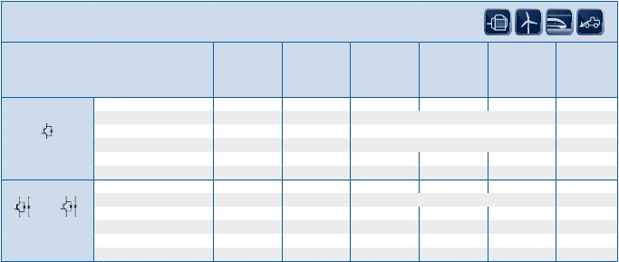

4.8

IHV Modules

1) IHM B / IHV B: Tvj,op = 150°C      …_B5: 6.5kV housing / 10.2kV insulation       u New type

u New type                    n Not recommended for new design

|  |  |  |  |  |  |
| --- | --- | --- | --- | --- | --- |
| Diode Modules | | | | | |
| Type | | VRRM  V | IF  A | Qr                           RthJC  µAs                          K/W  Tvj=125°C                 per arm  typ. | Outline/  page |
| diode modules | IGBT4 Standard (IHM B) 1)  u DD800S17H4_B2  u DD1200S12H4  u DD1200S17H4_B2  Standard  n DD400S17K6C_B2  DD600S17K3_B2  DZ3600S17K3_B2  Standard  DD200S33K2C  DD400S33K2C  DD800S33K2C  DD1200S33K2C  Low Loss  DD1200S33KL2C_B5  Standard in IHV B 1)  u DD500S33HE3  u DD1000S33HE3  Standard in IHV B 1)  u DD800S45HL3  u DD1200S45HL3  Standard in B5 housing  u DD400S45KL3_B5  u DD800S45KL3_B5  u DD1200S45KL3_B5 | 1700  1200  1700  1700  1700  1700  3300  3300  3300  3300  3300  3300  3300  4500  4500  4500  4500  4500 | 800  1200  1200  400  600  3600  200  400  800  1200  1200  500  1000  800  1200  400  800  1200 | 320                      0,051  195                        0,04  460                      0,038  145                      0,016  260                      0,051  1450                      0,014  220                      0,108  440                      0,051  900                      0,025  1300                      0,017  1450                      0,017  450                      0,044  900                    0,0235  data on request  data on request  700                      0,051  data on request  2100                      0,017 | H_IH4B/4.10  H_IH4B/4.10  H_IH4B/4.10  H_IH1/4.10  H_IH4/4.10  H_IH7/4.11  H_IH9/4.11  H_IH4/4.10  H_IH4/4.10  H_IH4/4.10  H_IH11/4.12  H_IH4B/4.10  H_IH4B/ 4.10  H_IH4B/ 4.10  H_IH7B/ 4.11  H_IH11/4.12  H_IH11/4.12  H_IH11/4.12 |
| diode modules | Standard  u DD250S65K3  u DD500S65K3  u DD600S65K3  u DD750S65K3 | 6500  6500  6500  6500 | 250  500  600  750 | 540                      0,056  1050                      0,028  1300                      0,022  1600                    0,0185 | H_IH11/4.12  H_IH11/4.12  H_IH11/4.12  H_IH11/4.12 |



IGBT High Power Modules

IGBT

HighPower

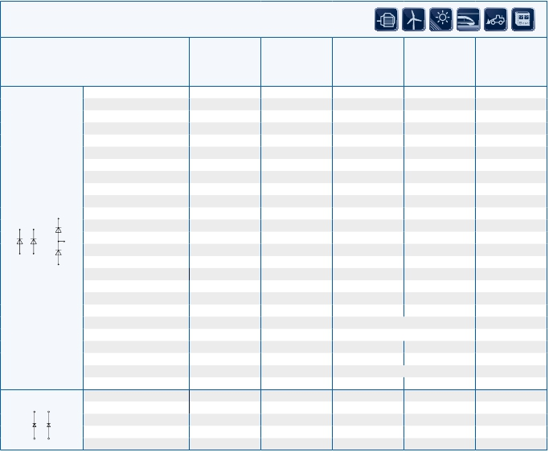

…_B2: AlSiC base-plate

Diode Modules

1) IHM B / IHV B: Tvj,op = 150°C            u New type             n Not recommended for new design

…_B5: 6.5kV housing / 10.2kV insulation

4.9

Outlines

IGBT

HighPower

5

38

5

35

14,511

20

124

140

30

5

38

20

15

124

140

40

40

5,2

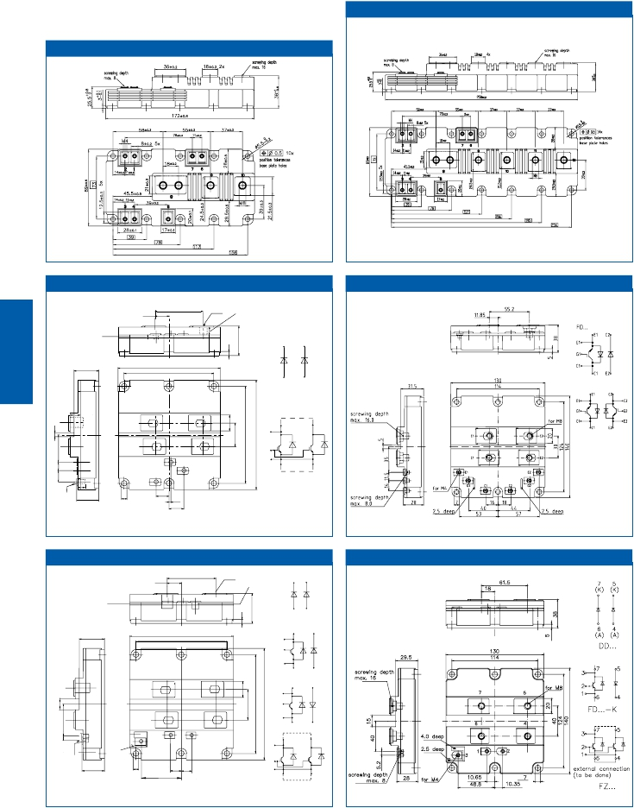

PrimePACK™ 2 H_PP2

PrimePACK™ 3                               H_PP3

IHM H_IH1

18                      screwing depthmax. 16

M8

max. 8                                                  C

(K)    C

61,5

screwing depth

(K)

IHM                                       H_IH2

31, 5

130

114

(A )    E

E

(A )

DD...

C

E

C

E

C

G

external connections

( to be done)

C                        C

C

E

G

E

E

FZ...

E

M4

28       7

16, 5

2, 5

18, 5

IHM/IHV H_IH4

IHM/IHV                                   H_IH4B

18

(K)   C

61,5

M8

screwing depth

max. 8

C

(K)

screwing depth

max. 16

29,5

130

114

C

G

E

E

(A)

(A)

DD...

C      C

E

C C

E      E

FD...

C      C

E E

C

G

E

FD...-K

M4

4,0 deep

2,5 deep

C          G

E

C

G

C         C

28 7 10,65

48,8

10,35

E

E         E

externalconnection

(tobedone)

FZ...

4.10

IHM H_IH5

max8

max16

20

124

160

40

15

80,1

68,6

50,5

39

140

5

38

38

15

40

5,2

40

124

140

20

5

38

16

38

140

124

30

736.5

41,95

17.55

30

30

124

140

30

5

10

5

IGBT

HighPower

5

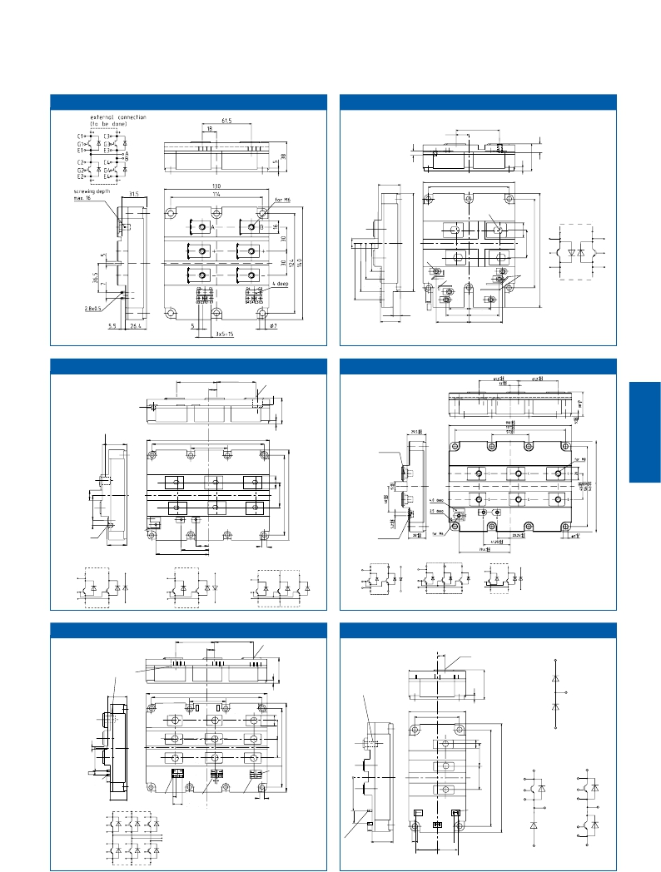

IHV                                       H_IH6

11,85

55,2

29,5

130

114

1

2

3

for M8

external

connections (to

E1 C2

E1

E1

C2

C2

7

for M4 C1

E2

G1

G2

C1

3,5 deep               3,5 deep

E2

G2

C1

C1

E2

E2

4

G1

5

6

28

10

7

E1

25,5

4529,5

C2

29,5

43

47

IHM/IHV H_IH7

IHM/IHV                                   H_IH7B

screwing depth

screwing depth

max. 8

61,5

13

61,5

M8

max. 16

screwing depth

max. 16

29,5

190

1          57

2

3

171

4

srewing depth

max. 16

C

C

C

E

E

E

M4

screwing depth

max. 8

28

4,0 deep

2,5 deep

C        G

E

8         7    6         5

20,25

79,4 41,25

7

srewing depth

max. 8

FD...-K

FZ

FD...

external connection (to be done)

E

E E

C               C    C  C

E   E   E  E

C C

C

FD...

G

E

E E

C

E

external connection (to be done)

C                   C

C

FD...-K

G

E

E                   E

C

E

FZ...

C

G

E

external connections (to be done)

C                 C               C

E                 E               E

C  C  C C

G

E

C                                                        C

G                                                        G

E

external connection (to be done)

IHM H_IH8

IHM/IHV                                    H_IH9

61,5

13

61,5

M8

9,75

for M5

C1 (K1)

screwing depth

max. 16

29,5

190      171

57

screwing depth

max. 16

E1/C2

(A1/K2)

1

U           V         W

2                3

4

73

57

+ + +

- - -

E1/C2

E2 (A2)

DD...

2,8x0,5

+

-

GX EX EU GU    GY EY EV GV   GZ EZ EW GW

5

+

Ew

Cz

external connections (to be done)

7

5,5

Cu

Gu

Eu

Cx

Gx

Ex

26,4

Cv

Gv

Ev

Cy

Gy

Ey

+

-

Cw

Gw

Gz

Ez

-

CX CU      CY CV     CZ CW

3,35

8          7     6                              5

7

3x5=15

U

V

W

4 deep

5,5

2,8x0,5

26,4

C1

E2

C1    C2/E1 G1

G2 E2

5

27,15  27,15

4 deep

C1

G1

C2/E1

C1

E1/C2

(K2)

E2 (A2)

FD...

C1

G1

C2/E1

G2

E2

C1

E2

FF...

E1/C2

4.11

IHV H_IH10

IGBT

HighPower

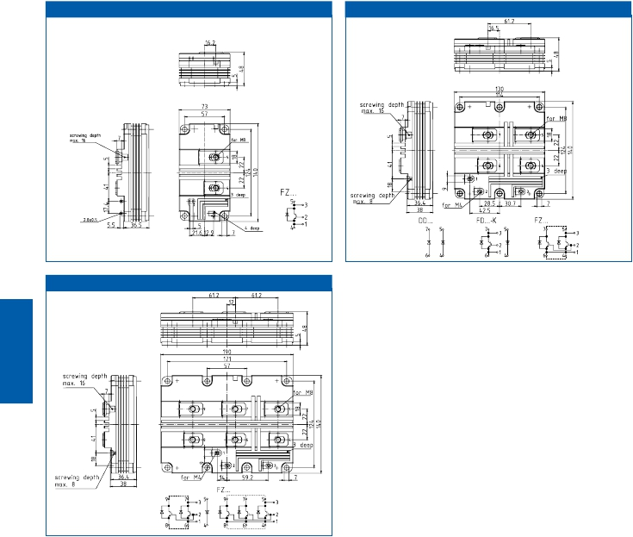

IHV                                      H_IH11

externalconnection

(tobedone)

IHV H_IH12

FD...-K

externalconnection

(tobedone)

4.12

|  |  |  |
| --- | --- | --- |
| IHM Modules | Housing Size (overall) | Packing  Units |
| IHM 73  IHM 130  IHM B 130  IHM190  IHM B 190 | 73,0 mm x 140,0 mm  130,0 mm x 140,0 mm  130,0 mm x 140,0 mm  190,0 mm x 140,0 mm  190,0 mm x 140,0 mm | 4  2  2  1  1 |

|  |  |  |
| --- | --- | --- |
| IHV Modules | Housing Size (overall) | Packing  Units |
| IHV 73  IHV 130  IHV 190  IHV B 130  IHV B 190 | 73,0 mm x 140,0 mm  130,0 mm x 140,0 mm  190,0 mm x 140,0 mm  130,0 mm x 140,0 mm  190,0 mm x 140,0 mm | 4  2  1  2  1 |

|  |  |  |
| --- | --- | --- |
| PrimePACK™ Modules | Housing Size (overall) | Packing  Units |
| PP2  PP3 | 89,0 mm x 172,0 mm  89,0 mm x 250,0 mm | 3/12  2/8 |

Package Units

IGBT

HighPower



4.13

IGBT High Power Modules

|  |  |  |
| --- | --- | --- |
| Application Notes, Product Briefs,  Flyers and Brochures | Type | Redirects |
| IHM, IHV Modules & PrimePACK™  4.5kV modules in IHV portfolio  3rd generation 6.5kV IGBT and diode  modules  IHM / IHV IGBT modules B-series  PrimePACK™ IGBT Modules  Application Notes  for all packages & technologies | Product Brief  Webpage  Webpage  Webpage  Webpage  Application Note  Collection | <http://www.infineon.com/ihm-ihv-primepack-product-brief>  <http://www.infineon.com/ihv>  <http://www.infineon.com/6.5kV-Modules>  <http://www.infineon.com/ihm-b>  <http://www.infineon.com/primepack>  <http://www.infineon.com/igbt-modules-application-notes> |
| Product Briefs  for all packages & technologies | Product Brief  Collection | <http://www.infineon.com/igbt-modules-product-briefs> |

Links

IGBT

HighPower



4.14

Systems

Systems

andDrivers

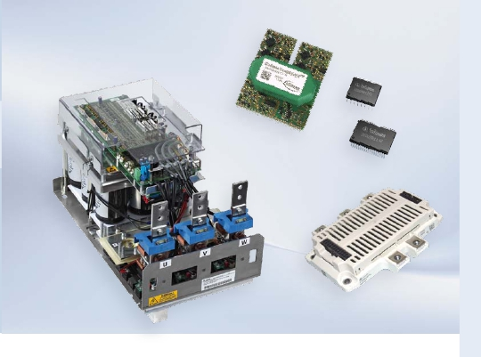

and Drivers

Today,  system  designers  are  challenged  to  reach  the  targets  in  therms  of  en-

ergy  efficiency,  reliability  as  well  as  rapid  time  to  market.  In  addition  to  this,

costs  need  to  be  optimized.  To  meet  these  demands,  industries  need  solutions

tailored  to  their  applications.  Infineon’s  system  expertise,  broad  application

competence  and  decades  of  experience  in  industrial  electronics  enable  us  to

provide  innovative,  reliable  and  energy-saving  power  solutions.

With  MIPAQ™,  Stacks  and  EiceDRIVER™  Infineon  provides  end-to-end  solutions

at  different  levels  of  system  integration  covering  a  power  range  from  1  kW  up  to

8 MW.

MIPAQ™  is  Infineon’s  integrated  IGBT  module  family  and  offers  a  very  high  level

of  functionality.  The  MIPAQ™  (Modules  Integrating  Power,  Application  and  Qual-

ity)  products  are  optimized  solutions  in  mastering  the  challenge  of  designing

powerful  and  compact  inverters  with  enhancements  in  efficiency  and  rugged-

ness.

Stacks  are  based  on  Infineon’s  latest  IGBT  modules  and  IGBT  technologies  com-

bined  with  thermal  management,  capacitors,  drivers,  sensors  and  temperature

monitoring.  The  power  section  and  control  electronics  are  fully  separated  from

each  other  by  “reinforced  isolation”.  Infineon’s  modules  are  developed  for  high

efficiency,  low  inductance  and  simple  paralleling  of  modules.  In  combination

with  specially  designed  high  performance  heat  exchangers,  the  modules  can

easily  reach  maximum  output  power.  All  inverter-  and  various  converter-topolo-

gies  are  available.

The  EiceDRIVER™  family  provides  a  solution  to  control  and  protect  Infineon’s

IGBT  modules  reliably  and  efficiently.  Infineon’s  HV  Gate  Drivers  are  the  best

choice  to  drive  all  IGBT  modules  up  to  1700 V.

5.1

5.2

Systems

andDrivers

LevelofSystemIntegration

OverviewStacksandMIPAQ™

ModSTACKTMHD

600…8MW

Page5.14

ModSTACKTM

700kW…4MW

Page5.12

PrimeSTACKTM

100kW…950kW

Page5.8

MIPAQTMserve

37kW…75kW

Page5.4

MIPAQTMsense

22kW…37kW

Page5.4

MIPAQTMbase

22kW…55kW

Power

Page5.4

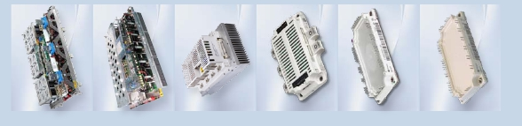

MIPAQ™

Systems

andDrivers

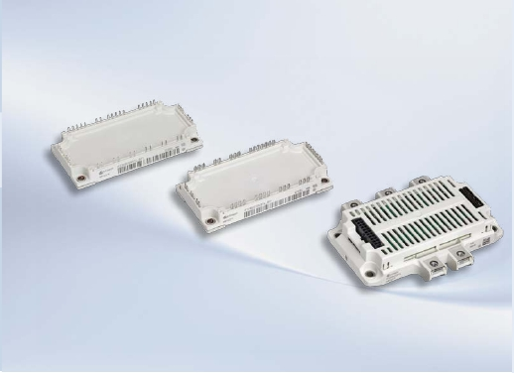

The  MIPAQ™  family  was  developed  in  order  to  offer  Modules  Integrating  Power,

Application  and  Quality.  It  is  a  functional  product  family  within  Infineon‘s  IGBT

modules  portfolio  and  as  such  dedicated  to  useful  integration  of  electronics  into

power  modules.  The  combination  of  an  IGBT  module  and  integrated  sensing  and

driving  electronics  leads  to  an  optimized  solution  in  mastering  the  challenge  of

designing  powerful  and  compact  inverters  for  low  and  medium  power.  It  eases

the  cost  situation  on  the  one  hand  and  contributes  to  energy  saving  on  the  other

hand.  Thus,  it  improves  the  profitability  and  protects  our  environment  at  the

same  time.

The  module  family  starts  with  MIPAQ™  base,  which  provides  an  IGBT  sixpack

plus  current  sense  shunts  inside.  Due  to  the  integration  of  specially  designed

shunts,  the  performance  with  regard  to  system  cost  is  excellent.  MIPAQ™  base

modules  in  sixpack  configuration  with  NTC  are  available  in  the  well-proven

EconoPACK™  3  housing  with  75 A,  100 A  and  even  150 A  nominal  current  and

1200 V  blocking  voltage.  MIPAQ™  base  shunt  modules  save  space  and  help  to

manage  the  temperature  on  the  PCB  with  very  high  measurement  accuracy.

The  next  level  of  integration  is  represented  by  MIPAQ™  sense  and  MIPAQ™

serve.  MIPAQ™  sense  integrates  an  IGBT  sixpack  in  the  range  up  to  100 A  at

1200 V  and  fully  digital  current  measurement  with  galvanically  isolated  output

signals.  The  measurement  principle  uses  the  Sigma  Delta  method.  The  MIPAQ™

serve  consists  of  an  IGBT  sixpack  plus  a  full  set  of  drivers  and  temperature

measurement  on  top  of  the  IGBT  module.  It  is  a  plug  and  play  solution  for  high

current  drive  applications.  Inside  the  module,  there  are  galvanically  isolated

drivers  based  on  Infineon’s  Coreless  Transformer  Technology.  The  temperature

measurement  of  the  base  plate  inside  the  module  offers  an  isolated  signal  as

well.  MIPAQ™  serve  covers  a  range  from  100 A  up  to  200 A  at  1200 V  blocking

voltage  and  features  the  EconoPACK™  4  package.

5.3

MIPAQ™ base

Systems

andDrivers

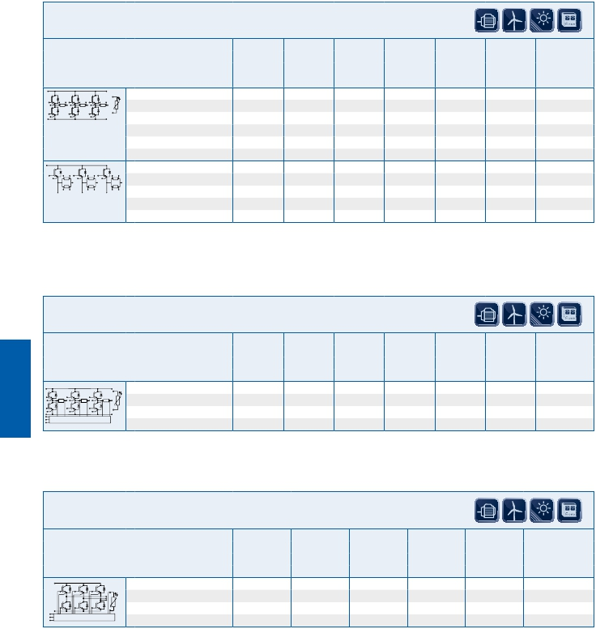

1200 VCES

Type VCES IC VCEsat Ptot RthJC Rshunt Outline/

V A V W K/W mΩ page

Tvj= 25°C max Tvj= 25°C

typ. typ.

IGBT 4

IFS75B12N3T4_B31 1200 75 1,85 385 0,39 2,40 M_E3n/5.5

IFS100B12N3T4_B31 1200 100 1,75 515 0,29 1,50 M_E3n/5.5

IFS150B12N3T4_B31 1200 150 1,75 750 0,20 1,00 M_E3n/5.5

sixpack with

shunts & NTC

IGBT 4

IFT150B12N3E4* 1200 150 1,75 750 0,20 1,20 M_E3h/5.5

tripack high

with shunts

MIPAQ™ sense

1200 VCES

Type VCES IC VCEsat Ptot RthJC Rshunt Outline/

V A V W K/W mΩ page

Tvj= 25°C max Tvj= 25°C

typ. typ.

IGBT 4

IFS75S12N3T4_B11 1200 75 1,85 350 0,43 2,40 M_E3o/5.5

∑/ +CLT

IFS100S12N3T4_B11       1200      100     1,75   455        0,33     1,50 M_E3o/5.5

MIPAQ™ serve

1200 VCES

Type VCES IC VCEsat Eon+Eoff RthJC Outline/

V A V mWs K/W page

Tvj= 25°C Tvj=125°C max

typ. typ.

IGBT 4

IFS100V12PT4 1200 100 1,75 22 0,30 M_EP4v/5.5

Isolated Driver Electronics

IFS150V12PT4             1200       150       1,75        34       0,22 M_EP4v/5.5

IFS200V12PT4             1200       200       1,75        40       0,15 M_EP4v/5.5

...B11 PressFIT modules ...B31 modules with pins for solder connection

* Low side to be found in EconoPACK™ configuration on page 1.14.

5.4

Outlines

Systems

andDrivers

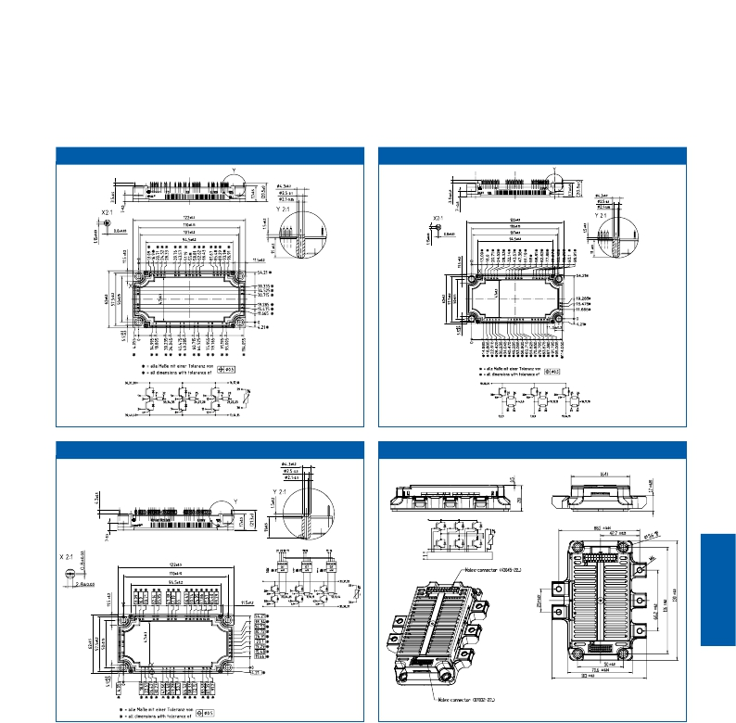

MIPAQ™ base M_E3n

MIPAQ™ base                               M_E3h

Infineon

MIPAQ™ sense M_E3o MIPAQ™ serve M_EP4v

Infineon

IsolatedDriverElectronics

5.5

5.6

Systems

andDrivers

PrimeSTACK™

Systems

andDrivers

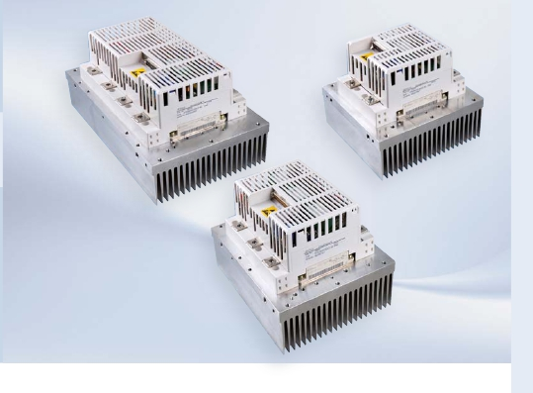

The  PrimeSTACK™  family  is  a  complete  switch  solution  for  power  electronic  cir-

cuits  containing  all  the  necessary  components  for  current,  voltage  and  tempera-

ture  measurements,  and  uses  the  field  proved  62 mm  Infineon  IGBT  modules.

Control  electronics  and  the  power  connections  are  fully  separated  from  each

other  by  “reinforced  isolation”.  With  several  superior  monitor  functions,

PrimeSTACK™  offers  a  self  protecting  switch  function.  PrimeSTACK™  enables

the  developement  of  highly  efficient  and  safe  inverters,  quickly  and  with  the

minimum  effort  for  the  designer.  The  product  scope  covers  chip  current  ratings

from  100 A  up  to  3600 A  at  600 V,  1200 V  or  1700 V.

General  features

n  600 V,  1200 V,  1700 V  IGBT  implemented

n  EiceDRIVER™  inside

n  Based  on  Infineon  standard  IGBT  modules

n  Current  sense  of  every  output  leg

n  Temperature  sense

n  Optional  DC-link  voltage  monitoring

n  Analogue  output  of  all  sensor  signals

n  Reinforced  isolation  according  to  EN50178

5.7

Available configurations

1700VIGBT

1200VIGBT

600VIGBT

Systems

andDrivers

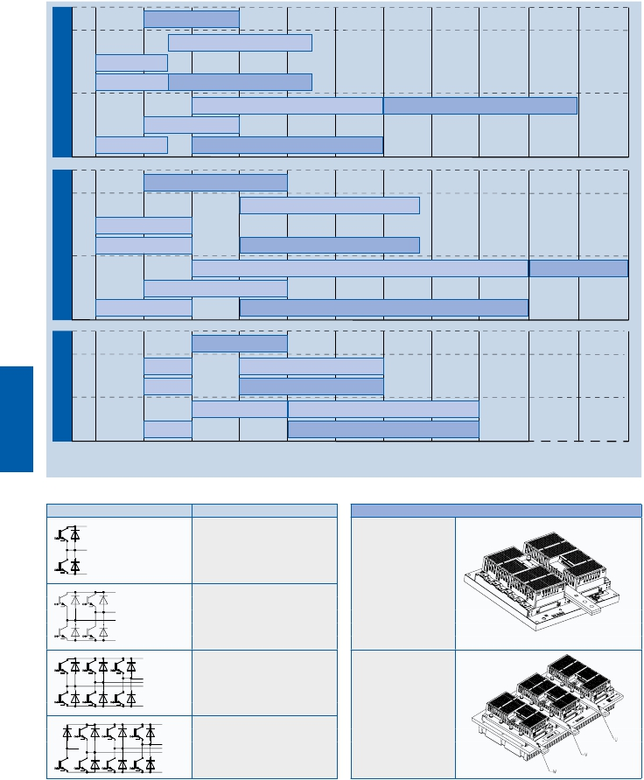

2pack(C2)/6pack(CD)

2pack(C3)

4pack(C3)

6pack(C3) 6pack(CE)

2pack(C4)

2pack(CC)

4pack(C3)

6+  1pack(C4)

6pack(CF)

2pack(C2)/6pack(CD)

4pack(C3)

6pack(C3)

2pack(C3)

6pack(CE)

2pack(C4)

2pack(CC)

4pack(C4)

6  +  1pack(C4)

6pack(CF)

2pack(C2)/6pack(CD)

4pack(C3)

6pack(C3)

2pack(C3)

6pack(CE)

4pack(C4)

2pack(C4)

6+1pack(C4)

6pack(CF)

100 200 400 600 800 1000 1200 1400 1600 1800 2400 3600

Ic[A]

IGBT PrimeSTACK™ Topology Description

½ B2I (2pack)

B2I (4pack)

B6I (6pack)

B6I + ½ B2IHK

(6pack + chopper)

5.8

New PrimeSTACK™ packages

CC: 2 x C4

per heatsink

CD: 3 x C2

CE: 3 x C3

CF: 3 x C4

per heatsink

|  |  |  |  |  |  |  |  |  |
| --- | --- | --- | --- | --- | --- | --- | --- | --- |
| IGBT3  1200  VCES  VAC = 400 VRMS/VDC=650 V | | | | | | | | |
| Pmax4)  [kW] | IRMS2)  [A] | fSWmax  [kHz] | Stack type | Topology | Implemented  IGBT3 Modules | Case  Cooling | Weight  [kg] | Width x depth x height  [mm] |
| 335  422  2x84  79  107  124  140 | 569  717  2x143  134  181  210  237 | 8  6  20  20  20  20  20 | 2PS12012E33G27261 *)  2PS16012E34G26571 *)  4PS01512E33G30487 *)  6PS01512E33G30863 *)  6PS03012E33G27093 *)  6PS04012E33G26572 *)  6PS04012E33G30188 *) | ½B2I(2pack)  ½B2I(2pack)  B2I (4pack)  B6I (6pack)  B6I (6pack)  B6I (6pack)  B6I (6pack) | 3xFF400R12KE3  4xFF400R12KE3  2xFF150R12KE3G  3xFF150R12KE3G  3xFF300R12KE3  3xFF400R12KE3  3xFF400R12KE3 | C3 air  C4 air  C3 air  C3 air  C3 air  C3 air  C3 air 5) | 9.2  11.8  9.1  9.1  9.1  9.2  8.9 | 216x280x167  216x360x167  216x280x167  216x280x167  216x280x167  216x280x167  216x280x165 |

|  |  |  |  |  |  |  |  |  |
| --- | --- | --- | --- | --- | --- | --- | --- | --- |
| IGBT2  Fast  1200  VCES  VAC = 400 VRMS/VDC=650 V | | | | | | | | |
| Pmax4)  [kW] | IRMS2)  [A] | fSWmax  [kHz] | Stack type | Topology | Implemented  IGBT2 Modules | Case  Cooling | Weight  [kg] | Width x depth x height  [mm] |
| 215  2 x 73  2 x 107  100 | 366  2x125  2x 183  168 | 13  20  20  16 | 2PS06012S42G28187 *)  4PS01512S43G34512  4PS03012S43G30699  6PS03012S43G28199 *) | ½B2I(2pack)  B2I (4pack)  B2I (4pack)  B6I (6pack) | 2xFF300R12KS4  2xFF150R12KS4  2xFF300R12KS4  3xFF300R12KS4 | C2 air  C3 air  C3 air  C3 air | 6.3  9.1  9.1  9.1 | 216x200x167  216x280x167  216x280x167  216x280x167 |

|  |  |  |  |  |  |  |  |  |
| --- | --- | --- | --- | --- | --- | --- | --- | --- |
| IGBT3  1700  VCES  VAC = 690 VRMS/VDC=1100 V | | | | | | | | |
| Pmax4)  [kW] | IRMS3)  [A] | fSWmax  [kHz] | Stack type | Topology | Implemented  IGBT3 Modules | Case  Cooling | Weight  [kg] | Width x depth x height  [mm] |
| 330  580  2 x 168  179 | 325  571  2x165  176 | 20  6  20  15 | 2PS06017E32G28213 *)  2PS12017E34G28217 *)  4PS03017E33G30260 *)  6PS03017E33G30907 *) | ½B2I(2pack)  ½B2I(2pack)  B2I (4pack)  B6I (6pack) | 2 x FF300R17KE3  4 x FF300R17KE3  2 x FF300R17KE3  3 x FF300R17KE3 | C2 air  C4 air  C3 air  C3 air 5) | 6.3  11.8  9.1  9.9 | 216 x 200 x 167  216 x 360 x 167  216 x 280 x 167  216 x 280 x 165 |

|  |  |  |  |  |  |  |  |  |
| --- | --- | --- | --- | --- | --- | --- | --- | --- |
| IGBT3  600  VCES  VAC = 230 VRMS/VDC=370 V | | | | | | | | |
| Pmax4)  [kW] | IRMS1)  [A] | fSWmax  [kHz] | Stack type | Topology | Implemented  IGBT3 Modules | Case  Cooling | Weight  [kg] | Width x depth x height  [mm] |
| 2 x 70  95 | 2x208  283 | 20  20 | 4PS02006E33G31632  6PS04006E33G29000 *) | B2I (4pack)  B6I (6pack) | 2 x FF200R06KE3  3 x FF400R06KE3 | C3 air  C3 air | 9.1  9.1 | 216 x 280 x 167  216 x 280 x 167 |



2) typical output current at V DC= 650V, VAC=400V, fSW=5kHz, f0=50Hz, cos(φ)=0.85, TA=40°C, Tvjmax≤125°C

Systems

andDrivers

PrimeSTACK™

1)  typical output current at VDC= 370V, VAC=230V, fSW=5kHz, f0=50Hz, cos(φ)=0.85, TA=40°C, Tvjmax≤125°C

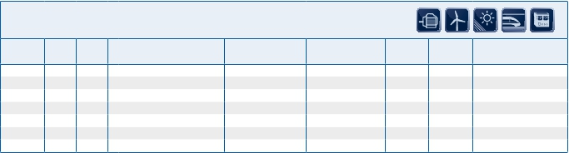

3) typical output current at V DC=1100V, VAC=690V, fSW=2kHz, f0=50Hz, cos(φ)=0.85, TA=40°C, Tvjmax=≤125°C

4) P max for 3-phase systems

5) high efficient heatsink

*) without V-option

5.9

|  |  |  |  |  |  |  |  |  |  |
| --- | --- | --- | --- | --- | --- | --- | --- | --- | --- |
| IGBT4  1200  VCES  VAC = 400 VRMS/VDC=650 V | | | | | | | | | |
| Pmax  [kW] | IRMS1)  [A] | fSW  [kHz] | fSWmax  [kHz] | Stack type | Implemented  IGBT4 Modules | DC link  [mF] | Topology | Case  Cooling | Width x depth x height  [mm] |
| 180  236 2)  254  429  487  453 2)  952 2)  952 | 306  401  432  729  828  770  1616  1616 | 5  5  5  5  5  5  3  3  5 | 20  12  12  6  6  6  3  3  12 | 6PS04012E4DG36022  2PS09012E42G35567*)  6PS09012E4DG35566  6PS18012E4FG35689  6PS18012E4FG34676  2PS18012E44F34383  2PS36012E4CG34996  6PS36012E4CG35121  6PS04512E43W37986 | 6 x FF200R12KE4  2 x FF450R12KE4  6 x FF450R12KE4  12 x FF450R12KE4  12 x FF450R12KE4  4 x FF450R12KE4  8 x FF450R12KE4  24 x FF450R12KE4  3 x FF450R12KE4 | 2.4  0.8  2.4  4.8  4.8  8.48  4.0  12.0  2.4 | 3 x 2pack  2pack  3 x 2pack  3 x 2pack  3 x 2pack  2pack  2pack  3 x 2pack  3 x 2pack | CD air (3xC2)  C2 air  CD air (3xC2)  CF air (3xC4)  CF air (3xC4)  with high efficient  heatsink  C4 air  with high efficient  heatsink and fan  CC air (2xC4)  3 x CC air  C3 air | 645 x 310 x 300  216 x 230 x 288  645 x 310 x 300  645 x 438 x 300  645 x 438 x 300  324 x 651 x 381  371 x 475 x 312  1142 x 475 x 318  216 x 315 x 390 |

|  |  |  |  |  |  |  |  |  |  |
| --- | --- | --- | --- | --- | --- | --- | --- | --- | --- |
| IGBT4  1700  VCES  VAC = 690 VRMS/VDC=1100 V | | | | | | | | | |
| Pmax  [kW] | IRMS3)  [A] | fSW  [kHz] | fSWmax  [kHz] | Stack type | Implemented  IGBT4 Modules | DC link  [mF] | Topology | Case  Cooling | Width x depth x height  [mm] |
| 583 2)  643 2)  600  640 2) | 574  633  591  630 | 2  2  2  2 | 7  7  7  7 | 2PS12017E44G35911 *)  2PS12017E44F36671 *)  6PS12017E4FG35151 *)  2PS12017E44F38055 | 4 x FF300R17KE4  4 x FF300R17KE4  12 x FF300R17KE4  4 x FF300R17KE4 | 1.6  1.6  4.8  1.6 | 2pack  2pack  3 x 2pack  2pack | C4 air  C4 air  with high efficient  heatsink and fan  CF air (3xC4)  C4 air  with high efficient  heatsink and fan | 216 x 360 x 288  270 x 671 x 291  645 x 438 x 300  270 x 671 x 291 |



PrimeSTACK™

Systems

andDrivers



2) P max for 3-phase systems likewise 3 x 2pack types

with DC Link

1) typical output current at V DC= 650V, VAC=400V, fSW=5kHz, f0=50Hz, cos(φ)=0.85, TA=40°C, Tvjmax≤125°C

3) typical output current at V DC=1100V, VAC=690V, fSW=2kHz, f0=50Hz, cos(φ)=0.85, TA=40°C, Tvjmax=≤125°C.

*) without V-option

5.10

ModSTACK™

Systems

andDrivers

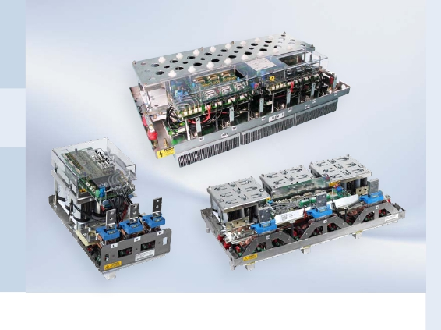

ModSTACK™ HD

The  ModSTACK™  Family  combines  Infineon  Technologies  IGBT  modules  and

IGBT  gate-drivers  to  achieve  current  ratings  from  600  A  up  to  2050  A  at  line

supply  up  to  690 V  AC.  The  appropriate  interfaces  and  thermal  management  are

included.  The  available  topologies  include  three-phase  inverters.

General  features

n  Modular  stack  system  designed  for  industrial  approved  cabinets

n  Low  inductance  DC  link  with  polypropylene  or  electrolytic  capacitors

n  Integrated  IGBT  driver

n  Voltage  signals  for  control  and  monitoring

(currents,  voltages,  short  circuit,  heat  sink  temperature,  failure  signals)

n  Liquid  or  forced  air  cooling  available

n  Electrical  or  optical  interface  for  digital  control  signals  available

n  Up  to  4  units  can  be  operated  in  parallel

5.11

|  |  |  |  |  |  |  |  |  |  |
| --- | --- | --- | --- | --- | --- | --- | --- | --- | --- |
| IGBT3  1700  VCES  VAC = 690 VRMS/ VDC = 1100V | | | | | | | | | |
| Pmax  [kW] | IRMS1)  [A] | fSW  [kHz] | cos(φ) | fSWmax2)  [kHz] | Stack type | Implemented  IGBT3 Modules | Topology | Case  Cooling | Width x depth x  height [mm] |
| 744  784  711  634  710  824  824  852  852  832  832  987  987  852  852  1048  1164  1165  1164  1164 | 629  663  700  536  600  726  726  750  750  800  800  860  860  750  750  974  974  975  1082  1082 | 2.0  2.0  2.0  2.0  2.0  3.0  3.0  2.5  2.5  2.5  2.5  3.5  3.5  2.5  2.5  2.0  1.7  1.7  2.0  2.0 | -0.99  0.99  0.85  0.99  -0.99  0.95  0.95  0.95  0.95  0.87  0.87  0.96  0.96  0.95  0.95  0.90  1.00  1.00  0.90  0.90 | 3.0  6.0  3.0  3.0  3.0  3.0  3.0  3.0  3.0  2.5  2.5  3.5  3.5  3.0  3.0  4.5  5.0  5.0  3.0  3.0 | 6MS24017E33F33878  6MS12017E33F33879  6MS24017E33G32859  6MS12017E33W33373  6MS12017E33W33372  6MS24017E33W31361  6MS24017E33W322744)  6MS24017E33W32605  6MS24017E33W32607*)  6MS24017E33W32859  6MS24017E33W32860  6MS24017E33W32832  6MS24017E33W32780  6MS24017E33W33846  6MS24017E33W33847  6MS16017E33W32630  6MS16017E33W32779  6MS16017E33W32831  6MS24017E33W32629  6MS24017E33W34402 | 6x FF1200R17KE3_B2  6x FF600R17KE3_B2  6x FF1200R17KE3_B2  6x FF1200R17KE3_B2  6x FF1200R17KE3_B2  6x FF1200R17KE3_B2  6x FF1200R17KE3_B2  6x FF1200R17KE3  6x FF1200R17KE3  6x FF1200R17KE3_B2  6x FF1200R17KE3_B2  6x FF1200R17KE3  6x FF1200R17KE3  6x FF1200R17KE3  6x FF1200R17KE3  6x FF800R17KE3_B2  6x FF800R17KE3  6x FF800R17KE3  6x FF1200R17KE3_B2  6x FF1200R17KE3_B2 | B6I  B6I  B6I  B6I  B6I  B6I  B6I  B6I  B6I  B6I  B6I  B6I  B6I  B6I  B6I  B6I  B6I  B6I  B6I  B6I | MS3 air 3)  MS3 air 3)  MS3 air  MS3 liquid  MS3 liquid  MS3 liquid  MS3 liquid  MS3 liquid  MS3 liquid  MS3 liquid  MS3 liquid  MS3 liquid  MS3 liquid  MS3 liquid  MS3 liquid  MS3 liquid  MS3 liquid  MS3 liquid  MS3 liquid  MS3 liquid | 1090 x 596 x 470  1090 x 596 x 470  1090 x 596 x 330  1090 x 496 x 258  1090 x 496 x 258  1090 x 596 x 273  1090 x 596 x 274  1090 x 596 x 251  1090 x 596 x 251  1090 x 596 x 330  1090 x 596 x 330  1090 x 596 x 329  1090 x 596 x 329  1090 x 596 x 272  1090 x 596 x 272  1090 x 596 x 257  1090 x 596 x 329  1090 x 596 x 329  1090 x 596 x 257  1090 x 596 x 257 |

|  |  |  |
| --- | --- | --- |
|  |  | |
|  | ModSTACK™ 3 | |
| Maximum dimensions  Width x Depth x Height [mm] | 1090 x 596 x 470 | |
| Cooling | forced air | liquid |
| Topology | B6I | B6I |
| *)  Max. current     [IRMS] at UDC=800...1100V  (≈450...690VAC) | 700 | 1082 |
| Approximate maximum power *)  With cos(φ) = 0.85 | 840 kVA  710 kW | 1290 kVA  1100 kW |

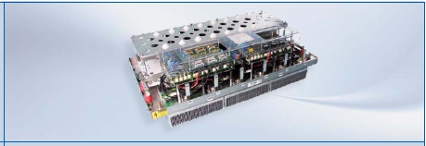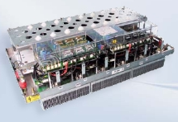

2) Current derating may be required

Systems

andDrivers

ModSTACK™

*) typical output current at VDC=1100V, fsw=2 kHz, VAC=690V, f0=50Hz, cos_phi=0.85, Ta=40°C, Tjmax=Tjop

1) typical output current at V DC=1100V, VAC=690V, 2...3.5kHz (see table), f0=50Hz, cos(φ)=0.85…1 (see table), TA=40°C, Tvjmax≤125°C

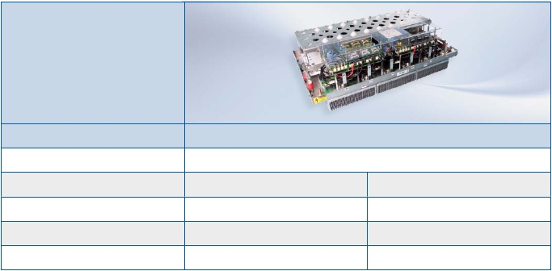

3) with fan included

4) stack contains customize filter resisitors at output

*) without V-option

5.12

|  |  |  |  |  |  |  |  |  |  |
| --- | --- | --- | --- | --- | --- | --- | --- | --- | --- |
| IGBT4  1700  VCES  VAC = 690 VRMS/ VDC = 1100V | | | | | | | | | |
| Pmax  [kW] | IRMS1)  [A] | fSW  [kHz] | cos(φ) | fSWmax2)  [kHz] | Stack type | Implemented  IGBT4 Modules | Topology | Case  Cooling | Width x depth x  height [mm] |
| 893  893 | 880  880 | 2.0  2.0 | 0.85  0.85 | 5.0  5.0 | 6MS16017P43W37047  6MS16017P43W37962 | 6x FF800R17KP4_B2  6x FF800R17KP4_B2 | B6I  B6I | MS3 liquid  MS3 liquid | 1090 x 496 x 273  1090 x 496 x 273 |



2) Current derating may be required

Systems

andDrivers

ModSTACK™

1) typical output current at V DC=1100V, VAC=690V, 2...3.5kHz (see table), f0=50Hz, cos(φ)=0.85…1 (see table), TA=40°C, Tvjmax≤125°C



5.13

|  |  |  |  |
| --- | --- | --- | --- |
|  |  |  | |
|  | ModSTACK™ HD1 | ModSTACK™ HD3 | |
| Maximum dimensions  Width x Depth x Height [mm] | 338 x 590 x 375 | 1090 x 596 x 366 | |
| Cooling | liquid | liquid | |
| Topology | B6I | B6I | B6I + B6I |
| 1)  Max current     [IRMS] | 3 x 680 | 3 x 2050 | Rect.: 3 x 680  Inv.: 3 x 1360 |
| Maximum power 1)  With cos(φ) = 0.85 | 813 kVA  691 kW | 2438 kVA  2072 kW | Rect.: 813 kVA, 691 kW  Inv.: 1626 kVA, 1382 kW |

|  |  |  |  |  |  |  |  |  |
| --- | --- | --- | --- | --- | --- | --- | --- | --- |
| IGBT4  1700  VCES  VAC = 690 VRMS/ VDC = 1100V | | | | | | | | |
| Pmax3)  [kW] | IRMS1)  [A] | fSW  [kHz] | fSWmax2)  [kHz] | Stack type | Implemented  IGBT4 Modules | Topology | Case  Cooling | Width x depth x  height [mm] |
| 609  691  1219  1219  1828  1828  1828  2082  691  1382 | 600  680  1200  1200  1800  1800  1800  2050  680  1360 | 3  3  3  3  3  3  3  3  3  3 | 5  5  4  4  3  4  3  3  8  4 | 6MS10017E41W36460  6MS10017E41W36775  6MS20017E43W37032  4)  6MS20017E43W38170  6MS30017E43W35613  4)  6MS30017E43W38169  6MS30017E43W33015  6MS30017E43W34404  12MS20017E43W35155 | 9 x FF1000R17IE4  3 x FF1000R17IE4  6 x FF1000R17IE4  6 x FF1000R17IE4  9 x FF1000R17IE4  9 x FF1000R17IE4  9 x FF1000R17IE4  9 x FF1000R17IE4  3 x FF1000R17IE4  6 x FF1000R17IE4 | B6I  B6I  B6I  B6I  B6I  B6I  B6I  B6I  B6I +  B6I | MS HD1  liquid (copper)  MS HD1  liquid (aluminium)  MS HD3  liquid (copper)  MS HD3  liquid (copper)  MS HD3  liquid (copper)  MS HD3  liquid (copper)  MS HD3  liquid (aluminium)  MS HD3  liquid (aluminium)  MS HD3  liquid (aluminium) | 338 x 590 x 350  338 x 590 x 375  1090 x 596 x 342  1090 x 596 x 342  1090 x 596 x 342  1090 x 596 x 342  1090 x 596 x 342  1090 x 596 x 366  1090 x 596 x 342 |

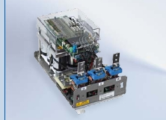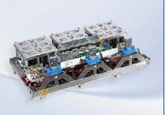

2) Current derating may be required

Systems

andDrivers

ModSTACK™ HD

1)  typical output current at VDC=1100V, VAC=690V, fSW= 3 kHz, f0=50Hz, cos(φ)=0.85, TA=40°C, Tvjmax≤150°C.

1)  typical output current at VDC=1100V, VAC=690V, fSW= 3 kHz, f0=50Hz, cos(φ)=0.85, TA=40°C, Tvjmax≤150°C.

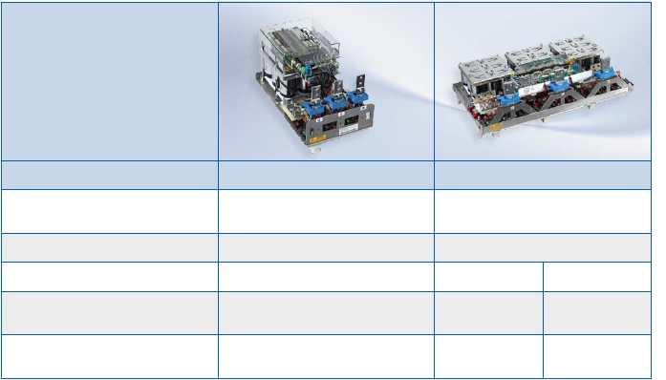

3) P max for 3-phase system likewise B6I types

4) Optical interface included

5.14

Type designation and topologies for IGBT Stacks

Systems

andDrivers

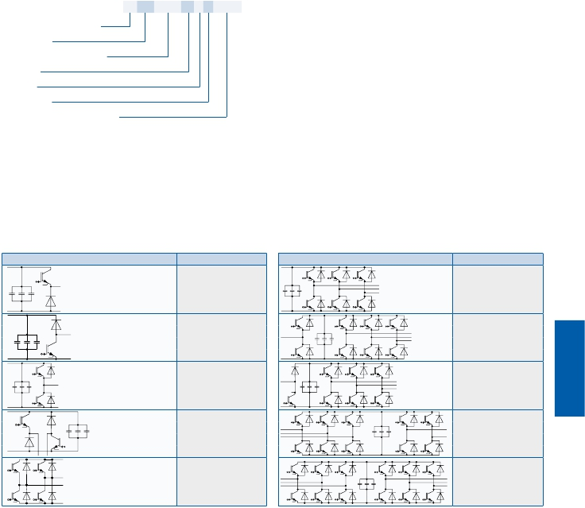

Type Designation for IGBT Stacks Topology, no. of Switches

Chip type

Topology, no. of switches

Stack Family

Semiconductor (main unit)

Chip type

Package

Cooling type

Internal stack identify number

6     MS 30017 E4 3 W 34404

2  1/2 B2I

4  B2I

6  B6I

12     2B6I or B6I+B6I

Stack family

MS ModSTACK

PS     PrimeSTACK

Semiconductor (main unit)

060Rated Chip Current at TCmax

devided by 10

12     VCES maximum Collector-

Voltage devided by 100

E3     KE3

E4     KE4 or IE4

S4     KS4

F6     KF6C

Package

2  MS2 or C2 for PS

3  MS3 or C3 for PS

4  C4 for PS

C  2xC4 for PS

D 3xC2 for PS

E  3xC3 for PS

F  3xC4 for PS

Topology Acronym

1/2B2IHA

1/2B2IHK

1/2B2I

B2IH

B2I

Cooling type

G Air cooled by cabinet fan

F  Air cooled with fan included

W Water cooled

Topology                         Acronym

B6I

1/2B2I+B6I

1/2B2IHK+B6I

B6I+B2I

B6I+B6I

5.15

5.16

Systems

andDrivers

EiceDRIVER™

Systems

andDrivers

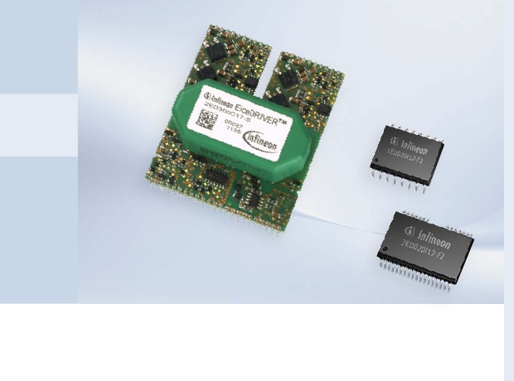

EiceDRIVER™  solutions  from  Infineon  are  the  expert’s  choice.  With  its  HV  Gate

Driver  Boards  and  HV  Gate  Driver  ICs  Infineon  provides  a  broad  spectrum  of  solu-

tions  for  reliable  and  efficient  controls  for  Infineon’s  IGBT  and  MOSFET  products.

The  HV  Gate  Driver  ICs  families  with  Silicon-On-Insulator  (SOI)  or  Coreless  Trans-

former  Technology  (CLT)  meet  the  requirements  for  high  performance  gate  driver

ICs  in  all  power  electronic  applications.  The  combination  of  EiceDRIVER™  ICs

with  Infineon  IGBTs  and  MOSFETs  in  discretes  and  modules  enables  customers

to  design  and  build  highly  reliable  and  efficient  systems.  The  integrated  safety

and  protection  features  like  Desaturation  detection,  Two  Level  Turn  Off  and  Un-

dervoltage  Lockout  enable  customers  to  strengthen  their  design.

HV  Gate  Driver  Boards  are  suitable  for  all  IGBT  modules  up  to  1700 V  and  can  be

operated  with  various  IGBT  module  designs.  With  the  help  of  additional  carrier

hardware,  it  can  be  adapted  to  be  used  on  large  six  packs,  duals  and  Infineon’s

high-power  modules.  Outstanding  protection  measures  and  integrated  fault

management  provide  safe  operation,  even  if  used  within  noise-intense  industrial

environments.

5.17

HV Gate Driver ICs

Systems

andDrivers

EiceDRIVER™ ICs

The  EiceDRIVER™  single  channel  products  1ED020I12-F2  and  1ED020I12-B2

start  with  features  like  desaturation  detection  (DESAT),  active  Miller  Clamp,  un-

dervoltage  lockout  (UVLO)  and  shut  down  in  functional  or  basic  isolation.  Both

devices  1ED020I12-FT  and  1ED020I12-BT  also  support  two-level-turn-off  (TLTO)

for  safe  overcurrent  shut  down.  In  2ED020I12-F2,  two  independent  channels  are

implemented  in  a  compact  package  providing  same  functions  as  1ED020I12-F2.

2ED020I12-FI  and  2ED020I06-FI  are  Infineon’s  cost  efficient  half  bridge  driver

ICs  with  shut  down  and  interlocking  feature.  The  1200V  2ED020I12-FI  also  im-

plements  an  operational  amplifier  (OpAmp)  and  a  comparator  (Comp)  for  current

measurement  or  overvoltage  detection  circuits.

Infineon’s  three  phase  driver  IC  family  now  includes  six  new  variants  for  low

power  drive  applications.  6ED003L06-F2  and  6ED003L02-F2  in  600V  and  200V

provide  basic  functions  like  undervoltage  lockout  for  IGBT  levels,  overcurrent

shut  down  (ITRIP),  interlocking  and  enable  (EN).  6EDL04I06NT  and  6EDL04I06PT

supplement  this  functionality  with  a  high  speed  bootstrap  circuit  for  each  high-

side  driver  stage.  To  complete  the  family,  6EDL04N06PT  and  6EDL04N02PR  are

optimized  for  MOSFET  operation.

Coreless  Transformer  (CLT)  Technology  allows  the  integration  of  a  pulse  trans-

former  into  an  IC,  combining  the  advantages  of  HVIC  technology  with  the  ca-

pability  of  a  magnetic  coupler.  This  results  in  an  extremely  rugged  IC  with  high

insulation  capability.  CLT  allows  faster  switching  speeds  with  no  performance

degradation  compared  to  optocouplers,  therefore  providing  constant  reliability

over  the  projected  lifetime.

Thin-Film  Silicon  On  Insulator  (SOI)  technology  is  an  advanced  technique  for

MOS/CMOS  fabrications.  It  differs  from  the  conventional  bulk  process  by  placing

the  active  transistor  layer  on  the  top  of  an  insulator.  This  leads  to  outstanding

robustness  against  latch-up  when  exposed  to  extreme  temperature  and  voltage

conditions.

Infineon’s  EiceDRIVER™  high  voltage  Driver  IC  family  covers  a  wide  power  range

and  enables  customers  to  build  reliable  and  efficient  drive  applications.

5.18

HV Gate Driver ICs

Systems

andDrivers

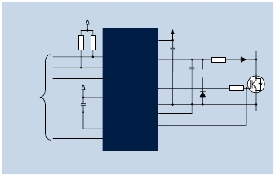

EiceDRIVER™ ICs

1ED020I12-B2

*ED-*

*ED-*

Enhanced

EiceDRIVER™ E

1ED020I12-BT

Enhanced

EiceDRIVER™ E

Single  Channel  isolated  gate  driver

Single  channel  isolated  gate  driver

n

n

n

Basic  isolation  according  to

EN60747-5-2,  recognized  under  UL1577

Fully  functional  at  transient  +/-  1420 V  and

static  voltages  of  +/-  1200 V

High  voltage  side  status  feedback

n

n

n

n

Same  functions  and  features  as  1ED020I12-F2

Basic  isolation  according  to  EN60747-5-2,

recognized  under  UL1577

Adjustable  two  level  turn-off  function

Desaturation  detection  with  500 µA

n

*ED-*

n

2A  sink  and  source  rail-to-rail  output

Max.  TJ  =  150 °C

1ED020I12-FT

Enhanced

EiceDRIVER™ E

n

Package  SO16  300 mil

Single  channel  isolated  gate  driver

n

Protection  functions:

–  Enhanced  desaturation  detection

n

n

Same  functions  and  features  as  1ED020I12-BT

Functional  isolation  of  1200 V

–  Active  Miller  clamp

*ED-*

–  Under  voltage  lockout

2ED020I12-F2

Enhanced

EiceDRIVER™ E

–  Shut  down

Dual  channel  isolated  gate  driver

–  Watchdog  timer

*ED-*

1ED020I12-F2

Enhanced

EiceDRIVER™ E

n

n

Same  functions  and  features  as  two  times

1ED020I12-F2

Package  SO36  300mil

Single  Channel  isolated  gate  driver

n

n

Same  functions  and  features  as  1ED020I12-B2

Functional  Isolation  of  1200 V

Typical  application  1ED020I12-F2

+5V

+15V

VCC2

RDY

/FLT

RST

DESAT

CVCC2

CDESAT

RDESAT

DDESAT

To control

logic

+5V

CVCC2

VCC

GATE

GND2

DProt

RG

GND

IN-

IN+

VEE2

CLAMP

1ED020I12-F2

5.19

|  |  |  |  |  |  |  |  |
| --- | --- | --- | --- | --- | --- | --- | --- |
| HV  Gate  Driver  ICs  Product  Type | | | | | | | |
| Products | | Packages | Topology | Io+/- | Turn On Propagation  Delay (max) | Tj (max) | Safety  Isolation Typ* |
| 1200 V | 1ED020I12-F2  1ED020I12-B2  1ED020I12-FT  1ED020I12-BT  2ED020I12-F2  2ED020I12-FI | PG-DSO-16  PG-DSO-16  PG-DSO-16  PG-DSO-16  PG-DSO-36  PG-DSO-18 | Single  Single  Single  Single  Dual  Half Bridge | 2.0 - 2.0 A  2.0 - 2.0 A  2.0 - 2.0 A  2.0 - 2.0 A  2.0 - 2.0 A  1.0 - 2.0 A | 195.0 ns  195.0 ns  2,000.0 ns  2,000.0 ns  195.0 ns  105.0 ns | 150.0 degC  150.0 degC  150.0 degC  150.0 degC  150.0 degC  150.0 degC | -  Basic  -  Basic  -  - |
| 650 V | 2ED020I06-FI | PG-DSO-18 | Half Bridge | 1.0 - 2.0 A | 105.0 ns | 150.0 degC | - |
| 600 V | 2EDL05I06PF  2EDL05I06BF  2EDL05N06PF  2EDL05I06PJ  2EDL23I06PJ  2EDL23N06PJ  6ED003L06-F2  6EDL04I06NT  6EDL04I06PT  6EDL04N06PT | PG-DSO-8  PG-DSO-8  PG-DSO-8  PG-DSO-14  PG-DSO-14  PG-DSO-14  PG-DSO-28  PG-DSO-28  PG-DSO-28  PG-DSO-28 | Half Bridge  Half Bridge  Half Bridge  Half Bridge  Half Bridge  Half Bridge  3-Phase  3-Phase  3-Phase  3-Phase | 0.25 - 0.5 A  0.25 - 0.5 A  0.25 - 0.5 A  0.25 - 0.5 A  1.5 - 2.3 A  1.5 - 2.3 A  180 - 380 mA  180 - 380 mA  180 - 380 mA  180 - 380 mA | 600.0 ns  600.0 ns  450.0 ns  600.0 ns  600.0 ns  450.0 ns  800.0 ns  800.0 ns  800.0 ns  800.0 ns | 125.0 degC  125.0 degC  125.0 degC  125.0 degC  125.0 degC  125.0 degC  125.0 degC  125.0 degC  125.0 degC  125.0 degC | -  -  -  -  -  -  -  -  -  - |
| 200 V | 6ED003L02-F2  6EDL04N02PR | PG-TSSOP-28  PG-TSSOP-28 | 3-Phase  3-Phase | 180 - 380 mA  180 - 380 mA | 800.0 ns  800.0 ns | 125.0 degC  125.0 degC | -  - |

HV Gate Driver ICs

Systems

andDrivers



EiceDRIVER™ ICs

2ED020I12-FI

1200 V  Isolated  high  side  half  bridge  gate  driver

2ED020I06-FI

650 V  isolated  high  side  half  bridge  gate  driver

n

n

n

n

n

n

n

n

Galvanic  isolation  of  high  side  driver

2A  sink  current,  1  A  source  current

Fully  functional  at  transient  and  static  voltages  of  +/-

1200V

Integrated  operational  amplifier  and  comparator

Matched  delay  times  of  high  side  and  low  side

Max.  Tj  =  150 °C

Package  SO18  300 mil

Protection  function:

–  Hardware  input  interlocking

n

n

n

n

n

n

n

Galvanic  isolation  of  high  side  driver

2A  sink  current,  1  A  source  current

Fully  functional  at  transient  and  static  voltages

of  +/-650V

Matched  delay  times  of  high  side  and  low  side

Max.  Tj  =  150 °C

Package  SO18  300 mil

Protection  function:

–  Hardware  input  interlocking

–  Under  voltage  lockout

–  Under  voltage  lockout

–  Shut  down  function

5.20

* Certified according to DIN EN 60747-5-2

|  |  |  |  |  |  |  |  |
| --- | --- | --- | --- | --- | --- | --- | --- |
|  | | | | | | | |
|  | UVLO_ON_max | Fault  Reporting | Shutdown /  Enable | Input Logic Type | Interlock | Two Level Turn Off | Package Outline/Page |
|  | 12.6 V  12.6 V  12.6 V  12.6 V  12.6 V  13.5 V | DESAT  DESAT  DESAT  DESAT  DESAT  OCP | /RST  /RST  /RST  /RST  /RST  /SD | pos/neg  pos/neg  pos/neg  pos/neg  pos/neg  pos | -  -  -  -  no  yes | no  no  yes  yes  no  no | PG-DSO-16-15/5.23  PG-DSO-16-15/5.23  PG-DSO-16-15/5.23  PG-DSO-16-15/5.23  PG-DSO-36-58/5.23  PG-DSO-18-2/5.23 |
|  | 13.5 V | - | /SD | pos | yes | no | PG-DSO-18-2/5.23 |
|  | 12.4 V  12.4 V  12.4 V  12.4 V  12.4 V  12.4 V  12.5 V  12.5 V  12.5 V  9.8 V | -  -  -  -  OCP  OCP  ITRIP  ITRIP  ITRIP  ITRIP | EN  EN  EN  EN  EN  EN  EN  EN  EN  EN | pos  pos  pos  pos  pos  pos  neg  neg  pos  pos | yes  -  yes  yes  yes  yes  yes  yes  yes  yes | no  no  no  no  no  no  no  no  no  no | PG-DSO-8/5.24  PG-DSO-8/5.24  PG-DSO-8/5.24  PG-DSO-14/5.24  PG-DSO-14/5.24  PG-DSO-14/5.24  PG-DSO-28-17/5.24  PG-DSO-28-17/5.24  PG-DSO-28-17/5.24  PG-DSO-28-17/5.24 |
|  | 12.5 V  9.8 V | ITRIP  ITRIP | EN  EN | neg  pos | yes  yes | no  no | PG-TSSOP-28-1/5.24  PG-TSSOP-28-1/5.24 |

2EDL  Compact  Family

Systems

andDrivers

*ED-*



Compact

EiceDRIVER™ C

n

n

Ultra  fast  integrated  bootstrap  diode

SO8  and  SO14  package

Typical  application  2EDL05x06yy

n

n

Enable  function  (2EDL23x  only)

Fault  indication  (2EDL23x  only)

DC-Bus

n

Protection  function:

–  Asymmetric  undervoltage  lockout

–  Active  shut  down

–  Undervoltage  lockout  levels  for  MOSFET  and  IGBT

–  Over  current  protection  (2EDL23x  only)

+5V

µC

PWM_H

PWM_L

GND

VCC            VCC                                VB

HO

VS

2EDL05x08yy

HIN

LIN                                  LO

GND

To

Load

To Opamp/

Comparator

–  Interlock  optional

–  Fixed  HW  dead  time  optional

DC-Bus

5.21

HV Gate Driver ICs

Systems

andDrivers

*ED-*

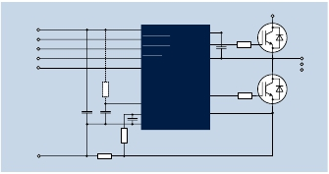

EiceDRIVER™ ICs

6ED  family  –  2nd  generation

200 V  and  600 V  3-phase  gate  driver

Compact

EiceDRIVER™ C

n

n

n

n

n

n

n

Ultra  fast  integrated  bootstrap  diode

Fully  functional  at  neg.  transient  voltages

down  to  -50 V  (500 ns)

Programmable  restart  after  over  current  protection

Shut  down  of  all  outputs  in  case  of  UVLO,  OCP

Package  SO28  300 mil  (600V)  and

package  TSSOP28  (200 V)

Protection  functions:

–  Over  current  protection  (OCP)

–  Hard  ware  input  interlocking

–  Under  voltage  lockout  (UVLO)

–  Fixed  hard  ware  dead  time  of  high  side  and  low  side

–  Enable  function

–  Pin  compatible  variants  of  first  generation  available

Typical  application  6EDL04I06NT

DC-Bus

VCC

HIN1,2,3

LIN1,2,3

FAULT

EN

VCC

HIN1,2,3

LIN1,2,3

FAULT

EN

VB1,2,3

HO1,2,3

VS1,2,3

To Load

VSS

RSh

RRCIN

CRCIN

RCIN

ITRIP

VSS

LO1,2,3

COM

6EDL04I06NT

5.22

Package Outlines

0.22+0.07

-0.1

STANDOFF

±0.052.34

2.64MAX.

0.25+0.07-0

.02

8°MAX.

0.2-0.1

STANDOFF

2.45-0.2

2.65MAX.

1.1

0.23+0.09

Systems

andDrivers

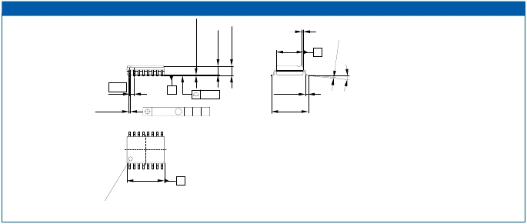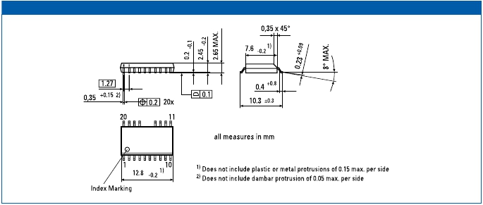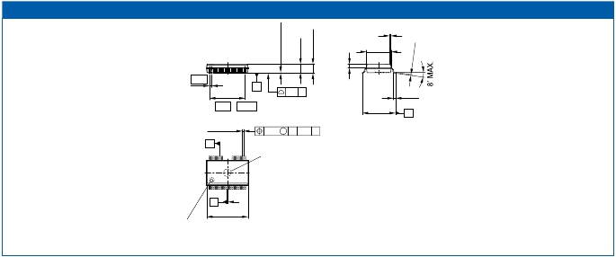

PG-DSO-16-15

0.33 x 45°

7.52 +0.07

-0.1

1)

B

1.27

0.41+0.07

-0.06

C

16x

0.254

M

0.08

A B C

0.7±0.075

10.31-0.15

+0.1

16 9

1 8

10.34 ±0.131)

Index Marking

A

1) Does not include plastic or metal protrusion of 0.15 max. per side

PG-DSO-16-4, -15-PO V06

PG-DSO-18-2

PG-DSO-18-2 (300 mil)

PG-DSO-36-58

0.35 x 45˚

7.6-0.21)

0.65

C

17 x 0.65 = 11.05

0.33±0.08 2)

0.1 C 32x

SEATING PLANE

0.17 M C A-B D 32x

10.3±0.3

0.7±0.2

D

A

36

30

25

19

Ejector Mark

Depth 0.2 MAX.

1 18

B

12.8-0.2

1)

Index Marking

1) Does not include plastic or metal protrusion of 0.15 max. per side

2) Does not include dambar protrusion of 0.05 max. per side

PG-DSO-36-58 V01

5.23

|  |  |  |  |  |  |  |  |  |  |  |
| --- | --- | --- | --- | --- | --- | --- | --- | --- | --- | --- |
|  |  |  |  |  |  |  | |  |  |  |
|  | | | | | | | | | | |
|  |  |  |  |  |  |  |  |  |  |  |
| 1                       14  18.1-0.41) | | | | | | | | | | |

Package Outlines

2.65MAX.

-0.22.45

-0.10.2

09+9

0.0

.1

8°MAX.

1.2MAX.

0.1±0.05

+0.051

-0.2

0.125+0.075

-0.035

Systems

andDrivers

...8°0°

1.75MAX.

±0.070.175

(1.45)

+0.060.19

1.75MAX.

0.1MIN.

(1.5)

8MAX.

MAX.8°

0.2+0.05

-01

.0

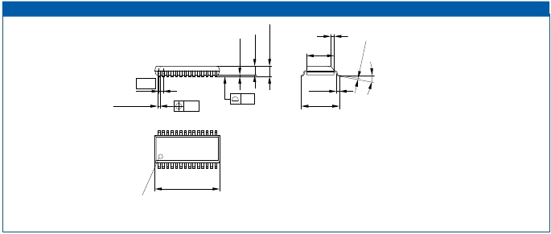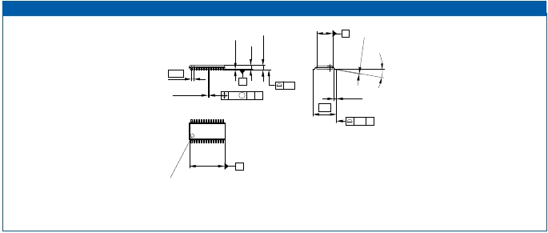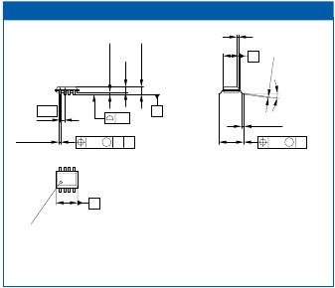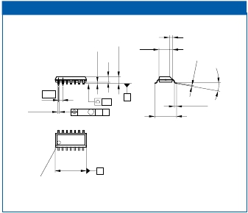

PG-DSO-28-17

1.27

7.6 -0.2

0.35 +0.15 2)

0.2 28x    0.1

0.35 x 45°

1)

0.4+0.8

10.3±0.3

1) Does not include plastic or metal protrusion of 0.15 max. per side

28            15

Index Marking

2) Does not include dambar protrusion of 0.05 max. per side

PG-DSO-28-1, -6, -7, -9, -11, -13, -14, -16, -17, -18, -19, -21, -22, -23, -24, -26, -27, -29, -30, -31, -32, -33, -34, -35, -36, -38, -41, -42, -43, -44, -45, -73 -PO V13

PG-TSSOP-28-1

4.4±0.11)

B

0.65

0.22 +0.08 2)

-0.03

C       0.1

0.1 M A C 28x

0.6 +0.15

-0.1

28

1

15

14

6.4

0.2 B 28x

9.7±0.11)

Index Marking

A

1)

2)

Does not include plastic or metal protrusion of 0.15 max. per side

Does not include dambar protrusion

GPS05867

DSO-8                                            DSO-14

0.35 x 45°

4-0.21)

C

0.33 ±0.08 x 45°

4 -0.21)

1.27

0.1

0.41-0.062)

+0.1

0.1

0.2 M A B 8x

B

6±0.2

0.64±0.25

0.2

M C 8x

1.27

0.41-0.06

+0.1

0.2

M

C

A C 14x         6 ±0.2

0.64 ±0.25

8  5

1 4

5-0.21)

Index Marking

A

14

8

1          7

8.75 -0.2 1)

A

1) Does not include plastic or metal protrusion of 0.15 max. per side

Does not include plastic or metal protrusion of 0.15 max. per side

2) Lead width can be 0.61 max. in dambar area

GPS01181

5.24

Index Marking

1)

|  |  |  |  |  |  |  |  |  |  |  |  |  |
| --- | --- | --- | --- | --- | --- | --- | --- | --- | --- | --- | --- | --- |
|  | | | | | | | | | | | | |
|  | Type | Channels | Control  Interface | IGBT max  VCE  V | VISO  kV | IGM  A | POUT  W | TOP  °C | size  mm x mm | mounting  by | for  modules | Outline/  page |
|  | 2ED300C17-S | 2 | 15V  CMOS  logic | 1700 | 5 | ±30 | 8 | -25/85 | 60,5 x 72 | solde-  ring | EconoPACK™ +,  62 mm, IHM,  EconoDUAL™,  PrimePACK™ | 5.26 |
| 2ED300C17-ST | 2 | 15V  CMOS  logic | 1700 | 5 | ±30 | 8 | -40/85 | 60,5 x 72 | solde-  ring | EconoPACK™ +,  62 mm, IHM,  EconoDUAL™,  PrimePACK™ | 5.26 |

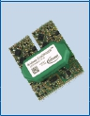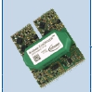

HV Gate Driver Boards

Systems

andDrivers

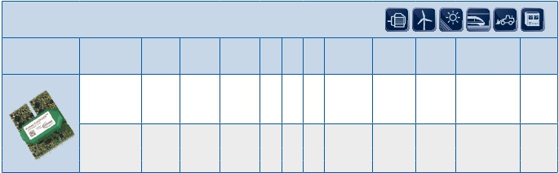

Technical  features  2ED300C17-S  /  2ED300C17-ST

EiceDriver™ Boards

Datasheets available under www.infineon.com/eicedriver-boards

*ED-*

n  Half-bridge  or  direct  mode  can  be  chosen

Symmetric  ±15  V  output  gate  drive  voltage

n

15V  CMOS  level  signal  processing

n

Low-resistance  and  therefore  noise  immune

n

15V  PWM  signal  input

Minimum  pulse  suppression  400ns

n

Interlocking  and  dead  time  generation  in

n

half-bridge  mode  included

Dynamic  over-current  detection  by  monitoring

n

the  saturation  voltage

Soft  shutdown  in  case  of  failure  shutdown

n

Failure  output

n

Reset  input  and  PWM  reset

n

External  detected  failure  analysis

n

Additional  ±16V  supply  outputs

n

2ED300C17-S:  temperature  range  -25°C/85°C

n

2ED300C17-ST:  temperature  range  -40°C/85°C

n

Safe

EiceDRIVER™ S

5.25

EiceDRIVER™ 2ED300C17-S/2ED300C17-ST

Systems

andDrivers

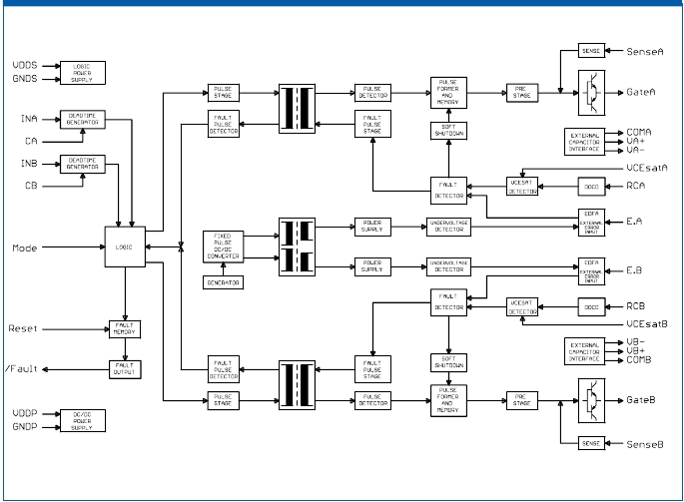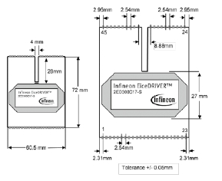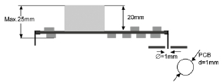

Clearance distance and creep page Primary/Secondary >15 mm

Clearance distance Secondary/Secondary > 4,59 mm

Creep page Secondary/Secondary > 14 mm

5.26

Evaluation

Systems

andDrivers

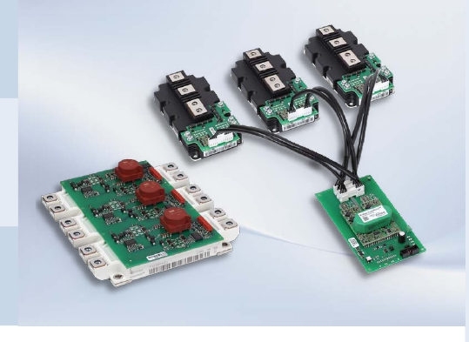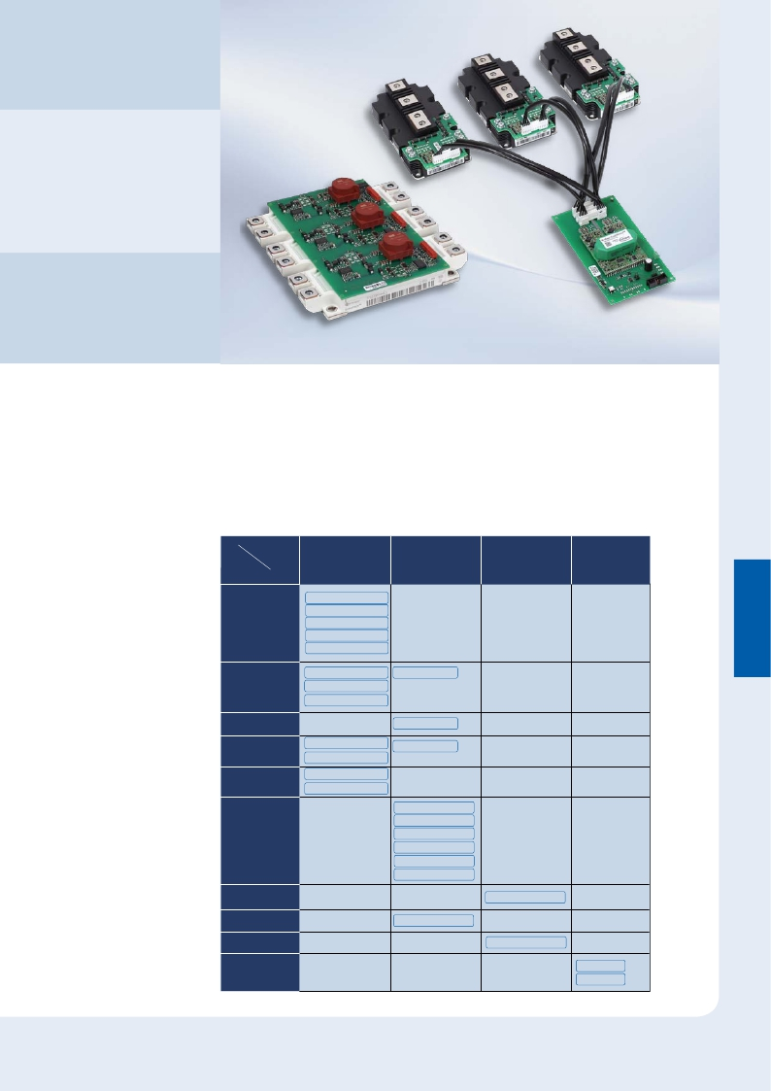

and Adapter

Boards

Infineon‘s  evaluation  boards  have  been  designed  in  several  configurations  to

drive  IGBT  modules.  These  boards  are  using  specially  designed  transformers  for

driving  power  modules  as  well  as  coreless  driver  ICs  like  the  1ED020 I 12-F  from

Infineon.

Module  selection  chart  for  Evaluation  Boards  and  driver  circuitry

Driver

ED C -S      ED (CLT chip)

Families

Product

Families

IHM

PrimePACK™

EconoPACK™+

EconoDUAL™

mm Modules

EconoPACK™

-level

SmartPIM

EasyPACK B

-level

EasyPIM™ B

MIPAQ™

EiceDRIVER™

ED      E     -SFO

MA      E

MA      E

MA      E

ED      E     -SFO   ED  E -F

MA      E

MA      E

ED  E -F

MA  E

ED  E -F

MA  E

MA  E

MA  E

F L      E     -F-P

MA L      E

F L        E     -F-P

MA L      E

F L        E     -F-P

MA L      E

F L  E -F-W

ED (CLT chip)

ED  E _FI_U

ED  E -FI-W

Other

MA AE

MA      E

5.27

|  |  |  |  |
| --- | --- | --- | --- |
|  | | | |
|  | Name of Evaluation Board | Supported Products | Description |
|  | 7ED020E12-FI-W2 | EasyPIM™ 2B  2ED020I12-FI | n Evaluation Driver Board for EasyPIM™  n Designed for Easy PressFIT  n Designed with 2ED020I12-FI |
|  | F3L030E07-F-W2 | EasyPACK 2B 3-level | n Evaluation Board for EasyPACK 2B 3-level  NPC1-Topology  n Designed with 1ED020I12-F |
|  | 7ED020E12_FI_U1 | SmartPIM 1 | n Evaluation Board for SmartPIM 1  n Designed with 2ED020I12-FI |
|  | MA3AE12 | MIPAQ™ base | n Isolating amplifier for current measurement  with MIPAQ™ base |
|  | MA040E12 | MIPAQ™ serve | n Isolated gate driver power supply and logic  interface for MIPAQ™ serve |
|  | F3L020E07-F-P | EconoPACK™ 4 3-Level | n Evaluation Driver Board for EconoPACK™ 4  3-Level modules in NPC1-Topology (650V)  n Designed with 1ED020I12-F |
|  | F3L2020E07-F-P | EconoPACK™ 4 3-Level | n Evaluation Driver Board for EconoPACK™ 4  3-Level modules in NPC2-Topology (650V)  n Designed with 1ED020I12-F |
|  | F3L2020E12-F-P | EconoPACK™ 4 3-Level | n Evaluation Driver Board for EconoPACK™ 4  3-Level modules in NPC-2-topology (1200V)  n Designed with 1ED020I12-F |
|  | 2ED100E12-F2 | EconoDUAL™ 3  EiceDRIVER™  1ED020I12-F | n Evaluation Driver Board for EconoDUAL™ 3 modules  n Designed with 1ED020I12-F  n Suitable for 600V & 1200V |
|  | 6ED100E12-F2 | EconoPACK™ +  EiceDRIVER™  1ED020I12-F | n Evaluation Driver Boards for EconoPACK™+ modules  n Designed with 1ED020I12-F  n Suitable for 600V & 1200V |
|  | 2ED250E12-F | PrimePACK™ 1200V  EiceDRIVER™ | n Evaluation Driver Board for  1200V PrimePACK™ modules |
|  | MA300E12 | PrimePACK™  Adapter Board | n PrimePACK™ - Adapter Board  for 1200V modules |
|  | MA300E17 | PrimePACK™  Adapter Board | n PrimePACK™ - Adapter Board  for 1700V modules |

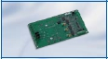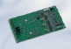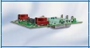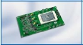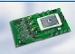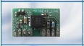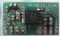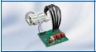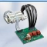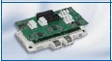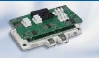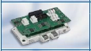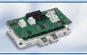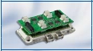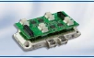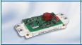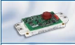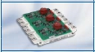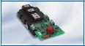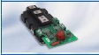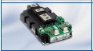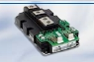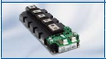

5.28

Systems

andDrivers

Evaluation Boards

Power portion not included.

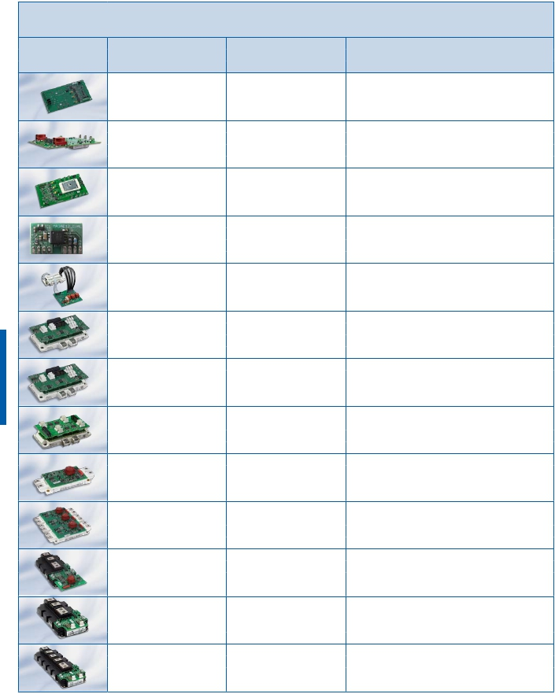

|  |  |  |  |
| --- | --- | --- | --- |
|  | | | |
|  | Name of Evaluation Board | Supported Products | Description |
|  | MA3L080E07 | EconoPACK™ 4 3-Level | n EconoPACK™ 4 3-Level Adapter Board for 650V  modules in NPC1-Topology |
|  | MA3L120E07 | EconoPACK™ 4 3-Level | n EconoPACK™ 4 3-Level Adapter Board for 650V  modules in NPC2-Topology |
|  | MA3L120E12 | EconoPACK™ 4 3-Level | n EconoPACK™ 4 3-Level Adapter Board for 1200V  modules in NPC2-topology |
|  | MA070E12 | 62mm Modules | n Adapter Board for 62mm Modules (1200V) |
|  | MA070E17 | 62mm Modules | n Adapter Board for 62mm Modules (1700V) |
|  | MA200E12 | EconoDUAL™ 3 | n EconoDUAL™ 3 Adapter Board for 1200V modules |
|  | MA200E17 | EconoDUAL™ 3 | n EconoDUAL™ 3 Adapter Board for 1700V modules |
|  | MA400E12 | IHM 130 mm x 140 mm | n IH4 Adapter Board for 1200V modules |
|  | MA400E17 | IHM 130 mm x 140 mm | n IH4 Adapter Board for 1700V modules |
|  | MA401E12 | IHM 140 mm x 190 mm | n IH7 Adapter Board for 1200V modules |
|  | MA401E17 | IHM 140 mm x 190 mm | n IH7 Adapter Board for 1700V modules |
|  | 2ED300E17-SFO | EiceDRIVER™  2ED300C17-S / -ST | n Evaluation Board for EiceDRIVER™  2ED300C17-S / -ST |

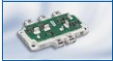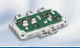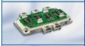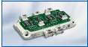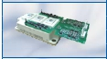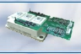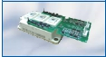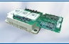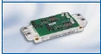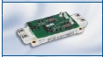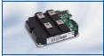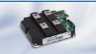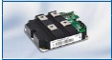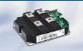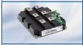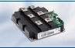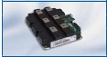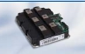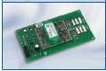

5.29

Systems

andDrivers

Evaluation Boards

Power portion not included.

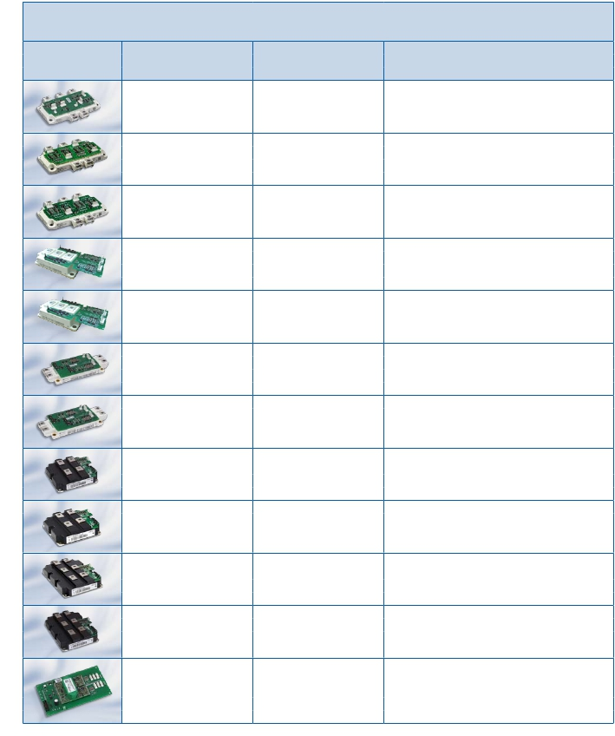

|  |  |  |
| --- | --- | --- |
| Application Notes, Product Briefs,  Flyers and Brochures | Type | Redirects |
| MIPAQ™ serve  MIPAQ™ base  MIPAQ™ sense  Technical Description 1ED Family  Technical Description 6ED Family  MIPAQ™ – More Than You Expect!  ModSTACK™ HD  Evaluation Boards  STACKs - We are the experts for power  solutions  EiceDRIVER™ Overview  EiceDRIVER™ Boards  Evaluation & Driver Boards - Productpage  MIPAQ™  Products Driver IC  STACKs - Productpage | Application Note  Application Note  Application Note  Application Note  Application Note  Brochure  Product Brief  Product Information  Product Information  Webpage  Webpage  Webpage  Webpage  Webpage  Webpage | <http://www.infineon.com/mipaq-serve-appnote>  <http://www.infineon.com/mipaq-base-appnote>  <http://www.infineon.com/mipaq-sense-appnote>  <http://www.infineon.com/tech-descript-1ED-family>  <http://www.infineon.com/tech-descript-6ED-family>  <http://www.infineon.com/mipaq-brochure>  <http://www.infineon.com/modstack-hd-product-brief>  <http://www.infineon.com/evaluation-boards-product-information>  <http://www.infineon.com/stacks-product-information>  <http://www.infineon.com/eicedriver>  [www.infineon.com/eicedriver-boards](http://www.infineon.com/eicedriver-boards)  <http://www.infineon.com/evaluation-boards>  <http://www.infineon.com/mipaq>  <http://www.infineon.com/gatedriver>  <http://www.infineon.com/stacks> |

Links

Systems

andDrivers



5.30

Bridge Rectifier

SCR

DiodeModules

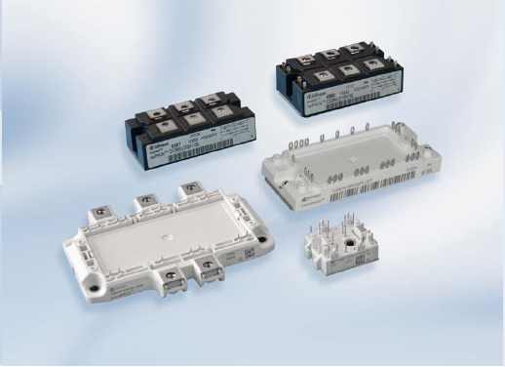

& AC-Switches

We  offer  bridge  rectifier  modules  in  solder  pin  design  like  EasyBRIDGE  or

eupec™  EconoBRIDGE ™  modules.  The  available  configurations  are  fully-  and

half  controlled  rectifiers  with  brake  IGBT  and  optional  NTC  resistor.  They  cover

the  current  range  from  25  A  up  to  180  A  at  800 V,  1600 V  and  1800 V.

The  IsoPACK™  family  with  screwable  load  terminals  are  fully-  ,  half-  and  uncon-

trolled  rectifier  modules.  The  three  phase  AC  Switches  complete  the  IsoPACK™

product  family.  The  current  range  covers  85  A  up  to  205  A  at  1600  V.

6.1

6.2

SCR

DiodeModules

OverviewBridgeRectifier,AC-Switches

2000

1800

1600

EasyBRIDGE

eupec™

eupec™

IsoPACK™IsoPACK™

Bridge

AC-Switch

eupec™

EconoBRIDGE™2

eupec™

EconoBRIDGE™4

Id=25-75A

Id=85-205A

IRMS=85-145A

Id=84-180A

Id=240-360A

Conﬁguration

B2U

B6U

Conﬁguration

B6

U/HK/C

Conﬁguration

W3C

Conﬁguration

B6U

B6HK

Conﬁguration

B6HK

VRRM

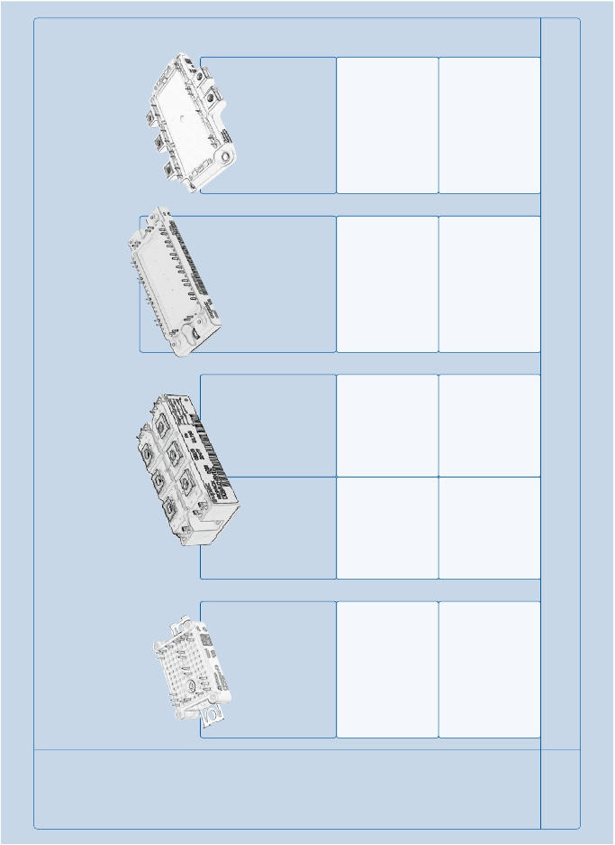

EasyBRIDGE

SCR

DiodeModules

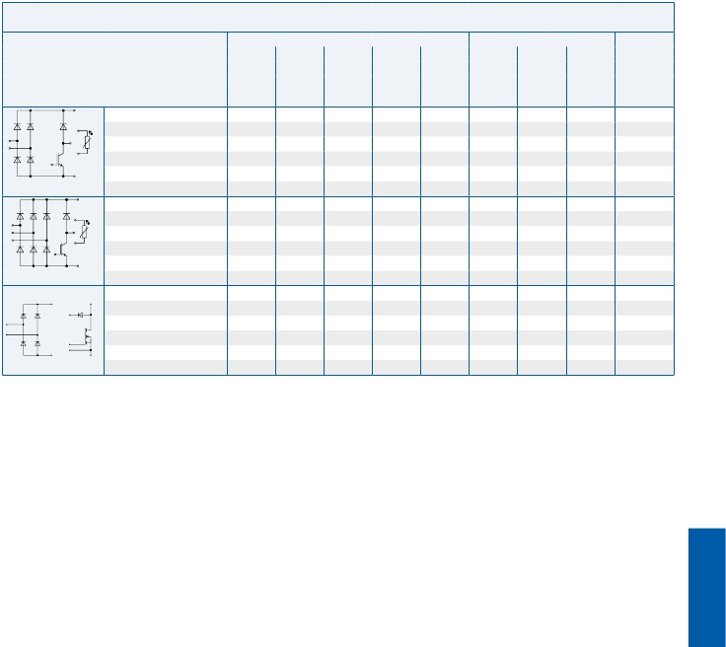

800 VCES

Type Diode Brake Chopper Outline/

VRRM Id RthJC Vt0 rt VCE IC* RthJC page

V A K/W V mΩ V A K/W

max. Tvj = TC = max.

150°C 80°C

DDB2U30N08VR 800 48 1,30 0,75 6,95 600 20 1,50 L_750d/6.7

single phase

DDB6U30N08VR 800 30 1,80 0,85 8,30 600 20 1,50 L_750e/6.7

three phase

DDB2U50N08W1R_B23 800 50 1,20 600 50 0,25 data on request

6.3

|  |  |  |  |  |
| --- | --- | --- | --- | --- |
| 1600 VCES | | | | |
| Type | | IGBT Inverter  VRRM            Id             RthJC            Vt0              rt  V               A             K/W             V             mΩ  max.          Tvj =  150°C | Brake Chopper  VCE             IC*            RthJC  V               A             K/W  TC =          max.  80°C | Outline/  page |
| three phase | DDB6U25N16VR | 1600             30         1,55         0,76         7,60 | 1200             15 1,45 | L_750e/6.7 |
| three phase | DDB6U75N16W1R  DDB6U75N16W1R_B11 | 1600             75         0,72  1600             75         0,72 | 1200             50         0,45  1200             50         0,45 | L_1ba/6.7  L_1ba/6.7 |

6.4

SCR

DiodeModules

EasyBRIDGE

* as specified in data sheet                       ..._B11 PressFIT Modules

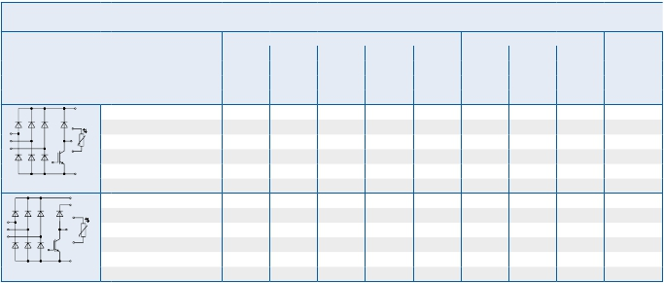

eupec™ EconoBRIDGE™ Rectifier

SCR

DiodeModules

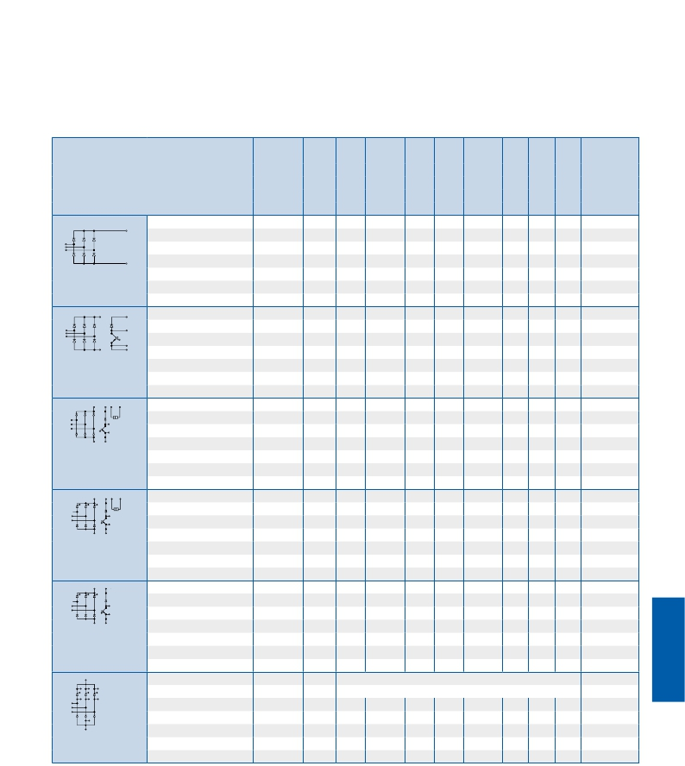

Type VDRM, VRRM IFRMSM IFSM Id/Tc V(TO) rT RthJC Tvj max VCES IC Outline/

V (ITRMSM) (ITSM) A/°C V mΩ °C/W °C V A page

VDSM = VDRM A A Tvj = Tvj = per arm

VRSM = 10 ms Tvj max Tvj max 120° el

VRRM+ 100V Tvj max Square

wave

DDB6U100N16R 1600 60 550 100/100 0,75 5,5 1,15 150 M_EB2a/6.8

DDB6U144N16R 1600 100 1000 145/100 0,75 3,1 0,89 150 M_EB2a/6.8

3 phase bridge rectifier,

uncontrolled

DDB6U84N16RR 1600 60 550 85/100 0,75 5,50 1,45 150 1200 50 M_EB2b/6.8

DDB6U100N16RR 1600 60 550 100/100 0,75 5,50 1,15 150 1200 50 M_EB2b/6.8

3 phase bridge rectifier,

uncontrolled with

brake chopper

DDB6U104N16RR 1600 60 550 105/100 0,75 5,50 1,08 150 1200 50 M_EB2c/6.8

DDB6U104N18RR 1800 60 550 105/100 0,75 5,50 1,08 150 1200 50 M_EB2c/6.8

DDB6U134N16RR 1600 80 550 134/100 0,75 6,30 0,70 150 1200 70 M_EB2c/6.8

3 phase bridge rectifier,

uncontrolled with

brake chopper and NTC

TDB6HK124N16RR 1600 70 550 125/85 0,75 6,30 0,63 125 1200 70 M_EB2d/6.8

3 phase bridge rectifier,

halfcontrolled with

brake chopper and NTC

TDB6HK180N16RR 1600 150 1400 180/80 0,83 2,30 0,35 150 1200 100 M_EB2f/6.8

TDB6HK180N16RR_B11 1600 150 1400 180/80 0,83 2,30 0,35 150 1200 100 M_EB2e/6.8

3 phase bridge rectifier,

halfcontrolled with brake

chopper

u

u

TDB6HK240N16P       1600  240               data on request               M_EB4a/6.9

TDB6HK360N16P       1600  360               data on request               M_EB4a/6.9

3 phase bridge rectifier,

half-controlled with NTC

u New type

_B11 PressFIT Modules eupec™ EconoBRIDGE™ Rectifiers are UL recognized

6.5

|  |  |  |  |  |  |  |  |  |  |  |
| --- | --- | --- | --- | --- | --- | --- | --- | --- | --- | --- |
| Type | | VDRM, VRRM  V  VDSM = VDRM  VRSM =  VRRM+ 100V | IFRMSM  (ITRMSM)  A | IFSM  (ITSM)  A  10 ms  Tvj max | Id/Tc  A/°C | V(TO)  V  Tvj =  Tvj max | rT  mΩ  Tvj =  Tvj max | RthJC  °C/W  per arm  120° el  Square  wave | Tvj max  °C | Outline/  page |
| 3 phase bridge rectifier,  uncontrolled | DDB6U85N16L  DDB6U145N16L  DDB6U205N16L  DDB6U215N16L | 1600  1600  1600  1600 | 60  100  120  125 | 550  1000  1375  1850 | 85/100  145/100  205/100  215/100 | 0,75  0,75  0,75  0,75 | 5,50  3,10  2,20  1,60 | 1,45  0,89  0,59  0,49 | 150  150  150  150 | M_1Pa/6.9  M_1Pa/6.9  M_1Pa/6.9  M_1Pa/6.9 |
| 3 phase bridge rectifier,  half controlled | TDB6HK95N16LOF  TDB6HK135N16LOF  TDB6HK165N16LOF | 1600  1600  1600 | 75  100  120 | 620  870  1050 | 95/85  135/85  165/85 | 0,95  0,95  0,95 | 5,50  4,30  3,20 | 0,82  0,59  0,49 | 125  125  125 | M_1Pb/6.9  M_1Pb/6.9  M_1Pb/6.9 |
| 3 phase bridge rectifier,  fully controlled | TTB6C95N16LOF  TTB6C135N16LOF  TTB6C165N16LOF | 1600  1600  1600 | 75  100  120 | 620  870  1050 | 95/85  135/85  165/85 | 0,95  0,95  0,95 | 5,50  4,30  3,20 | 0,82  0,59  0,49 | 125  125  125 | M_1Pb/6.9  M_1Pb/6.9  M_1Pb/6.9 |

|  |  |  |  |  |  |  |  |  |  |  |
| --- | --- | --- | --- | --- | --- | --- | --- | --- | --- | --- |
| Type | | VDRM, VRRM  V  VDSM = VDRM  VRSM =  VRRM+ 100V | IFRMSM  (ITRMSM)  A | IFSM  (ITSM)  A  10 ms  Tvj max | Id/Tc  A/°C | V(TO)  V  Tvj =  Tvj max | rT  mΩ  Tvj =  Tvj max | RthJC  °C/W  per arm  120° el  Square  wave | Tvj max  °C | Outline/  page |
| 3 phase AC-Switches,  fully controlled | TTW3C85N16LOF  TTW3C115N16LOF  TTW3C145N16LOF | 1600  1600  1600 | 75  100  120 | 620  870  1050 | 85/85  115/85  145/85 | 0,95  0,95  0,95 | 5,50  4,30  3,20 | 0,70  0,50  0,42 | 125  125  125 | M_1Pb/6.9  M_1Pb/6.9  M_1Pb/6.9 |

6.6

SCR

DiodeModules

eupec™ IsoPACK™ Bridge Rectifier

eupec™ IsoPACK™ AC-Switches

eupec™ IsoPACK™ modules are UL recognized

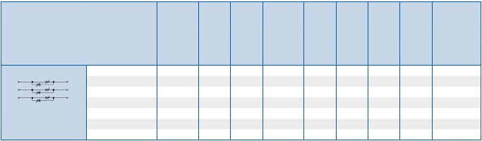

Outlines

SCR

DiodeModules

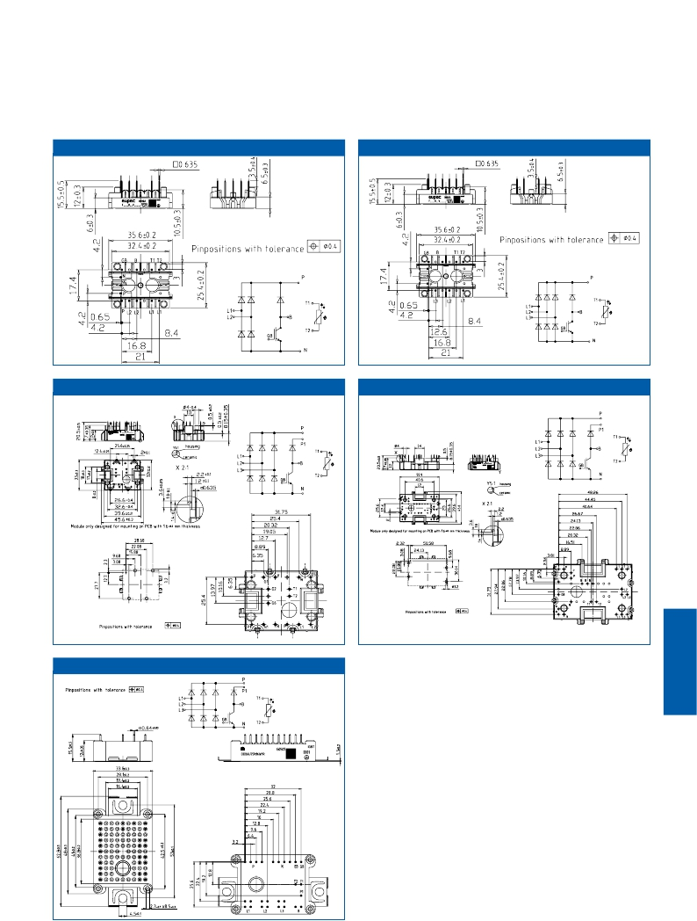

EasyBRIDGE750 L_750d

EasyBRIDGE750                             L_750e

EasyBRIDGE1 L_1c

EasyBRIDGE2                                 L_2i

EasyBRIDGE1B L_1ba

Infineon

6.7

eupec™ EconoBRIDGE™ 2 Rectifier M_EB2a

SCR

DiodeModules

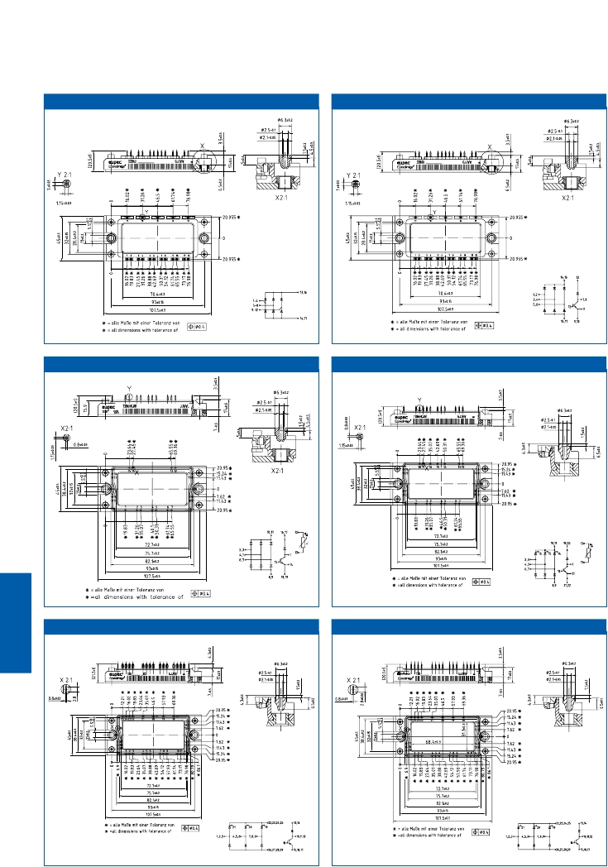

eupec™ EconoBRIDGE™ 2 Rectifier               M_EB2b

eupec™ EconoBRIDGE™ 2 Rectifier M_EB2c

eupec™ EconoBRIDGE™ 2 Rectifier               M_EB2d

eupec™ EconoBRIDGE™ 2 Rectifier M_EB2e eupec™ EconoBRIDGE™ 2 Rectifier M_EB2f

6.8

eupec™ EconoBRIDGE™ 4 M_EB4a

12

30

30

3

8,5max.

30

3

6

54

21,5

41,5

30

42

6

SCR

DiodeModules

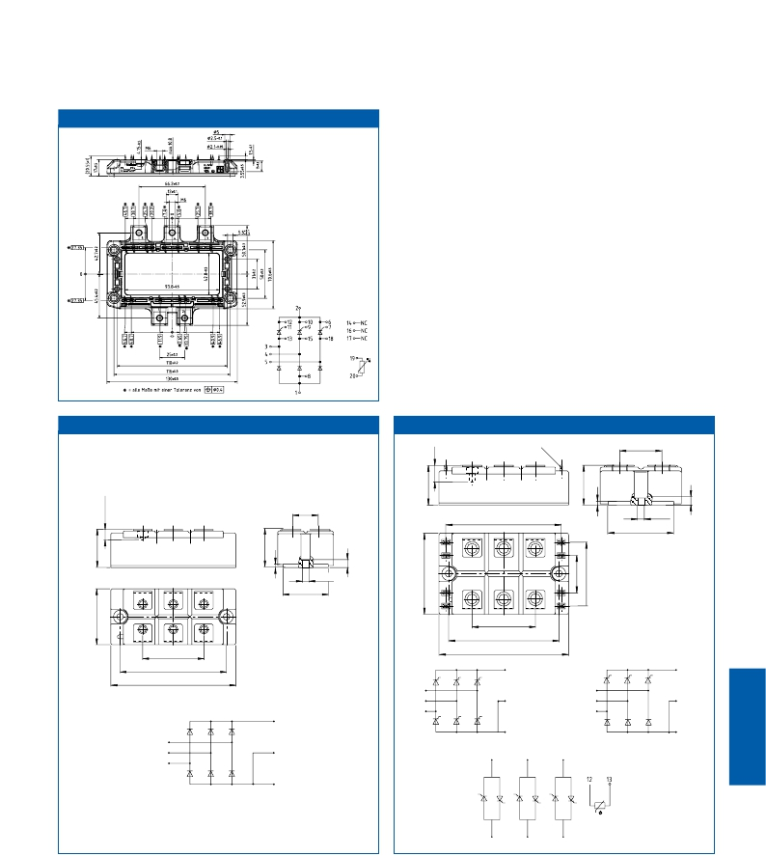

eupec™ IsoPACK™ 42 M_1Pa eupec™ IsoPACK™ 54 M_1Pb

M6

2,8 x 0,8

32

M5

18

84

48

Æ 6,4

71

2

14

8

3

13

Æ 6,4

1 2 3

34

94

5          6

12

4 5 6

46

10                   11

46

80

94

80

94

10   9    11

4

10   9    11

4

3

2

5

3

2

5

4

1

7    8    14

1

6

6

3

2

1

5

1        2         3

6

7

8        14

10        9        11

6

4        5

6.9

|  |  |  |
| --- | --- | --- |
| Rectifier Modules | Housing Size (overall) | Packing  Units |
| IsoPACK™ | 42 mm  54 mm | 4  3 |
| eupec EconoBRIDGE™ 2  eupec EconoBRIDGE™ 4 | 45 mm x 107 mm  130,0 mm x 103,0 mm | 10  6 |
| EasyBRIDGE 750  EasyBRIDGE 1  EasyBRIDGE 2 | 25,4mm x 35,6 mm  33 mm x 45,6 mm  45,6 mm x 55,9 mm | 40  20  20 |

Package Units

SCR

DiodeModules



6.10

Thyristor &

SCR

DiodeModules

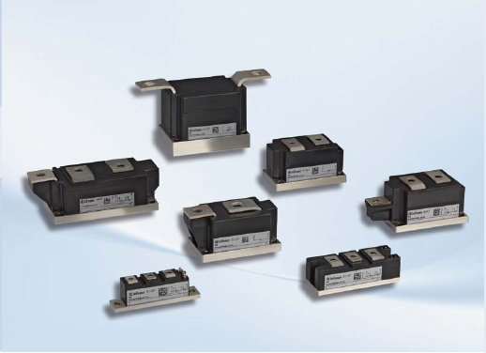

Diode Modules

We  offer  a  broad  range  of  PowerBLOCK  modules  containing  thyristor  and  diode

pellets  in  a  voltage  range  of  1200V  to  4400V  and  a  current  range  of  61A  up  to

1070A.

The  modules  are  designed  and  assembled  in  high  reliable  pressure  contact  tech-

nology  using  an  isolated  copper  base  plate.

They  are  offered  in  several  dual  and  single  device  topologies  for  almost  all  phase

control  or  rectifier  applications.

Application  areas  for  our  modules  are  e.g.  electrical  drives,  as  well  as  low  volt-

age  soft  starters  and  general  purpose  power  supplies.

6.11

6.12

OverviewPowerBLOCKThyristorModulesforPhaseControl

20mm

34mm

50mm

50mmSingle

60mm

70mmSingle

TT61N...KOF

TT92N...KOF

TT104N...KOF

TT140N16SOF

TT142N...KOF

TT162N...KOF

TT166N16SOF

TT180N...KOF

TT150N...KOF

TT170N...KOF

TT210N...KOF

TT215N...KOF

TT250N...KOF

TT251N...KOF

TT260N22KOF

TT285N...KOF

TT305N16KOF

TT330N...KOF

TZ150N...KOF

TZ310N...KOF

TZ375N...KOF

TZ425N...KOF

TZ400N...KOF

TZ430N...KOF

TZ500N...KOF

TZ600N...KOF

TT240N...KOF

TT310N...KOF

TZ240N...KOF

TT122N...KOF

TT140N...KOF

TT380N...KOF

TT425N...KOF

TT375N...KOF

TT400N...KOF

TT430N...KOF

TT500N...KOF

TT570N...KOF

TT600N16KOF

TZ530N...KOF

TZ630N...KOF

TZ740N...KOF

TT520N22KOF

TZ800N...KOF

3600

1600

1800

2200

1400

2000

2400

2600

2800

3200

3400

3000

1200

VRRM[V]

SCR

DiodeModules

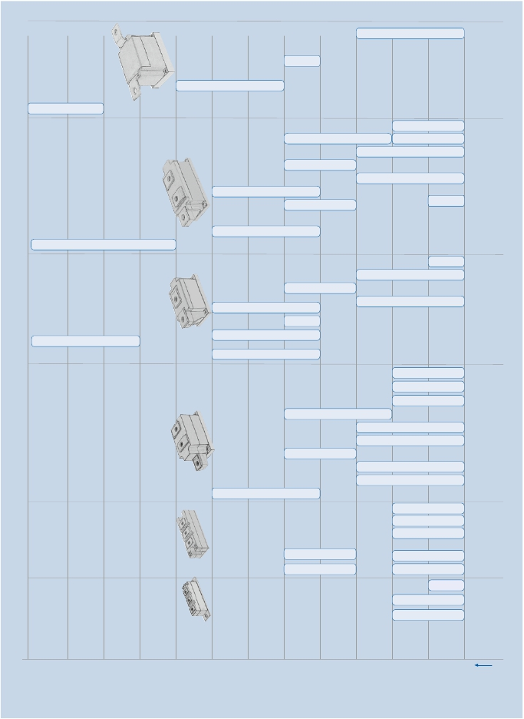

|  |  |  |  |  |
| --- | --- | --- | --- | --- |
|  | | | | |
| Type | | VDRM, VRRM  [V]  VDSM = VDRM  VRSM =  VRRM + 100 V | 2  ITSM        ∫i dt     ITAVM/Tc     V(TO)          rT       (di/dt)cr       tq          RthJC       RthCK     Tvj max  2              3  [A]      [A s·10 ]     [A/°C]       [V]        [mΩ]     [A/µs]      [µs]       [K/W]     [K/W]     [°C]  @10ms, 10 ms,     @180° @Tvj max @Tvj max     @DIN     typisch     @180°     @180°  Tvj max     Tvj max     el sin                                       IEC                       el sin     el sin  747- 6 | Outline /  page |
| Base  plate =  20 mm | TT 61 N16 KOF  TT 92 N16 KOF  TT 104 N14 KOF | 1600  1600  1400 | 1400         9,8     60/85      0,80      3,40        150        120       0,52       0,16     125  1800       16,2     92/85       0,85       2,15        150        150       0,37       0,10     130  1800       16,2 104/85       0,85       2,15        150        150       0,37       0,10     140 | TP20/6.23  TP20/6.23  TP20/6.23 |
| Base  plate =  34 mm | TT 122 N22 KOF  TT 140 N22 KOF  u TT 140 N16 SOF  TT 142 N16 KOF  u TT 166 N16 SOF  TT 162 N16 KOF  TT 180 N16 KOF | 2200  2200  1600  1600  1600  1600  1600 | 2950       43,5 122/85       1,00       2,15        100        300      0,20      0,06     125  3200       51,2 140/85      0,90       1,75        150        300       0,19      0,06     125  data on request  4100      84,0 142/85      0,90       1,10        150        200       0,22      0,06     125  data on request  4400       97,0 162/85       0,85       0,95        150        200      0,20      0,06     125  4100      84,0 180/85       0,85      0,90        150        200      0,20      0,06     130 | TP34/6.23  TP34/6.23  TS34/6.23  TP34/6.23  TS34/6.23  TP34/6.23  TP34/6.23 |
| Base  plate =  50 mm | TT 150 N26 KOF  n TT 170 N18 KOF  TT 210 N18 KOF  TT 215 N22 KOF  TT 250 N18 KOF  TT 251 N18 KOF  TT 260 N22 KOF  TT285 N16 KOF  u TT 305 N16 KOF  TT 330 N16 KOF | 2600  1800  1800  2200  1800  1800  2200  1600  1600  1600 | 4000          80 150/85       1,20       2,30          60        300     0,130      0,04     125  4600        106 170/85       0,95       1,00        150        250     0,170      0,04     125  5800        168 210/85       1,00       0,85        150        200     0,130      0,04     125  6300        198 215/85       0,95      0,92        100        300     0,130      0,04     125  7000        245 250/85      0,80       0,70        150        250     0,130      0,04     125  8000        320 250/85      0,80       0,70        250        250     0,130      0,04     125  8000        320 260/85       0,85      0,64        250        250     0,120      0,04     130  8000        320 285/92      0,80       0,70        250        250     0,117      0,04     135  9000        400 305/85      0,80       0,58        250        250     0,120      0,04     130  8000        320 330/85      0,80      0,60        250        250     0,117      0,04     135 | TP50/6.23  TP50A/6.23  TP50A/6.23  TP50A/6.23  TP50A/6.23  TP50A/6.23  TP50A/6.23  TP50A/6.23  TP50A/6.23  TP50A/6.23 |
| Base  plate =  60 mm | n TT 240 N36 KOF  n TT 310 N26 KOF  n TT 375 N22 KOF  n TT 380 N14 KOF  TT 400 N26 KOF  TT 425 N18 KOF  TT 430 N22 KOF  TT 500 N18 KOF  u TT 520 N22 KOF  TT 570 N16 KOF  u     TT 600 N16 KOF | 3600  2600  2200  1400  2600  1800  2200  1800  2200  1600  1600 | 5500        151 240/85       1,17       1,70        100        350     0,078       0,02     125  9000        405 310/85       1,00      0,86        120        300     0,078       0,02     125  10600        561 375/85       0,85       0,56        120        300     0,078       0,02     125  11000        605 380/85       1,00      0,38        120        250     0,078       0,02     125  11000        605 400/85       1,00       0,50        150        300     0,065       0,02     125  12500        781 425/85      0,90      0,30        120        250     0,078       0,02     125  12000        720 430/85       0,95       0,45        150        300     0,065       0,02     125  14500      1051 500/85      0,90       0,27        200        250     0,065       0,02     125  14500      1051 520/85       0,85       0,35        200        250     0,058       0,02     125  14000        980 570/87      0,90       0,27        200        250     0,065       0,02     125  17500       1531 600/85      0,80       0,26        200        250     0,058       0,02     125 | TP60/6.24  TP60/6.24  TP60/6.24  TP60/6.24  TP60/6.24  TP60/6.24  TP60/6.24  TP60/6.24  TP60A/6.24  TP60/6.24  TP60A/6.24 |



PowerBLOCK

SCR

DiodeModules



Common anode or cathode on request

Thyristor Modules for Phase Control

PowerBLOCK modules are UL recognized

u New type n Not for new design

6.13

|  |  |  |  |  |  |  |  |  |  |  |  |  |  |
| --- | --- | --- | --- | --- | --- | --- | --- | --- | --- | --- | --- | --- | --- |
|  | | | | | | | | | | | | | |
| Type | | VDRM, VRRM  [V]  VDSM = VDRM  VRSM =  VRRM + 100 V | ITSM  [A]  @10ms,  Tvj max | 2  ∫i dt  2              3  [A s·10 ]  10 ms,  Tvj max | ITAVM/Tc  [A/°C]  @180°  el sin | V(TO)  [V]  @Tvj max | rT  [mΩ]  @Tvj max | (di/dt)cr  [A/µs]  @DIN  IEC  747- 6 | tq  [µs]  typisch | RthJC  [K/W]  @180°  el sin | RthCK  [K/W]  @180°  el sin | Tvj max  [°C] | Outline /  page |
| Base  plate =  50 mm | n     TZ 150 N26 KOF  TZ 240 N36 KOF  TZ 310 N26 KOF  TZ 400 N26 KOF  TZ 425 N18 KOF  TZ 430 N22 KOF  TZ 500 N18 KOF  TZ 600 N16 KOF | 2600  3600  2600  2600  1800  2200  1800  1600 | 4000  5500  8000  11000  12500  12000  14500  14000 | 80  151  320  605  781  720  1051  980 | 150/85  240/85  310/85  400/85  425/85  430/85  500/85  600/85 | 1,20  1,17  1,00  1,00  0,90  0,95  0,90  0,90 | 2,30  1,70  0,86  0,50  0,30  0,45  0,27  0,27 | 60  100  120  150  120  150  200  200 | 300  350  300  300  250  300  250  250 | 0,130  0,078  0,078  0,065  0,078  0,065  0,065  0,065 | 0,02  0,02  0,02  0,02  0,02  0,02  0,02  0,02 | 125  125  125  125  125  125  125  125 | TP50.1/6.24  TP50.1/6.24  TP50.1/6.24  TP50.1/6.24  TP50.1/6.24  TP50.1/6.24  TP50.1/6.24  TP50.1/6.24 |
| Base  plate =  70 mm | TZ 530 N36 KOF  TZ 630 N28 KOF  TZ 749 N22 KOF  TZ 800 N18 KOF | 3600  2800  2200  1800 | 20000  23000  26500  30000 | 2000  2650  3500  4500 | 530/85  630/85  740/85  800/85 | 1,05  0,95  0,90  0,85 | 0,49  0,37  0,21  0,17 | 80  150  200  200 | 400  400  350  240 | 0,045  0,042  0,042  0,042 | 0,01  0,01  0,01  0,01 | 125  125  125  125 | TP70/6.24  TP70/6.24  TP70/6.24  TP70/6.24 |



PowerBLOCK

SCR

DiodeModules

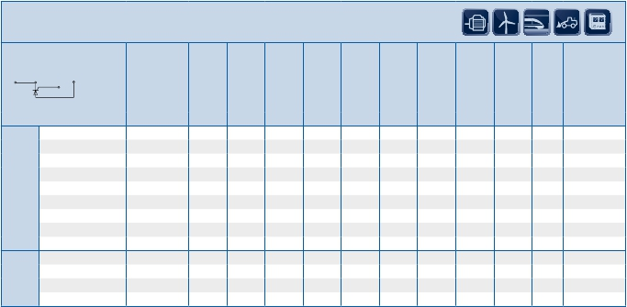

n Not for new design

Single Thyristor Modules for Phase Control

PowerBLOCK modules are UL recognized

6.14

6.15

VRRM[V]

TD

TD

TD

TD

TD

TD

TD

TD

N...KOF

N...KOF

N...KOF

N

SOF

TD

TD

N...KOF

N...KOF

mm

mm

N...KOF

N...KOF

N

SOF

N...KOF

TD

N...KOF

OverviewPowerBLOCKThyristor/DiodeModulesforPhaseControl

SCR

DiodeModules

TD

TD

TD

TD

N...KOF

N...KOF

N...KOF

N...KOF

TD

N

KOF

mm

mm

TD

TD

TD

TD

N...KOF

N

KOF

N...KOF

N

KOF

TD

TD

TD

TD

N...KOF

TD

TD

TD

TD

N...KOF

N...KOF

N

KOF

TD

N

KOF

N...KOF

N...KOF

TD

N...KOF

N...KOF

N...KOF

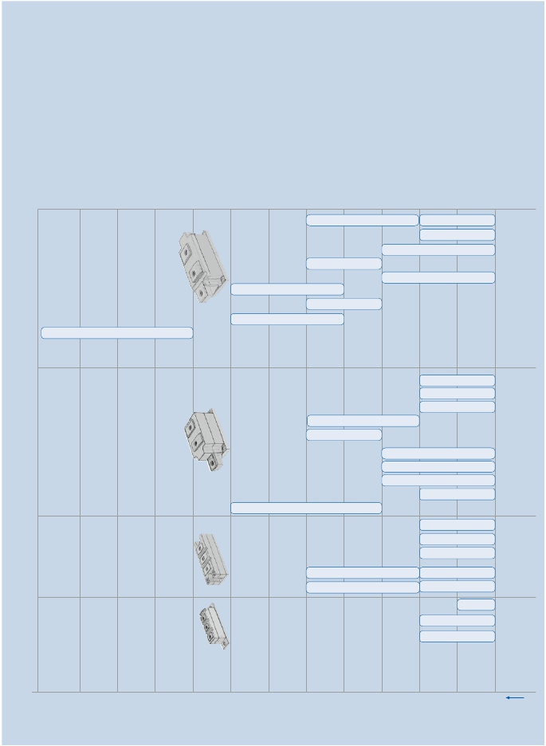

|  |  |  |  |  |
| --- | --- | --- | --- | --- |
|  | | | | |
| Type | | VDRM, VRRM  [V]  VDSM = VDRM  VRSM =  VRRM + 100 V | 2  ITSM        ∫i dt     ITAVM/Tc     V(TO)          rT       (di/dt)cr       tq          RthJC       RthCK     Tvj max  2              3  [A]      [A s·10 ]     [A/°C]       [V]        [mΩ]     [A/µs]      [µs]       [K/W]     [K/W]     [°C]  @10ms, 10 ms,     @180° @Tvj max @Tvj max     @DIN     typisch     @180°     @180°  Tvj max     Tvj max     el sin                                       IEC                       el sin     el sin  747- 6 | Outline /  page |
| Base  plate =  20 mm | TD 61 N16 KOF  TD 92 N16 KOF  TD 104 N14 KOF | 1600  1600  1400 | 1400         9,8     60/85      0,80      3,40        150        120       0,52       0,16     125  1800       16,2     92/85       0,85       2,15        150        150       0,37       0,10     130  1800       16,2 104/85       0,85       2,15        150        150       0,37       0,10     140 | TP20/6.23  TP20/6.23  TP20/6.23 |
| Base  plate =  34 mm | TD 122 N22 KOF  TD 140 N22 KOF  TD 140 N16 SOF  TD 142 N16 KOF  TD 162 N16 KOF  TD 166 N16 SOF  TD 180 N16 KOF | 2200  2200  1600  1600  1600  1600  1600 | 2950       43,5 122/85       1,00       2,15        100        300      0,20      0,06     125  3200       51,2 140/85      0,90       1,75        150        300       0,19      0,06     125  data on request  4100          84 142/85      0,90       1,10        150        200       0,22      0,06     125  4400          97 162/85       0,85       0,95        150        200      0,20      0,06     125  data on request  4100          84 180/85       0,85      0,90        150        200      0,20      0,06     130 | TP34/6.23  TP34/6.23  TS34/6.23  TP34/6.23  TP34/6.23  TS34/6.23  TP34/6.23 |
| Base  plate =  50 mm | TD 150 N26 KOF  n TD 170 N16 KOF  TD 210 N18 KOF  TD 215 N22 KOF  TD 250 N18 KOF  TD 251 N18 KOF  u TD 260N22 KOF  TD 285 N16 KOF  u TD 305 N16 KOF  TD 330 N16 KOF | 2600  1600  1800  2200  1800  1800  2200  1600  1600  1600 | 4000          80 150/85       1,20       2,30          60        300     0,130      0,04     125  4600        106 170/85       0,95       1,00        150        250     0,170      0,04     125  5800        168 210/85       1,00       0,85        150        200     0,130      0,04     125  6300        198 215/85       0,95      0,92        100        300     0,130      0,04     125  7000        245 250/85      0,80       0,70        150        250     0,130      0,04     125  8000        320 250/85      0,80       0,70        250        250     0,130      0,04     125  8000        320 260/85       0,85      0,64        250        250     0,120      0,04     130  8000        320 285/92      0,80       0,70        250        250     0,117      0,04     135  9000        400 305/85      0,80       0,58        250        250     0,120      0,04     130  8000        320 330/85      0,80      0,60        250        250     0,117      0,04     135 | TP50/6.23  TP50A/6.23  TP50A/6.23  TP50A/6.23  TP50A/6.23  TP50A/6.23  TP50A/6.23  TP50A/6.23  TP50A/6.23  TP50A/6.23 |
| Base  plate =  60 mm | n TD 240 N36 KOF  n TD 310 N26 KOF  TD 400 N26 KOF  TD 425 N18 KOF  TD 430 N22 KOF  TD 500 N18 KOF  u TD 520 N22 KOF  TD 570 N16 KOF  u TD 600 N16 KOF | 3600  2600  2600  1800  2200  1800  2200  1600  1600 | 5500        151 240/85       1,17       1,70        100        350     0,078       0,02     125  9000        405 310/85       1,00      0,86        120        300     0,078       0,02     125  11000        605 400/85       1,00       0,50        150        300     0,065       0,02     125  12500        781 425/85      0,90      0,30        120        250     0,078       0,02     125  12000        720 430/85       0,95       0,45        150        300     0,065       0,02     125  14500      1051 500/85      0,90       0,27        200        250     0,065       0,02     125  14500      1051 520/85       0,85       0,35        200        250     0,058       0,02     125  14000        980 570/87      0,90       0,27        200        250     0,065       0,02     135  17500      1531 600/85      0,80       0,26        200        250     0,058       0,02     125 | TP60/6.24  TP60/6.24  TP60/6.24  TP60/6.24  TP60/6.24  TP60/6.24  TP60A/6.24  TP60/6.24  TP60A/6.24 |



PowerBLOCK

SCR

DiodeModules



Common anode or cathode on request

Thyristor/Diode Modules for Phase Control

PowerBLOCK modules are UL recognized

u New type n Not for new design

6.16

6.17

OverviewPowerBLOCKDiode/ThyristorModulesforPhaseControl

DT

N

KOF

N...KOF

N...KOF

N...KOF

DT

KOF

DT

DT

mm

mm

DT

N

mm

DT

N...KOF

VRRM[V]

SCR

DiodeModules

DT

N

KOF

mm

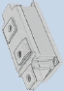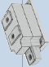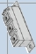

|  |  |  |  |  |  |  |  |  |  |  |  |  |  |
| --- | --- | --- | --- | --- | --- | --- | --- | --- | --- | --- | --- | --- | --- |
|  | | | | | | | | | | | | | |
| Type | | VDRM, VRRM  [V]  VDSM = VDRM  VRSM =  VRRM + 100 V | ITSM  [A]  @10ms,  Tvj max | 2  ∫i dt  2              3  [A s·10 ]  10 ms,  Tvj max | ITAVM/Tc  [A/°C]  @180°  el sin | V(TO)  [V]  @Tvj max | rT  [mΩ]  @Tvj max | (di/dt)cr  [A/µs]  @DIN  IEC  747- 6 | tq  [µs]  typisch | RthJC  [K/W]  @180°  el sin | RthCK  [K/W]  @180°  el sin | Tvj max  [°C] | Outline /  page |
| Base  plate =  20 mm | DT 61 N16 KOF  DT 92 N16 KOF | 1600  1600 | 1400  1800 | 9,8  16,2 | 60/85  92/85 | 0,80  0,85 | 3,40  2,15 | 150  150 | 120  150 | 0,52  0,37 | 0,16  0,10 | 125  130 | TP20/6.23  TP20/6.23 |
| Base  plate =  34 mm | DT 142 N12 KOF | 1200 | 4100 | 84 | 142/85 | 0,90 | 1,10 | 150 | 200 | 0,22 | 0,06 | 125 | TP34/6.23 |
| Base  plate =  50 mm | DT 150 N26 KOF  DT 170 N12 KOF  DT 250 N16 KOF | 2600  1200  1600 | 4000  4600  7000 | 80  106  245 | 150/85  170/85  250/85 | 1,20  0,95  0,80 | 2,30  1,00  0,70 | 60  150  150 | 300  250  250 | 0,13  0,17  0,13 | 0,04  0,04  0,04 | 125  125  125 | TP50/6.23  TP50/6.23  TP50/6.23 |
| Base  plate =  60 mm | DT 430 N22 KOF | 2200 | 12000 | 720 | 430/85 | 0,95 | 0,45 | 150 | 300 | 0,065 | 0,02 | 125 | TP60/6.24 |



PowerBLOCK

SCR

DiodeModules

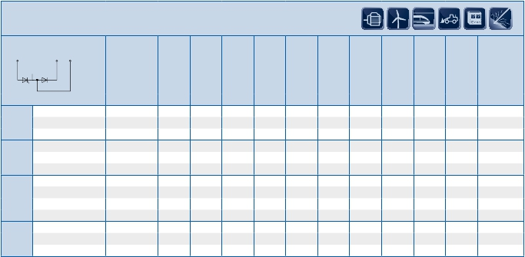

6.18

Diode/Thyristor Modules for Phase Control

PowerBLOCK modules are UL recognized

6.19

VRRM[V]

1200

20mm

34mm

1600

1800

2200

4200

DD89N...K

ND89N...K

DD98N...K

DD/ND104N...K

DD170N16S

DD/ND171N...K

1400

DD160N22K

2000

2400

2600

2800

3000

3200

3400

3600

3800

4000

4400

OverviewPowerBLOCKDiodeModulesforPhaseControl

SCR

DiodeModules

DD175N...K

DD/ND260N...K

DD231N...K

50mm

50mmSingle

60mm

70mmSingle

ND350N...K

DD350N...K

DD380N16K

DD360N22K

DD/ND261N...K

DZ540N...K

DZ435N...K

DZ600N...K

DD435N...K

DD540N...K

DD/ND600N...K

DD710N16K

DD700N22K

DZ950N...K

DZ1070N...K

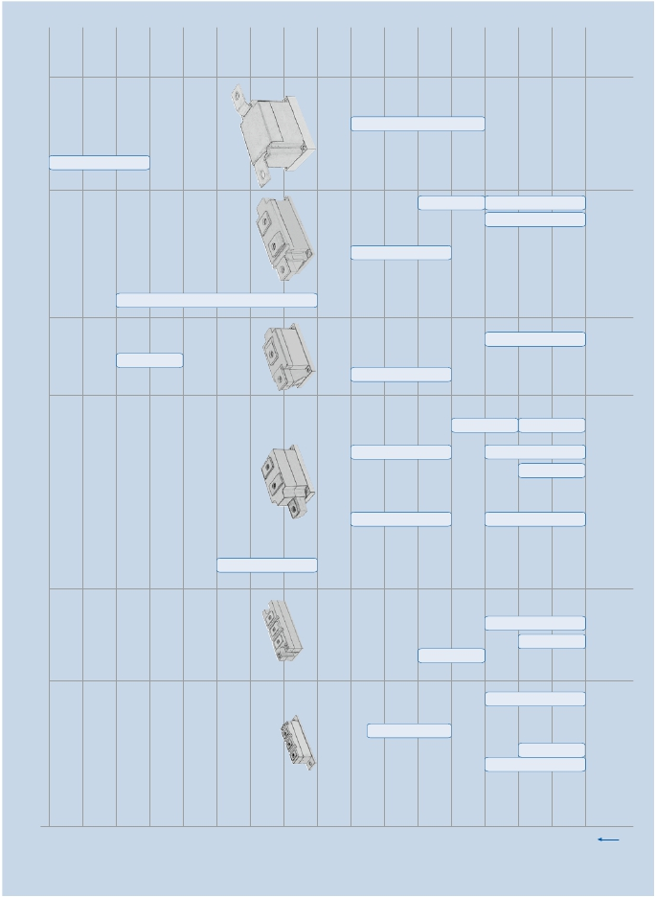

|  |  |  |  |  |
| --- | --- | --- | --- | --- |
|  | | | | |
| Type | | VRRM [V] | IFSM           ∫i2dt        IFAVM/Tc        V(TO)             rT             Rthjc           Rthch          Tvj max  2                 3]  [A]        [A s · 10           [A]              [V]           [mΩ]         [K/W]        [K/W]          [°C]  @10ms,     @10 ms,     @180°       Tvj max        Tvj max       @180°      @180°  Tvj max        Tvj max         el sin                                              el sin         el sin | Outline /  page |
| Base  plate =  20 mm | DD 89 N18 K  ND 89 N16 K  DD 98 N25 K  DD 104 N18 K  ND 104 N18 K | 1800  1600  2500  1800  1800 | 2400          28,8      89/100         0,75            2,3          0,45          0,10           150  2400          28,8      89/100         0,75            2,3          0,45          0,10           150  2000              20      98/100         0,82            2,0          0,39          0,10           150  2500        31,25     104/100         0,70            2,1          0,39          0,10           150  2500        31,25     104/100         0,70            2,1          0,39          0,10           150 | DP20/6.25  DP20/6.25  DP20/6.25  DP20/6.25  DP20/6.25 |
| Base  plate =  34 mm | DD 160 N22 K  DD 170 N16 S  DD 171 N18 K  ND 171 N18 K | 2200  1600  1800  1800 | 4600        105,8     160/100         0,80         1,00          0,26          0,06           150  data on request  5600            157     170/100         0,75            0,8          0,26          0,06           150  5600            157     170/100         0,75            0,8          0,26          0,06           150 | DP34/6.25  DS34/6.25  DP34/6.25  DP34/6.25 |
| Base  plate =  50 mm | DD 175 N34 K  DD 231 N26 K  DD 260 N18 K  ND 260 N16 K  DD 261 N24 K  ND 261 N26 K  DD 285 N04 K  DD 350 N18 K  ND 350 N18 K  u     DD 380 N 16 K  u     DD 360 N 22 K  DZ 435 N40 K  DZ 540 N26 K  DZ 600 N18 K | 3400  2600  1800  1600  2400  2600  400*)  1800  1800  1600  2200  4000  2600  1800 | 4000              80     175/100         0,90         1,80          0,17          0,04           150  6400           205     231/100         0,80         1,84          0,17          0,04           150  8300           344     260/100         0,70         0,68          0,17          0,04           150  8300           344     260/100         0,70         0,68          0,17          0,04           150  8300           344     260/100         0,70         0,68          0,17          0,04           150  8300           344     260/100         0,70         0,68          0,17          0,04           150  8300           344     285/100         0,75         0,40          0,17          0,04           150  11000           605     350/100         0,75         0,40          0,13          0,04           150  11000           605     350/100         0,75         0,40          0,13          0,04           150  11500           660     380/100         0,75         0,32        0,125          0,04           150  11500           550     360/100         0,75         0,40        0,125          0,04           150  12000           720     435/100         0,84         0,60        0,078          0,02           150  14000           980     540/100         0,78         0,31        0,078          0,02           150  19000         1805     600/100         0,75         0,22        0,078          0,02           150 | DP50/6.25  DP50/6.25  DP50/6.25  DP50ND/6.26  DP50/6.25  DP50ND/6.26  DP50/6.25  DP50/6.25  DP50ND/6.26  DP50A/6.25  DP50A/6.25  DP50.1/6.26  DP50.1/6.26  DP50.1/6.26 |
| Base  plate =  60 mm | DD 435 N40 K  DD 540 N26 K  DD 600 N18 K  ND 600 N18 K  u     DD 700 N22 K  u     DD 710 N16 K | 4000  2600  1800  1800  2200  1600 | 12000           720     435/100         0,84         0,60        0,078          0,02           150  14000           980     540/100         0,78         0,31        0,078          0,02           150  19000         1800     600/100         0,75         0,22        0,078          0,02           150  19000         1800     600/100         0,75         0,22        0,078          0,02           150  21000         2205     700/100         0,78          0,19        0,065          0,02           150  22000         2420     710/100         0,75       0,145        0,065          0,02           150 | DP60/6.25  DP60/6.25  DP60/6.25  DP60/6.25  DP60A/6.26  DP60A/6.26 |
| Base  plate =  70 mm | DZ 950 N44 K  DZ 1070 N26 K | 4400  2600 | 29000         4205     950/100         0,85         0,28        0,042          0,01           150  35000         6125 1070/100            0,8          0,17        0,045          0,01           160 | DP70/6.26  DP70/6.26 |



PowerBLOCK

SCR

DiodeModules



Common anode or cathode on request

Rectifier Diode Modules

PowerBLOCK modules are UL recognized

*) V RSM = VRRM + 50V

u New type

6.20

|  |  |  |  |  |  |  |  |  |  |  |  |  |
| --- | --- | --- | --- | --- | --- | --- | --- | --- | --- | --- | --- | --- |
|  | | | | | | | | | | | | |
| Type | | VRRM  [V]  VRSM =  VRRM + 100 V | IFSM  [A]  @10ms,  Tvj max | 2  ∫i dt  2               3  [A s·10 ]  @10ms,  Tvj max | IFAVM/Tc  [A/°C]  @180°  el sin | V(TO)  [V]  @Tvj max | rT  [mΩ]  @Tvj max | IRM  [A]  @Tvj max  di/dt =  100 A/µs | Rthjc  [K/W]  @180°  el sin | Rthch  [K/W]  @180°  el sin | Tvj max  [°C] | Outline /  page |
| Base  plate =  20 mm | DD 46 S12 K  DD 61 S14 K  DD 81 S14 K  DD 82 S10 K | 1200*)  1400  1400  1000*) | 820  1600  1900  1900 | 3,6  12,8  18,1  18,1 | 45/85  61/100  81/100  81/100 | 0,9  1  0,95  0,95 | 3,9  2,2  1,7  1,7 | 82  87  65 | 0,68  0,62  0,48  0,48 | 0,16  0,16  0,16  0,16 | 125  150  150  150 | DP20/6.25  DP20/6.25  DP20/6.25  DP20/6.25 |
| Base  plate =  50 mm | DD 230 S26 K  DD 241 S14 K  ND 241 S14 K | 2600  1400*)  1400*) | 7500  7500  7500 | 281  281  281 | 230/100  240/100  240/100 | 1,0  1,1  1,1 | 0,8  0,5  0,5 | 135  135 | 0,15  0,15  0,15 | 0,04  0,04  0,04 | 150  150  150 | DP50/6.25  DP50/6.25  DP50ND/6.26 |
| DD 242 S10 K  ND 242 S10 K | 1000*)  1000*) | 7500  7500 | 281  281 | 240/100  240/100 | 1,1  1,1 | 0,5  0,5 | 98  98 | 0,15  0,15 | 0,04  0,04 | 150  150 | DP50/6.25  DP50ND/6.26 |



PowerBLOCK

SCR

DiodeModules

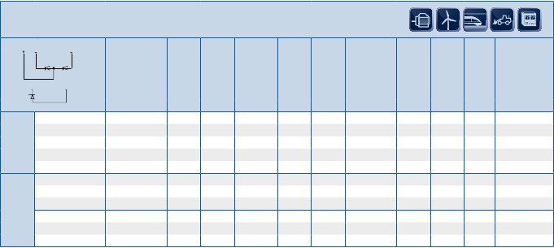

Common anode or cathode on request

Fast Diode Modules

PowerBLOCK modules are UL recognized

*) V RRM ≤ 1000 V : VRSM = VRRM +50 V

6.21

Gate Leads for PowerBLOCK Thyristor Modules

SCR

DiodeModules

descr.    gate lead

color    "HK" lead

color     length

[mm]      Ordering Code

20           Gatelead L=500 PB20 G1/K1     5/4    G1/K1    red    white    500     SP000983478

34, 50, 60      Gatelead L=500 PB34-60 G1/K1   5/4    G1/K1    red    white    500     SP000983496

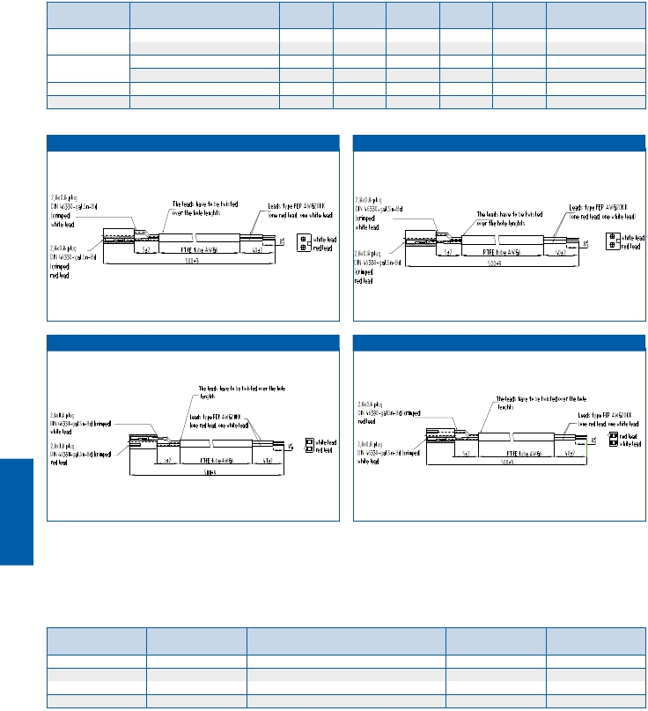

Gate leads must be ordered separately

Base plate width Type Terminal # Terminal

[mm]

Gatelead L=500 PB20 G2/K2 6/7 G2/K2 red white 500 SP000983484

Gatelead L=500 PB34-60 G2/K2 6/7 G2/K2 red white 500 SP000983490

50 single Gatelead L=500 PB34-60 G1/K1 5/4 G1/K1 red white 500 SP000983496

70 single Gatelead L=500 PB34-70 G2/K2 5/4 G1/K1 red white 500 SP000983490

SP000983478

SP000983484

SP000983496 SP000983490

Screws for electrical connection

of PowerBLOCK Thyristor and Diode Modules

screws must be ordered separately

Base plate screw Salesname packing unit SP No

20 mm M5x11 SHR DIN7985-M5X11 500 SP000485868

50 mm M8x18 SHR DIN933-M8X18 500 SP000485876

50 mm single M10x23 SHR DIN933-M10X23 500 SP000485880

60 mm M10x23 SHR DIN933-M10X23 500 SP000485880

6.22

Outlines

9

5

6

24±0,5

(2,8x0,8)

12,5

34±0,3

30+0,5

-0

29

27

-1.052

±0.5

±0.532

2.8

-0.28

+231

67

45

585

±0.250

±0.238

18

39,5

±0.5

SCR

DiodeModules

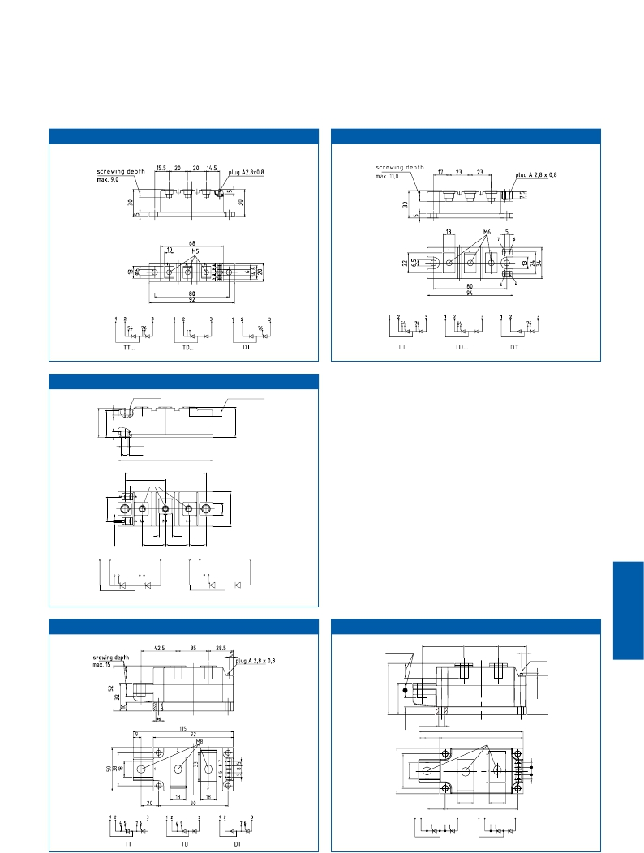

20 mm TP20

34 mm                                     TP34

34 mm TS34

plugA2,8x0,8

n 6,5

screwingdepthmax.9

n 8,5

40±0,5

94±0,3

80±0,3

5

M6

13

23±0,5  23±0,5 17±0,5

1  2

3

1  2

3

54 76

54

TT

TD

50 mm TP50

50 mm                                     TP50A

screwingdepth

max.15

42.5          35±0.2

±0.3

28.5

5

plugA

2,8x0,8

Ø6+0.2

115

+2.0

9±0.5

92±0.2

M8

2

1

18

3

18

20±0.3

80±0.2

1 2

3

1

2

3

45

TT

76

45

TD

6.23

50 mm TP50.1 60 mm TP60

SCR

DiodeModules

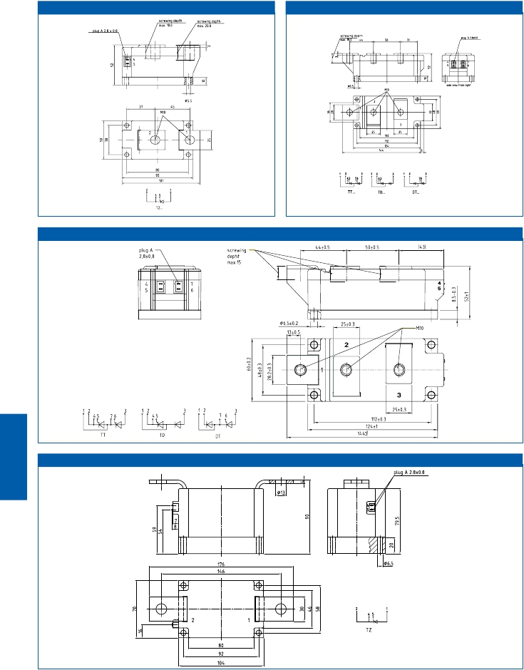

60 mm TP60A

70 mm TP70

6.24

20 mm DP20 34 mm DP34

9

6

12,5

34±0,3

30+0,5

-0

27

SCR

DiodeModules

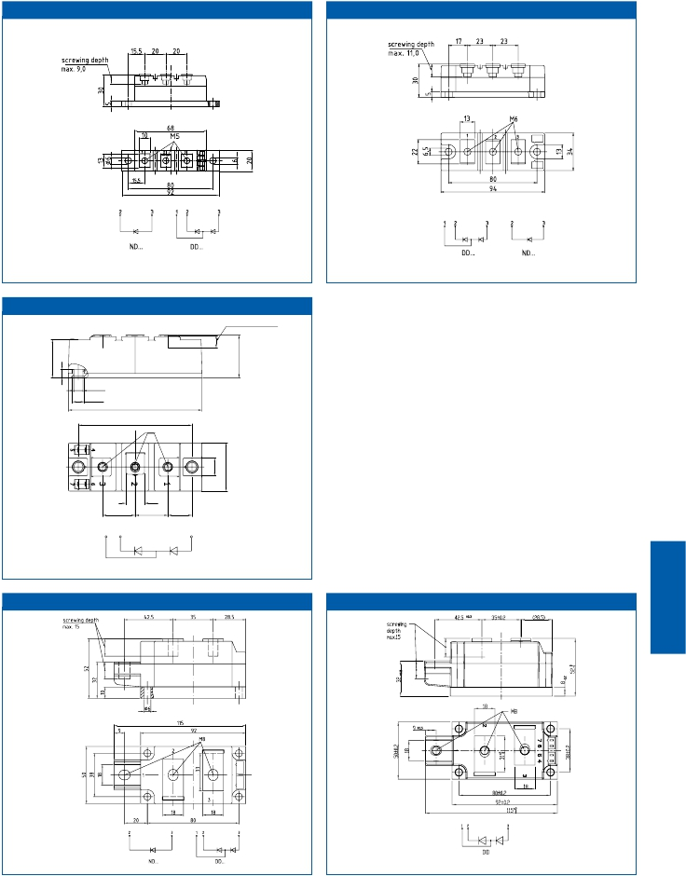

34 mm DS34

screwing depth max. 9

n 6,5

n 8,5

94±0,3

80±0,3

M6

13

23±0,5

23±0,5  17±0,5

1  2 3

DD

50 mm DP50 50 mm DP50A

6.25

50 mm DP50.1

SCR

DiodeModules

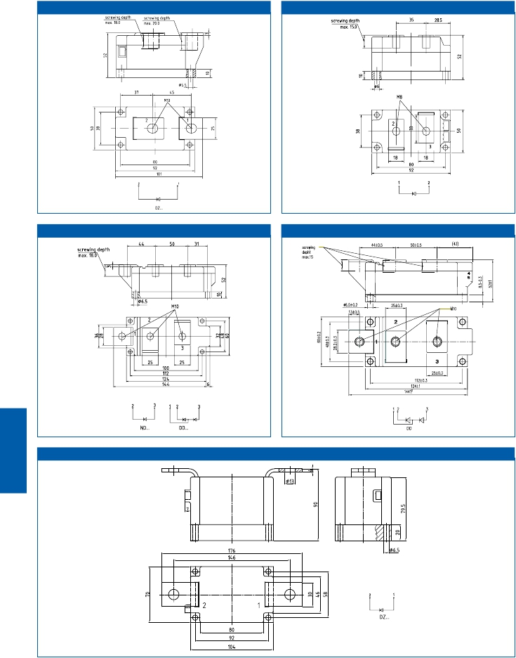

50 mm                                   DP50ND

ND...

60 mm DP60 60 mm DP60A

70 mm DP70

6.26

|  |  |  |  |
| --- | --- | --- | --- |
| Type | Outline | Housing | Packing units |
| TT 61 N...KOF  TT 92 N...KOF  TT 104 N...KOF  TT 122 N...KOF  TT 140 N...KOF  TT 140 N 16 SOF  TT 142 N...KOF  u     TT 160 N 16 SOF  TT 162 N...KOF  TT 180 N...KOF  TT 150 N...KOF  TT 170 N...KOF  TT 210 N...KOF  TT 215 N...KOF  TT 250 N...KOF  TT 251 N...KOF  u     TT 260 N 22 KOF  TT 285 N...KOF  u     TT 305 N 16 KOF  TT 330 N...KOF  TT 330 N 16 AOF  TT 240 N...KOF  TT 310 N...KOF  TT 375 N...KOF  TT 380 N...KOF  TT 400 N...KOF  TT 425 N...KOF  TT 430 N...KOF  TT 500 N...KOF  TT 520 N 22 KOF  TT 570 N...KOF  u     TT 600 N 16 KOF  TZ 150 N...KOF  TZ 240 N...KOF  TZ 310 N...KOF  TZ 375 N...KOF  TZ 400 N...KOF  TZ 425 N...KOF  TZ 430 N...KOF  TZ 500 N...KOF  TZ 600 N...KOF  TZ 530 N...KOF  TZ 630 N...KOF  TZ 749 N...KOF  TZ 800 N...KOF  TD 61 N...KOF  TD 92 N...KOF  TD 104 N...KOF  TD 122 N...KOF  TD 140 N...KOF  u     TD 140 N 16 SOF  TD 142 N...KOF  TD 162 N...KOF  u     TD 160 N 16 SOF  TD 180 N...KOF | TP20/6.23  TP20/6.23  TP20/6.23  TP34/6.23  TP34/6.23  TS34/6.23  TP34/6.23  TS34/6.23  TP34/6.23  TP34/6.23  TP50/6.23  TP50/6.23  TP50/6.23  TP50/6.23  TP50/6.23  TP50/6.23  TP50A/6.23  TP50/6.23  TP50/6.23  TP50/6.23  TP50A/6.23  TP60/6.24  TP60/6.24  TP60/6.24  TP60/6.24  TP60/6.24  TP60/6.24  TP60/6.24  TP60/6.24  TP60A/6.24  TP60/6.24  TP60A/6.24  TP50.1/6.24  TP50.1/6.24  TP50.1/6.24  TP50.1/6.24  TP50.1/6.24  TP50.1/6.24  TP50.1/6.24  TP50.1/6.24  TP50.1/6.24  TP70/6.24  TP70/6.24  TP70/6.24  TP70/6.24  TP20/6.23  TP20/6.23  TP20/6.23  TP34/6.23  TP34/6.23  TS34/6.23  TP34/6.23  TP34/6.23  TS34/6.23  TP34/6.23 | PB20  PB20  PB20  PB34  PB34  SB34  PB34  SB34  PB34  PB34  PB50  PB50AT  PB50AT  PB50AT  PB50AT  PB50AT  PB50AT  PB50AT  PB50AT  PB50  PB50AT  PB60  PB60  PB60  PB60  PB60  PB60  PB60  PB60  PB60AT  PB60  PB60AT  PB50.1  PB50.1  PB50.1  PB50.1  PB50.1  PB50.1  PB50.1  PB50.1  PB50.1  PB70  PB70  PB70  PB70  PB20  PB20  PB20  PB34  PB34  SB34  PB34  PB34  SB34  PB34 | 15  15  15  8  8  8  8  8  8  8  3  3  3  3  3  3  3  3  3  3  3  2  2  2  2  2  2  2  2  2  2  2  3  3  3  3  3  3  3  3  3  1  1  1  1  15  15  15  8  8  8  8  8  8  8 |

|  |  |  |  |
| --- | --- | --- | --- |
| Type | Outline | Housing | Packing units |
| TD 150 N...KOF  TD 170 N...KOF  TD 210 N...KOF  TD 215 N...KOF  TD 250 N...KOF  TD 251 N...KOF  u     TD 270 N 16 AOF  u     TD 260 N 22 AOF  TD 285 N...KOF  TD 330 N...KOF  TD 330 N 16 AOF  TD 240 N...KOF  TD 310 N...KOF  TD 375 N...KOF  TD 400 N...KOF  TD 425 N...KOF  TD 430 N...KOF  TD 500 N...KOF  TD520 N 22 KOF  TD 570 N...KOF  TD600 N 16 KOF  DT 61 N...KOF  DT 92 N...KOF  DT 142 N...KOF  DT 150 N...KOF  DT 170 N...KOF  DT 250 N...KOF  DT 430 N...KOF  DD 89 N...K...K  ND 89 N...K  DD 98 N...K  DD 104 N...K  ND 104 N...K  u        DD 140 N 16 S  DD 160 N...K  u         DD160 N 16 S  DD 171 N...K  ND 171 N...K  DD 175 N...K  DD 231 N...K  DD 260 N...K  KD 260 N...K  DD 261 N...K  ND 261 N...K  DD 285 N...K  DD 350 N...K  ND 350 N...K  DD 380 N 16 AOF  u     DD 360 N 22 AOF  DZ 435 N...K  DZ 540 N...K  DZ 600 N...K  DD 435 N...K  DD 540 N...K  DD 600 N...K | TP50/6.23  TP50/6.23  TP50/6.23  TP50/6.23  TP50/6.23  TP50/6.23  TP50A/6.23  TP50A/6.23  TP50/6.23  TP50/6.23  TP50A/6.23  TP60/6.24  TP60/6.24  TP60/6.24  TP60/6.24  TP60/6.24  TP60/6.24  TP60/6.24  TP60A/6.24  TP60/6.24  TP60A/6.24  TP20/6.23  TP20/6.23  TP34/6.23  TP50/6.23  TP50/6.23  TP50/6.23  TP60/6.24  DP20/6.25  DP20/6.25  DP20/6.25  DP20/6.25  DP20/6.25  DS34/6.25  DP34/6.25  DS34/6.25  DP34/6.25  DP34/6.25  DP50/6.25  DP50/6.25  DP50/6.25  DP50ND/6.26  DP50/6.25  DP50ND/6.26  DP50/6.25  DP50/6.25  DP50ND/6.26  DP50A/6.25  DP50A/6.25  DP50.1/6.25  DP50.1/6.25  DP50.1/6.25  DP60/6.26  DP60/6.26  DP60/6.26 | PB50  PB50AT  PB50AT  PB50AT  PB50AT  PB50  PB50AT  PB50AT  PB50AT  PB50  PB50AT  PB60  PB60  PB60  PB60  PB60  PB60  PB60  PB60AT  PB60  PB60AT  PB20  PB20  PB34  PB50  PB50AT  PB50AT  PB60  PB20  PB20  PB20  PB20  PB20  SB34  PB34  SB34  PB34  PB34  PB50  PB50  PB50  PB50ND  PB50AT  PB50ND  PB50  PB50AT  PB50ND  PB50AT  PB50AT  PB50.1  PB50.1  PB50.1  PB60  PB60  PB60 | 3  3  3  3  3  3  3  3  3  3  3  2  2  2  2  2  2  2  2  2  2  15  15  8  3  3  3  2  15  15  15  15  15  8  8  8  8  8  3  3  3  3  3  3  3  3  3  3  3  3  3  3  2  2  2 |

Package Units

SCR

DiodeModules



6.27

PowerBLOCK Modules

u New type

|  |  |  |  |
| --- | --- | --- | --- |
| Type | Outline | Housing | Packing units |
| ND 600 N...K  DD 700 N...K  u        DD 710 N 16 K  DZ 950 N...K  DZ 1070 N...K  DD 46 S...K  DD 61 S...K  DD 81 S...K  DD 82 S...K  DD 230 S...K  DD 241 S...K  ND 241 S...K  DD 242 S...K  ND 242 S...K | DP60/6.26  DP60/6.26  DP60A/6.26  DP70/6.26  DP70/6.26  DP20/6.25  DP20/6.25  DP20/6.25  DP20/6.25  DP50/6.25  DP50/6.25  DP50ND/6.26  DP50/6.25  DP50ND/6.26 | PB60  PB60  PB60AT  PB70  PB70  PB20  PB20  PB20  PB20  PB50  PB50  PB50ND  PB50  PB50ND | 2  2  2  1  1  15  15  15  15  3  3  3  3  3 |

Package Units

SCR

DiodeModules



u

PowerBLOCK Modules

6.28

New type

|  |  |  |
| --- | --- | --- |
| Application Notes, Product Briefs,  Flyers and Brochures | Type | Redirects |
| Technical Information for Bipolar  Semiconductors (english)  Technical Information for Bipolar  Semiconductors (german)  IFBIP Company Brochure  IFBIP Web shop  Thyristor and Diode Modules  Thyristor/Diode Modules in solder bond  technology  Standard gate leads for PowerBLOCK  modules | Application Note  Application Note  Brochure  Webpage  Product Brief  Product Brief  Product Information | <http://www.infineon.com/technical-information-appnote>  <http://www.infineon.com/technical-information-appnote-german>  <http://www.infineon.com/ifbip-company-brochure>  <http://www.ifbip-shop.com>  <http://www.infineon.com/thyristor-and-diodes-product-brief>  <http://www.infineon.com/solder-bond-modules-product-brief>  [http://www.infineon.com/gate-leads-for-powerblock-modules-](http://www.infineon.com/gate-leads-for-powerblock-modules-product-information)  [product-information](http://www.infineon.com/gate-leads-for-powerblock-modules-product-information) |

Links

SCR

DiodeModules



6.29

Infineon  Technologies  Bipolar

SCR

DiodeModules

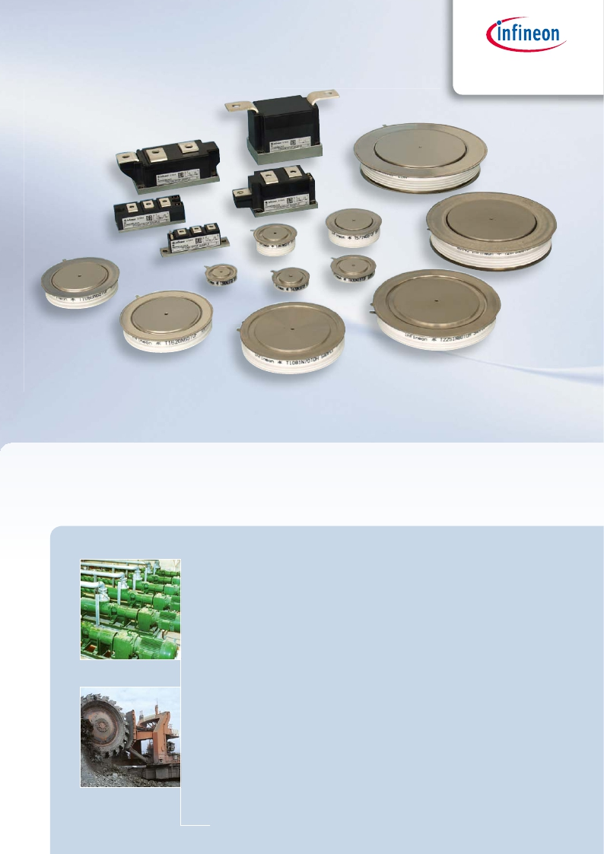

GmbH  &  Co.  KG

Core Components for Soft Starters

Broadest  portfolio  of  SCR  for  Soft  Starters  Applications

I  Isolated  SCR  modules  from  1.2  kV  up  to  3.6  kV

I  SCR  Discs  from  1.2  kV  to  >6.5  kV

I  Current  capability  from  100A  to  >3000A

I  Robust  designs  for  highest  performance  and  highest  reliability

I  Global  sales  and  distribution  network

I  Excellent  service  and  support

For  further  information  please  visit  our  website.

6.30

www.ifbip.com               ...for   energy   efficiency!

Thyristor &

Presspacks

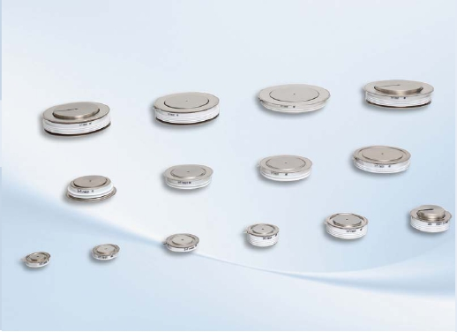

Diode Presspacks

We  offer  a  broad  range  of  Press  pack  disc  housings  containing  thyristor  and

diode  pellets  in  a  voltage  range  of  200 V  to  9500 V  and  a  current  range  of  56 A  to

8400 A.

All  discs  are  assembled  in  highly  reliable,  robust  and  hermetic  sealed  ceramic

housings  in  order  to  avoid  mechanical  damages  as  well  as  almost  any  negative

environmental  influences  as  e.g.  high  humidity.

Beside  the  standard  electrical  triggered  thyristor  disc  types  for  phase  control

applications  and  diode  disc  types  for  rectifier  applications,  we  offer  a  range  of

discs  as  fast  switching  diodes,  as  well  as  soft  and  fast  recovery  freewheeling

diodes  for  IGCT  and  IGBT  switches.

As  an  extension,  our  product  portfolio  contains  disc  types  as  light  triggered

thyristors  (LTT).  These  ceramic  discs  offer  an  easy  way  of  triggering  by  using

fiber  optics  to  avoid  insulation  problems  between  load  and  trigger  unit.  Higher

reliability  thanks  to  less  electronic  components  on  high  electric  potential  by

using  monolithic  integrated  protection  functions  (BoD  and  dv/dt  protection).

The  power  range  covers  blocking  voltages  from  5200 V  up  to  8000 V  and  current

ratings  from  550 A  up  to  3500 A.

7.1

|  |  |  |  |  |  |  |  |  |  |  |
| --- | --- | --- | --- | --- | --- | --- | --- | --- | --- | --- |
|  |  |  |  |  |  |  |  |  |  |  |
|  |  |  |  | |  |  |  |  |  |  |
|  |  | |  | |  | |  | |  |  |
|  |  | |  | | | |  | |  |  |
|  |  | |  | | | |  | |  |  |
|  |  | |  | | | |  | |  |  |
|  |  | |  | | | |  | |  |  |
|  |  | |  | | | |  | |  |  |
|  |  | |  | | | |  | |  |  |
|  |  | |  | | | |  |  |  |  |

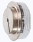

7.2

Presspacks

T600N

T533N

T2251N

T1901N

T1851NT1081N

T1651NT1201N

T281N

T571N

T2351NT1551N

T2161NT1451N

T1060N

T1620N

T3441N

T2851N

T4003N

T4021N

T3011N

T2871N

T1503N

T2563N

T731N

T730N

T1800N

T1930N

T860NT930N

T901N

T2001N

T1601N

T1220N

T460N

T700N

T830NT940NT720NT590NT880N

T1040N

T1190N

T660N

T740N

T1330N

T1500N

T1960N

T2180N

T2810N

T3160N

T1590N

T2480N

T3801N

T3401N

T4771N

T4301N

T1971N

T1401N

T3101N

T680N

T1410N

34/36mm

58mm

T2510N

50mm

75mm

T3710N

65mm

100mm

75mm

111mm

86mm

120mm

100mm

150mm

115mm

172mm

OverviewPhaseControlThyristorsinDiscHousings

VDRM

9500V

8000V

7000V

LightTriggered

Thyristor(LTT)

6500V

5200V

ElectricTriggered

Thyristor(ETT)

4400V

V4200

3800V

3600V

2800V

2600V

T360N

2200V

T300NT430N

T560NT640N

1800V

1600V

1400V

T390N

T470N

600V

T580N

T690N

T920NT1080N

ContactØ

23mm

30mm

CaseØ

42mm

48mm



|  |  |  |  |  |  |  |  |  |  |  |  |  |
| --- | --- | --- | --- | --- | --- | --- | --- | --- | --- | --- | --- | --- |
| up  to  1800  V | | | | | | | | | | | | |
| Type | VDRM, VRRM  [V]  VDSM = VDRM  VRSM =  VRRM + 100 V | ITSM  [kA]  @10ms,  Tvj max | 2  ∫i dt  2                 3  [A s· 10 ]  @10ms,  Tvj max | VT/IT  [V/kA]  Tvj max | ITAVM  [A]  @180 °  el sin  Tc = 85 °C | V(TO)  [V]  @Tvj max | rT  [mΩ]  @Tvj max | (di/dt)cr  [A/µs]  @DINIEC  747-6 | tq  [µs]  typ. | RthJC  [K/kW]  @180 °  el sin | Tvj max  [°C] | Outline /  page |
| T 86 N16 BOF  T 130 N18 BOF  T 130 N16 EOF  T 160 N18 BOF  T 160 N18 EOF  T 221 N18 BOF  T 300 N18 TOF  T 345 N18 EOF  T 390 N16 TOF  T 430 N18 TOF  T 470 N16 TOF  T 420 N18 TOF  T 560 N18 TOF  T 590 N18 TOF  T 640 N18 TOF  T 680 N14 TOF  T 720 N18 TOF  T 830 N18 TOF  T 880 N18 TOF  T 940 N18 TOF  T 1190 N18 TOF VT  T 1500 N18 TOF VT  T 2180 N18 TOF VT  T 3160 N18 TOF VT | 1600  1800  1600  1800  1800  1800  1800  1800  1600  1800  1600  1800  1800  1800  1800  1400  1800  1800  1800  1800  1800  1800  1800  1800 | 2,0  3,0  3,0  3,4  3,4  5,7  3,4  6,9  4,3  4,6  6,4  6,4  6,9  8,0  8,0  9,5  12,5  12,5  15,5  15,5  22,5  33,5  36,0  57,0 | 20  45  45  58  58  163  58  238  91  106  202  205  238  320  320  451  781  781  1200  1200  2530  5611  6480  16245 | 1,99/0,4  1,96/0,6  1,96/0,7  1,96/0,6  1,96/0,7  1,74/0,8  2,20/0,8  1,56/1,0  2,00/1,1  2,07/1,2  1,85/1,2  2,10/1,5  1,92/1,6  2,15/2,4  2,15/2,4  1,75/2,0  1,94/3,0  1,94/3,0  1,95/3,6  1,95/3,6  2,05/5,4  2,10/7,0  2,05/8,0  1,37/6,0 | 86  130  130  160  160  221  303  345  381  433  470  424  559  588  644  681  718  844  879  959  1190  1500  2180  3160 | 1,00  1,08  1,08  1,08  1,08  1,10  0,90  0,80  0,85  0,85  0,80  0,90  0,80  0,80  0,80  0,80  0,85  0,85  0,85  0,85  0,90  0,90  0,90  0,85 | 2,600  1,530  1,530  1,530  1,530  0,750  1,350  0,700  0,900  0,900  0,750  0,750  0,600  0,500  0,500  0,420  0,350  0,300  0,270  0,270  0,190  0,150  0,106  0,082 | 150  150  150  150  150  150  150  150  150  150  150  120  120  200  200  200  120  120  200  200  200  200  200  200 | 200  180  180  200  200  200  200  250  200  250  250  220  250  250  250  250  250  250  250  250  240  240  250  250 | 300  200  200  150  150  120  69  80  62  51  51  56  44  45  39  39  38  30  32  28  23  18,4  12,5  8,5 | 125  125  125  125  125  125  125  125  125  125  125  125  125  125  125  125  125  125  125  125  125  125  125  125 | TSW27/7.7  TSW27/7.7  TFL36/7.7  TSW27/7.7  TFL36/7.7  TSW41/7.7  T42.14K0/7.8  TFL54/7.7  T42.14K0/7.8  T42.14K0/7.8  T42.14K0/7.8  T48.14K0/7.8  T48.14K0/7.8  T58.26K0/7.8  T48.14K0/7.8  T48.14K0/7.8  T58.26K0/7.8  T58.14K0/7.8  T58.26K0/7.8  T58.14K0/7.8  T75.26K0/7.9  T75.26K0/7.9  T100.26K0/7.9  T111.26K0/7.9 |

|  |  |  |  |  |  |  |  |  |  |  |  |  |
| --- | --- | --- | --- | --- | --- | --- | --- | --- | --- | --- | --- | --- |
| up  to  600  V | | | | | | | | | | | | |
| Type | VDRM, VRRM  [V]  VDSM = VDRM  VRSM =  VRRM + 50 V | ITSM  [kA]  @10ms,  Tvj max | 2  ∫i dt  2                 3  [A s· 10 ]  @10ms,  Tvj max | VT/IT  [V/kA]  Tvj max | ITAVM  [A]  @180 °  el sin  Tc = 85 °C | V(TO)  [V]  @Tvj max | rT  [mΩ]  @Tvj max | (di/dt)cr  [A/µs]  @DINIEC  747-6 | tq  [µs]  typ. | RthJC  [K/kW]  @180 °  el sin | Tvj max  [°C] | Outline /  page |
| T 580 N06 TOF  T 690 N06 TOF  T 920 N06 TOF  T 1080 N06 TOF  T 1410 N06 TOF  T 2510 N06 TOF VT  T 3710 N06 TOF VT | 600  600  600  600  600  600  600 | 5,5  6,7  12,0  14,5  20,0  42,0  60,0 | 151  225  720  1050  2000  8820  18000 | 1,63/1,5  1,76/2,0  1,65/2,5  1,81/3,5  1,50/4,5  1,22/6,0  1,50/15,0 | 568  694  925  1075  1490  2509  3710 | 1,00  0,80  1,00  1,02  1,00  0,75  0,75 | 0,400  0,440  0,230  0,200  0,100  0,072  0,048 | 200  200  300  200  120  200  200 | 200  200  150  150  200  200  200 | 62,0  51,0  39,0  33,0  27,0  18,4  12,5 | 140  140  140  140  140  140  140 | T42.14K0/7.8  T42.14K0/7.8  T48.14K0/7.8  T48.14K0/7.8  T58.14K0/7.8  T75.26K0/7.9  T100.26K0/7.9 |



7.3

Presspacks

Phase Control Thyristors

...VT -> VT-class printed on housing

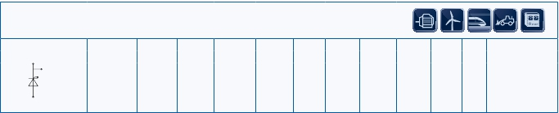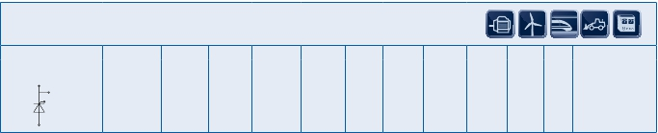

|  |  |  |  |  |  |  |  |  |  |  |  |  |
| --- | --- | --- | --- | --- | --- | --- | --- | --- | --- | --- | --- | --- |
| up  to  3000  V | | | | | | | | | | | | |
| Type | VDRM, VRRM  [V]  VDSM = VDRM  VRSM =  VRRM + 100 V | ITSM  [kA]  @10ms,  Tvj max | 2  ∫i dt  2                 3  [A s· 10 ]  @10ms,  Tvj max | VT/IT  [V/kA]  Tvj max | ITAVM  [A]  @180 °  el sin  Tc =85°C | V(TO)  [V]  @Tvj max | rT  [mΩ]  @Tvj max | (di/dt)cr  [A/µs]  @DIN IEC  747-6 | tq  [µs]  typ. | RthJC  [K/kW]  @180 °  el sin | Tvj max  [°C] | Outline /  page |
| T 360 N28 TOF  T 460 N26 TOF  T 660 N26 TOF  T 700 N22 TOF  T 740 N26 TOF  T 1040 N22 TOF VT  T 1220 N28 TOF VT  T 1330 N22 TOF VT  T 1590 N28 TOF VT  T 1960 N22 TOF VT  T 2160 N28 TOF VT  T 2480 N28 TOF VT  T 2810 N22 TOF VT  T 4301 N29 TOF VT  T 4771 N29 TOF VT | 2800  2600  2600  2200  2600  2200  2800  2200  2800  2200  2800  2800  2200  2900  2900 | 4,5  9,0  11,5  12,2  11,5  18,5  22,5  23,0  28,0  35,0  40,0  43,5  50,0  91,0  91,0 | 101  405  660  744  660  1711  2531  2645  3920  6125  8000  9460  12500  41400  41400 | 2,88/1,1  2,75/2,0  2,53/2,85  2,32/2,85  2,53/2,85  1,53/2,0  1,38/1,0  1,13/1,0  2,45/5,0  2,20/8,0  2,65/8,8  1,43/3,0  2,35/11,0  1,20/4,0  1,20/4,0 | 360  459  659  699  745  1039  1220  1329  1590  1960  2400  2480  2810  4300  4640 | 1,10  1,00  1,00  0,95  1,00  0,90  1,00  0,90  1,10  0,90  1,05  0,95  0,90  0,77  0,77 | 1,600  0,840  0,500  0,450  0,500  0,300  0,275  0,234  0,237  0,150  0,154  0,154  0,112  0,107  0,107 | 60  120  150  200  150  200  150  200  150  200  150  200  200  300  300 | 350  300  300  300  300  300  350  300  400  300  400  400  300  250  250 | 44,0  45,5  33,0  32,0  28,0  23,1  18,4  18,4  12,5  12,5  8,5  8,5  8,5  5,4  4,8 | 125  125  125  125  125  125  125  125  125  125  125  125  125  125  125 | T48.14K0/7.8  T58.26K0/7.8  T58.26K0/7.8  T58.26K0/7.8  T58.14K0/7.8  T75.26K0/7.9  T75.26K0/7.9  T75.26K0/7.9  T100.26K0/7.9  T100.26K0/7.9  T111.26K0/7.9  T111.26K0/7.9  T111.26K0/7.9  T150.35K/7.10  T150.26K/7.10 |

|  |  |  |  |  |  |  |  |  |  |  |  |  |
| --- | --- | --- | --- | --- | --- | --- | --- | --- | --- | --- | --- | --- |
| up  to  4500  V | | | | | | | | | | | | |
| Type | VDRM, VRRM  [V]  VDSM = VDRM  VRSM =  VRRM + 100 V | ITSM  [kA]  @10ms,  Tvj max | 2  ∫i dt  2                 3  [A s· 10 ]  @10ms,  Tvj max | VT/IT  [V/kA]  Tvj max | ITAVM  [A]  @180 °  el sin  Tc = 85 °C | V(TO)  [V]  @Tvj max | rT  [mΩ]  @Tvj max | (di/dt)cr  [A/µs]  @DIN IEC  747-6 | tq  [µs]  typ. | RthJC  [K/kW]  @180 °  el sin | Tvj max  [°C] | Outline /  page |
| T 730 N42 TOF VT  T 731 N44 TOH  T 860 N36 TOF VT  T 901 N36 TOF  T 930 N36 TOF VT  T 1401 N42 TOH  T 1971 N44 TOH  T 1601 N36 TOF  T 1800 N42 TOF  T 1930 N38 TOF VT  T 2001 N36 TOF  T 3101 N42 TOH  T 3401 N36 TOH  T 3801 N36 TOH | 4200  4400  3600  3600  3600  4200  4400  3600  4200  3800  3600  4200  3600  3600 | 15,8  16,0  17,0  17,0  17,5  36,0  36,0  41,0  41,0  37,0  41,0  83,0  87,0  87,0 | 1250  1280  1445  1445  1530  6480  6480  8400  8405  6850  8400  34000  37850  37850 | 3,40/3,5  1,86/1,2  3,18/3,8  1,75/1,2  2,70/3,6  1,95/2,0  1,95/2,0  1,50/2,0  1,65/2,0  2,90/8,0  1,50/2,0  1,6/4,0  1,40/4,0  1,40/4,0 | 730  910  860  950  930  1600  1730  1920  1800  2180  2060  3160  3800  4100 | 1,20  1,08  1,08  1,16  1,00  1,29  1,29  1,00  0,85  1,08  1,00  0,90  0,82  0,82 | 0,570  0,650  0,500  0,494  0,430  0,330  0,330  0,250  0,400  0,200  0,250  0,175  0,145  0,145 | 80  300  80  300  80  300  300  300  150  150  300  300  300  300 | 400  500  400  300  500  350  350  300  900  450  300  400  300  300 | 21,5  18,5  21  18,5  21,5  9,7  8,6  9,7  8,5  8,5  8,7  5,4  5,4  4,8 | 120  125  125  125  125  125  125  125  125  125  125  125  125  125 | T75.26K0/7.9  T76.26K/7.19  T75.26K0/7.9  T76.26K/7.19  T75.26K0/7.9  T120.35K/7.10  T120.26K/7.9  T120.35K/7.10  T111.26K0/7.9  T111.26K0/7.9  T120.26K/7.9  T150.35K/7.10  T150.35K/7.10  T150.26K/7.10 |



7.4

Presspacks

Phase Control Thyristors

...VT -> VT-class printed on housing

...VT -> VT-class printed on housing

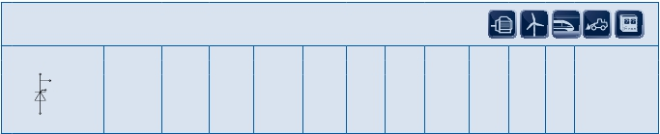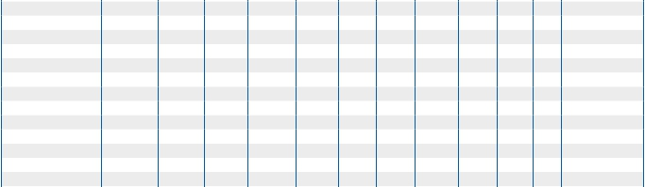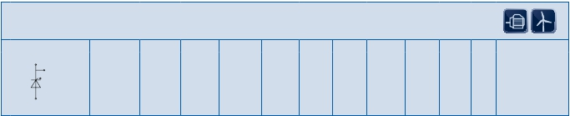

|  |  |  |  |  |  |  |  |  |  |  |  |  |
| --- | --- | --- | --- | --- | --- | --- | --- | --- | --- | --- | --- | --- |
| up  to  10000  V | | | | | | | | | | | | |
| Type | VDRM, VRRM  [V]  VDSM = VDRM  VRSM =  VRRM + 100 V | ITSM  [kA]  @10ms,  Tvj max | 2  ∫i dt  2                 3  [A s· 10 ]  @10ms,  Tvj max | VT/IT  [V/kA]  Tvj max | ITAVM  [A]  @180 °  el sin  Tc = 85 °C | V(TO)  [V]  @Tvj max | rT  [mΩ]  @Tvj max | (di/dt)cr  [A/µs]  @DIN IEC  747-6 | tq  [µs]  typ. | RthJC  [K/kW]  @180 °  el sin | Tvj max  [°C] | Outline /  page |
| T 281 N65 TOF  T 571 N65 TOF  T 1060 N65 TOF  T 1620 N65 TOF  T 1081 N70 TOH  T 1201 N70 TOH  T 1651 N70 TOH  T 1851 N70 TOH  T 1901 N80 TOH  T 2251 N80 TOH  T 2871 N80 TOH  u      T 3011 N80 TOH  u        T 600 N95 TOH | 6500  6500  6500  6500  7000  7000  7000  7000  8000  8000  8000  8000  9500 | 4,8  9,4  22,5  32,0  34,0  34,0  48,0  48,0  65,0  65,0  90,0  90,0  12,8 | 115  442  2530  5120  5780  5780  11500  11500  21100  21100  40500  43250  820 | 2,75/0,5  2,75/1,0  3,5/3,0  3,3/4,5  2,7/2,0  2,7/2,0  2,65/3,0  2,65/3,0  3,0/4,0  3,0/4,0  2,95/5,0  2,95/5,0  2,8/1,0 | 280  540  1050  1610  1330  1230  1685  1850  2130  2280  2680  2800  570 | 1,35  1,35  1,35  1,35  1,18  1,18  1,22  1,22  1,24  1,24  1,27  1,27  1,18 | 2,800  1,400  0,720  0,430  0,759  0,759  0,490  0,490  0,440  0,440  0,336  0,336  1,620 | 150  150  150  150  300  300  300  300  300  300  300  300  100 | 1000  1000  1000  1000  600  600  600  600  550  550  550  550  900 | 43,0  23,0  11,8  8,1  8,6  9,7  7,5  6,5  5,4  4,8  4,5  4,0  20,5 | 125  125  125  125  125  125  125  125  125  125  125  125  125 | T58.26K0/7.8  T75.26K0/7.9  T100.26K0/7.9  T111.26K0/7.9  T120.26K/7.9  T120.35K/7.10  T120.35K/7.10  T120.26K/7.9  T150.35K/7.10  T150.26K/7.10  T172.26K/7.10  T172.26K/7.10  T75.26K0/7.9 |

|  |  |  |  |  |  |  |  |  |  |  |  |  |
| --- | --- | --- | --- | --- | --- | --- | --- | --- | --- | --- | --- | --- |
| up  to  5500  V | | | | | | | | | | | | |
| Type | VDRM, VRRM  [V]  VDSM = VDRM  VRSM =  VRRM + 100 V | ITSM  [kA]  @10ms,  Tvj max | 2  ∫i dt  2                 3  [A s· 10 ]  @10ms,  Tvj max | VT/IT  [V/kA]  Tvj max | ITAVM  [A]  @180 °  el sin  Tc = 85 °C | V(TO)  [V]  @Tvj max | rT  [mΩ]  @Tvj max | (di/dt)cr  [A/µs]  @DIN IEC  747-6 | tq  [µs]  typ. | RthJC  [K/kW]  @180 °  el sin | Tvj max  [°C] | Outline /  page |
| T 1451 N52 TOH  T 1551 N52 TOH  T 2161 N52 TOH  T 2351 N52 TOH  T 2851 N52 TOH  T 3441 N52 TOH  T 4021 N53 TOH | 5200  5200  5200  5200  5200  5200  5350 | 43,0  43,0  54,0  54,0  79,0  79,0  100,0 | 9250  9250  14600  14600  31000  31000  50000 | 1,70/2,0  1,70/2,0  1,85/3,0  1,85/3,0  1,70/4,0  1,70/4,0  1,80/6,0 | 1690  1830  2170  2360  3000  3200  3920 | 0,92  0,92  0,81  0,81  0,77  0,77  0,92 | 0,370  0,370  0,360  0,360  0,235  0,235  0,142 | 300  300  300  300  300  300  300 | 450  450  450  450  600  600  550 | 9,7  8,6  7,5  6,5  5,4  4,8  4,45 | 125  125  125  125  125  125  125 | T120.35K/7.10  T120.26K/7.9  T120.35K/7.10  T120.26K/7.9  T150.35K/7.10  T150.26K/7.10  T172.26K/7.10 |

|  |  |  |  |  |  |  |  |  |  |  |  |  |  |
| --- | --- | --- | --- | --- | --- | --- | --- | --- | --- | --- | --- | --- | --- |
|  | | | | | | | | | | | | | |
| Type | VBO  V | VDRM, VRRM  [V]  VDSM = VDRM  VRSM =  VRRM + 100 V | ITSM  [kA]  @10ms,  Tvj max | 2  ∫i dt  2                 3  [A s· 10 ]  @10ms,  Tvj max | VT/IT  [V/kA]  @Tvj max | ITAVM  [A/°C]  @180 °  el sin  Tc = 85 °C | V(TO)  [V]  @Tvj max | rT  [mΩ]  @Tvj max | (di/dt)cr  [A/µs]  @DIN IEC  747-6 | tq  [µs]  typ. | RthJC  [K/kW]  @180 °  el sin | Tvj max  [°C] | Outline /  page |
| T 533 N80 TOH  T1503N80TOH  T2563N80TOH  T4003N52TOH | 6500  7500  7500  5200 | 8000  8000  8000  5200 | 11,2  55  90  100 | 672  15125  40500  50000 | 2,80/1,0  3,00/4,0  2,95/5,0  1,80/5,0 | 535  1770  2520  3480 | 1,31  1,24  1,28  0,92 | 1,500  0,440  0,278  0,142 | 300  300  300  300 | 800  550  550  500 | 20  6,3  4,8  4,8 | 120  120  120  120 | T76.35L/7.10  T150.40L/7.11  T172.40L/7.11  T172.40L/7.11 |



7.5

Presspacks

Phase Control Thyristors

...VT -> VT-class printed on housing

u New type

Light Triggered Thyristors

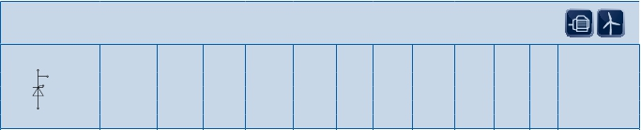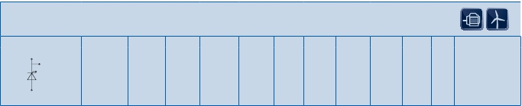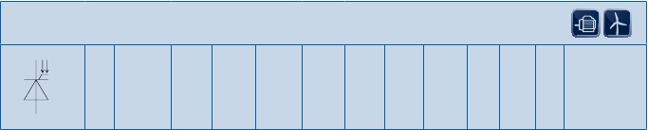

|  |  |  |  |  |  |  |  |  |  |
| --- | --- | --- | --- | --- | --- | --- | --- | --- | --- |
|  | | | | | | | | | |
| Type | VBO  [V] | VRRM  [V] | ITSM  [kA]  @10ms  Tvjmax | VT(F)/IT(F)  [V/kA]  @Tvjmax | di/dtcr(on)  [A/µs]  @single  pulse | di/dtcr(off)  [A/µs]  @single  pulse | RthJC  [K/kW]  @ 180°  el sin | Tvj max  [°C] | Outline /  page |
| T 4003 NH52TOH  T 1503 NH80TOH  T 2563 NH80TOH  D 2601 NH...TOH | 5200  7500  7500 | 5200  7500…8000  7500…8000 | 100  55  90  22 | 1,80/5,0  3,00/4,0  2,95/5,0  5,5/4,0 | 5000  5000  5000 | 7500 | 4,5  6,0  4,5  7,5 | 120  120  120  140 | T172.40L/7.11  T150.40L/7.11  T172.40L/7.11  D120.26K/7.24 |



7.6

Presspacks

Pulsed Power Applications

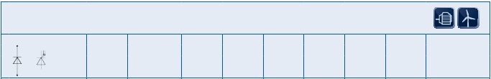

Outlines

Presspacks

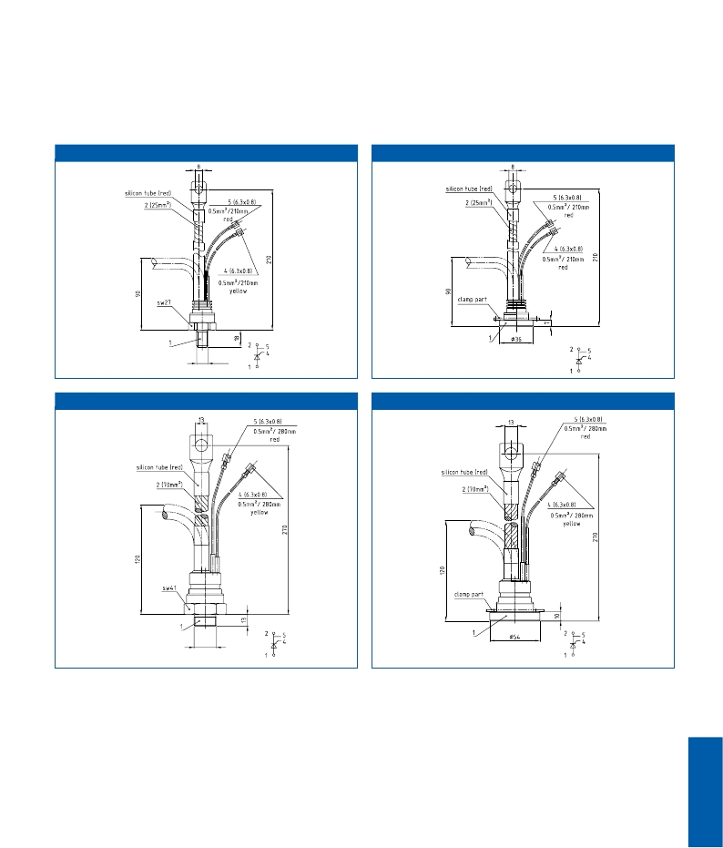

TSW27

TFL36

M12 x 1,75

TSW41

TFL54

M24 x 1,5

7.7

T42.14K0

Presspacks

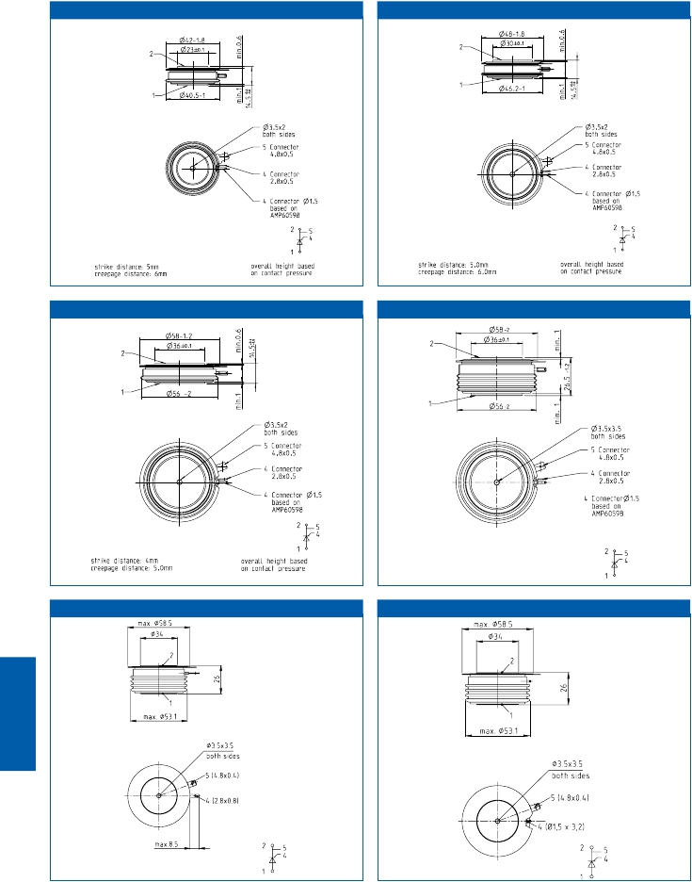

T48.14K0

T58.14K0

T58.26K0

T58.26K

T58.26K1

7.8

T75.26K0

min.1

min.1

26.5

-1.2

Presspacks

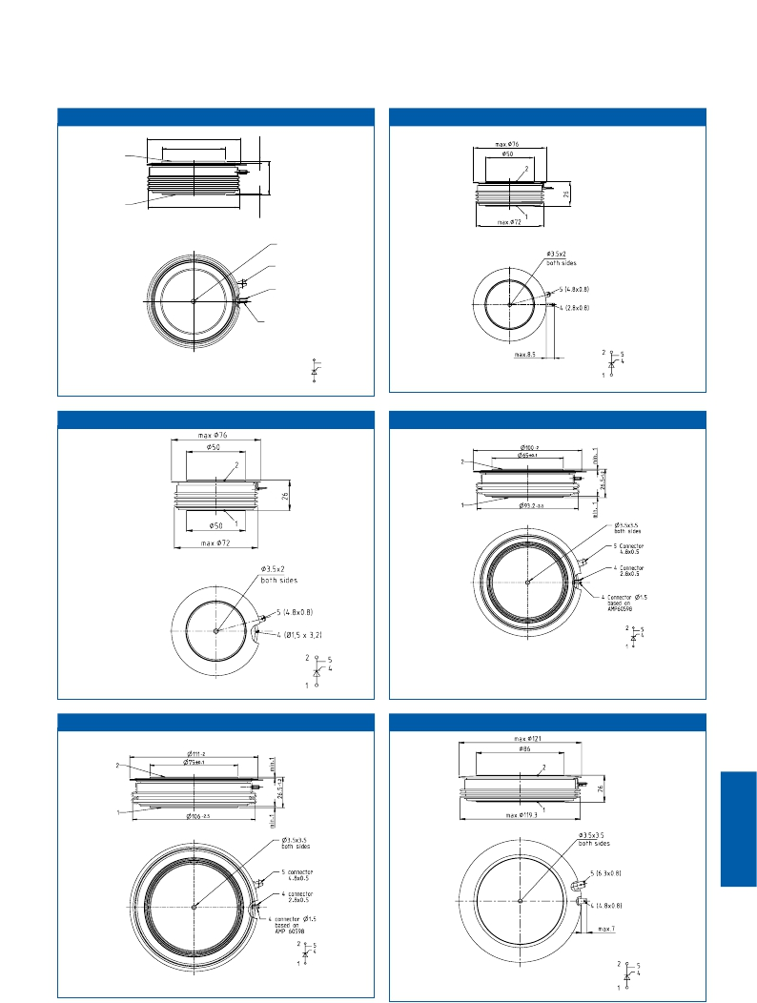

T76.26K

Ø75-2

Ø50±0.1

2

1

Ø73.5

-2

Ø3.5x3.5

bothsides

5Connector

4.8x0.5

4Connector

2.8x0.5

4ConnectorØ1.5

basedon

AMP60598

2

1

5

4

T75.26K1                                          T100.26K0

T111.26K0 T120.26K

7.9

T120.35K T150.26K

Presspacks

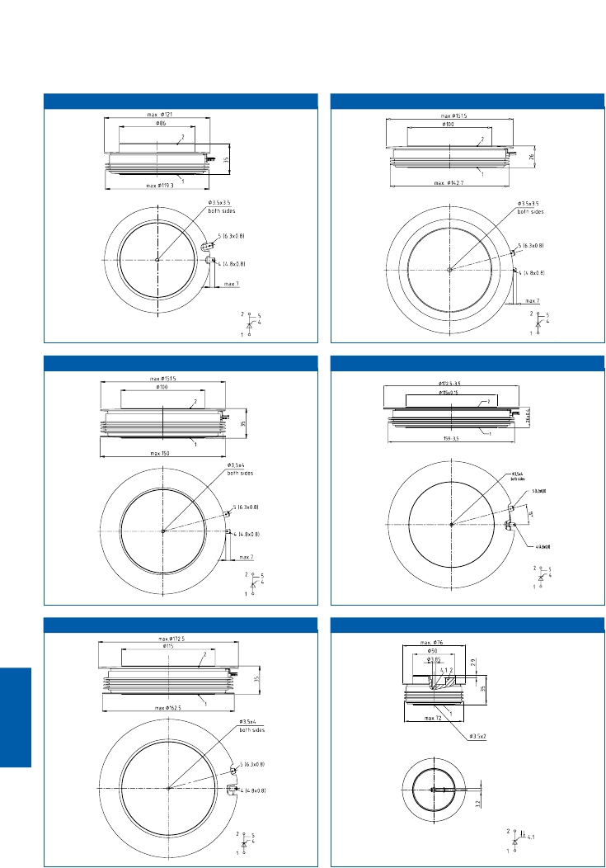

T150.35K

T172.26K

T172.35K

T76.35L

7.10

T150.40L T172.40L

Presspacks

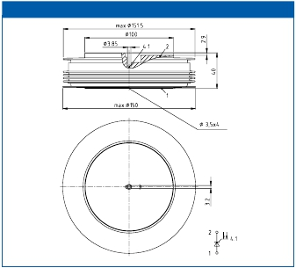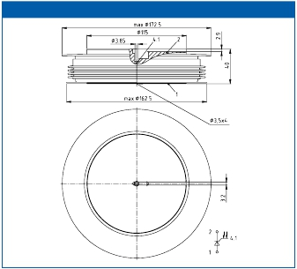

7.11

|  |  |  |
| --- | --- | --- |
| Typ | Recommended  Clamping force range [kN | Outline |
| T 281 N65 TOF  T 300 N...TOF  T 360 N...TOF  T 390 N...TOF  T 420 N...TOF  T 430 N...TOF  T 460 N...TOF  T 470 N...TOF  T 533 N...TOH  T 560 N...TOF  T 571 N65 TOF  T 580 N...TOF  T 590 N...TOF  T 600 N...TOF  T 640 N...TOF  T 660 N...TOF  T 680 N...TOF  T 690 N...TOF  T 700 N...TOF  T 720 N...TOF  T 730 N...TOF  T 731 N...TOH  T 740 N...TOF  T 830 N...TOF  T 860 N...TOF  T 880 N...TOF  T 901 N...TOF  T 920 N...TOF  T 930 N...TOF  T 940 N...TOF  T 1040 N...TOF  T 1060 N...TOF  T 1080 N...TOF  T 1081 N...TOH  T 1190 N...TOF  T 1201 N...TOH  T 1220 N...TOF  T 1330 N...TOF  T 1401 N...TOH  T 1410 N...TOF  T 1451 N...TOH  T 1500 N...TOF  T 1503 N…TOH  T 1503 NH…TOH  T 1551 N...TOH  T 1590 N...TOF  T 1601 N...TOF  T 1620 N...TOF  T 1651 N...TOH  T 1800 N...TOF  T 1851 N...TOH  T 1901 N...TOH  T 1930 N...TOF  T 1960 N...TOF  T 1971 N...TOH  T 2001 N...TOF | 7,0…12,0  2,5…5,0  5,0…10,0  3,0…6,0  5,0…10,0  4,0…8,0  7,5…17,5  4,0…8,0  15,0…24,0  5,0…10,0  15,0…24,0  3,0…6,0  6,0…12,0  15,0…24,0  6,0…12,0  10,5…21,0  6,0…12,0  4,0…8,0  10,5…21,0  9,0…18,0  18,0…43,0  15,0…24,0  10,5…21,0  9,0…18,0  20,0…45,0  10,5…21,0  15,0…24,0  5,5…8,0  20,0…45,0  10,5…21,0  16,0…32,0  30,0…50,0  8,0…16,0  36…52,0  16,0…32,0  36,0…52,0  20,0…45,0  20,0…45,0  36,0…52,0  12,0…24,0  36,0…52,0  24,0…56,0  63,0…91,0  63,0…91,0  36,0…52,0  30,0…65,0  36,0…52,0  42,0…65,0  45,0…65,0  42,0…95,0  45,0…65,0  63,0…91,0  42,0…95,0  30,0…65,0  36,0…52,0  36,0…52,0 | T58.26K  T42.14K0  T48.14K0  T42.14K0  T48.14K0  T42.14K0  T58.26K0  T42.14K0  T76.35L  T48.14K0  T75.26K  T42.14K0  T58.26K0  T75.26K0  T48.14K0  T58.26K0  T48.14K0  T42.14K0  T58.26K0  T58.26K0  T75.26K0  T76.26K  T58.14K0  T58.14K0  T75.26K0  T58.26K0  T76.26K  T48.14K0  T75.26K0  T58.14K0  T75.26K0  T100.26K0  T48.14K0  T120.26K  T75.26K0  T120.35K  T75.26K0  T75.26K0  T120.35K  T58.14K0  T120.35K  T75.26K0  T150.40L  T150.40L  T120.26K  T100.26K0  T120.35K  T111.26K0  T120.35K  T111.26K0  T120.26K  T150.35K  T111.26K0  T100.26K0  T120.26K  T120.26K |

|  |  |  |
| --- | --- | --- |
| Typ | Recommended  Clamping force range [kN | Outline |
| T 2160 N...TOF  T 2161 N...TOH  T 2180 N...TOF  T 2251 N...TOH  T 2351 N...TOH  T 2480 N...TOF  T 2510 N...TOF  T 2563 N…TOH  T 2563 NH…TOH  T 2810 N...TOF  T 2851 N...TOH  T 2871 N...TOH  T 3101 N...TOH  T 3160 N...TOF  T 3011 N...TOH  T 3401 N...TOH  T 3441 N...TOH  T 3710 N...TOF  T 3801 N...TOH  T 4003 N…TOH  T 4003 NH…TOH  T 4021 N...TOH  T 4301 N...TOF  T 4771 N...TOF | 42,0…95,0  45,0…65,0  30,0…65,0  63,0…91,0  45,0…65,0  42,0…95,0  24,0…56,0  90,0…130.0  90,0…130.0  42,0…95,0  63,0…91,0  90,0…130,0  63,0...91,0  42,0…95,0  90,0...130,0  63,0…91,0  63,0….91,0  30,0…65,0  63,0…91,0  90,0…130,0  90,0…130,0  90,0…130,0  63,0…91,0  63,0…91,0 | T111.26K0  T120.35K  T100.26K0  T150.26K  T120.26K  T111.26K0  T75.26K0  T172.40L  T172.40L  T111.26K0  T150.35K  T172.35K  T150.35K  T111.26K0  T172.26K  T150.35K  T150.26K  T100.26K0  T150.26K  T172.40L  T172.40L  T172.35K  T150.35K  T150.26K |

7.12

Presspacks

Clamping Forces for Thyristor Discs



|  |  |  |
| --- | --- | --- |
| Type | Outline | Packing units |
| T 280 N...TOF  T 300 N...TOF  T 360 N...TOF  T 390 N...TOF  T 420 N...TOF  T 430 N...TOF  T 460 N...TOF  T 470 N...TOF  T 533 N...TOH  T 560 N...TOF  T 570 N...TOF  T 580 N...TOF  T 590 N...TOF  T 600 N...TOF  T 640 N...TOF  T 660 N...TOF  T 680 N...TOF  T 690 N...TOF  T 700 N...TOF  T 720 N...TOF  T 730 N...TOF  T 731 N...TOH  T 740 N...TOF  T 830 N...TOF  T 860 N...TOF  T 880 N...TOF  T 901 N...TOF  T 920 N...TOF  T 930 N...TOF  T 940 N...TOF  T 1040 N...TOF  T 1060 N...TOF  T 1080 N...TOF  T 1081 N...TOH  T 1190 N...TOF  T 1201 N...TOH  T 1220 N...TOF  T 1330 N...TOF  T 1401 N...TOH  T 1410 N...TOF  T 1451 N...TOH  T 1500 N...TOF  T 1503 N...TOH  T 1503 NH...TOH  T 1551 N...TOH  T 1590 N...TOF  T 1601 N...TOF  T 1620 N...TOF  T 1651 N...TOH  T 1800 N...TOF  T 1851 N...TOH  T 1901 N...TOH  T 1930 N...TOF  T 1960 N...TOF  T 1971 N...TOH  T 2001 N...TOF | T58.26K0  T42.14K0  T48.14K0  T42.14K0  T48.14K0  T42.14K0  T58.26K0  T42.14K0  T76.35L  T48.14K0  T75.26K0  T42.14K0  T58.26K0  T75.26K0  T48.14K0  T58.26K0  T48.14K0  T42.14K0  T58.26K0  T58.26K0  T75.26K0  T76.26K  T58.14K0  T58.14K0  T75.26K0  T58.26K0  T76.26K  T48.14K0  T75.26K0  T58.14K0  T75.26K0  T100.26K0  T48.14K0  T120.26K  T75.26K0  T120.35K  T75.26K0  T75.26K0  T120.35K  T58.14K0  T120.35K  T75.26K0  T150.40L  T150.40L  T120.26K  T100.26K0  T120.35K  T111.26K0  T120.35K  T111.26K0  T120.26K  T150.35K  T111.26K0  T100.26K0  T120.26K  T120.26K | 3  12  10  12  10  12  3  12  3  10  2  12  3  2  10  3  10  12  3  3  2  2  6  6  2  3  2  10  2  6  2  3  10  2  2  1  2  2  1  6  1  2  1  1  2  3  1  2  1  2  2  1  2  3  2  2 |

|  |  |  |
| --- | --- | --- |
| Type | Outline | Packing units |
| T 2160 N...TOF  T 2161 N...TOH  T 2180 N...TOF  T 2251 N...TOH  T 2351 N...TOH  T 2480 N...TOF  T 2510 N...TOF  T 2563 N...TOH  T 2563 NH...TOH  T 2810 N...TOF  T 2851 N...TOH  T 2871 N...TOH  T 3101 N...TOH  T 3160 N...TOF  T 3011 N...TOH  T 3401 N...TOF  T 3441 N...TOH  T 3710 N...TOF  T 3801 N...TOF  T 4003 N...TOH  T 4003 NH...TOH  T 4021 N...TOH  T 4301 N...TOH  T 4771 N...TOF | T111.26K0  T120.35K  T100.26K0  T150.26K  T120.26K  T111.26K0  T75.26K0  T172.40L  T172.40L  T111.26K0  T150.35K  T172.35K  T150.35K  T111.26K0  T172.26K  T150.35K  T150.26K  T100.26K0  T150.26K  T172.40L  T172.40L  T172.35K  T150.35K  T150.26K | 2  1  3  1  2  2  2  1  1  2  1  1  1  2  1  1  1  3  1  1  1  1  1  1 |

7.13

Presspacks

Package Units Thyristor Discs



|  |  |  |  |  |
| --- | --- | --- | --- | --- |
| Disc outline/page                          Type  T42.14K0/7.8  T48.14K0/7.8  T58.14K0/7.8                            GATELEAD  T58.26K0/7.8                        L=750/0,5 MP  T75.26K0/7.9  T100.26K0/7.9  T111.26K0/7.9 | Color  red/white | Connector [mm]  4,8x0,5/2,8x0,5 | Length [mm]  750 | Ordering Code  SP000983448 |
| T120.26K/7.9  T120.35K/7.10                         GATELEAD  T150.26K/7.10                      L=750/0,8 HP  T150.35K/7.10  T172.26K/7.10 | red/white | 6,3x0,8/4,8x0,8 | 750 | SP000983442 |

Standard Gate Leads for Disc Type Devices

Presspacks

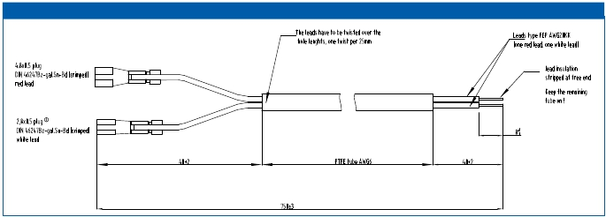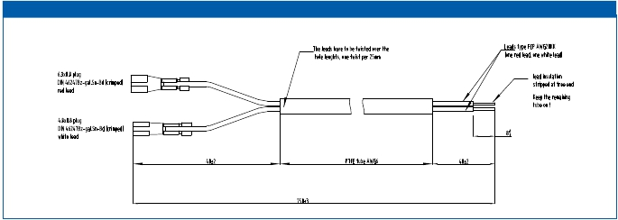

Leads and gate leads must be ordered separately

Gatelead L=750/0,5 MP

Gatelead L=750/0,8 HP

7.14

|  |  |  |
| --- | --- | --- |
| device  for type                  Outline/page | laser diode  Salesname                    Ordering Code | light fiber  Salesname                      length [mm]              Ordering Code |
| T533N                    T76.35L/7.10  T1503N(H)            T150.40L/7.11  T2563N(H)            T172.40L/7.11  T4003N(H)            T172.40L/7.11 | LASERDI SPL-PL90 A     SP000091118  LASERDI SPL-PL90 A     SP000091118  LASERDI SPL-PL90 A     SP000091118  LASERDI SPL-PL90 A     SP000091118 | LWL R10LR50L3000 A 3000                          SP000091119  LWL R10 LR87-L3000     3000                          SP000091117  LWL R10 LR87-L3000     3000                          SP000091117  LWL R10 LR87-L3000     3000                          SP000091117 |

Laser Diode and Light Fiber

Presspacks



for light triggered Thyristors (LTT)

laser diodes and light fibers must be ordered separately

7.15

7.16

Presspacks

D471N

D2601ND2601NH

D711N

D1481N

D3040N

D3001ND3041N

D6001N

D740N

D1800N

D3501N

D850N

D270N

D820N

D1030N

D2200N

D950N

D2520N

D2650N

D4201N

D4810N

D1230N

D1050N

D2450N

D5810N

D8320N

30mm

48mm

34/36mm

58mm

50mm

75mm

65mm

100mm

75mm

111mm

86mm

120mm

100mm

150mm

OverviewRectifierinDiscHousings

VRRM

9000V

6800V

5000V

4800V

4200V

3800V

3600V

2800V

2600V

2400V

2200V

2000V

D770N

1800V

1400V

600V

D650N

D970N

Contact

Ø

23mm

CaseØ

42mm



|  |  |  |  |  |  |  |  |  |  |
| --- | --- | --- | --- | --- | --- | --- | --- | --- | --- |
| up  to  3000  V | | | | | | | | | |
| Type | VRRM  [V]  VDSM=VDRM  VRSM =  VRRM + 50 V | IFSM  [kA]  @10 ms,  Tvj max | 2  ∫i dt  2                  3  [A s ·10 ]  @10ms  Tvj max | IFAVM/Tc  [A/°C]  @ 180° el sin | V(TO)  [V]  @Tvj max | rT  [mΩ]  @Tvj max | RthJC  [K/kW]  @ 180°  el sin | Tvjmax  [°C] | Outline /  page |
| D 121 N 20 B  D 121 K 20 B  D 251 N 20 B  D 251 N 20 E  D 251 K 20 B  D 251 K 20 E  D 400 N 20 B  D 400 K 16 B  D 770 N 20 T  D 820 N 28 T  D 950 N 22 T  D 1030 N 26 T  D 2200 N 24 T VF  D 2520 N 22 T VF  D 2650 N 24 T  D 4201 N 22 T  D 4810 N 28 T VF | 2000  2000  2000  2000  2000  2000  2000  1600  2000  2800  2200  2600  2400  2200  2400  2200  2800 | 2,6  2,4  5,3  5,3  4,7  4,7  9,8  9,8  6,0  9,0  10,3  14,5  35,0  35,0  33,5  73,5  60,0 | 33,8  28,8  140,5  140,5  110,5  110,5  480,2  480,2  180,0  405,0  525,0  1051,0  6125,0  6125,0  5611,0  27000,0  18000,0 | 120/130  120/113  250/130  250/130  250/102  250/102  400/130  400/130  767/100  818/100  950/100  1030/100  2200/100  2520/100  2650/100  4830/100  4710/100 | 0,72  0,72  0,80  0,80  0,80  0,80  0,70  0,70  0,81  0,83  0,70  0,82  0,83  0,73  0,82  0,67  0,83 | 1,90  1,90  0,85  0,85  0,85  0,85  0,62  0,62  0,54  0,52  0,50  0,28  0,15  0,10  0,15  0,08  0,06 | 324,0  434,0  151,0  151,0  236,0  236,0  95,0  95,0  57,0  39,0  45,0  38,0  17,0  22,0  16,9  9,2  8,0 | 180  180  180  180  180  180  180  180  180  160  180  160  160  175  180  160  160 | DSW27/7.22  DSW27/7.22  DSW27/7.22  DFL36/7.22  DSW27/7.22  DFL36/7.22  DSW41/7.22  DSW41/7.22  D42.14K0/7.23  D42.14K0/7.23  D42.14K0/7.23  D48.14K0/7.23  D75.26K0/7.24  D75.26K0/7.24  D75.26K0/7.24  D120.26K/7.24  D111.26K0/7.24 |

|  |  |  |  |  |  |  |  |  |  |
| --- | --- | --- | --- | --- | --- | --- | --- | --- | --- |
| up  to  800  V | | | | | | | | | |
| Type | VRRM  [V]  VDSM=VDRM  VRSM =  VRRM + 50 V | IFSM  [kA]  @10 ms,  Tvj max | 2  ∫i dt  2                  3  [A s ·10 ]  @10ms  Tvj max | IFAVM/Tc  [A/°C]  @ 180° el sin | V(TO)  [V]  @Tvj max | rT  [mΩ]  @Tvj max | RthJC  [K/kW]  @ 180°  el sin | Tvjmax  [°C] | Outline /  page |
| D 255 N 08 B  D 255 K 08 B  D 650 N 08 T  D 970 N 08 T  D 2450 N 06 T  D 5810 N 06 T VF  D 8320 N 06 T VF | 800  800  800  800  600  600  600 | 4,6  4,0  5,1  8,8  28,5  70,0  95,0 | 106  80  130  387  4061  24500  45000 | 255/110  255/75  651/100  972/100  2452/100  5800/58  8320/56 | 0,65  0,65  0,70  0,70  0,70  0,70  0,70 | 0,85  0,85  0,51  0,31  0,10  0,04  0,02 | 230,0  345,0  81,0  57,0  25,3  17,0  12,5 | 180  180  180  180  180  180  180 | DSW27/7.22  DSW27/7.22  D42.14K0/7.23  D42.14K0/7.23  D58.14K0/7.23  D75.26K0/7.24  D100.26K0/7.24 |

|  |  |  |  |  |  |  |  |  |  |
| --- | --- | --- | --- | --- | --- | --- | --- | --- | --- |
| up  to  1800  V | | | | | | | | | |
| Type | VRRM  [V]  VDSM=VDRM  VRSM =  VRRM + 50 V | IFSM  [kA]  @10 ms,  Tvj max | 2  ∫i dt  2                  3  [A s ·10 ]  @10ms  Tvj max | IFAVM/Tc  [A/°C]  @ 180° el sin | V(TO)  [V]  @Tvj max | rT  [mΩ]  @Tvj max | RthJC  [K/kW]  @ 180°  el sin | Tvjmax  [°C] | Outline /  page |
| D 452 N 18 E VF  D 452 K 18 E  D 1230 N 18 T  D 1050 N 18 T | 1800  1800  1800  1800 | 10,8  10,8  11,8  18,5 | 583  583  696  1710 | 450/130  450/130  1234/100  1050/130 | 0,77  0,77  0,81  0,81 | 0,48  0,48  0,28  0,17 | 85,5  85,5  39,0  38,0 | 180  180  180  180 | DFL54/7.22  DFL54/7.22  D48.14K0/7.23  D58.26K0/7.23 |



7.17

Presspacks

Rectifier Diodes

...VF -> VF-class printed on housing

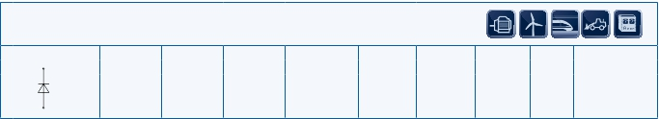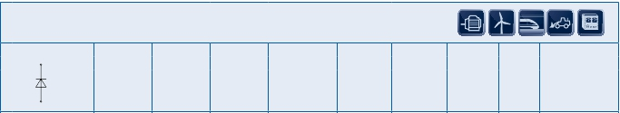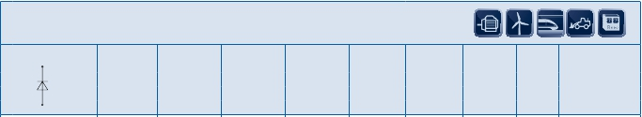

|  |  |  |  |  |  |  |  |  |  |
| --- | --- | --- | --- | --- | --- | --- | --- | --- | --- |
| up  to  5000  V | | | | | | | | | |
| Type | VRRM  [V]  VDSM=VDRM  VRSM =  VRRM + 50 V | IFSM  [kA]  @10 ms,  Tvj max | 2  ∫i dt  2                  3  [A s ·10 ]  @10ms  Tvj max | IFAVM/Tc  [A/°C]  @ 180° el sin | V(TO)  [V]  @Tvj max | rT  [mΩ]  @Tvj max | RthJC  [K/kW]  @ 180°  el sin | Tvjmax  [°C] | Outline /  page |
| D 270 N 36 T  D 475 N 36 B  D 740 N 48 T  D 850 N 40 T  D 1800 N 48 T  D 3501 N 42 T  D 5201 N 50 T  D 6001 N 50 T | 3600  3600  4800  4000  4800  4200  5000  5000 | 4,0  10,9  11,0  12,8  27,5  56,0  110,0  110,0 | 80  594  605  819  3781  15700  60500  60500 | 270/100  475/100  750/100  850/100  1800/100  3690/100  5170/100  6070/100 | 0,86  0,77  0,85  0,84  0,85  0,73  0,63  0,80 | 1,54  0,61  0,65  0,49  0,25  0,13  0,09  0,09 | 98,0  85,0  39,0  38,0  16,9  9,2  5,8  4,6 | 150  160  160  160  160  160  160  160 | D58.26K0/7.23  DSW41.1/7.22  D58.26K0/7.23  D58.26K0/7.23  D75.26K0/7.24  D120.35K/7.24  D150.35K/7.25  D150.26K/7.25 |

|  |  |  |  |  |  |  |  |  |  |
| --- | --- | --- | --- | --- | --- | --- | --- | --- | --- |
| up to 10000 V | | | | | | | | | |
| Type | v  [V]  VDSM=VDRM  VRSM =  VRRM + 50 V | IFSM  [kA]  @10 ms,  Tvj max | 2  ∫i dt  2                  3  [A s ·10 ]  @10ms  Tvj max | IFAVM/Tc  [A/°C]  @ 180° el sin | V(TO)  [V]  @Tvj max | rT  [mΩ]  @Tvj max | RthJC  [K/kW]  @ 180°  el sin | Tvjmax  [°C] | Outline /  page |
| D 711 N 68 T  D 1481 N 68 T  D 3001 N 68 T  D 3040 N 68 T  D 3041 N 68 T  D 471 N 90 T  D 2601 N 90 T | 6800  6800  6800  6800  6800  9000  9000 | 10,5  24,5  53,0  53,0  53,0  10,0  50,0 | 550  3000  14040  14040  14040  500  12500 | 790/100  1650/100  2900/100  3040/100  3040/100  565/100  2240/100 | 0,84  0,75  0,84  0,84  0,84  1,04  0,94 | 0,87  0,42  0,22  0,22  0,22  1,78  0,41 | 31,5  15,8  9,2  7,3  8,55  31,5  8,55 | 160  160  160  160  160  160  160 | D58.26K/7.23  D76.26K/7.24  D120.35K/7.24  D111.26K0/7.24  D120.26K/7.24  D58.26K/7.23  D120.26K/7.24 |

|  |  |  |  |  |  |  |  |  |  |
| --- | --- | --- | --- | --- | --- | --- | --- | --- | --- |
| up  to  600  V | | | | | | | | | |
| Type | VRRM  [V]  VDSM=VDRM  VRSM =  VRRM + 50 V | IFSM  [kA]  @10 ms,  Tvj max | 2  ∫i dt  2                  3  [A s ·10 ]  @10ms  Tvj max | IFAVM/Tc  [A/°C]  @ 180° el sin | V(TO)  [V]  @Tvj max | rT  [mΩ]  @Tvj max | RthJC  [K/kW]  @ 180°  el sin | Tvjmax  [°C] | Outline /  page |
| 25 DN 06  38 DN 06  46 DN 06  56 DN 06  56 DN 06 B01  65 DN 06 | 600  600  600  600  600  600 | 12,8  32,3  52,0  70,0  70,0  95,0 | 813  5200  13500  24500  24500  45000 | 1145/155  3885/120  5100/118  6400/116  8400/110  8470/98 | 0,70  0,66  0,70  0,70  0,66  0,70 | 0,19  0,06  0,05  0,04  0,04  0,03 | 17,40  12,40  9,35  6,20  5,8  4,70 | 180  180  180  180  180  180 | 25DN06/7.25  38DN06/7.25  46DN06/7.25  56DN06/7.25  56DN06B01/7.25  65DN06/7.25 |



7.18

Presspacks

Rectifier Diodes

Welding Diodes

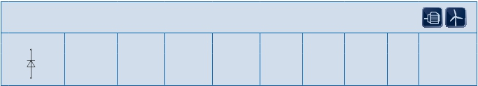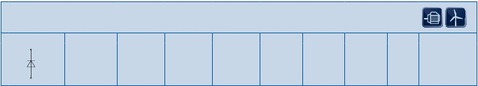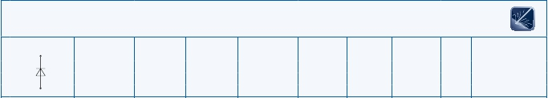

7.19

OverviewIGCT/IGBT-FreewheelingDiodes&FastRectifierDiodes

FastRectiﬁer

D931SH

D1130SH

D1951SH

D1131SH

IGBTFW

IGCTFW

VRRM

6500V

4500V

D350SH

D911SH

D1031SH

D1330SH

D1960SH

D1121SH

D1331SH

D1301SH

D1961SH

D56S

D56U

2600V

D690S

2400V

2000V

1800V

D450S

1600V

1400V

D650S

1200V

Contact

36mm

58mm

75mm

100mm

50mm

63mm

Ø

–

23mm

75mm

111mm

86mm

120mm

100mm

150mm

CaseØ

DSW27.2

42mm

Presspacks

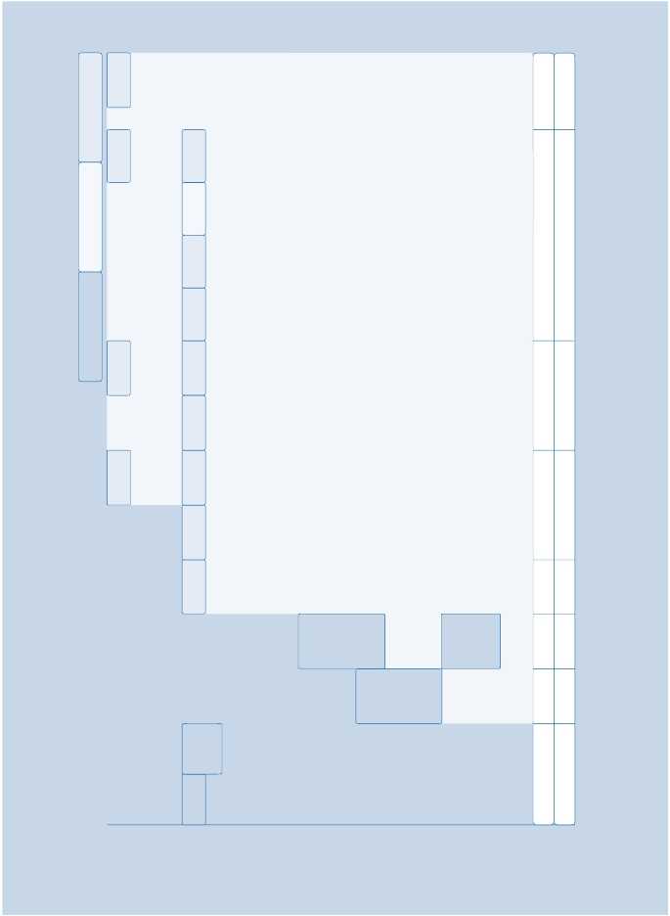

|  |  |  |  |  |  |  |  |  |  |  |
| --- | --- | --- | --- | --- | --- | --- | --- | --- | --- | --- |
|  | | | | | | | | | | |
| Type | VRRM  [V] | VR(D)  *  [kV]  Tc=25 | I(FSM)  [kA]  sin, 10 ms  Tvj max | 2  ∫i dt  2                    3  [A s · 10 ]  sin, 10 ms  Tvj max | VF  [V]  @IF=2,5 kA  Tvj max | IRM  [A]**  @di/dt =  1000 A/µs,  IFM=2,5kA,  Tvj max | Qrr  **  [mAs]  @di/dt =  1000 A/µs,  IFM =2,5kA,  Tvj max | RthJC  [K/kW]  @DC | Tvj max  [°C] | Outline /  page |
| u     D 350 SH45 T  D 911 SH45 T  D 1031 SH45 T  D 1121 SH45 T  D 1330 SH45 T  D 1331 SH45 T  D 1960 SH45 T  D 1961 SH45 T  D 931 SH45 T  D 1130 SH65 T  D 1131 SH65 T  D 1951 SH65 T | 4500  4500  4500  4500  4500  4500  4500  4500  6500  6500  6500  6500 | 2,8  2,8  2,8  2,8  2,8  2,8  2,8  2,8  3,2  3,2  3,2  3,2 | 13  17  23  17,5  28  28  40  40  16  22  22  44 | 845  1445  2645  1530  3920  3920  8000  8000  1280  2400  2400  9680 | 4,5  6,0  4,2  5,6  4,2  4,2  2,5  2,5  5,6  5,6  5,6  4,0 | tbd  1200  1500  1200  1500  1500  2250  2250  1300  1300  1300  1800 | tdb  2,8  3,5  3,5  3,5  3,5  12,0  12,0  3,5  3,5  3,5  5,0 | 41,3  10,0  10,0  7,5  7,3  7,5  7,3  7,5  10,0  7,3  7,5  4,5 | 140  140  140  140  140  140  140  140  140  140  140  140 | D75.26K/7.23  D100.26K/7.24  D100.26K/7.24  D120.26K/7.24  D111.26K0/7.24  D120.26K/7.24  D111.26K0/7.24  D120.26K/7.24  D100.26K/7.24  D111.26K0/7.24  D120.26K/7.24  D150.26K/7.25 |

|  |  |  |  |  |  |  |  |  |  |  |
| --- | --- | --- | --- | --- | --- | --- | --- | --- | --- | --- |
|  | | | | | | | | | | |
| Type | VRRM  [V] | VR(D)  *  [kV]  Tc=25 | I(FSM)  [kA]  sin, 10 ms  Tvj max | 2  ∫i dt  2                    3  [A s · 10 ]  sin, 10 ms  Tvj max | VF  [V]  @IF=2,5 kA  Tvj max | IRM  [A]**  @di/dt =  5000 A/µs,  IFM=2,5kA,  Tvj max | Qrr  **  [mAs]  @di/dt =  5000 A/µs,  IFM =2,5kA,  Tvj max | RthJC  [K/kW]  @DC | Tvj max  [°C] | Outline /  page |
| u     D 1301 SH45T | 4500 | 2,8 | 28 | 3920 | 4,0 | 3600 | 6,0 | 7,5 | 140 | D120.26K/7.24 |



u New type

Presspacks

IGCT – Freewheeling Diodes

*) Estimated failure rate l ~ 100 fit    **) Clamp circuit L = 0,25 µH

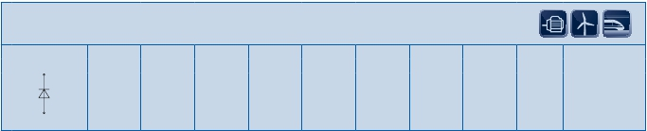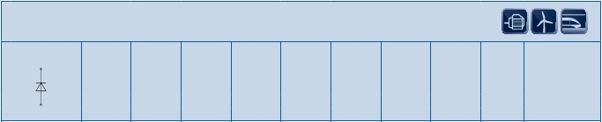

u New type

IGBT – Freewheeling Diodes

*) Estimated failure rate l ~ 100 fit    **) Clamp circuit L = 0,25 µH

7.20

|  |  |  |  |  |  |  |  |  |  |  |
| --- | --- | --- | --- | --- | --- | --- | --- | --- | --- | --- |
| up  to  2600  V | | | | | | | | | | |
| Type | VRRM  [V]  VDSM=VDRM  VRSM =  VRRM + 50 V | IFSM  [kA]  @10 ms,  Tvj max | 2  ∫i dt  2                  3  [A s ·10 ]  @10ms  Tvj max | IFAVM/Tc  [A/°C]  @ 180°  el sin | VTO  [V]  @Tvj max | rT  [mΩ]  @Tvj max | IRM  [A]  @iF = IFAVM,  di/dt =  50 A/µs | RthJC  [K/kW]  @180 °  el sin | Tvj max  [°C] | Outline /  page |
| D 450 S20T  D 690 S26T | 2000  2600 | 4,6  11,5 | 106  661 | 443/100  690/100 | 1,0  1,0 | 0,9  0,5 | 160  230 | 57  39 | 150  150 | D42.14K0/7.23  D58.26K0/7.23 |

|  |  |  |  |  |  |  |  |  |  |  |
| --- | --- | --- | --- | --- | --- | --- | --- | --- | --- | --- |
| up  to  6000  V | | | | | | | | | | |
| Type | VRRM  [V]  VDSM=VDRM  VRSM =  VRRM + 50 V | IFSM  [kA]  @10 ms,  Tvj max | 2  ∫i dt  2                  3  [A s ·10 ]  @10ms  Tvj max | IFAVM/Tc  [A/°C]  @ 180°  el sin | VTO  [V]  @Tvj max | rT  [mΩ]  @Tvj max | IRM  [A]  @iF=150A,  di/dt =  200 A/µs | RthJC  [K/kW]  @180 °  el sin | Tvj max  [°C] | Outline /  page |
| D 56 S45C  D 56 U45C | 4500  4500 | 1,35  1,2 | 9,1  7,2 | 56/85  56/73 | 1,64  1,64 | 8  8 | 230  230 | 260  340 | 125  125 | DSW27.2/7.22  DSW27.2/7.22 |

|  |  |  |  |  |  |  |  |  |  |  |
| --- | --- | --- | --- | --- | --- | --- | --- | --- | --- | --- |
| up  to  1800  V | | | | | | | | | | |
| Type | VRRM  [V]  VDSM=VDRM  VRSM =  VRRM + 50 V | IFSM  [kA]  @10 ms,  Tvj max | 2  ∫i dt  2                  3  [A s ·10 ]  @10ms  Tvj max | IFAVM/Tc  [A/°C]  @ 180°  el sin | VTO  [V]  @Tvj max | rT  [mΩ]  @Tvj max | IRM  [A]  @iF = IFAVM,  di/dt =  50 A/µs | RthJC  [K/kW]  @180 °  el sin | Tvj max  [°C] | Outline /  page |
| D 650 S14T | 1400 | 10,1 | 510 | 650/96 | 1,0 | 0,45 | 122 | 48 | 150 | D58.26K0/7.23 |



7.21

Presspacks

Fast Rectifier Diodes

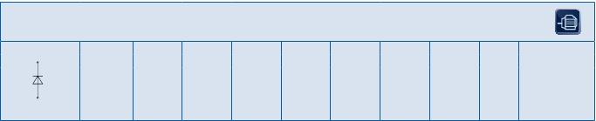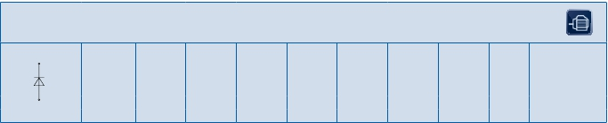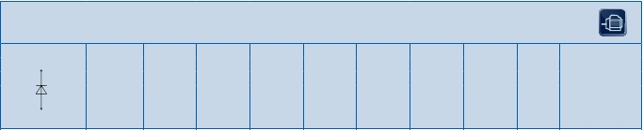

Outlines

Presspacks

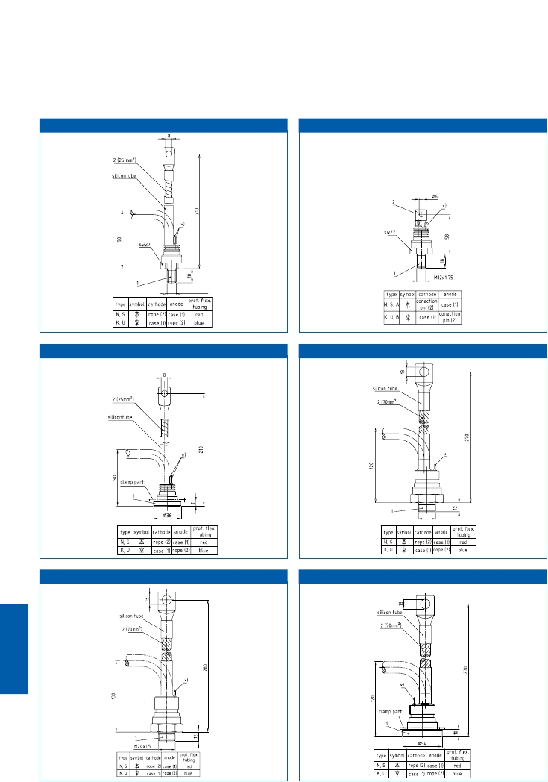

DSW27 DSW27.2

M12 x 1,75

DFL36

DSW41

M24x1,5

DSW41.1 DFL54

x) = evacuation pipe

7.22

D42.14K0

Presspacks

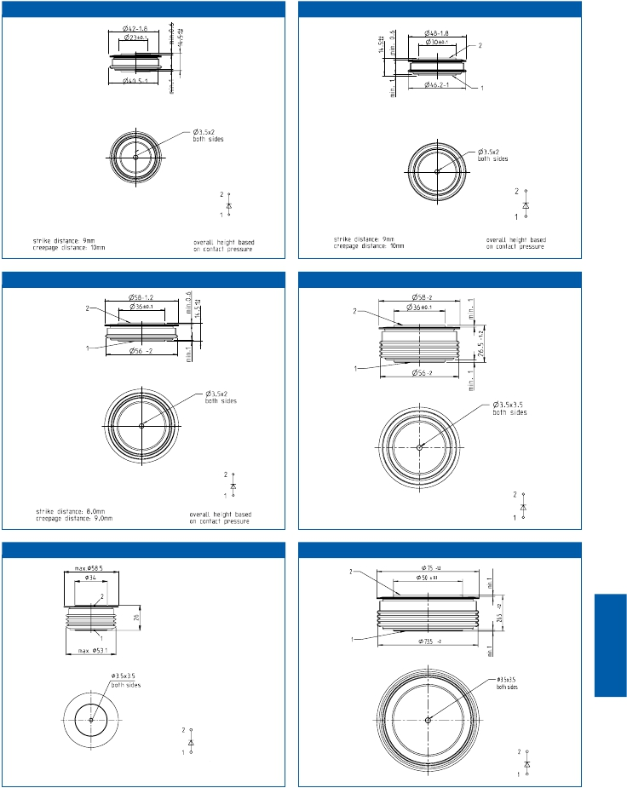

D48.14K0

D58.14K0

D58.26K0

D58.26K

D75.26K0

x) = evacuation pipe

7.23

D76.26K

Presspacks

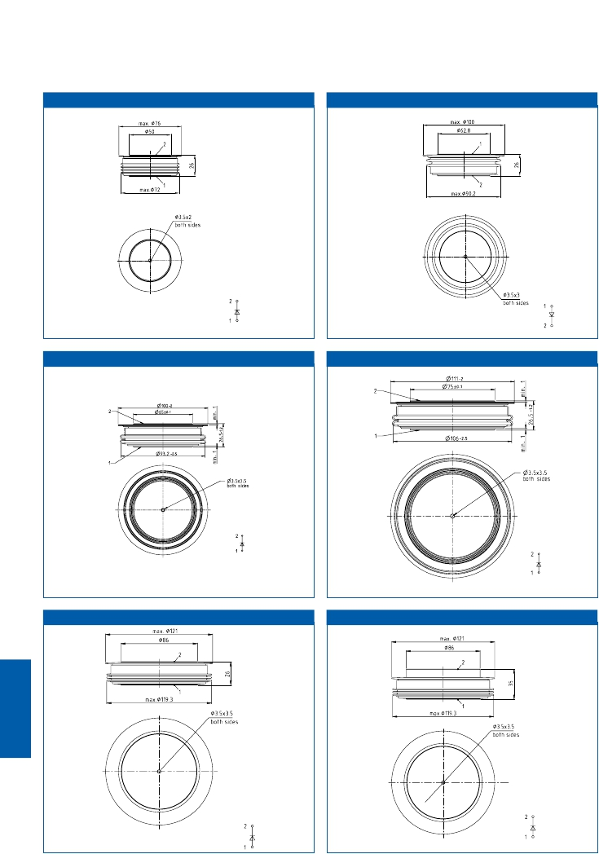

D100.26K

D100.26K0 D111.26K0

D120.26K D120.35K

7.24

|  |  |  |  |
| --- | --- | --- | --- |
| 2  a  b                                                              2  1  1 | | | |
| Designation | a [mm] | b [mm] | c [mm] |
| 25DN06 | Ø 22 | Ø 25 | 3,6 |
| 38DN06 | Ø 34 | Ø 38 | 4,0 |
| 46DN06 | Ø 43 | Ø 46 | 4,0 |
| 56DN06 | Ø 50 | Ø 56 | 5,0 |
| 56DN06B01 | Ø 50 | Ø 56 | 5,0 |
| 65DN06 | Ø 58 | Ø 65 | 5,0 |

D150.26K D150.35K

c

Presspacks

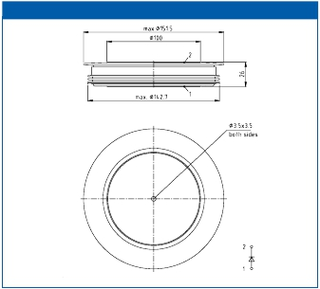

7.25

welding diodes

|  |  |  |  |
| --- | --- | --- | --- |
| Typ | Recommended  Clamping force  range [kN] | Disc diameter  [mm] | Outline |
| D 270 N...T  D 471 N...T  D 711 N...T  D 740 N...T  D 770 N...T  D 820 N...T  D 850 N...T  D 950 N...T  D 970 N...T  D 1030 N...T  D 1050 N...T  D 1230 N...T  D 1481 N...T  D 1800 N...T  D 2200 N...T  D 2450 N...T  D 2520 N...T  D 2601 N...T  D 2601 NH…T  D 2650 N...T  D 3001 N...T  D 3040 N...T  D 3041 N...T  D 3501 N...T  D 4201 N...T  D 4810 N...T  D 5201 N...T  D 5810 N...T  D 6001 N...T  D 8320 N...T | 3,2…7,6  10,0…16,0  10,0…16,0  10,0…24,0  3,2…7,6  6,0…15,0  10,0…24,0  6,0…12,0  3,8…7,6  10,0…24,0  10,0…24,0  6,0…15,0  15,0…36,0  24,0…60,0  24,0…60,0  12.0…24,0  15,0…24,0  36,0…52,0  36,0…52,0  24,0…60,0  36,0…52,0  42,0…95,0  36,0…52,0  36,0…52,0  36,0…52,0  42,0…95,0  63,0…91,0  30,0…60,0  63,0…91,0  40,0…80,0 | 58  58  58  58  42  48  58  42  42  58  58  48  75  75  75  58  75  120  120  75  120  111  120  120  120  111  150  75  150  100 | D58.26K0  D58.26K  D58.26K  D58.26K0  D42.14K0  D48.14K0  D58.26K0  D42.14K0  D42.14K0  D58.26K0  D58.26K0  D48.14K0  D76.26K  D75.26K0  D75.26K0  D58.14K0  D75.26K0  D120.26K  D120.26K  D75.26K0  D120.35K  D111.26K0  D120.26K  D120.35K  D120.35K  D111.26K0  D150.35K  T75.26K0  D150.26K  D100.26K0 |

Clamping Forces for Diode Discs

Presspacks



7.26

Rectifier Diodes

|  |  |  |  |
| --- | --- | --- | --- |
| Typ | Recommended  Clamping force  range [kN] | Disc diameter  [mm] | Outline |
| D 350 SH  D 911 SH  D 931 SH  D 1031 SH  D 1121 SH  D 1130 SH  D1131 SH  D 1330 SH  D 1331 SH  D 1951 SH  D 1960 SH  D 1961 SH | 15,0…24,0  27,0…45,0  27,0…45,0  27,0…45,0  36,0…52,0  42,0…95,0  36,0…52,0  42,0…95,0  36,0…52,0  55,0…91,0  42,0…95,0  36,0…52,0 | 75  100  100  100  120  111  120  111  120  150  111  120 | D75.26K0  D100.26K  D100.26K  D100.26K  D120.26K  D111.26K0  D120.26K  D111.26K0  D120.26K  D150.26K  D111.26K0  D120.26K |

|  |  |  |
| --- | --- | --- |
| Typ | Recommended  Clamping force  range [kN] | Disc diameter  [mm] |
| 25 DN 06  38 DN 06  46 DN 06  56 DN 06  56 DN 06 B01  65 DN 06 | 4,0…8,0  20,0…30,0  30,0…45,0  40,0…60,0  40,0…60,0  55,0…80,0 | 25  38  46  56  56  65 |

|  |  |  |  |
| --- | --- | --- | --- |
| Typ | Recommended  Clamping force  range [kN] | Disc diameter  [mm] | Outline |
| D 450 S  D 650 S  D 690 S | 3,2…7,6  6,0…14,5  10,0…24,0 | 42  58  58 | D42.14K0  D58.26K0  D58.26K0 |

|  |  |  |  |
| --- | --- | --- | --- |
| Typ | Recommended  Clamping force  range [kN] | Disc diameter  [mm] | Outline |
| D 1301 SH | 36,0…52,0 | 120 | D120.26K |

Clamping Forces for Diode Discs

Presspacks



7.27

Welding Diodes

IGCT-Freewheeling Diodes

IGBT-Freewheeling Diodes

Fast Rectifier Diodes

|  |  |  |
| --- | --- | --- |
| Type | Outline | Packing units |
| D 270 N  D 471 N  D 711 N  D 740 N  D 770 N  D 820 N  D 850 N  D 950 N  D 970 N  D 1030 N  D 1050 N  D 1230 N  D 1481 N  D 1800 N  D 2200 N  D 2450 N  D 2520 N  D 2601 N  D 2601 NH  D 2650 N  D 3001 N  D 3040 N  D 3041 N  D 3501 N  D 4201 N  D 4810 N  D 5201 N  D 5810 N  D 6001 N  D 8320 N  D 350 SH  D 911 SH  D 931 SH  D 1031 SH  D 1121 SH  D 1130 SH  D1131 SH  D 1330 SH  D 1331 SH  D 1951 SH  D 1960 SH  D 1961 SH  D 1301 SH  D 450 S  D 650 S  D 690 S | D58.26K0  D58.26K  D58.26K  D58.26K0  D42.14K0  D48.14K0  D58.26K0  D42.14K0  D42.14K0  D58.26K0  D58.26K0  D48.14K0  D76.26K  D75.26K0  D75.26K0  D58.14K0  D75.26K0  D120.26K  D120.26K  D75.26K0  D120.35K  D111.26K0  D120.26K  D120.35K  D120.35K  D111.26K0  D150.35K  D75.26K0  D150.26K  D100.26K0  D75.26K0  D100.26K  D100.26K  D100.26K  D120.26K  D111.26K0  D120.26K  D111.26K0  D120.26K  D150.26K  D111.26K0  D120.26K  D120.26K  D42.14K0  D58.26K0  D58.26K0 | 3  3  3  3  12  10  3  12  12  3  3  10  2  2  2  6  2  2  2  2  1  2  2  1  1  2  1  2  1  3  2  3  3  3  2  2  2  2  2  1  2  2  2  12  3  3 |

7.28

Presspacks

Package Units for Diode Discs



|  |  |  |  |  |  |  |  |
| --- | --- | --- | --- | --- | --- | --- | --- |
| Salesname | Packing Units | Clamping force  [kN] | Disc diameter  [mm] | height [mm] | min. creeping  distance [mm] | Ordering Code | Outline/page |
| V50-14.45M  V50-14.45N  V50-14.60M  V50-14.60N  V61-14.80M  V61-14.80N  V72-14.150M  V72-26.80M  V72-26.120M  V72-26.150M  V89-26.170N  V89-26.300N  V89-26.400N  V100-35.200N | 21  14  21  14  12  12  10  10  10  10  4  4  4  3 | 4,5  4,5  6,0  6,0  8,0  8,0  15,0  8,0  12,0  15,0  17,0  30,0  40,0  20,0 | 42  42  42  42  48  48  58  58  58  58  75  75  75  75 | 14  14  14  14  14  14  14  26  26  26  26  26  26  26 | 11  11  11  11  11  11  11  23  23  23  26  26  26  26 | SP000096563  SP000090625  SP000096564  SP000090626  SP000096565  SP000090627  SP000096566  SP000096569  SP000096567  SP000096568  SP000358597  SP000090624  SP000090662  SP000090635 | V50…M/7.30  V50…N/7.30  V50…M/7.30  V50…N/7.30  V61…M/7.30  V61…N/7.30  V72…M/7.31  V72…M/7.31  V72…M/7.31  V72…M/7.31  V89…N/7.31  V89…N/7.31  V89…N/7.31  V100…N/7.31 |

7.29

Presspacks

Clamping Units for Disc Type Devices



|  |  |  |  |  |  |
| --- | --- | --- | --- | --- | --- |
| Zyl. Bolt  M6*35 DIN 84-5.8  equal to  Cell-hights  Possible Outlets  for Thyristor-  Control Leads | | | | | |
| type designation | ordering code | clamping  force [kN] | suitable for Ø  [mm] housings | height  [mm] | minimum creepage  [mm] distance |
| V61-14.80N | SP000090627 | 8.0 | 48 | 14 | 11 |

|  |  |  |  |
| --- | --- | --- | --- |
| Zyl. Bolt  M5*30 DIN 84-5.8  2                                                                                                       23,5  24,5  14  5.5  40                                                                                                                               Labeling  -                                                                                                                                                                       Possible Outlets  20         9                                                                                                                                                        for Thyristor-  Control Leads  50  46  49  73 | | | |
| type designation | ordering code | clamping  force [kN] | suitable for Ø     height     minimum creepage  [mm] housings     [mm]              [mm] distance |
| V50-14.45N | SP000090625 | 4.5 | 42                         14                                 11 |
| V50-14.60N | SP000090626 | 6.0 | 42                         14                                 11 |

|  |  |  |  |  |  |
| --- | --- | --- | --- | --- | --- |
| with assembled cell  Hot Connection Bolt                                            Nut  acc. to DIN 46200                                                M10 DIN 934-MS  Fastening Torque for  the Nutr: 10 Nm                                                   Zyl. Bolt  M6x35 DIN 84-6.8  equal to  6,5                                                                                         Cell-hights  Possible Outlets  for Thyristor-  Control Leads  61  55  5~~8~~ | | | | | |
| type designation | ordering code | clamping  force [kN] | suitable for Ø  [mm] housings | height  [mm] | minimum creepage  [mm] distance |
| V61-14.80M | SP000096565 | 8.0 | 48 | 14 | 11 |

|  |  |  |
| --- | --- | --- |
| Hot Connection Bolt                  M8                                                                     with assembled cell  according to DIN 46200                     Nutr B M8  Zyl.-Bolt                                                DIN 439-Ms  M5*30 DIN 84-5.8                                 Fastening Torque  6 Nm  equal to  Cell-hights  5.5  Possible Outlets  for Thyristor  Control Leads  50  46  49 | | |
| type designation     ordering code       clamping  force [kN] | suitable for Ø  [mm] housings | height     minimum creepage  [mm]              [mm] distance |
| V50-14.45M               SP000096563              4.5 | 42 | 14                                 11 |
| V50-14.60M               SP000096564              6.0 | 42 | 14                                 11 |

Outlines

~50

23.5

24.5

14

46

~60

46

25

26

14

55

Presspacks



7.30

V50..M

V50..N

V61..M

V61..N

V72-14..M V72-26..M

68

withassembledcell

14

withassembledcell

26

withassembledcell

68

72

72

68

80

withassembledcell

41.5

48

36

32

44

53.5

Presspacks

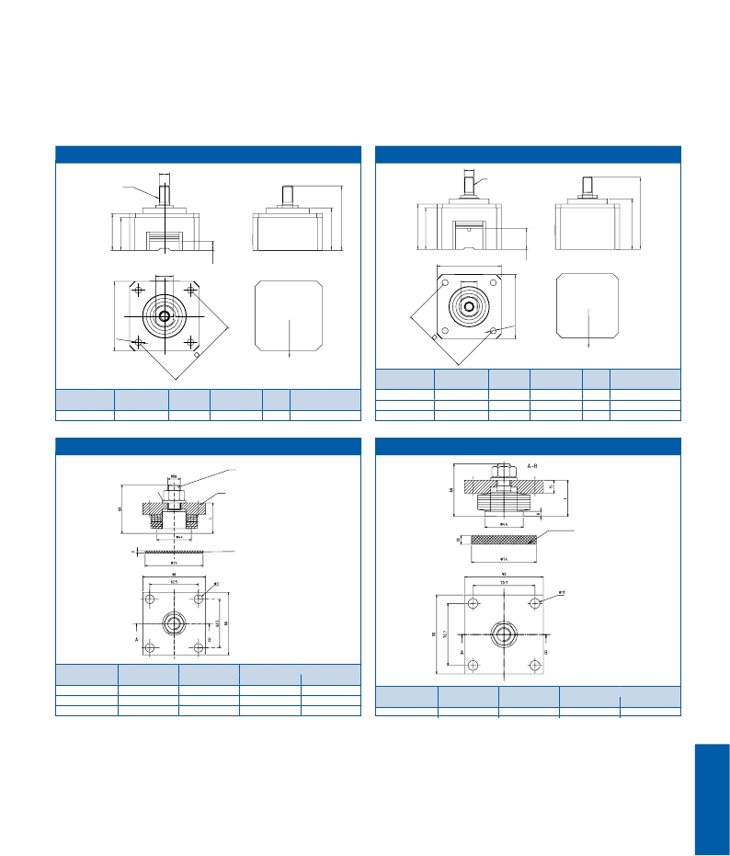

hotconnectionbolt

accordingtoDIN

46200

fasteningtorque

10Nm

M10

M10

hotconnectionbolt

accordingtoDIN

46200

fasteningtorque

10Nm

equalstocellheight

17

equalstocellheigth

68

17

possible

outlets

forthyristor-

controlleads

Ø6.5

possible

outlets

forthyristor-

controlleads

Ø6.5

type designation ordering code  clamping suitable for Ø height minimum creepage

force [kN] [mm] housings [mm] [mm] distance

V72-14.150M SP000096566 15.0 58 14 11

V 89

type designation     ordering code clamping       suitable for Ø     height     minimum creepage

force [kN]     [mm] housings     [mm]              [mm] distance

V72-26.80M   SP000096569   8.0       58      26        23

V72-26.120M  SP000096567   12.0       58      26        23

V72-26.150M  SP000096568   15.0       58      26        23

V 100

A-B

M16

Bolt

DIN 267

Zn 8 gl c B (A3K)

Washer

Clamping plate

DIN 267

Zn 8 gl c B (A3K)

pre-pressed power unit

Isolating disc

pre-pressed power unit

Isolating disc

type designation ordering code clamping force

[kN]           suitable for housings

[kN]           suitable for housings

Ø [mm] height [mm]

V89-26.170N SP000358597 17 75 26

V89-26.300N SP000090624 30 75 26

V89-26.400N SP000090662 40 75 26

type designation  ordering code  clamping force

Ø [mm]     height [mm]

V100-35.200N   SP000090635      20          75          26

7.31

|  |  |  |
| --- | --- | --- |
| Application Notes, Product Briefs,  Flyers and Brochures | Type | Redirects |
| Technical Information for Bipolar  Semiconductors (english)  Technical Information for Bipolar  Semiconductors (german)  IFBIP Company Brochure  ifbip shop  Thyristor and Diode Modules  4.5kV/6.5kV Soft recovery FWDs  for IGCTs and PP IGBTs  6.5 kV SCR series  for Medium Voltage Soft starters  540A/8 kV 2" Light triggered Thyristor  9.5 kV SCR for Medium Voltage Soft starters  Clamping Forces for disc type devices  Standard gate leads for disc type devices | Application Note  Application Note  Broschure  Webpage  Product Brief  Product Brief  Product Brief  Product Brief  Product Brief  Product Information  Product Information | <http://www.infineon.com/technical-information-appnote>  <http://www.infineon.com/technical-information-appnote-german>  <http://www.infineon.com/ifbip-company-brochure>  <http://www.ifbip-shop.com>  http://www.infineon.com/thyristor-and-diodes-product-brief  [http://www.infineon.com/sr-fwd-product-brief](http://www.infineon.com/www.infineon.com/sr-fwd-product-brief)  <http://www.infineon.com/6500v-scr-product-brief>  <http://www.infineon.com/8000v-ltt-scr-product-brief>  <http://www.infineon.com/9500v-scr-product-brief>  <http://www.infineon.com/clamping-forces-product-information>  <http://www.infineon.com/gate-leads-for-discs-product-information> |

Links

Presspacks



7.32

Business  Excellence  due  to

Explanations



Quality  Management

In  quality  and  reliability  of  our  innovative  products  and

services  for  power  electronics  we  are  a  worldwide  leading

company.

We  have  developed  and  introduced  a  quality  management

which  continuously  supervises  the  stability  and  the  per-

formance  of  our  production  and  business  progresses.  The

qualification  of  our  innovative  products  and  services  with

the  most  progressive  quality  tools  contributes  effectively

and efficiently to a positive business development.

Our  quality  management  is  permanently  brought  in  line

with the requests and expectations of our customers, part-

ners  and  employees.  The  base  are  the  standards  DIN  EN

ISO  9001:2000  and  the  ISO/TS  16949,  which  includes  the

requirements of the automobile industry. In addition to this

standards we use the EFQM-Model for Business Excellence

and  the  SIX  SIGMA  methodology  to  force  the  continual  im-

provement of our company.

Our  competent  and  qualified  employees  are  motivated  to

fulfill  the  requests  and  wishes  of  our  customers  to  their

highest satisfaction at all times.

Environmental  and  safety  management

By  the  use  of  our  products,  the  consumption  of  electrical

energy  can  be  reduced.  Following  from  this,  we  also  dur-

ing  our  parts‘  manufacturing  put  focus  on  environmental

protection  and  economical  use  of  natural  resources.  Our

means  aiming  at  environmentally  friendly  organisation

cover all production flows and the whole product range.

Our efforts regarding environmental protection are accom-

panied  by  our  activities  concerning  accident  control  and

health protection of our employees. By anticipatory protec-

tion-  and  training  courses  we  meet  the  high  responsibilty

for our employees.

We consider the consistent implementation of environmetal

protection,  health  protection,  and  operational  safety  as  a

main factor for our company‘s continued success and moni-

tor  progress  in  these  areas  regularly,  evaluate  the  results,

und set new focus points and targets.

Our  environmental  management  is  certified  as  per  DIN  EN

ISO 1400, our safety management as per OSHAS 18001.

8.1

Type designation

Explanations

IGBT  Modules MIPAQ

FF 400 R33 K F x example for an IGBT module

FZ single switch with one

IGBT and FWD

FF half bridge (two IGBTs an FWDs)

FP Power Integrated Module

FM Matrix Module

FD/DF chopper module

FB Integrated modules in B2

configuration with IGBT & NTC

DD dual diode module

FR Switched Reluctance Modul

F3L 3-level configuration

FS3L 3-level 3 phase bridge

FT tripack

F4 fourpack

F5 fivepack

FS sixpack

400 max. DC-collector current (A)

R reverse conducting

S fast Diode

33 collector-emitter-voltage in 100 V

K/H/I/M/N/O/P mechanical construction:

W/V/X/Y module

F fast switching type

H high speed IGBT

J SiC JFET

L type with low VCEsat

M MOSFET Chip

S fast short tail IGBT Chip

E low sat and fast trench IGBT

T fast trench IGBT

P soft switching trench IGBT

1…n internal reference numbers

C Emitter Controlled

D higher Diode current

F very fast Diode

G module in big housing

I integrated cooling

P with pre applied TIM

R reduced number of pins

T low temperature type

-K design with common cathode

B1 … n Construction variation

S1 … n Electrical selection

IFF 150B 12 N3 T     4

I                    MIPAQ™ family

FF                  dual switch

FZ                  single switch

FT                   tripack

FS                  3 phase full bridge

FP                  power integrated module

150               max. DC-collector current in A

integration level:

B              with current sensors

S              with full digital current measurement

V              with gate driver and temperature

measurement

12           collector-emitter-voltage in 100V

mechanical construction: module

N1..3       EconoPACK™ 1..3

P          EconoPACK™ 4

U1..3       package: Smart1..3

chip technology

S        fast short tail IGBT chip

E        low sat and fast IGBT chip

T        fast trench IGBT

P        soft switching trench IGBT

1..n    internal reference

B1..n construction variation

S1..n electrical selection

8.2

Type designation

Explanations

IGBT  Modules

BSM 100 GB 120 DL x example for a IGBT module with an

old designation

BSM switch with IGBT and FWD

BYM diode module

100 max. DC-collector current (A)

GA single switch with one

IGBT and FWD

GB half bridge

(two IGBTs and FWDs)

GD 3 phase full bridge (6-pack)

GT 3 single switches with FWDs

(tripack)

GP Power Intergrated Module

B6/Break/Inverter

GAL chopper module (diode on

collector side)

GAR chopper module (diode on

emitter side)

A single diode

120 collector-emitter-voltage in 10 V

DL Typ with low VCEsat

DN2 fast switching type

DLC low loss type with Emitter Controlled

Diode

S with collector sense

G Design Variation

Exxx special type

Bridge  Rectifiers  and  AC-Switches

TD     B6 H K 135 N     16 L OF

DD                   diode module

TT                    thyristor module

TD                   thyristor/diode

B6                three phase bridge

W3                three phase AC-switch

C               fully controlled

H               half controlled

U               uncontrolled

K             common cathode of thyristors

135          output current (A)

(W3C: RMS-current)

N        phase control thyristor/diode

16     repetitive peak off-state

voltage in 100 V

L    eupec™ IsoPACK™

R    EconoBRIDGE™ without integr.

brake chopper IGBT

RR   EconoBRIDGE™ with integr.

brake chopper IGBT

O     no guaranteed turn-off time

F critical rate of rise of

off-state voltage

8.3

Type designation

Explanations

Presspacks

T640 N 18 T O F

T thyristor

D diode

930 average on state current (A)

0 standard ceramic disc

1 high power ceramic disc

3 light triggered thyristor, ceramic disc

N phase control device

K phase control diode with cathode

on case (only flatbase or stud)

S fast diode

U fast diode with cathode on case

(only flatbase or metric)

A avalanche diode with anode on case

B avalanche diode with cathode

on case (only flatbase or metric)

NH Diode: soft recovery for high current

pulses

Thyristor: high turn-on di/dt capability

SH softrecovery diode

18 repetitive peak off-state and

reverse voltage in 100 V

B metric thread with cable

C metric thread with solder pin

E flat base

T disc

O no guaranteed turn off time

critical rate of off-state voltage

C 500 V/µs

F 1000 V/µs

G 1500 V/µs

H 2000 V/µs

B01...n contruction variation

S01...n electrical selection

PowerBLOCK  Modules

TT 162 N     16     K     O     F -K

TT                   with 2 thyristors

DD                  with 2 diodes

ND, DZ, TZ             with 1 thyristor or 1 diode

TD, DT                with 1 thyristor and 1 diode

162                average on state current (A)

N              phase control device

S              fast diode

16           repetitive peak off-state and

reverse voltage in 100 V

K         mechanical construction: module

A         mechanical construction: module

O      no guaranteed turn off time

F     critical rate of rise of off-state

voltage (see disc devices)

-K   design with common cathode

-A   design with common anode

B01...n construction variation

S01...n electrical selection

8.4

Letter Symbols

Explanations



B DC current gain

FBSOA forward biased safe operating area

f frequency

fo repetition frequency

F clamping force

G weight

IC maximum permissible DC collector current

ICAVM maximum permiss. average collector current

ICES collector-emitter cut-off current

IGES gate-leakage current

ICRM permissible repetitive peak collector current

iD forward off-state current

iG gate current

IGD gate non trigger current

iGM peak gate current

IGT gate trigger current

IH holding current

IL latching current

iR reverse current

IRMS RMS current

IRM peak reverse recovery current

iT/iF on-state current

ITAV/IFAV on-state current (average value)

ITAVM/IFAVM maximum average on-state current

ITINT/IFINT on-state current at intermittent duty

ITM/IFM on-state current (peak value)

IT(OV)/IF(OV) on-state current at shorttime duty

IT(OV)M/IF(OV)M maximum overload on-state current

IT(RC)M repetitive turn-on current (from snubber)

ITRMSM/IFRMSM maximum RMS on-state current

ITSM/IFSM surge non repetitive on-state current

IF DC forward current

IFRM repetitve peak forward current

∫i2 dt I2t value

diG/dt rate of rise of gate current

diT/dt/diF/dt rate of rise of on-state current

(di/dt)cr critical rate of rise of on-state current

L inductance

M mounting torque

PON turn-on dissipation

POFF turn-off dissipation

P power dissipation

PD forward off-state dissipation

PG gate dissipation

PR reverse power dissipation

PRQ turn-off dissipation

PTT + PRQ switching dissipation

PT/PF on-state power dissipation

PTAV/PFAV on-state power dissipation (average value)

PTT turn-on dissipation

Ptot total power dissipation

Qr recovered charge

Qs lag charge

R resistance

rT slope resistance

RthCA thermal resistance, case to coolant

RthCK thermal resistance, case to heatsink

RthJA thermal resistance, junction to coolant

RthJC        thermal resistance, junction to case

RBSOA       reverse biased safe operating area

t           time

T           period

TA          coolant temperature

TC          case temperature

Top         operating temperature

tg          trigger pulse duration

tgd         gate controlled delay time

Th          heatsink temperature

tp          current pulse duration (sinusoidal)

tq          circuit commutated turn-off time

trr          reverse recovery time

Tvj         junction temperature

Tvj max       maximum permissible junction temperature

tw          current pulse duration (trapezoidal)

tf          fall time

toff         turn-off time

ton         turn-on time

ts          storage time

Tvj op        junction operating temperature

Tstg         storage temperature

vD          forward off-state voltage

vDM         forward off-state voltage (peak value)

VDRM        repetitive peak forward off-state voltage

VDSM        non-repetitive peak forward off-state voltage

vG          gate voltage

VGD         gate non trigger voltage

VGE (th)       gate threshold voltage

VGT         gate trigger voltage

VISOL        insulation test voltage

vL          no-load voltage of trigger pulse generator

vR          reverse voltage

VR         direct reverse voltage

VR(D)        continuous diode reverse voltage

VRG         reverse gate voltage

VRGM        peak reverse gatevoltage

vRM         reverse voltage (peak value)

VRMS VDC     RMS or DC voltage value

VRRM        repetitive reverse voltage

VRRM(C)       repetitive peak reverse voltage after commutation

VRSM        non-repetitive peak reverse voltage

vT/vF        on-state voltage

V(TO)        threshold voltage

VM         repetitive peak voltage

VCE sat       collector-emitter saturation voltage

VCES, VCE      maximum permissible collector-emitter voltage

dvD/dt       rate of rise of forward off-state voltage

dvR/dt       rate of rise of reverse voltage

(dv/dt)cr      critical rate of rise of off-state voltage

VL          air quantity

VW         water quantity

W           energy

Wtot        total energy

ZthCA        transient thermal impedance, case to coolant

ZthJA        transient thermal impedance, junction to coolant

ZthJC        transient thermal impedance, junction to case

Q           current conduct. angle

8.5

Terms  and  Conditions  of  Delivery

Explanations



All our deliveries and services are exclusively subject to the

“General Conditions for the Supply of the Infineon Technol-

ogies  AG”,  hereinafter  referred  to  as  “General  Conditions

of  Supply”.  Conflicting  or  deviating  terms  and  conditions

of  our  customers  are  rejected,  unless  and  to  the  extent  we

have given our explicit written consent. The General Condi-

tions  of  Supply  shall  apply  even  where  we  have  performed

the  delivery  and  service  without  expressly  rejecting  con-

flicting or deviating conditions of our customer.

Minimum  Order  Value

Orders will only be handled in whole packing units and multi-

ple of these. For order-values below 250 Euro we will charge

our customers an additional handling charge of 40 Euro.

Data in this Brochure and Product related Data

Specifically  due  to  technological  progress  we  have  to  re-

serve  the  right  to  change  this  brochure  and/or  product  re-

lated date at any time.

The  product  data  contained  in  this  brochure  is  exclusively

intended  for  technically  trained  customers  and  their  staff.

Our  customers  and  their  technical  departments  are  re-

quired  to  evaluate  the  suitability  of  our  products  for  the

intended application and the  completeness of the product

data with respect to such application.

This  brochure  like  the  relevant  product  data  sheet  is  de-

scribing the specifications of our products for which a war-

ranty  is  granted.  Any  such  warranty  is  granted  exclusively

8.6

pursuant to the above General Conditions of Supply. There

will  be  no  guarantee  of  any  kind  for  the  product,  any  of  its

characteristics and/or its specifications. The information in

the  valid  application-  and  assembly  notes  of  the  modules

must be considered.

Customers that require product information in excess of the

data  given  in  this  brochure  or  which  concerns  the  specific

application of our product, are asked to contact our closest

sales office. (www.infineon.com ) For those who are specifi-

cally interested we may provide application notes.

Dangerous  Substances  and  Applications

According to technical requirements our products may con-

tain dangerous substances. For information on the types in

question please contact our closest sales office.

(www.infineon.com )

Should  our  customer  intend  to  use  the  product  in  aviation

applications,  in  health  or  live  endangering  or  life  support

applications, he is required to give us notification.

For any such applications we urgently recommend

n  to perform joint Risk and Quality Assessments

n  the conclusion of Quality Agreements

n  to establish joint measures of an ongoing product survey,

and notify to our customers that we may make delivery de-

pended on the realization/establishment of any such meas-

ures.

If and to the extent necessary or required by applicable law,

our customers are required to forward equivalent notices to

your customers.

Infineon IGBT Collaterals



App for technical reference and detailed information

The  free  App  for  technical  reference  and  detailed  information  for  IGBT

semiconductor  products  of  Infineon  Technologies  AG.

Infineon  IGBT  Collaterals  is  your  tool  to  have  all  media  directly  and  immediately

available  at  your  iPhone,  iPad  or  iPod  Touch.  It’s  a  useful  tool  for  sales,  developing,

engineers,  students  and  marketing  staff.  It  can  be  used  for  all  your  needs:

Detailed  technical  data  on  our  products,  news,  documents  and  other  group-

specific  content

All  media  is  updated  and  extended  regularly  to  the  newest  available  data.

Compatible  with:  iPhone  3G  and  newer,  iPod  touch,  iPad.

Internet  connection  is  required  to  download  new  media,

but  once  downloaded  it  can  be  used  offline.

[www.infineon.com/igbt-app](http://www.infineon.com/igbt-app)

Ask  Infineon.  Get  connected  with  the  answers.



Where  you  need  it.  When  you  need  it.

Infineon  offers  its  toll-free  0800/4001  service  hotline  as  one  central  number,

available  24/7  in  English,  Mandarin  and  German.

Our  global  connection  service  goes  way  beyond  standard  switchboard  services

by  offering  qualified  support  on  the  phone.  Call  us!

  Germany .....................   0800  951  951  951  (German/English)







  China,  mainland  .........   4001  200  951  (Mandarin/English)

  India  ...........................   000  800  4402  951  (English)

  USA  ............................   1-866  951  9519  (English/German)





  Other  countries  ...........   00*  800  951  951  951  (English/German)

  Direct  access  ..............   +49  89  234-0  (interconnection  fee,  German/English)



* Please note: Some countries may require you to dial a code other than “00” to access this international number,

please visit www.infineon.com/service for your country!

Where  to  Buy

Infineon  Distribution  Partners  and  Sales  Offices

Please  use  our  location  finder  to  get  in  contact  with  your  nearest

Infineon  distributor  or  sales  office.

[www.infineon.com/WhereToBuy](http://www.infineon.com/WhereToBuy)

Infineon  Technologies  –  innovative  semiconductor  solutions  for  energy  efficiency,  mobility  and  security.

Published by

Infineon Technologies AG

85579 Neubiberg, Germany

© 2013 Infineon Technologies AG.

All Rights Reserved.

Visit us:

[www.infineon.com](http://www.infineon.com)

Order Number: B133-H9378-G4-X-7600

Date: 04 / 2013

ATTENTION PLEASE!

The information given in this document shall in no event

be regarded as a guarantee of conditions or characteristics

(“Beschaffenheitsgarantie”). With respect to any examples

or hints given herein, any typical values stated herein and/

or any information regarding the application of the device,

Infineon Technologies hereby disclaims any and all warran-

ties and liabilities of any kind, including without limita-

tion warranties of non-infringement of intellectual property

rights of any third party.

INFORMATION

For further information on technology, delivery terms and

conditions and prices please contact your nearest Infineon

Technologies Office (www.infineon.com).

WARNINGS

Due to technical requirements components may contain

dangerous substances. For information on the types in

question please contact your nearest Infineon Technologies

Office. Infineon Technologies Components may only be

used in life-support devices or systems with the express

written approval of Infineon Technologies, if a failure of

such components can reasonably be expected to cause

the failure of that life-support device or system, or to affect

the safety or effectiveness of that device or system. Life

support devices or systems are intended to be implanted

in the human body, or to support and/or maintain and

sustain and/or protect human life. If they fail, it is reason-

able to assume that the health of the user or other persons

may be endangered.